Test Issue Log |  |  |  |  |  | SCP ID# :
Project Name: | AGROBANK BUSINESS INTERNET BANKING
Test Stage: | Unit Functionality Integration System Interface  Performance Regression Acceptance Pilot
Test Case Number: | #6702 |  |  | Test Started Date: |  |  | 27/10/2016
Test Title: | LHDN: Upload Employer File to DB
Test Description: | - To ensure that new verification added applied.  https://10.6.6.20/bib.sit.lhdn/common/Login.do
Test Functionality: | IBAM  BIB > BIB LHDN Registered Employer  BIB - Initiator  Payroll > LHDN  BIB – Approver  Authentication
Test Procedure: | - Positive Testing  - Login as Administrator on IBAM and go to “BIB LHDN Registered Company” navigation to upload the Employer Data file.  - Edit the “Employer” field into number that has been recorded on IBAM.  - Login as Initiator to BIB to upload LHDN file that has been edit the “Employer” field.  - View AgronetBiz Transaction History  - Login as Approver to Approved on transaction made. Then view Approval Result  - Login as Initiator back to view the AgronetBiz Transaction History.  - Negative Testing  - Change the Employer Number on “Employer Field” to be any number that not registered with LHDN.  - Login to BIB as Initiator and try to upload the edit file  - View Result.
Test Result: | Pass: Fail: | Tested by: |  |  | Erni Suhaireen binti Zulkifli
Reason for Failure:
TEST DESCRIPTION
- Positive Testing
- Login as Administrator on IBAM and go to “BIB LHDN Registered Company” navigation to upload the Employer Data file
  - Click on “Upload” button.
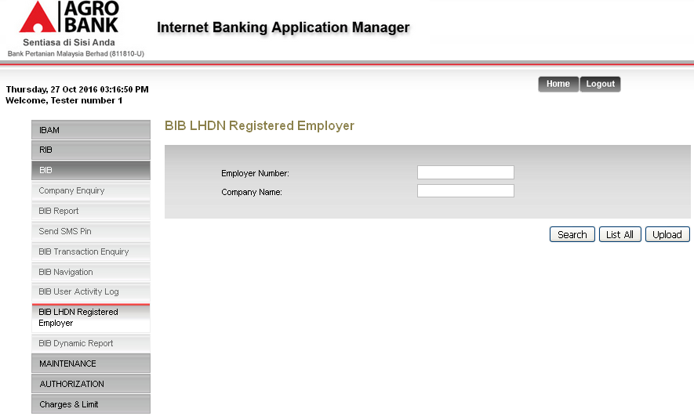

  - Click on “Browse” button to upload the file. Then click on “Next” to proceed.
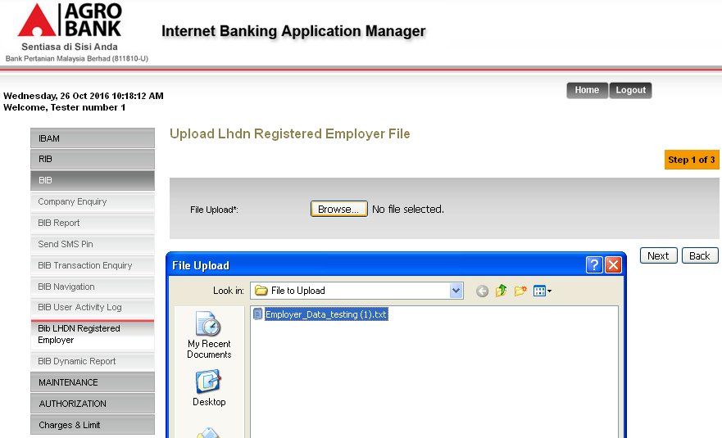
  - Click on “Confirm” button to proceed.
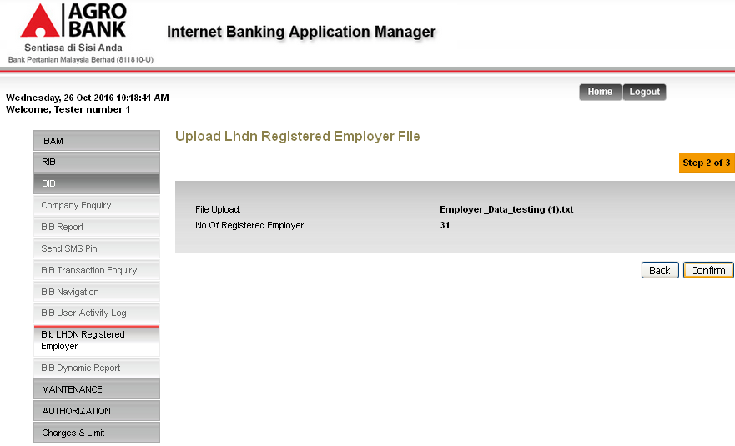

  - View Result Page.
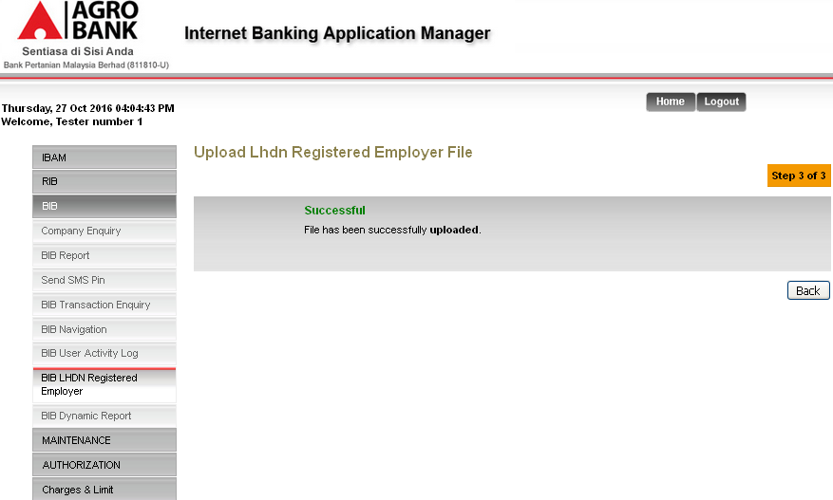

- Edit the “Employer” field into number that has been recorded on IBAM.
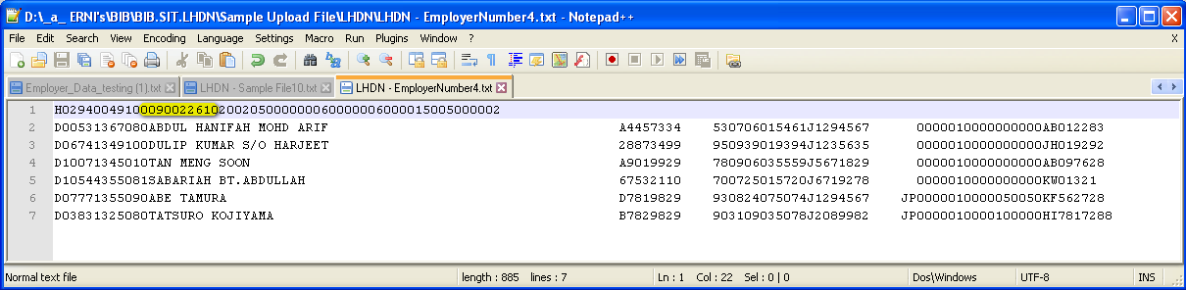

- Login as Initiator to BIB to upload LHDN file that has been edit the “Employer” field.
  - Go to Payroll > LHDN and Upload the file. Then click “Next” button to proceed.
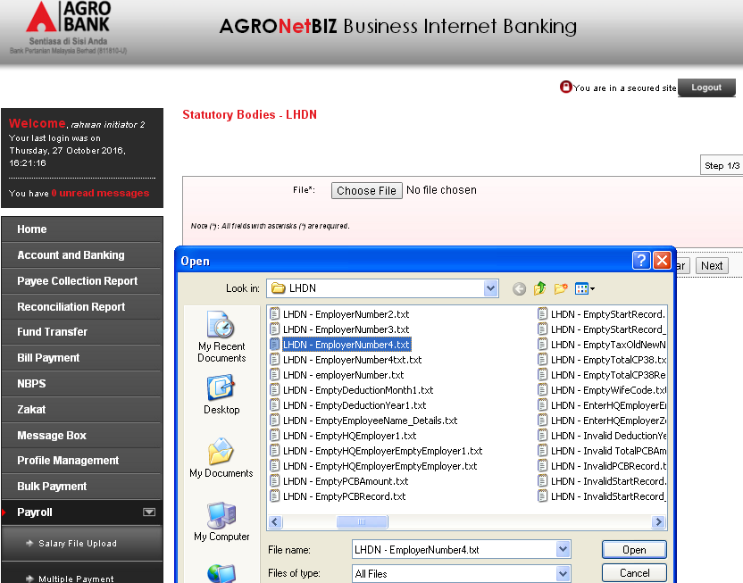

  - On the next page, choose on “From Account”, “Payment To”, enter the “Remarks” then click on “Confirm” button to proceed.
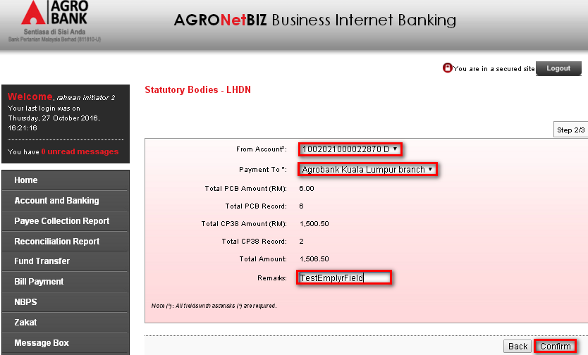

  - View Result Page
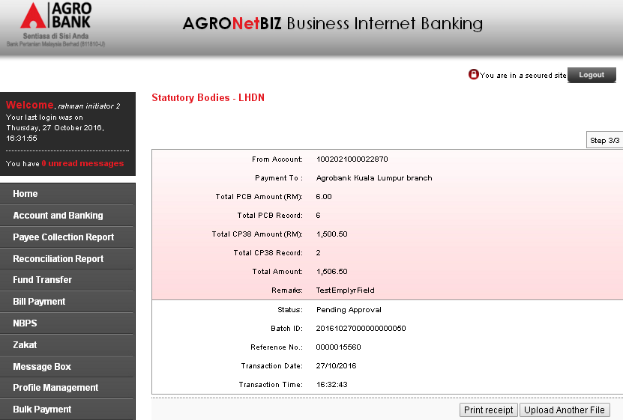
Result
Reference Number: 0000015560
Batch ID: 20161027000000000050
Total Amount: RM 1,506.50
Status: Pending Approval

  - View AgronetBiz Transaction History
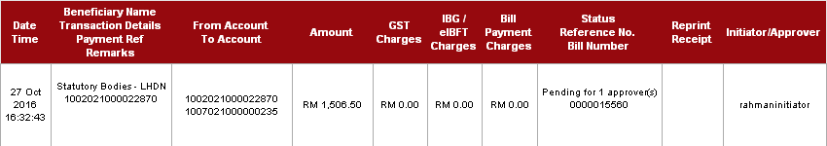
Result
Reference Number: 0000015560
Total Amount: RM 1,506.50
Status: Pending for 1 approver(s)

- Approve the transaction made.
  - Login as Approver and go to Authentication to view the Approval List.
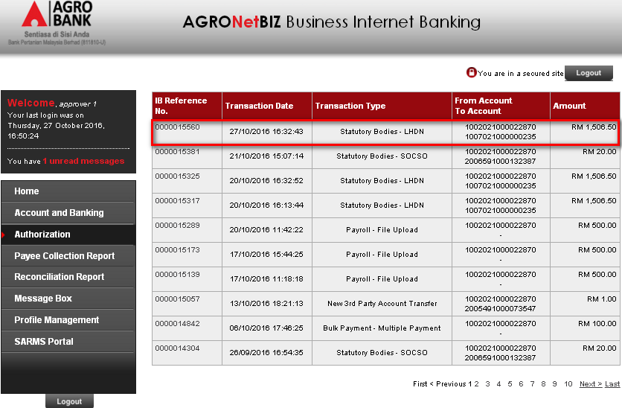

  - Choose on “Approve” Action, Enter the “Remarks” and “TAC Pin Number” then click on “Confirm” button.
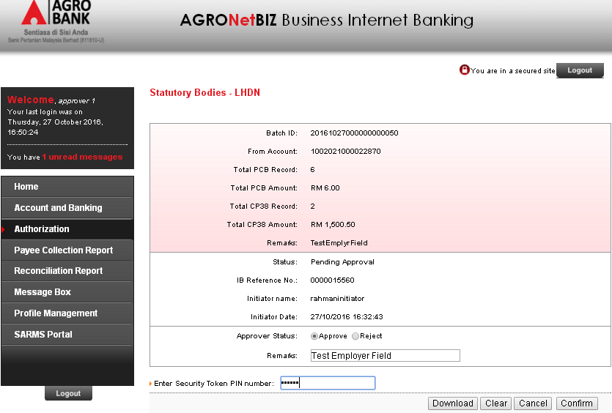
  - View Result Page
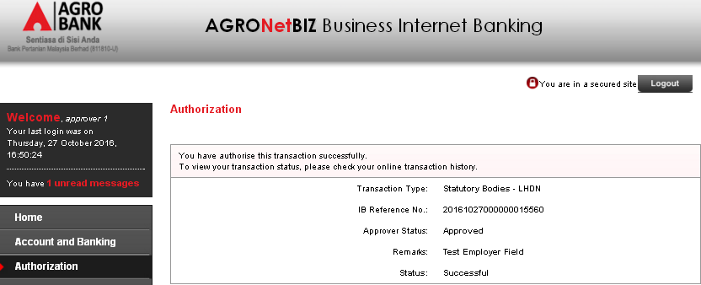
Result
IB Reference Number: 20161027000000015560
Approver Status: Approved
Transaction Status: Successful

  - Login as Initiator back to view the AgronetBiz Transaction History.
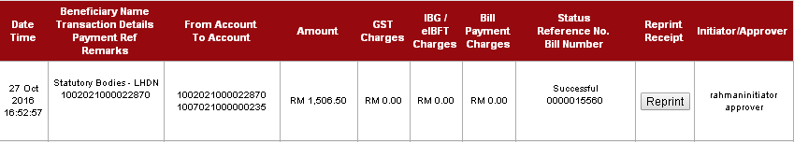
Result
Reference Number: 0000015560
Total Amount: RM 1,506.50
Status: Successful

- Negative Testing
- Change the Employer Number on “Employer Field” to be any number that not registered with LHDN.
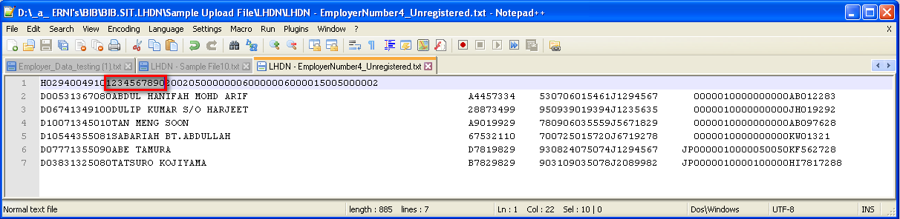
- Login to BIB as Initiator and try to upload the edit file
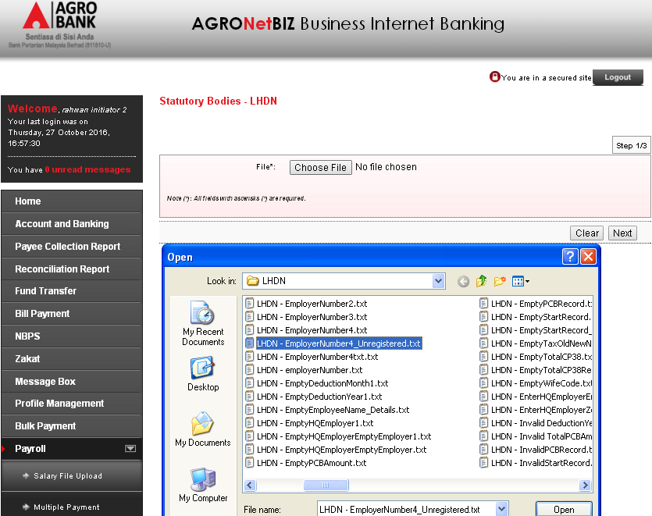

- View Result
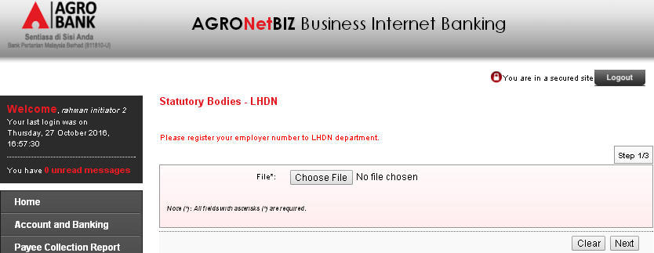
Error Message Displayed: Please register your employer number to LHDN department.

Reviewed By: (PMO)
 |  |  | Name/Position : Norhaidah Binti Md Dasuki / Senior Manager, Quality Assurance and Support  Date : 26/10/2016

