Test Issue Log |  |  |  |  |  | SCP ID# : 3433
Project Name: | AGROBANK BUSINESS INTERNET BANKING
Test Stage: | Unit Functionality Integration System Interface  Performance Regression Acceptance Pilot
Test Case Number: | Support #6737 |  |  | Test Started Date: |  |  | 31/10/2016
Test Title: | Bank Admin cannot allow Account Inquiry service for approver at IBAM
Test Description: | To ensure Account Enquiry is listed when Bank Admin try to edit service for approver.  https://10.6.6.20/bib.prod.kada/common/Login.do
Test Functionality: | IBAM  Company Enquiry > Company Details > User Maintenance  BIB  Account and Banking  - Role – Approver
Test Procedure: | IBAM  - Login to IBAM  - Access to User Maintenance.  - Choose on Approver role. Then view the services allow. Click on Account and Banking checkbox to allow this service. Or unclick on Account and Banking checkbox to unable this service.  BIB - Approver  - Login to BIB as Approver  - Click on Account and Banking module to view the edited result.  *Comfort Test:  1. Perform to edit service allow for another role (Initiator).  Result: Account and Banking shall list on Services List and were able to access Account and Banking module on BIB.
Test Result: | Pass: Fail: | Tested by: |  |  | Erni Suhaireen binti Zulkifli
Reason for Failure:
TEST DESCRIPTION
- Administrator
- Login on IBAM.PROD.FIXES as Administrator and go to Company Enquiry> User Maintenance. On User Maintenance page, select on Approver Role.
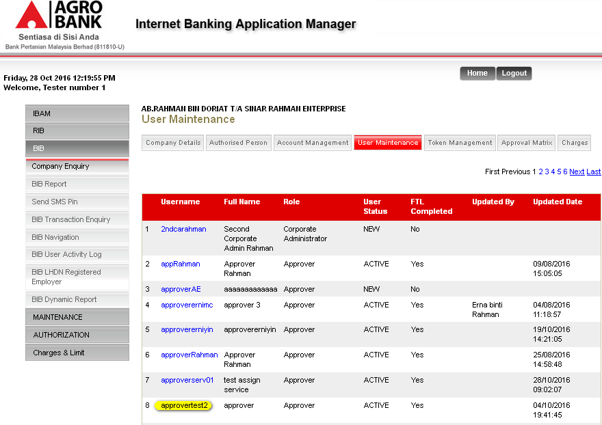

- On the next page, click on “Edit” button.
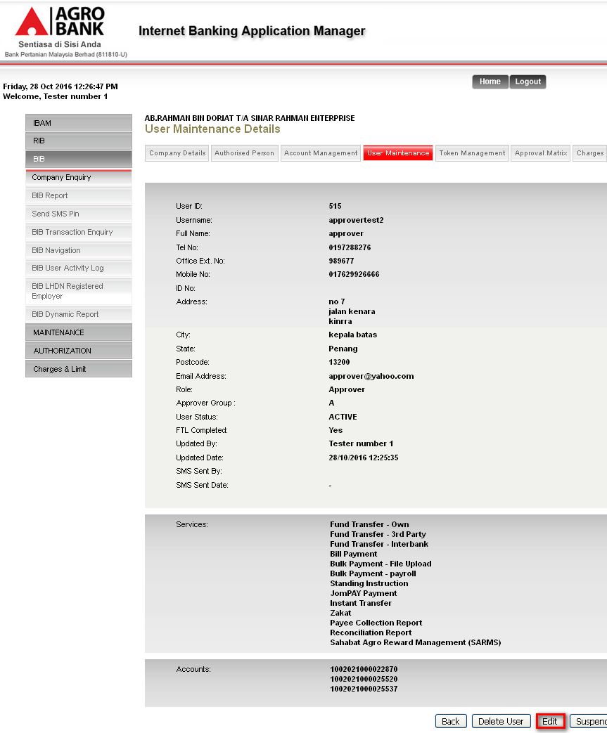

- Account Enquiry displayed on User Details Page. To allow on this service, click on the Account Enquiry checkbox. Then click on “Next” button.
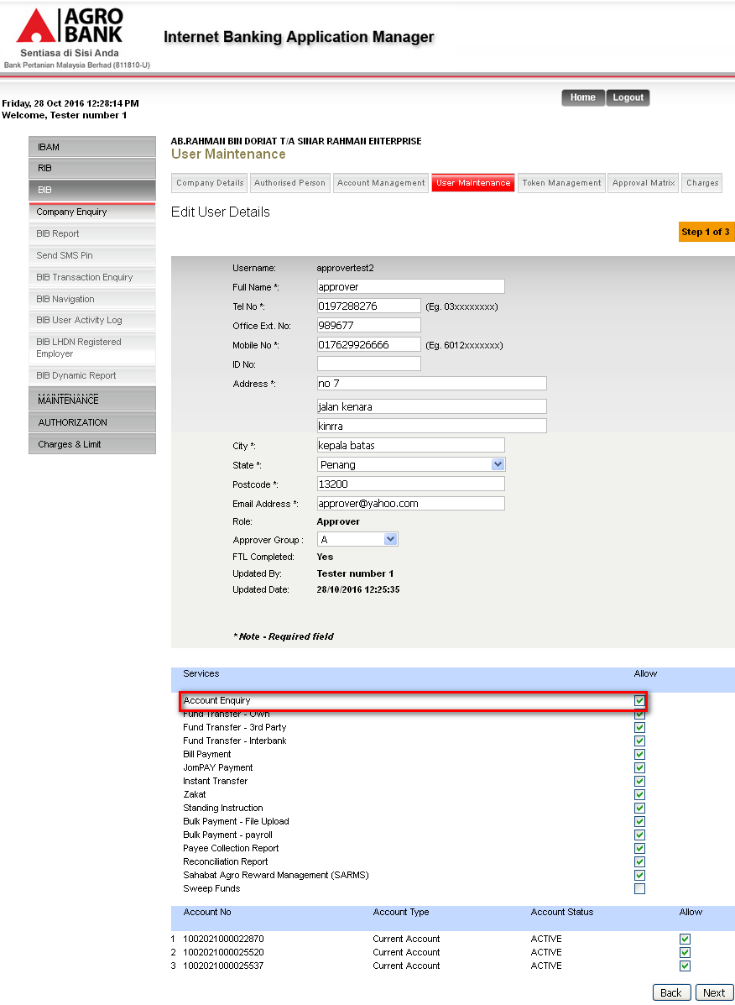

- Click “Confirm” button on Confirm Page.
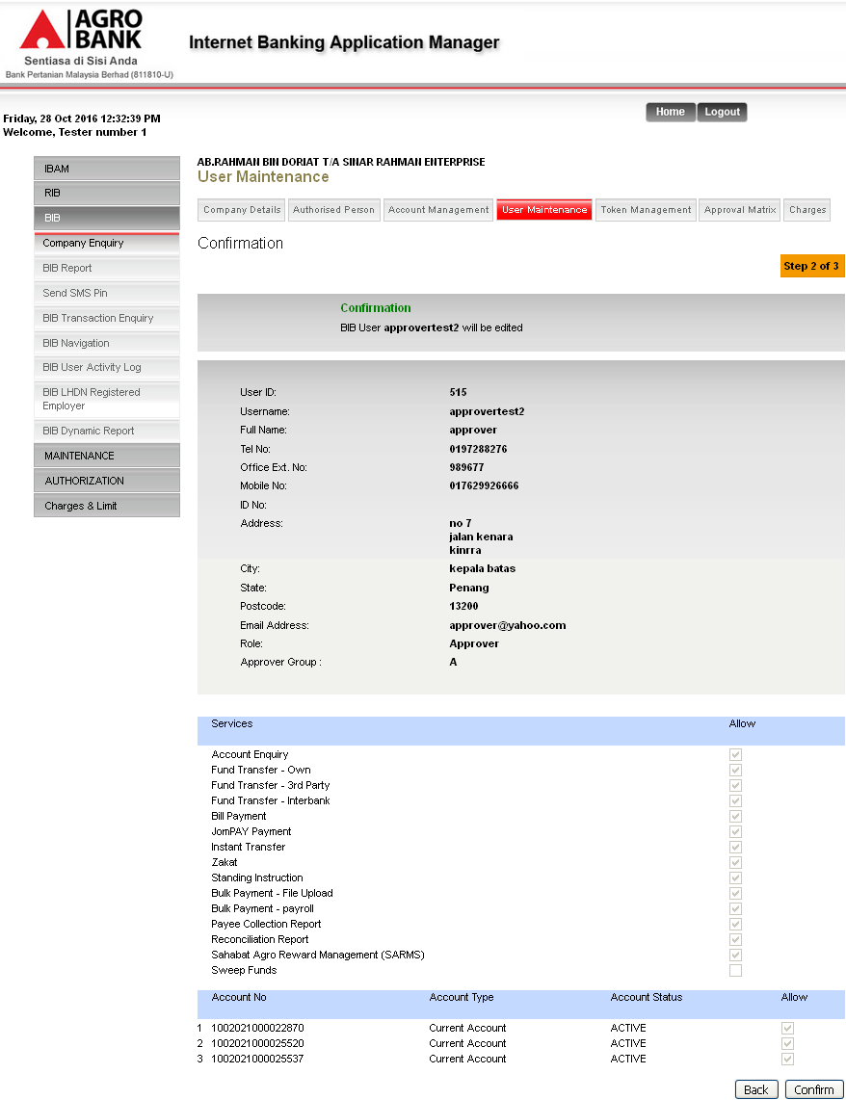

- Result Page.
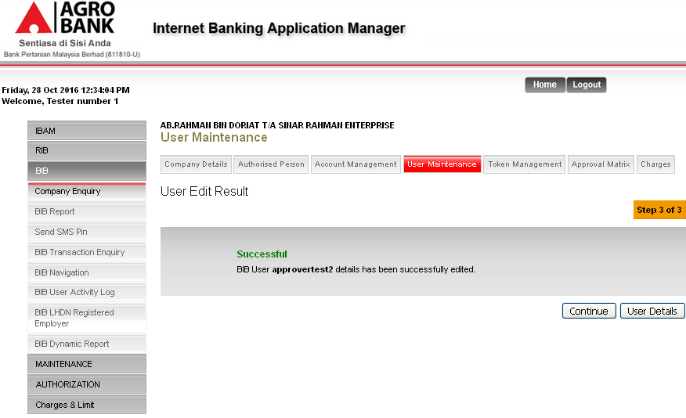
Result
Details have successfully been edited.

- Approver
- Login to BIB to view result edited on IBAM.
  - If unable Account Enquiry services on IBAM.
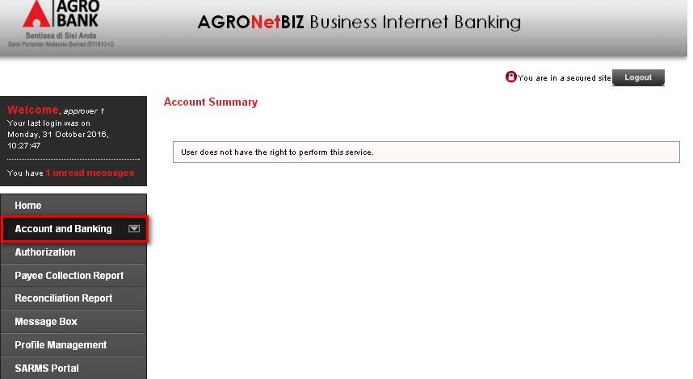
  - If able Account Enquiry services on IBAM.
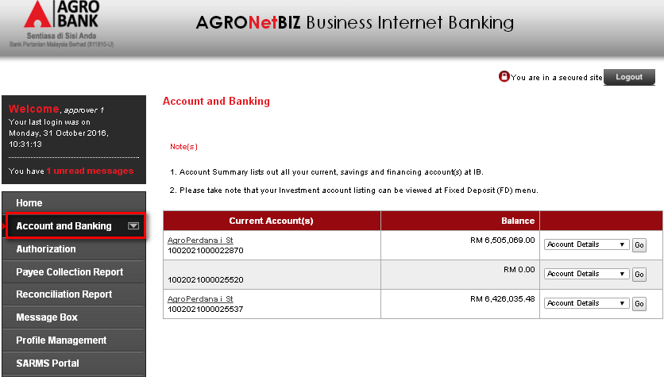

Comfort Test
- Perform to edit service allow for another role (Initiator).
Result:
Account and Banking was listed on Services List and were able to access Account and Banking module on BIB.

Reviewed By: (PMO)
 |  |  | Name/Position : Norhaidah Binti Md Dasuki / Senior Manager, Quality Assurance and Support  Date : 26/10/2016

