Test Issue Log |  |  |  |  |  | SCP ID# : SB_SOCSO_003
Project Name: | AGROBANK BUSINESS INTERNET BANKING
Test Stage: | Unit Functionality Integration System Interface  Performance Regression Acceptance Pilot
Test Case Number: | Bug #6745 |  |  | Test Started Date: |  |  | 01/11/2016
Test Title: | SOCSO – Employer Reference Number Validation
Test Description: | To ensure that user can only upload file with a valid employer number that has been set on IBAM.  https://10.6.6.20/bib.sit.lhdn/common/Login.do  https://10.6.6.20/ibam.sit.lhdn/common/Login.do
Test Functionality: | IBAM  Company Enquiry > Company Details – SOCSO Employer Number  Company Enquiry > Company Details – LHDN Employer Number  BIB  - Role – Initiator  Payroll > Statutory Bodies > LHDN  Payroll > Statutory Bodies > LHDN
Test Procedure: | IBAM  - Login to IBAM  - Access to BIB Company Details  - Set on SOCSO Employer Number has been set.  - Set on LHDN Employer Number has been set.  BIB - Initiator  - Login to BIB as Initiator  - Perform SOCSO transfer with the file that has been edit on Employer Number to be same as Employer Number set on IBAM.  - Perform SOCSO transfer with the file that has not been edit on Employer Number to be same as Employer Number set on IBAM.  - Perform LHDN transfer with the file that has been edit on Employer Number to be same as Employer Number set on IBAM.  - Perform LHDN transfer with the file that has not been edit on Employer Number to be same as Employer Number set on IBAM.
Test Result: | Pass: Fail: | Tested by: |  |  | Erni Suhaireen binti Zulkifli
Reason for Failure:
TEST DESCRIPTION
- IBAM
- Login to IBAM
- Access to BIB Company Details
- Set on SOCSO Employer Number has been set.
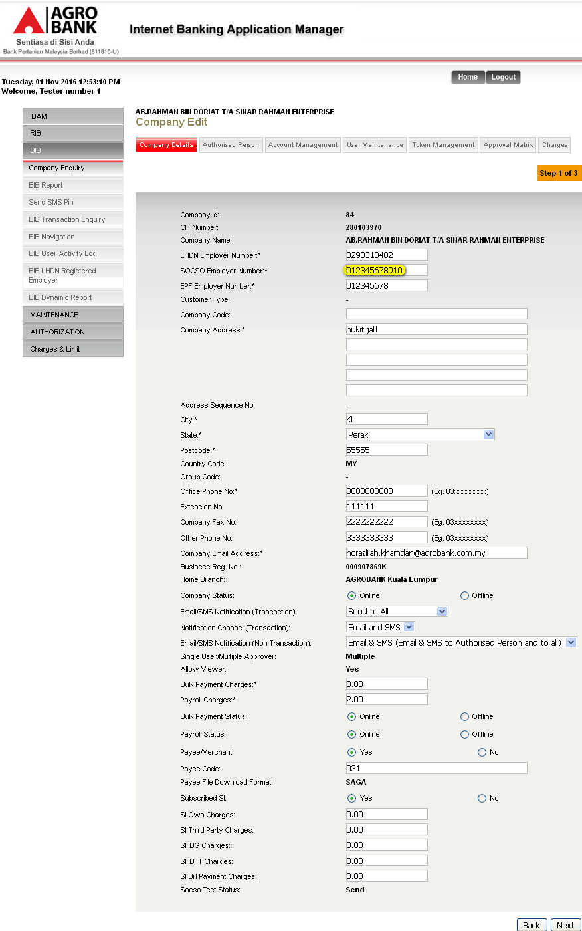
- Set on LHDN Employer Number has been set.
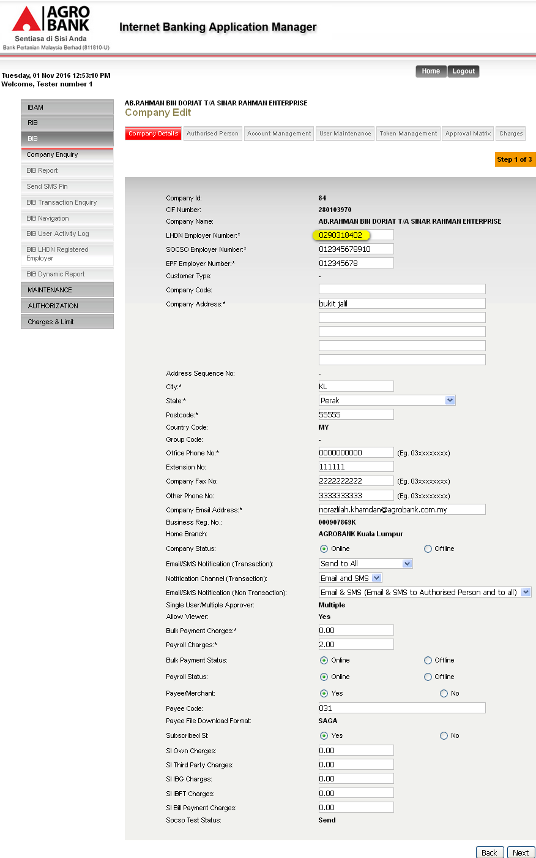

- BIB – Initiator
- Edit File.
  - Edit SOCSO file on Employer field to be same as Employer Number set on IBAM.
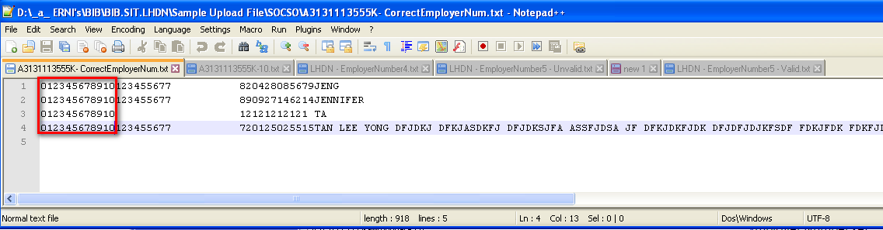
  - Edit SOCSO file on Employer field to be not same as Employer Number set on IBAM.
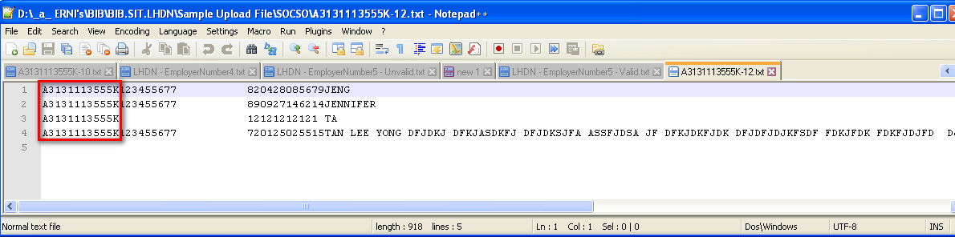
  - Edit LHDN file on Employer field to be same as Employer Number set on IBAM.
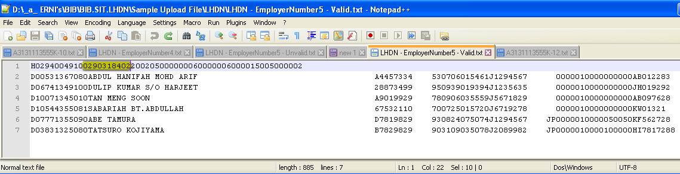
  - Edit LHDN file on Employer field to be not same as Employer Number set on IBAM.
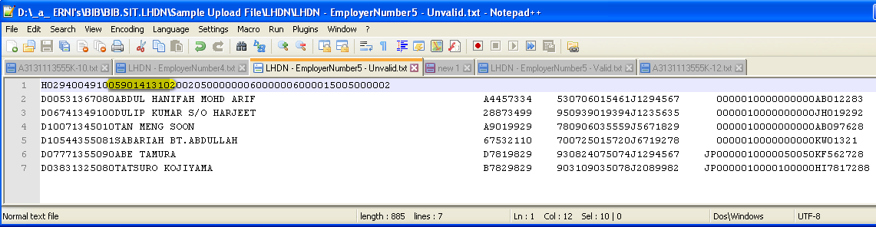

- Login to BIB as Initiator
- Perform SOCSO transfer with the file that has been edit on Employer Number to be same as Employer Number set on IBAM.
  - Upload the file.
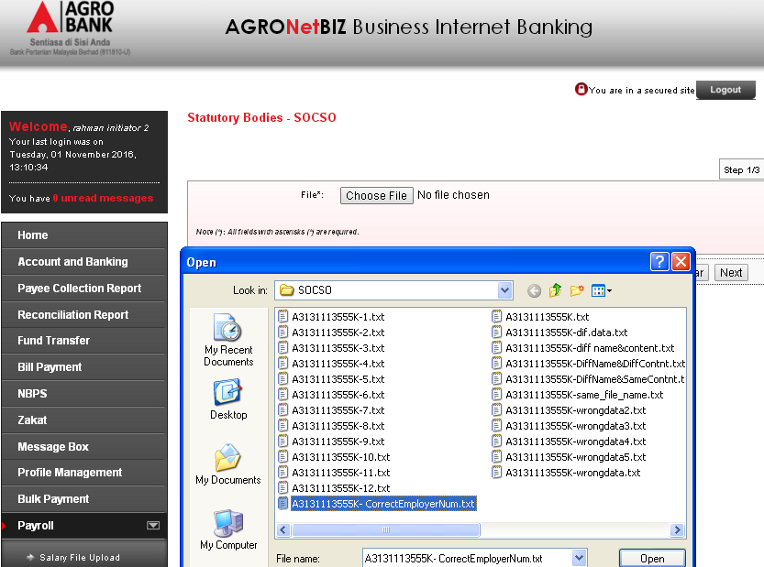
  - Click on Confirm to proceed.
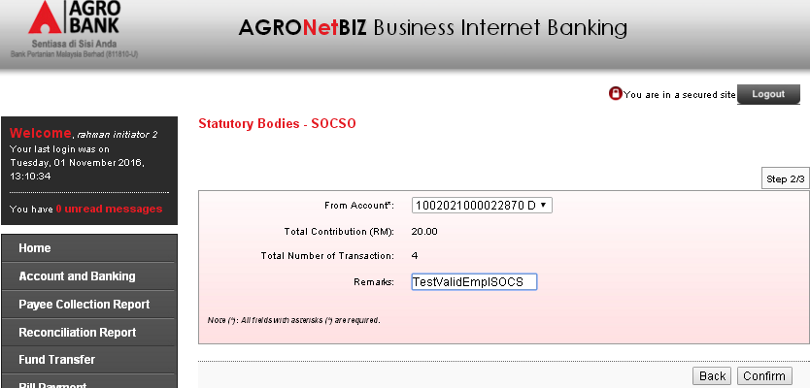
  - Result Page.
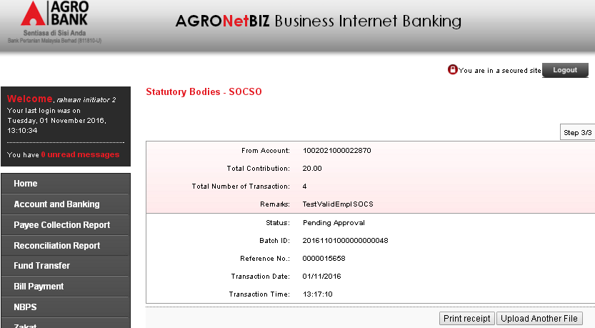
Result
File with valid Employer Number can successfully been uploaded.

- Perform SOCSO transfer with the file that has not been edit on Employer Number to be same as Employer Number set on IBAM.
  - Upload the file.
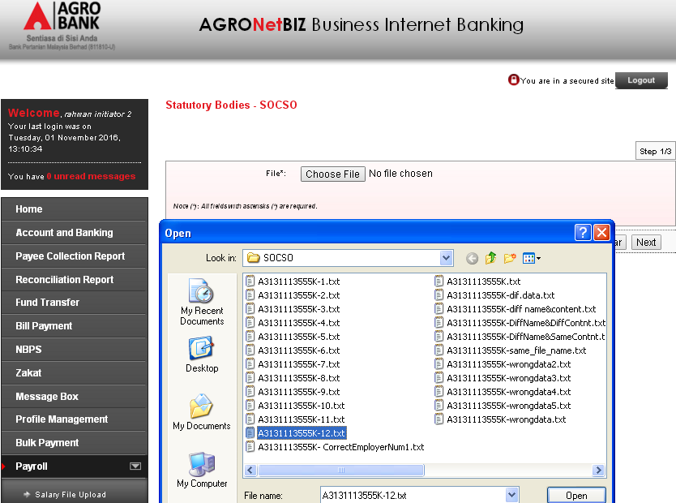\
  - Result Page.
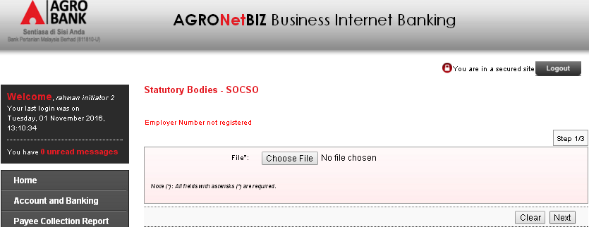
Result
Validation applied. Error message displayed: Employer Number not registered
- Perform LHDN transfer with the file that has been edit on Employer Number to be same as Employer Number set on IBAM.
  - Upload the file.
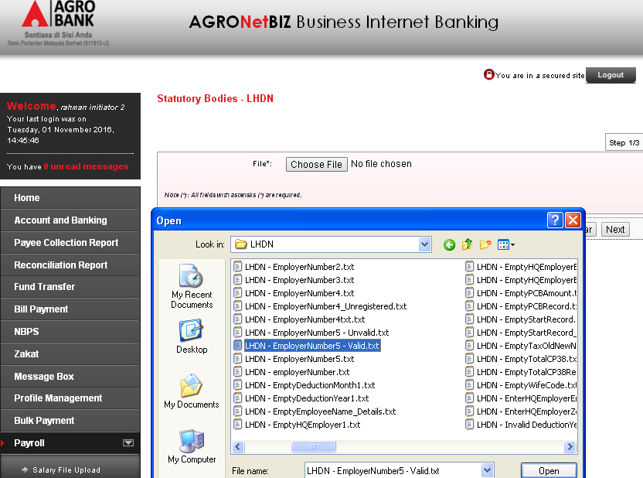
  - Click on Confirm to proceed.
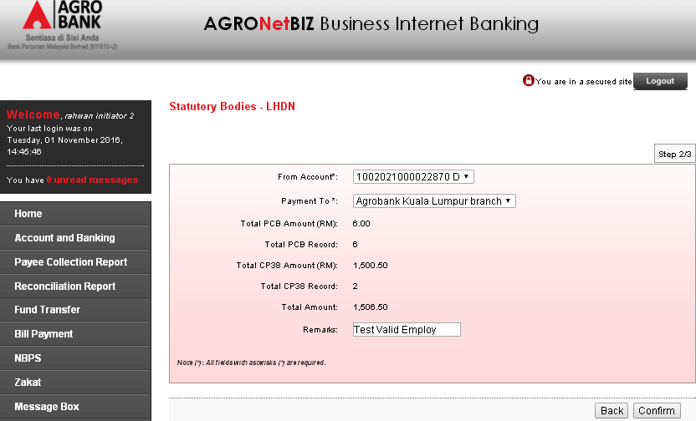
  - Result Page.
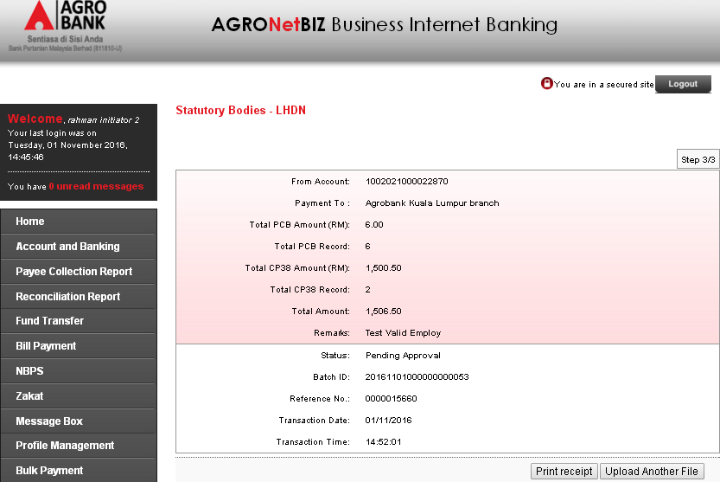
Result
File with valid Employer Number can successfully been uploaded.

- Perform LHDN transfer with the file that has not been edit on Employer Number to be same as Employer Number set on IBAM.
  - Upload the file.
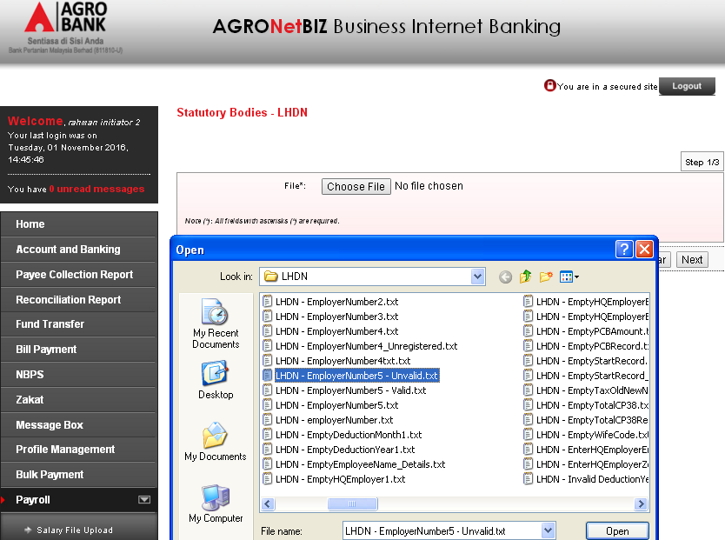
  - Result Page.
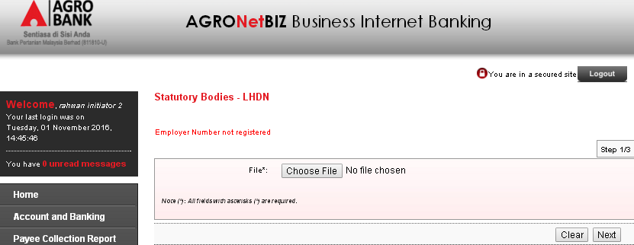Result:
Validation applied. Error message displayed: Employer Number not registered.
Reviewed By: (PMO)
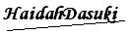 |  |  | Name/Position : Norhaidah Binti Md Dasuki / Senior Manager, Quality Assurance and Support  Date : 26/10/2016

