Test Issue Log |  |  |  |  |  | SCP ID# : SB_SOCSO_001
Project Name: | AGROBANK BUSINESS INTERNET BANKING
Test Stage: | Unit Functionality Integration System Interface  Performance Regression Acceptance Pilot
Test Case Number: | Support #6742 |  |  | Test Started Date: |  |  | 30/10/2016
Test Title: | SOCSO – Facing Error when Approver Confirm Transaction
Test Description: | To ensure that Approver role can approve the transaction even when SOCSO Test Status on IBAM has set to be “Not Register”.  https://10.6.6.20/bib.sit.lhdn/common/Login.do  https://10.6.6.20/ibam.sit.lhdn/common/Login.do
Test Functionality: | IBAM  Company Enquiry > Company Details – SOCSO Test Status  BIB  - Role – Initiator  Payroll > Statutory Bodies > SOCSO  - Role – Approver  Authentication > Approval List
Test Procedure: | IBAM  - Login to IBAM  - Access to BIB Company Details  - Ensure that SOCSO Test Status has changed to “Not Register”.  BIB - Initiator  - Login to BIB as Initiator  - Perform SOCSO transaction.  BIB - Approver  - Login to BIB as Approver  - Click to Authorization sub-navigation to approve on related transaction made.  - View AgronetBiz Transaction History.  - View SOCSO Transfer Status
Test Result: | Pass: Fail: | Tested by: |  |  | Erni Suhaireen binti Zulkifli
Reason for Failure:
TEST DESCRIPTION
- IBAM
- Login to IBAM to ensure that SOCSO Test Status has changed to “Not Register”.
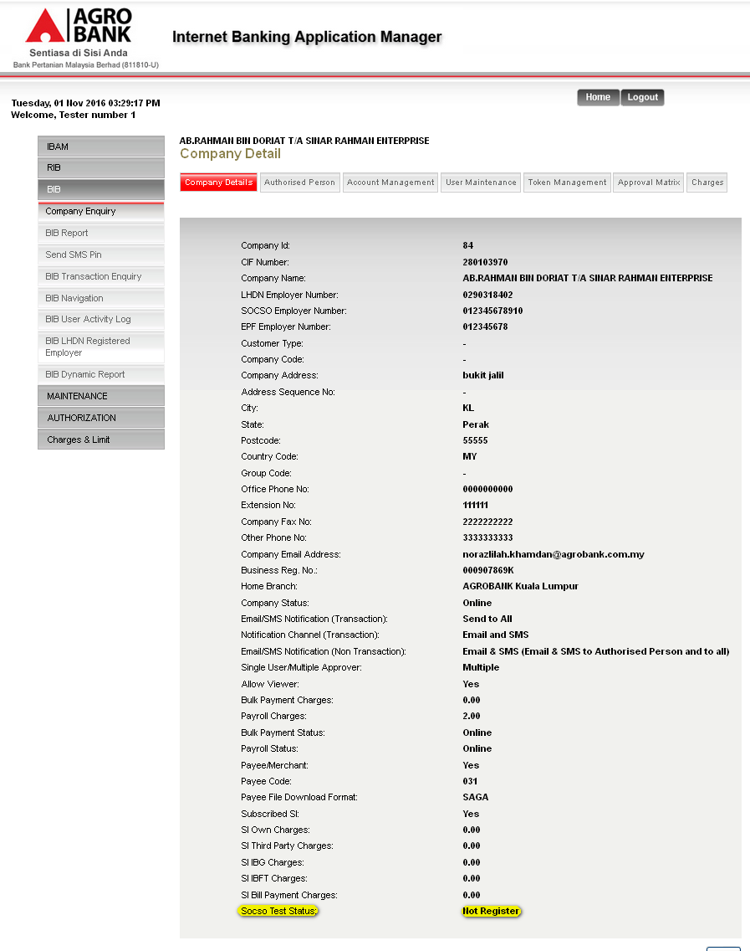
- BIB – Initiator
- Login to BIB as Initiator and perform SOCSO Transfer.
  - Upload the file.
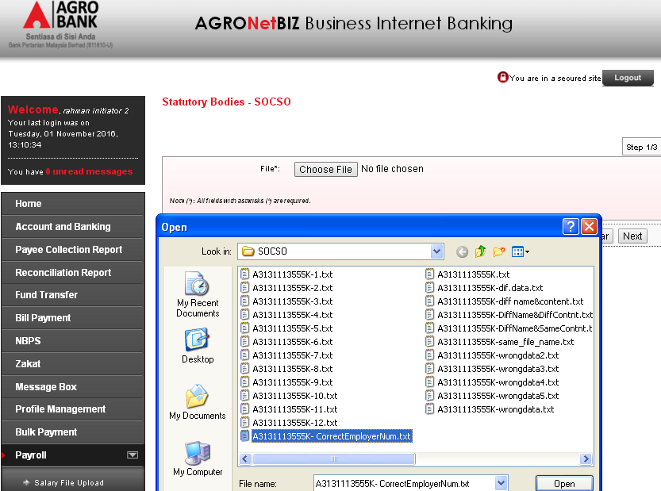
  - Click confirm on Confirm page.
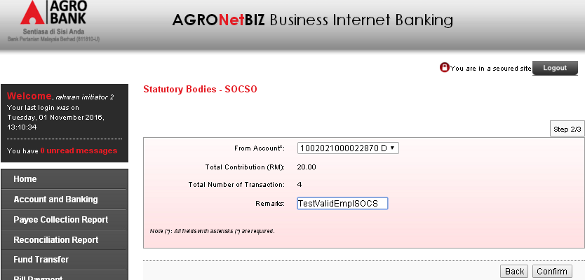
  - View Result Page.
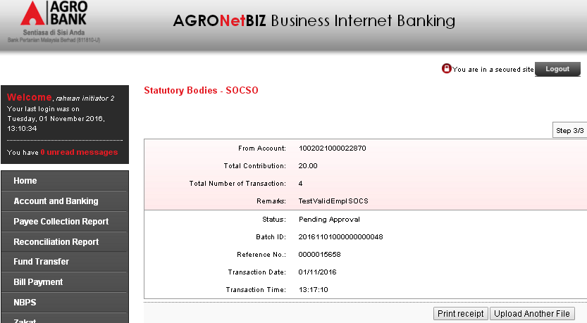
- View SOCSO Transfer History.
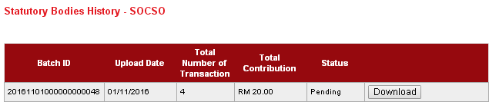
- View AgronetBiz Transaction History.
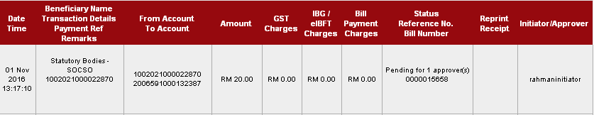

- BIB – Approver
- Login to BIB as Approver to approve the transaction made.
  - View Approval list. Click on transaction IB Reference Num. of the transaction made.
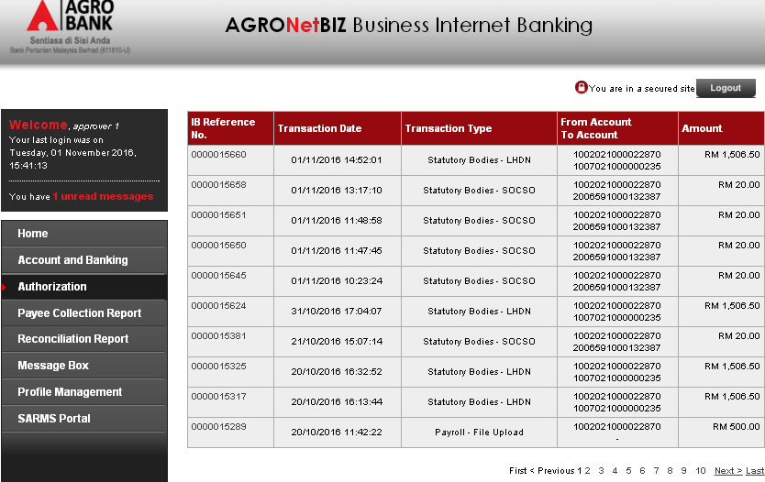

  - Click on Confirm to proceed
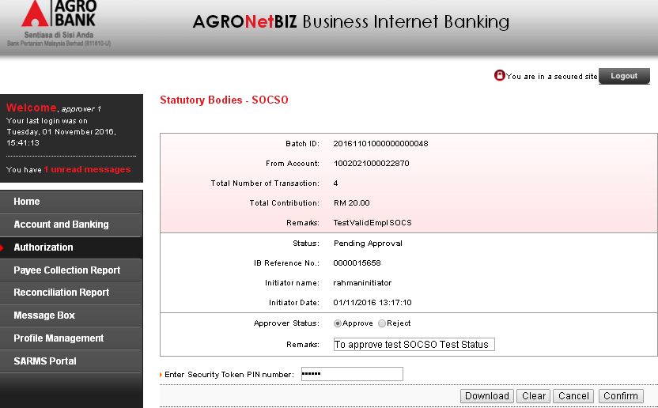
  - System has successfully approved the transaction. No bug.
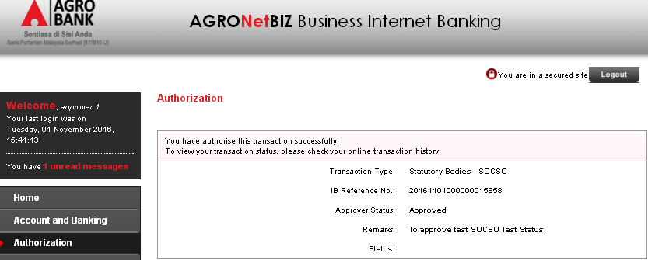
Result:
Approver Status: Approved

- View AgronetBiz Transaction History.
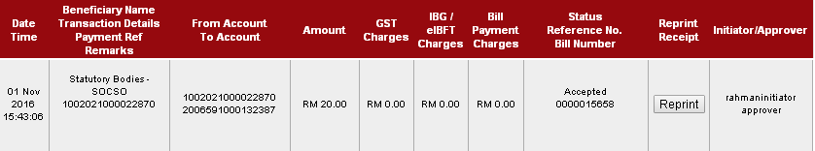
- View SOCSO Transfer Status
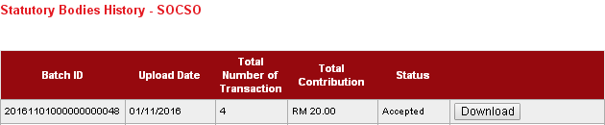

Reviewed By: (PMO)
 |  |  | Name/Position : Norhaidah Binti Md Dasuki / Senior Manager, Quality Assurance and Support  Date : 26/10/2016

