Test Issue Log |  |  |  |  |  | SCP ID# : SB_SOCSO_003
Project Name: | AGROBANK BUSINESS INTERNET BANKING
Test Stage: | Unit Functionality Integration System Interface  Performance Regression Acceptance Pilot
Test Case Number: | Bug #6745 |  |  | Test Started Date: |  |  | 01/11/2016
Test Title: | SOCSO – Employer Reference Number Validation
Test Description: | To ensure that every SOCSO employer number is valid for only one company.  https://10.6.6.20/bib.sit.lhdn/common/Login.do  https://10.6.6.20/ibam.sit.lhdn/common/Login.do
Test Functionality: | IBAM  Company Enquiry > Company Details – SOCSO Employer Number
Test Procedure: | IBAM  - Login to IBAM  - Access to BIB Company Details  - View SOCSO Employer Number for Multiple User Company (Rahman).  - View SOCSO Employer Number for Single User Company (Abdullah).
Test Result: | Pass: Fail: | Tested by: |  |  | Erni Suhaireen binti Zulkifli
Reason for Failure: | There are two company have the same SOCSO Employer Number.
TEST DESCRIPTION
IBAM
- Login to IBAM
- Access to BIB Company Details
- View SOCSO Employer Number for Multiple User Company (Rahman).
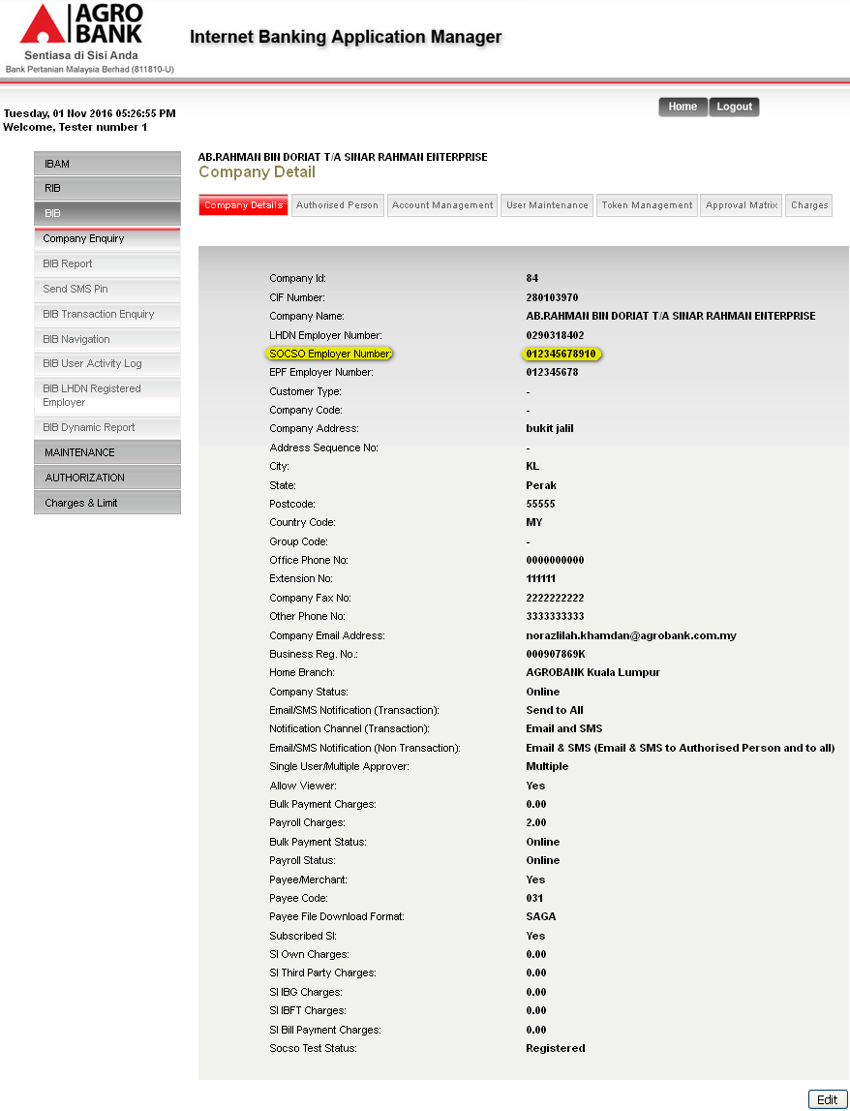
- View SOCSO Employer Number for Single User Company (Abdullah).
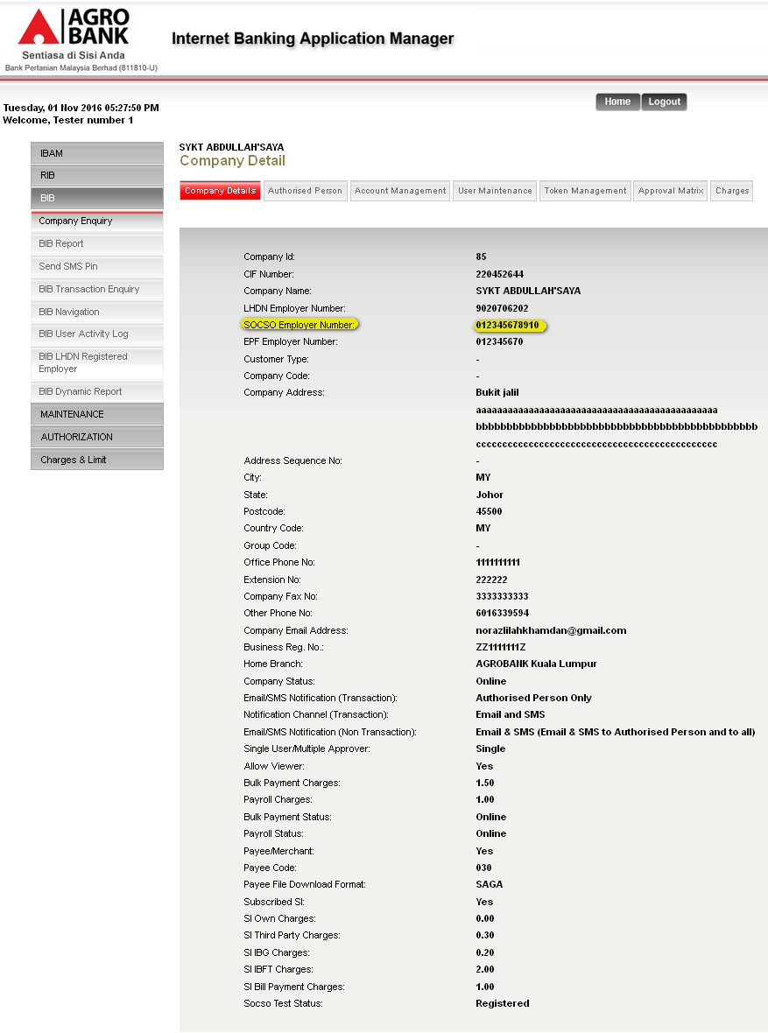
Reviewed By: (PMO)
 |  |  | Name/Position : Norhaidah Binti Md Dasuki / Senior Manager, Quality Assurance and Support  Date : 26/10/2016

