Test Issue Log
Project Name: | CMS Labuan FTT
Test Stage: | Unit Functionality Integration System Interface  Performance Regression Acceptance Pilot
Test Case Number: | Task#6320 |  | Test Started Date: |  | 24/06/2016
Test Title: | CMS Labuan FTT – Straight Through Processing (Additional Request)
Test Description: | To test file generated from the application in development with Swift Format.
Test Functionality: | Open Foreign Telegraphic Transfer  Registered Foreign Telegraphic Transfer
Test Procedure: | - Perform Open & Registered FTT transaction: Fill all field including optional & mandatory fields.  - Perform Open & Registered FTT transaction: Leave blank for 3 new field (‘Currency/Instructed Amount’, ‘FED Wire Field’ and ‘Sender Swift Code’)  - Perform Open & Registered FTT transaction: Fill all field except ‘Sender Swift Code’.  - Perform Open & Registered FTT transaction: Leave blank all optional field except Beneficiary Bank Code (BIC/SWIFT)  - Print Receipt.  - View Transaction History.  - Generate Swift File.  - Check with SWIFT system
Test Result: | Pass: Fail: Conditional Pass: | Tested by: |  | Nurul Akmal binti Yusof
Reason for Failure:
TEST DESCRIPTION

http://kfhib10:8110/kfh_bib_labuan_swift_dev/common/Login.do

Test item No.1: Setting: Fill all fields.

Open FTT

Confirm page

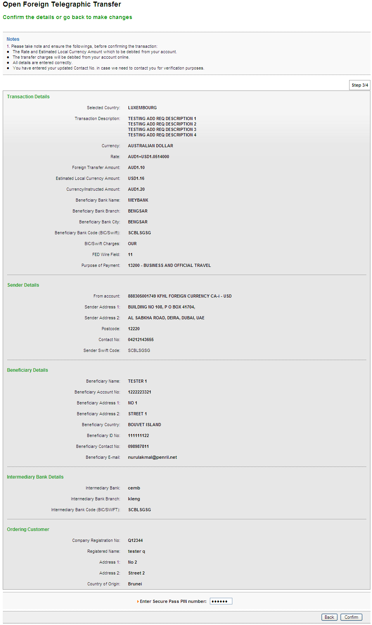

Result page
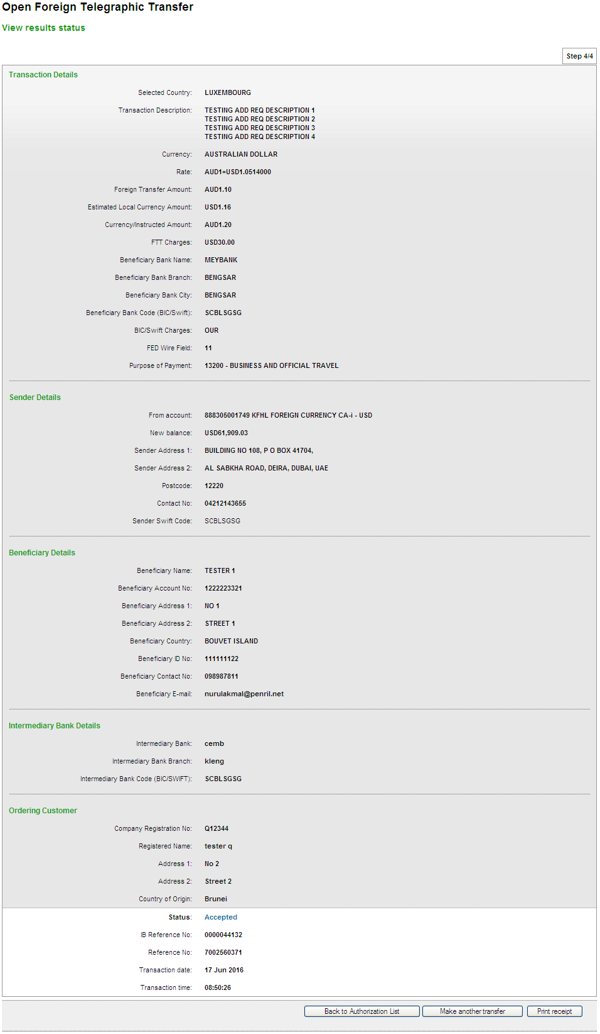

Print Receipt
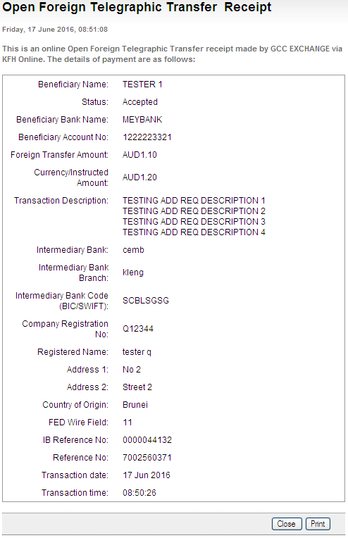

Generated SWIFT103 Text File
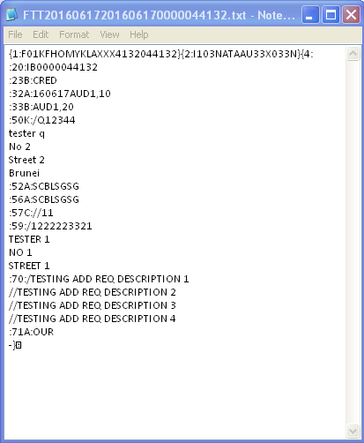

Output from Swift System - Able to view Swift text, approve or reject.
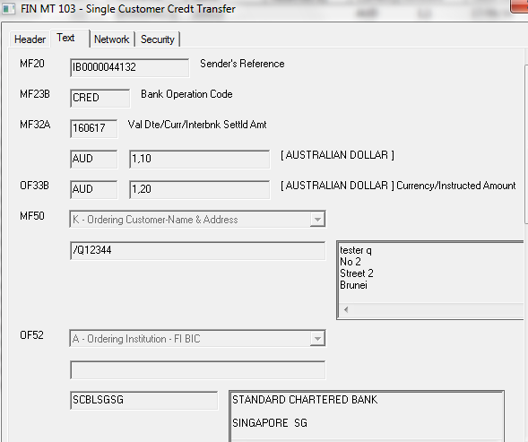
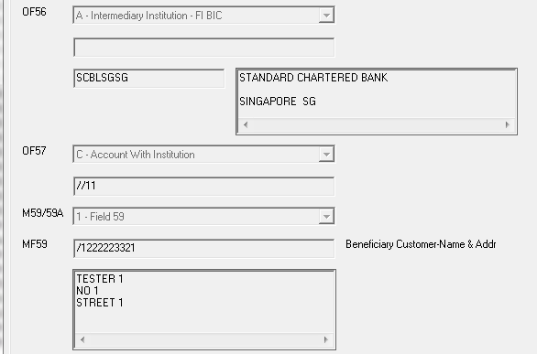
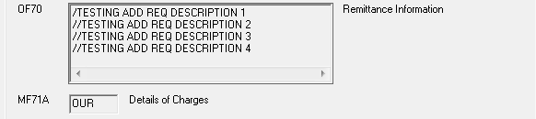

Registered FTT

Confirm page
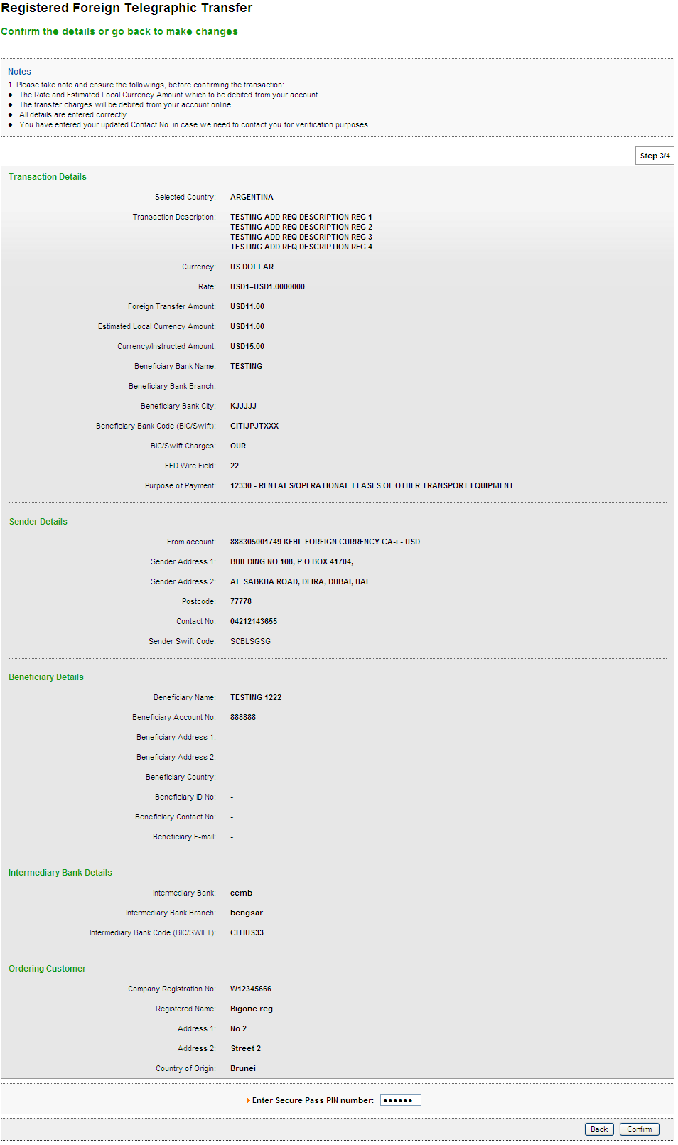

Result page
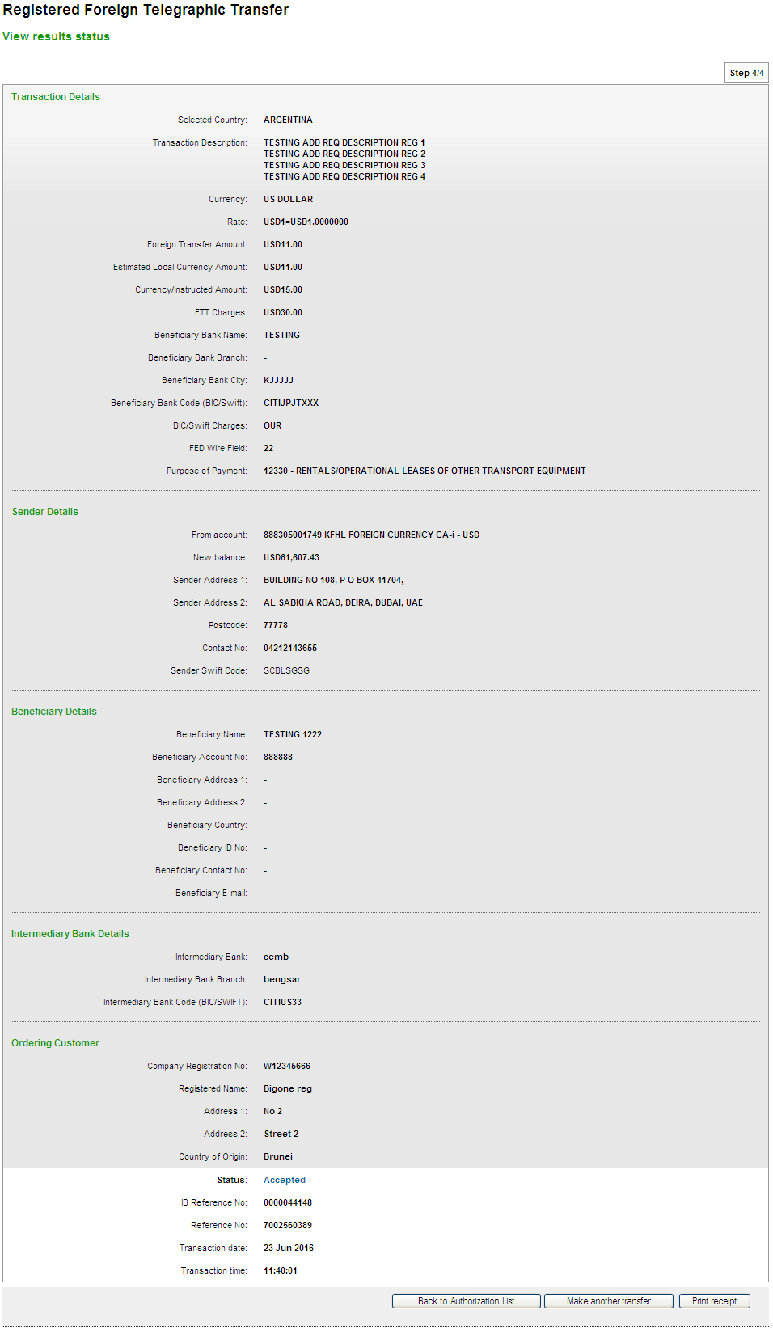

Print Receipt
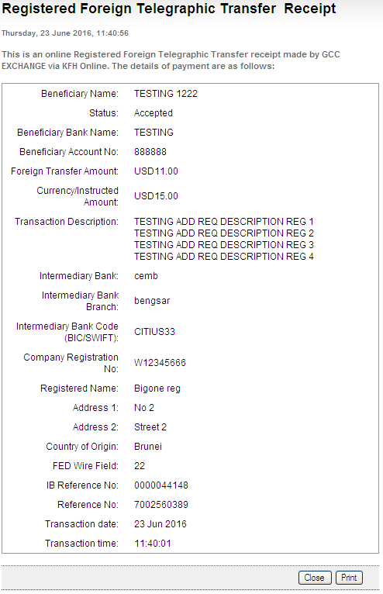

Generated SWIFT103 Text File
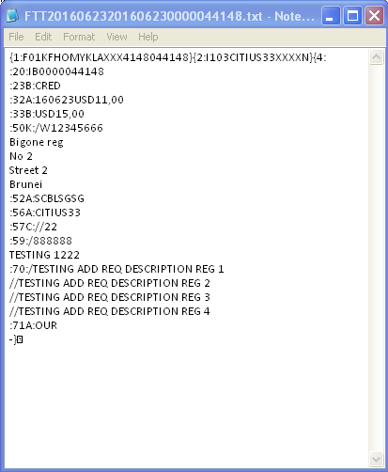

Output from Swift System - Able to view Swift text, approve or reject.
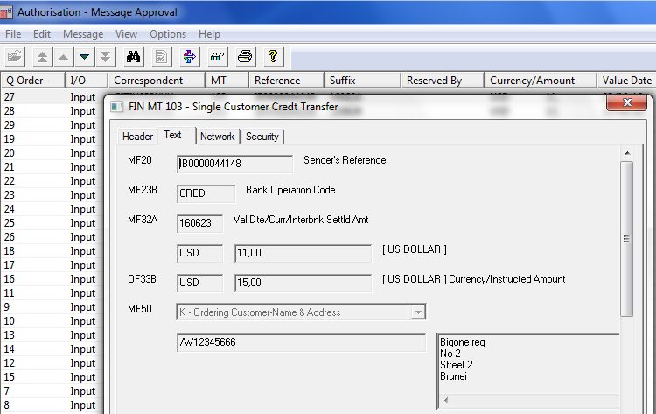
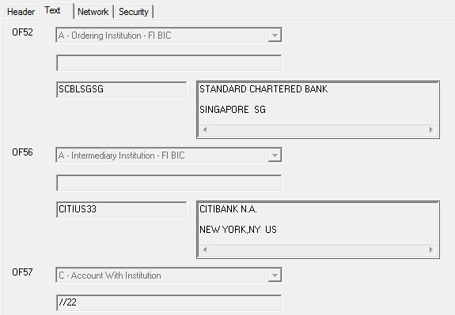
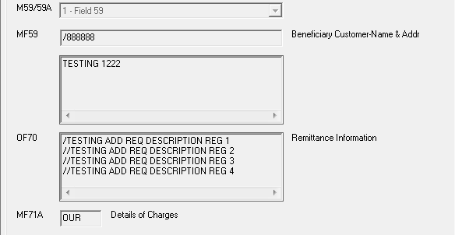

Test item No.2: Setting: Leave blank for ‘Currency/Instructed Amount’, ‘FED Wire Field’ and ‘Sender Swift Code’ field.

Open FTT

Confirm page
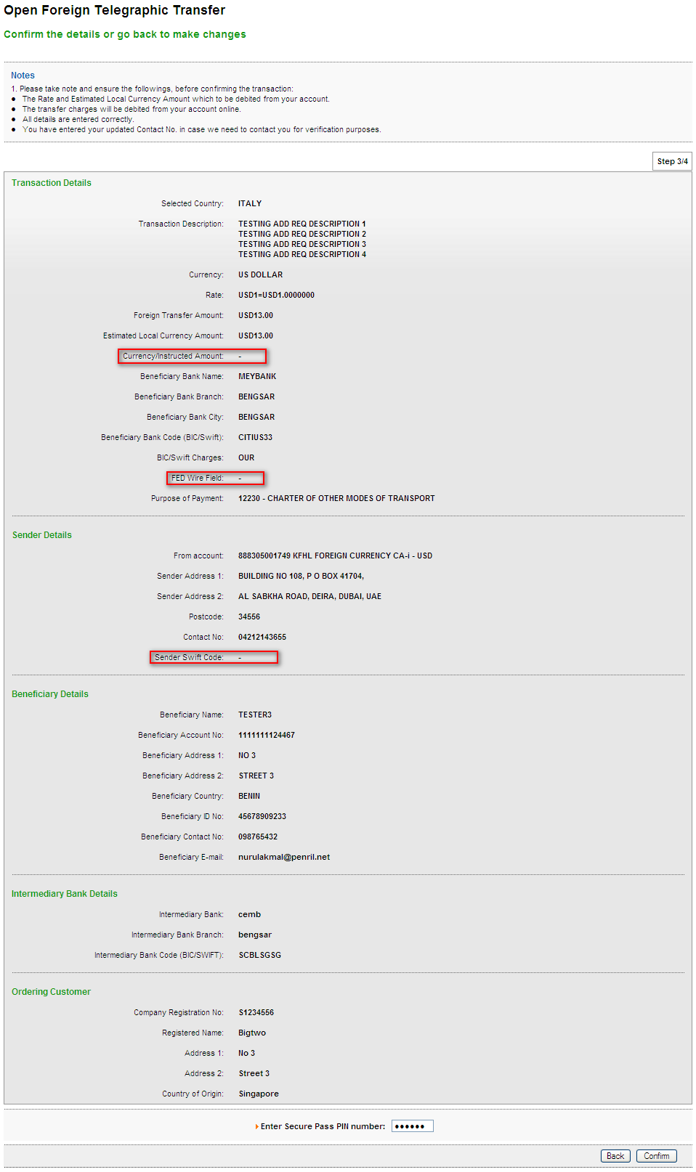

Result page
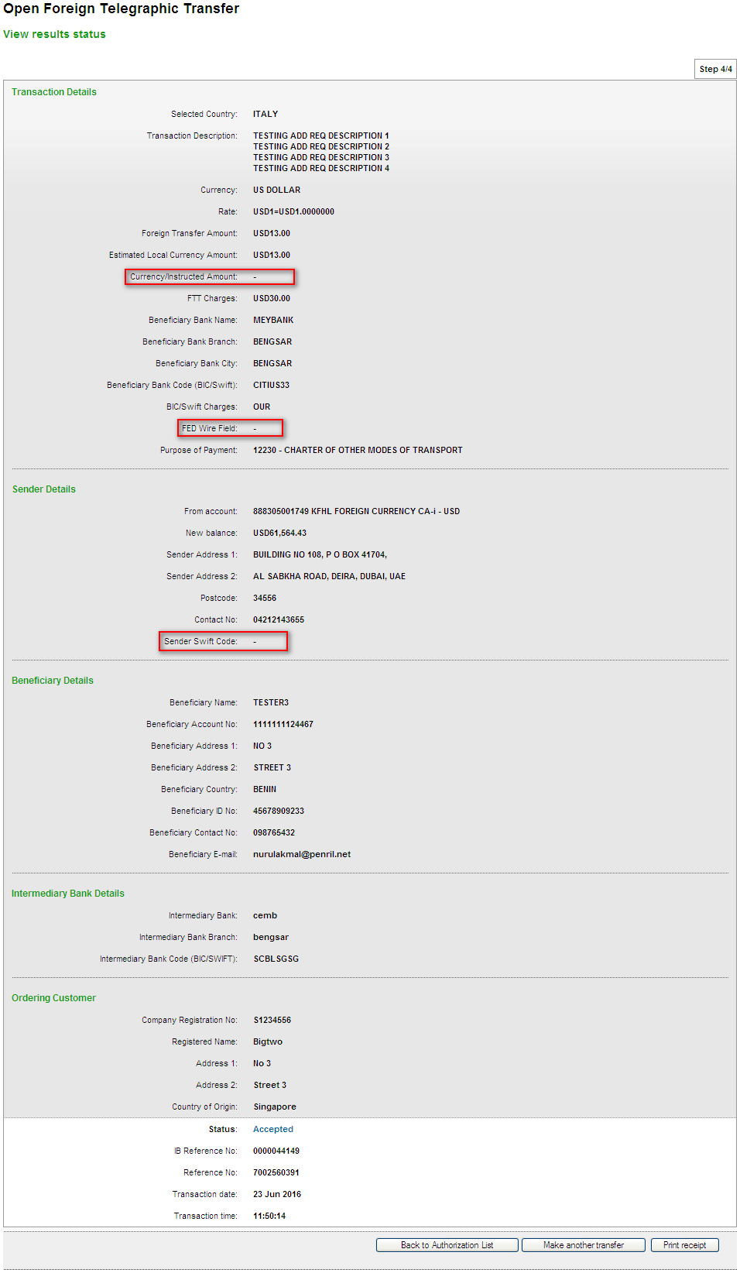

Print Receipt
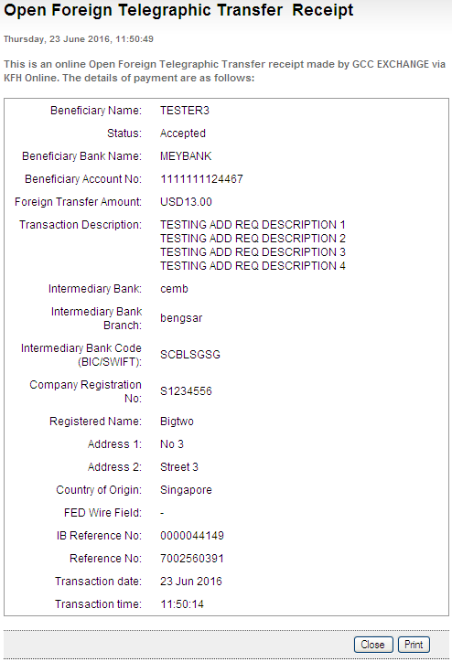

Generated SWIFT103 Text File
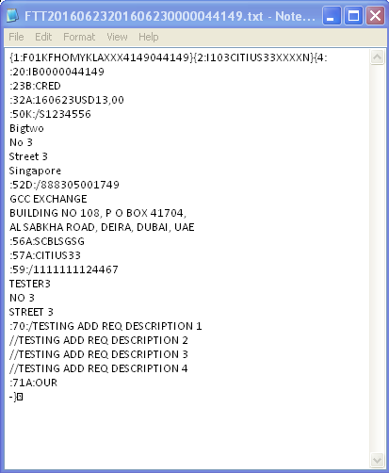

Output from Swift System - Able to view Swift text, approve or reject.
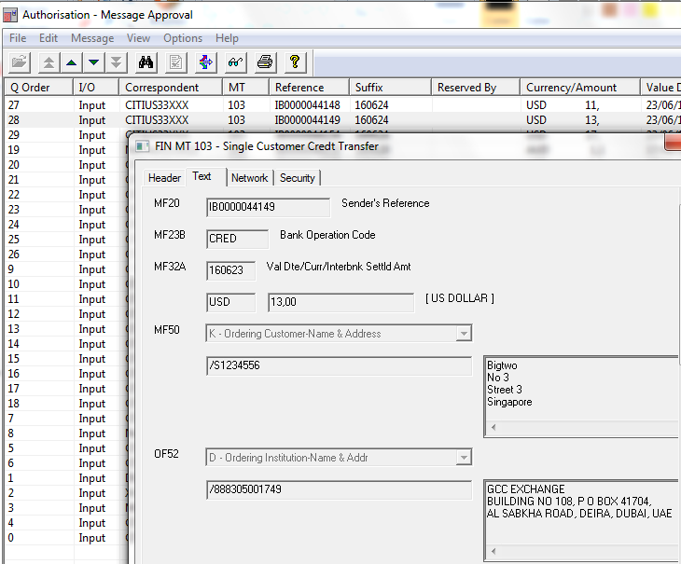
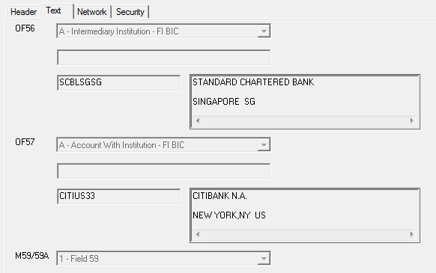
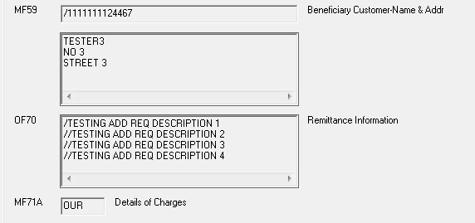

Registered FTT

Confirm page
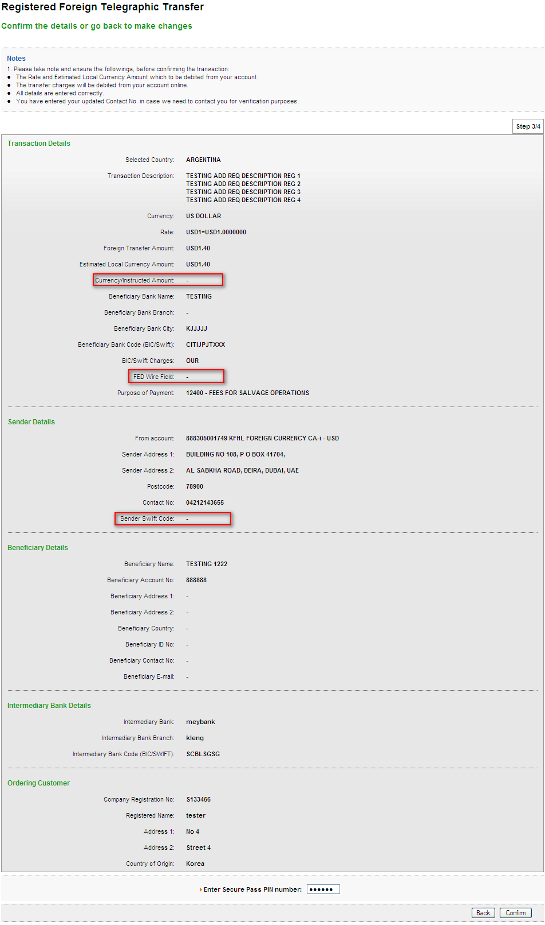

Result page
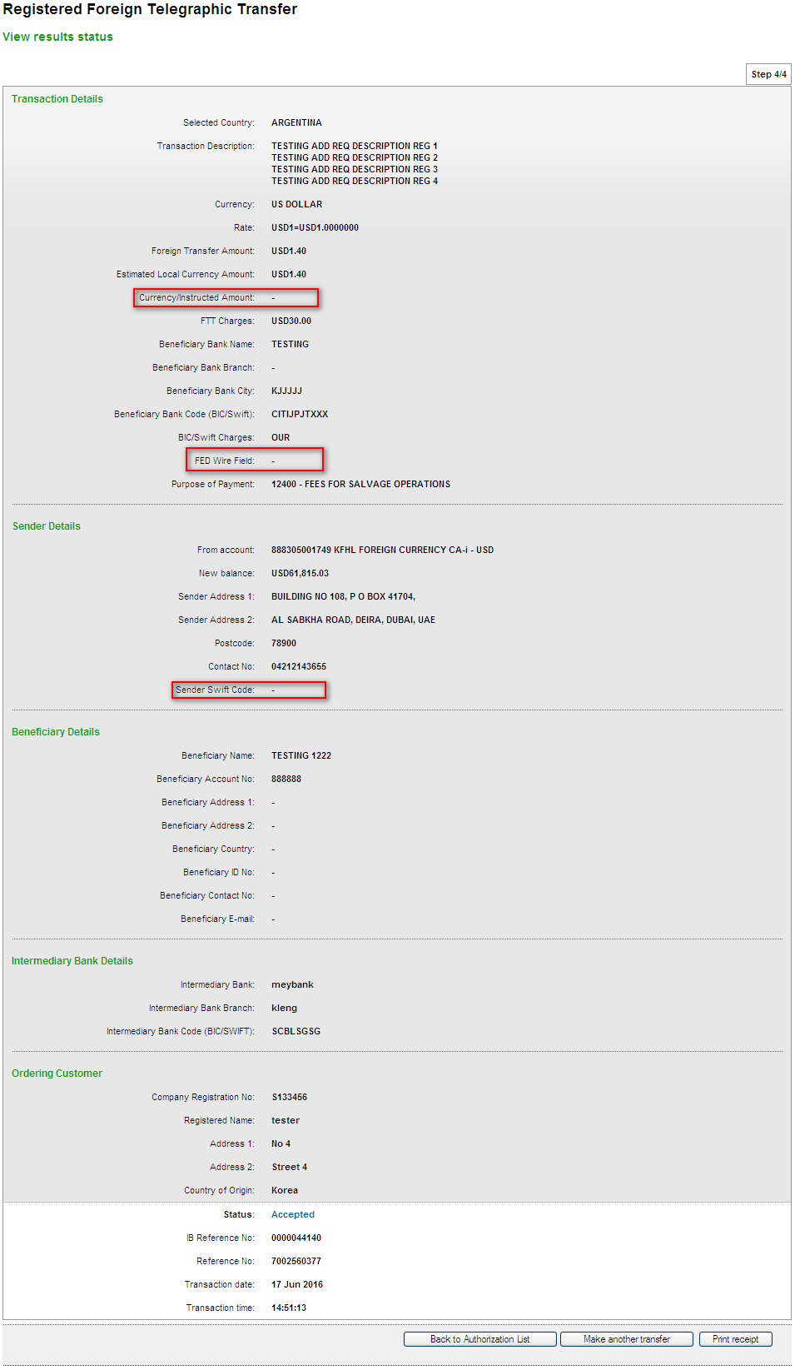

Print Receipt
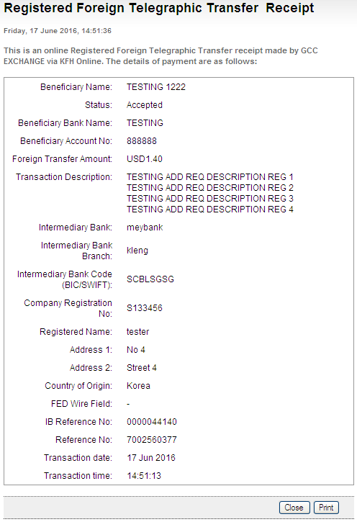

Generated SWIFT103 Text File
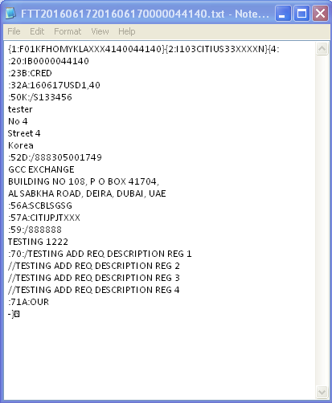

Output from Swift System - Able to view Swift text, approve or reject.
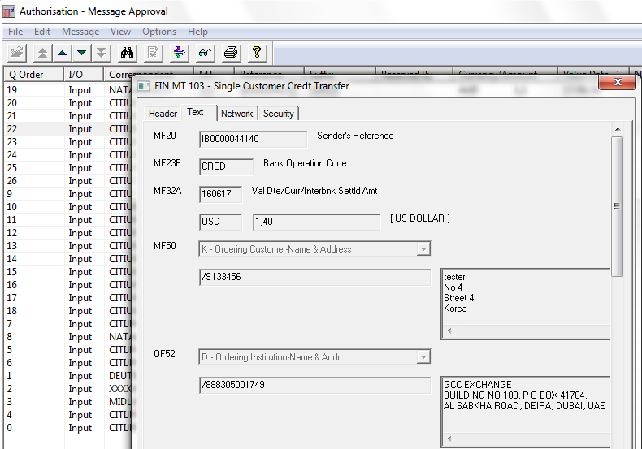
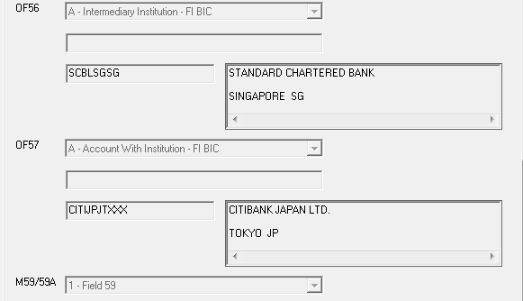
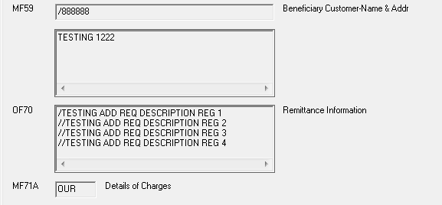

Test item No.3: Setting: Leave blank for ‘Sender Swift Code’ field.

Open FTT

Confirm page
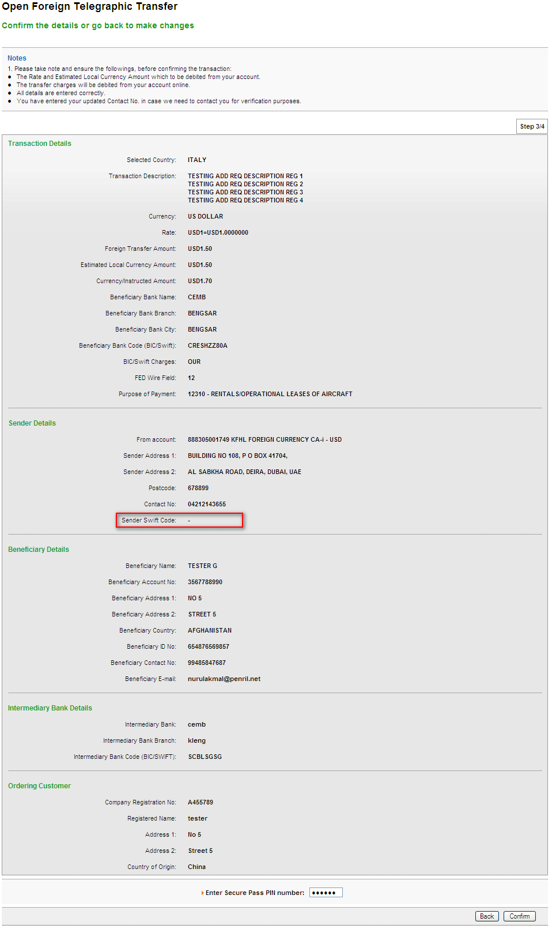

Result page
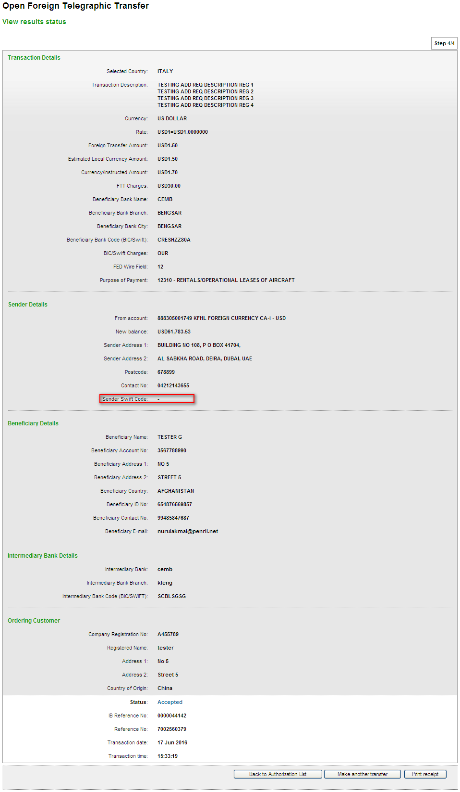

Print Receipt
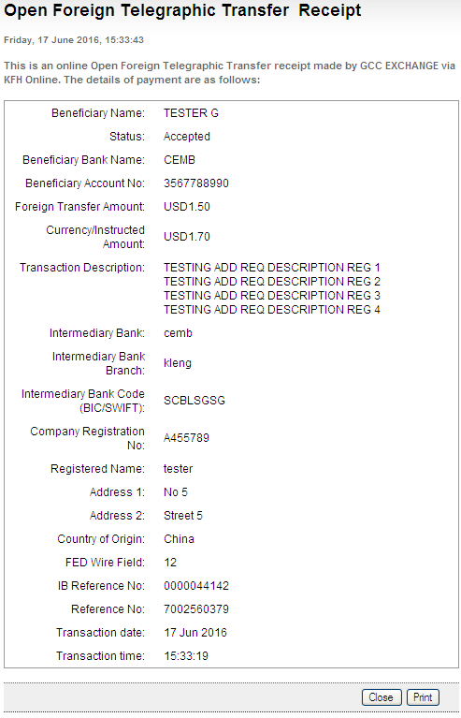

Generated SWIFT103 Text File
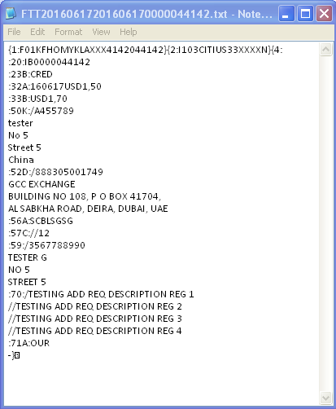

Output from Swift System - Able to view Swift text, approve or reject.
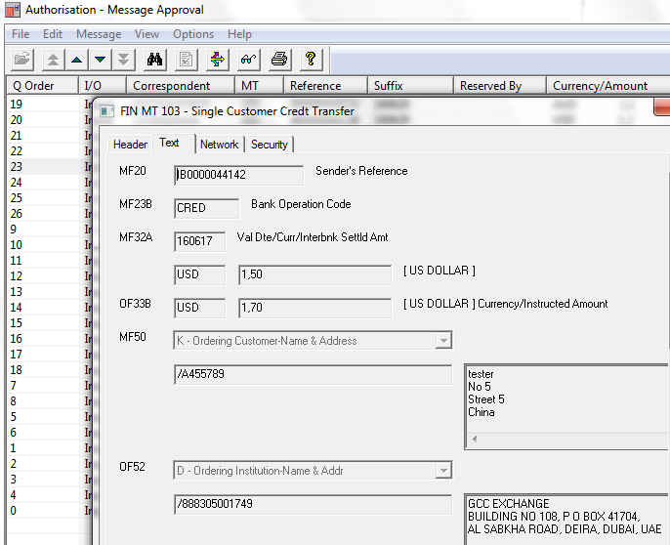
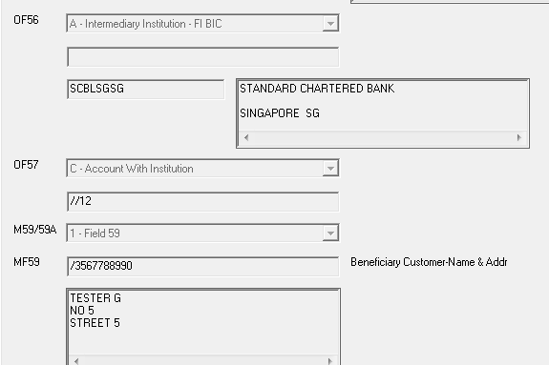
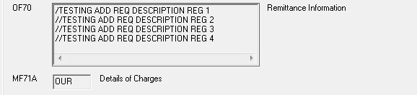

Registered FTT

Confirm page
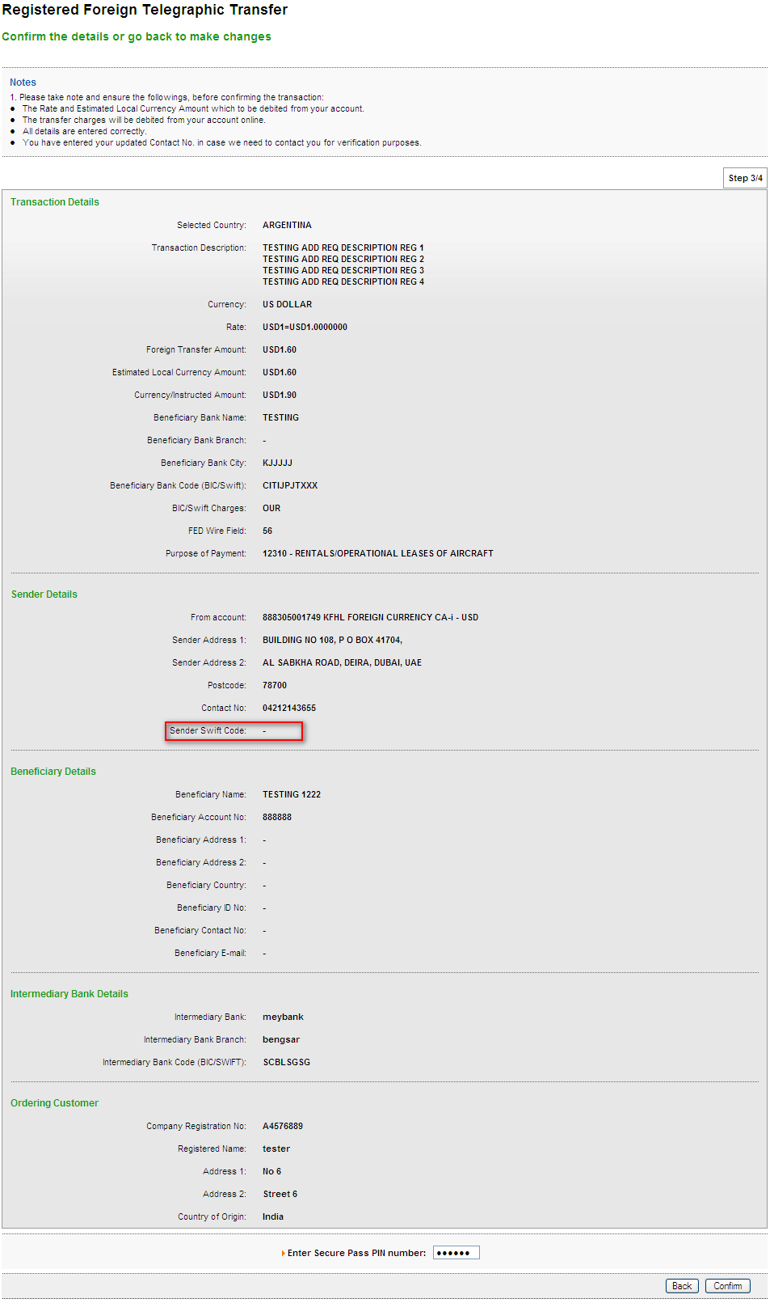

Result page
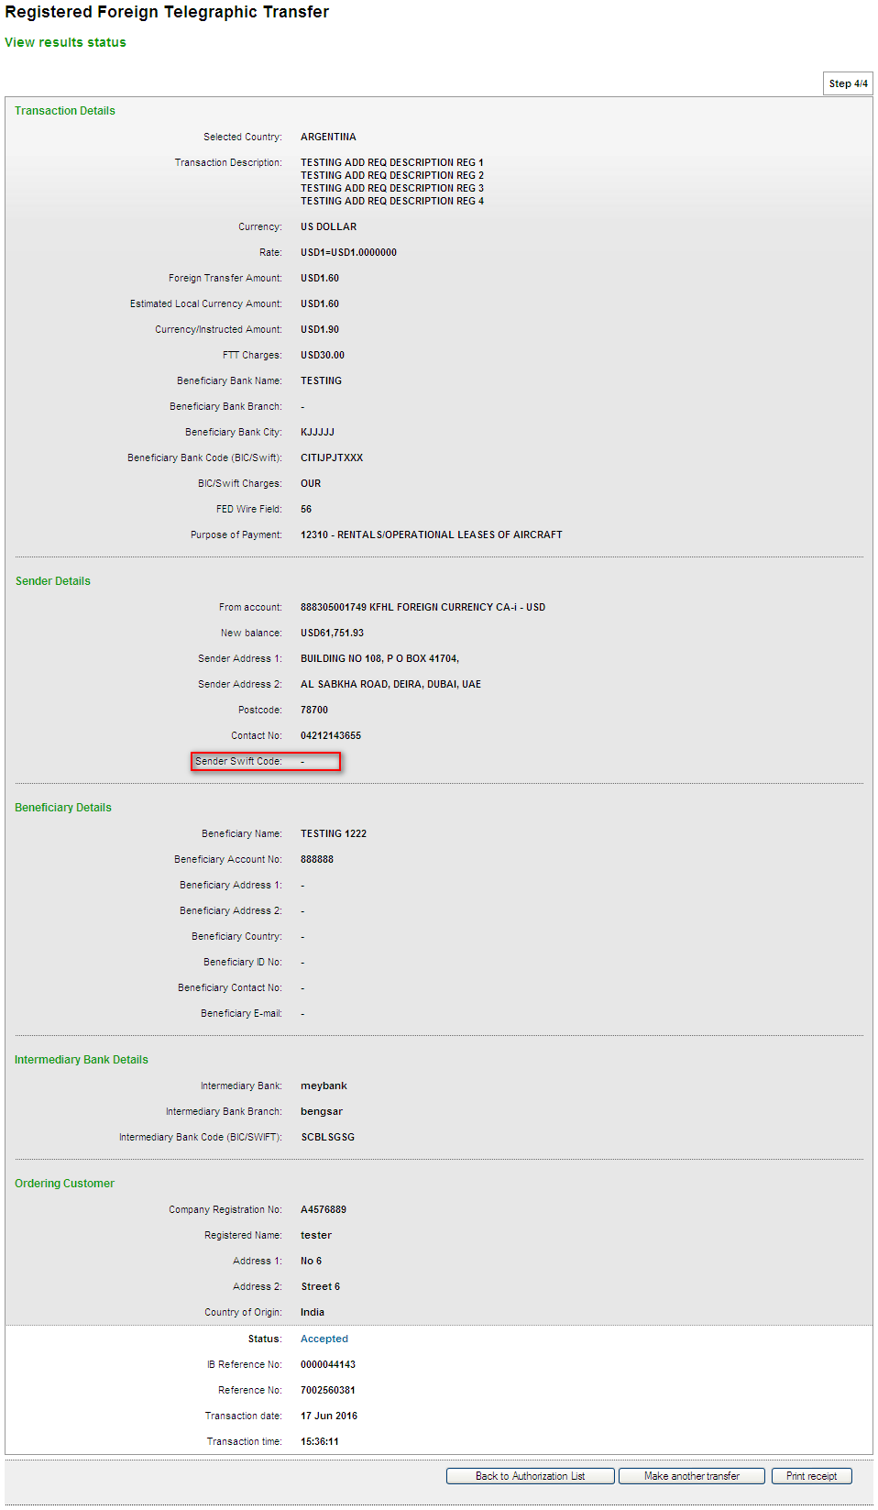

Print Receipt
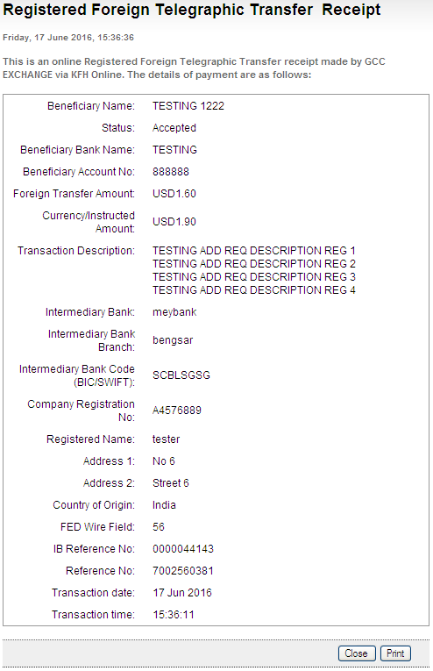

Generated SWIFT103 Text File
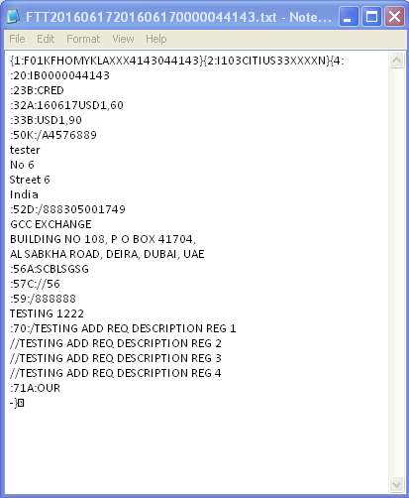

Output from Swift System - Able to view Swift text, approve or reject.
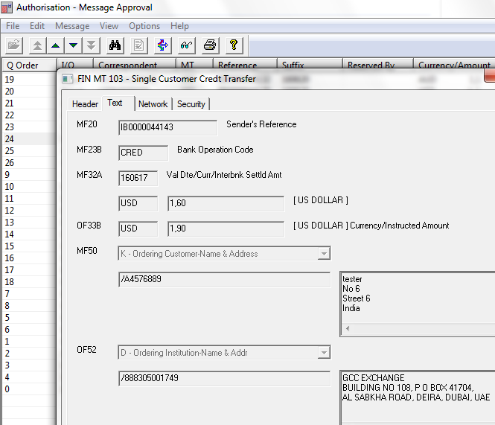
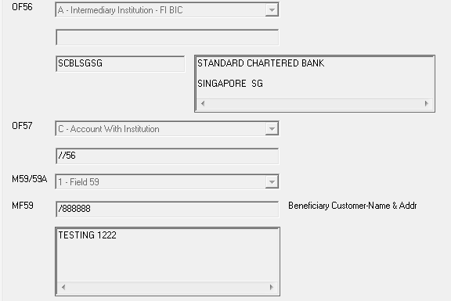
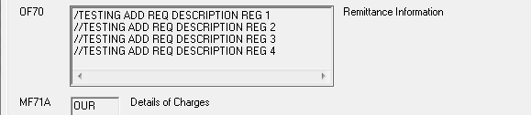

Test item No.4: Setting: Only Key in BIC Swift Code

Open FTT

Confirm page
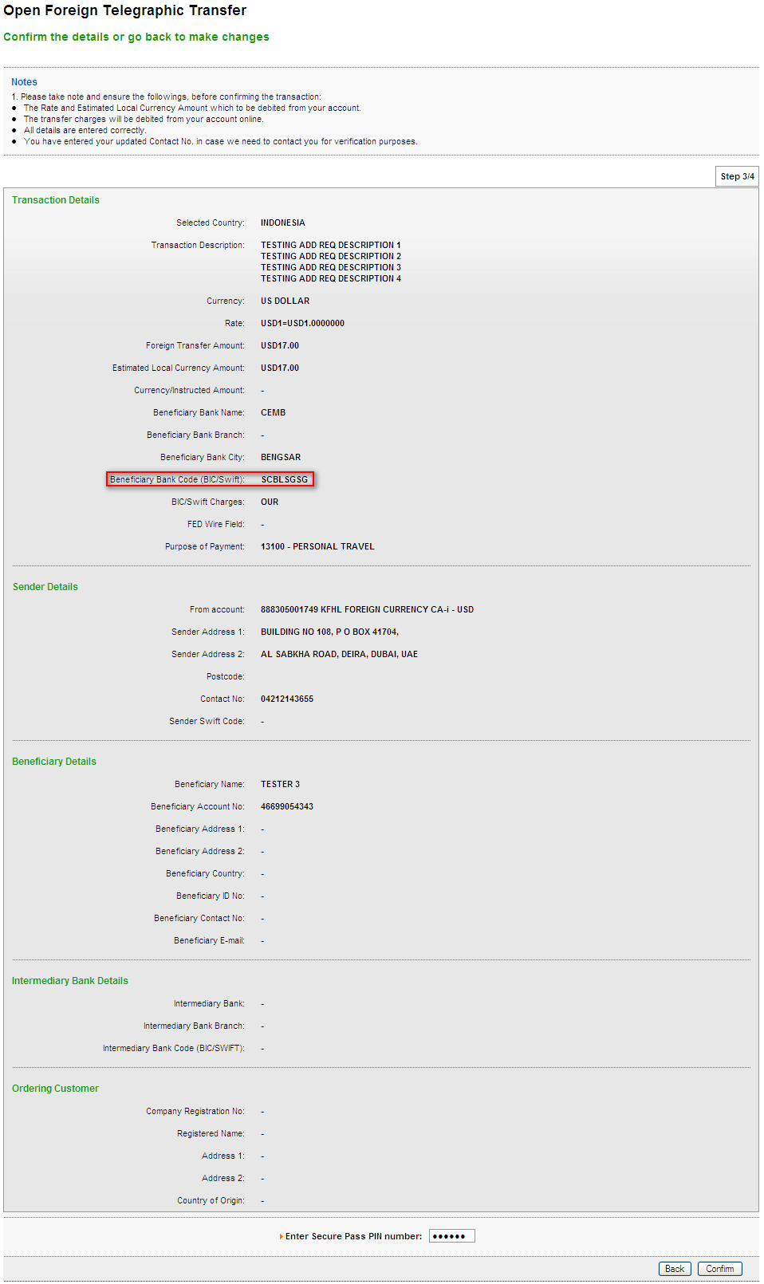

Result page
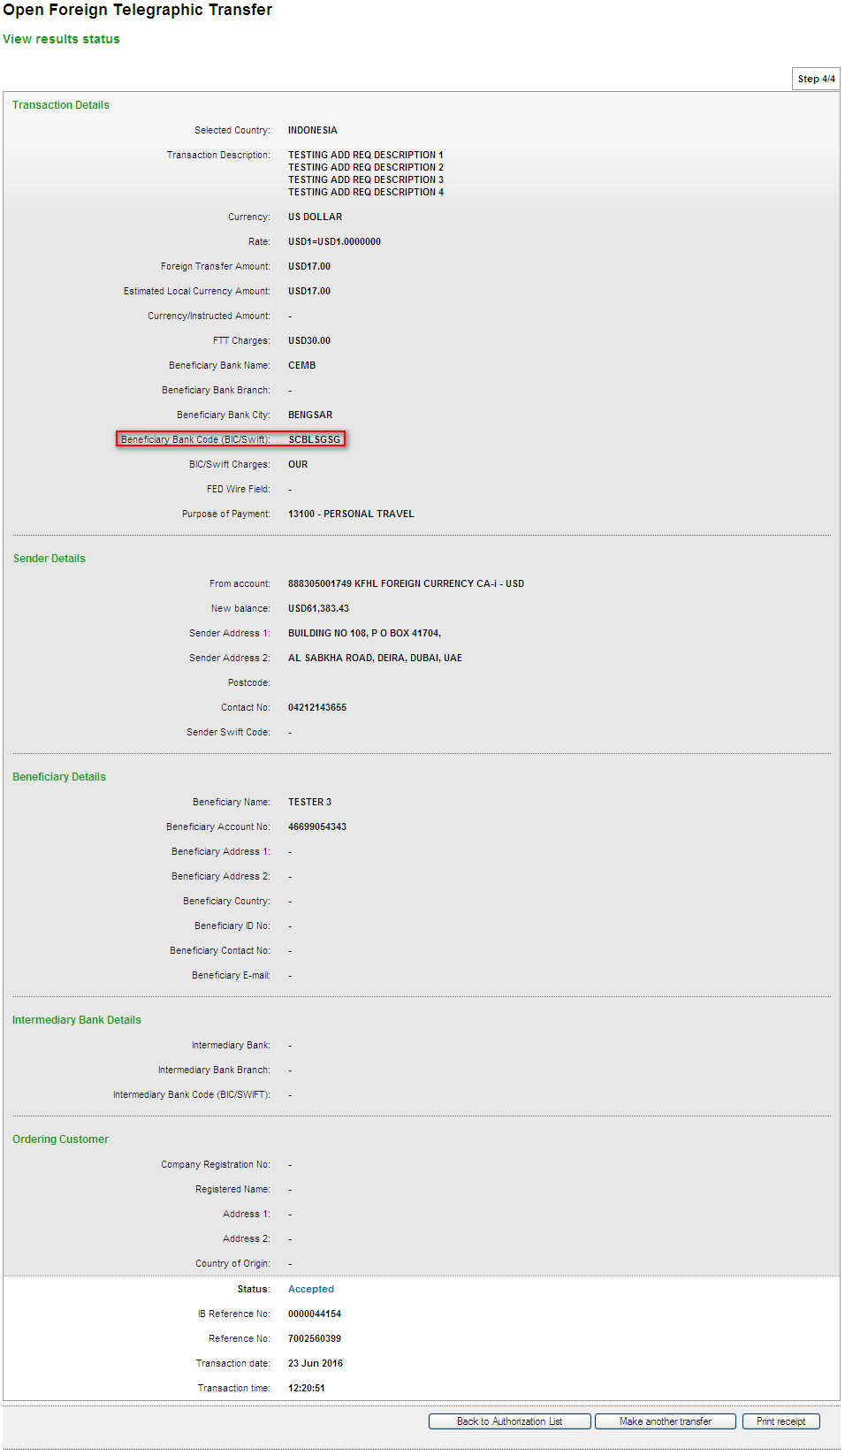

Print Receipt
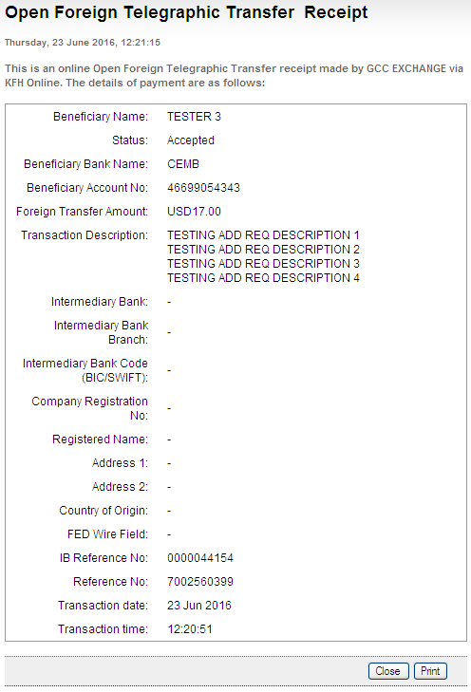

Generated SWIFT103 Text File
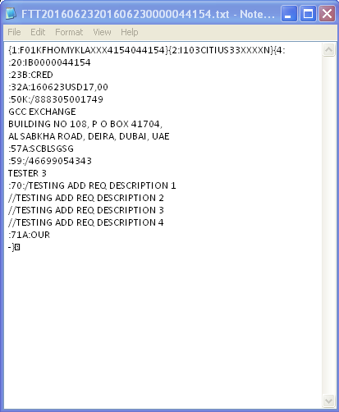

Output from Swift System - Able to view Swift text, approve or reject.
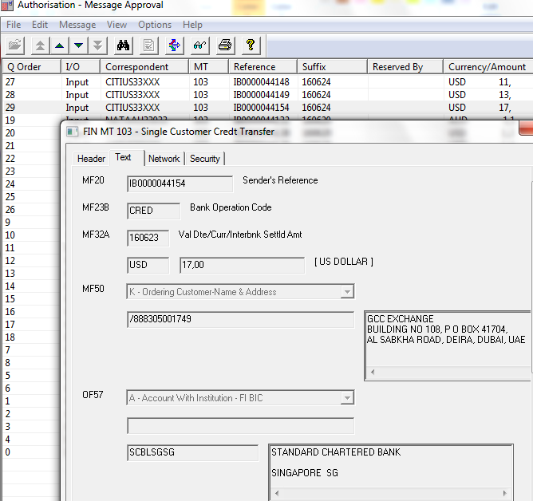
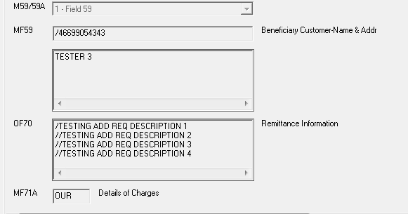

Registered FTT

Confirm page
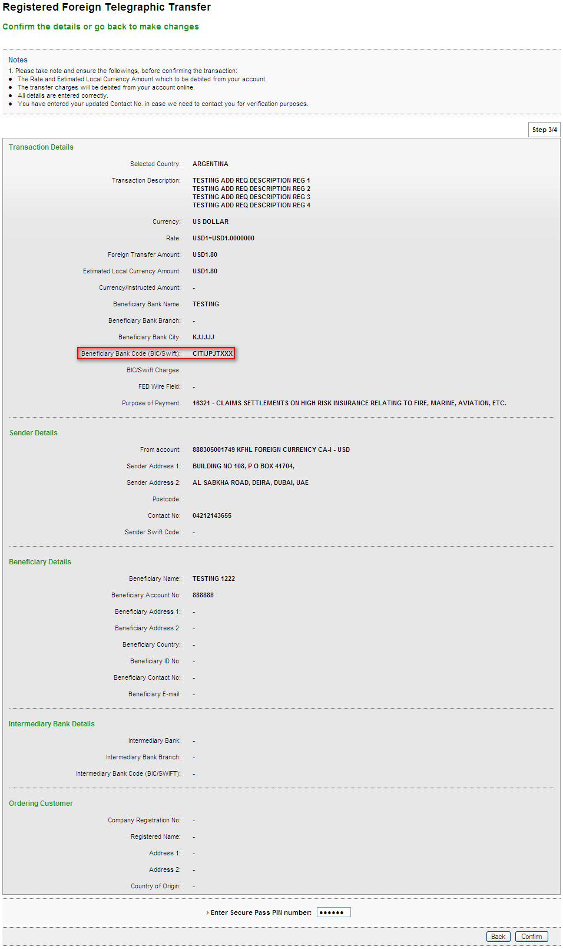

Result page
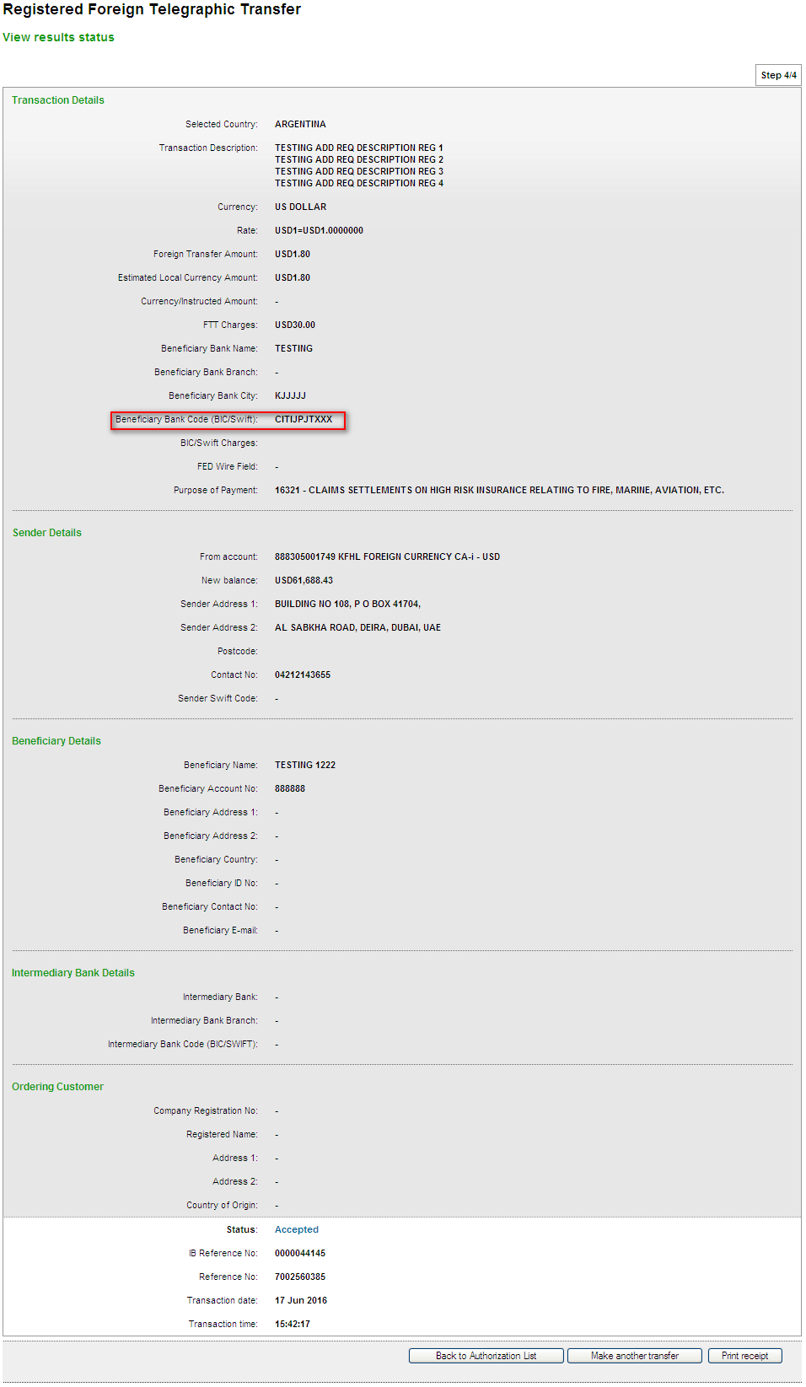

Print Receipt
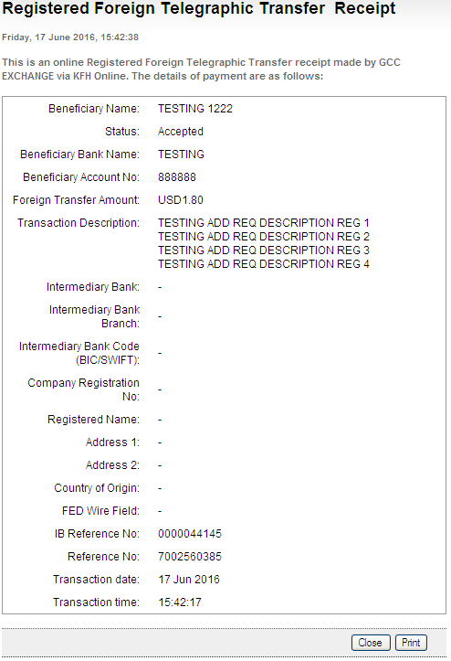

Generated SWIFT103 Text File
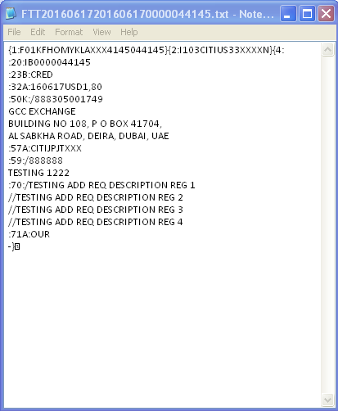

Output from Swift System - Able to view Swift text, approve or reject.
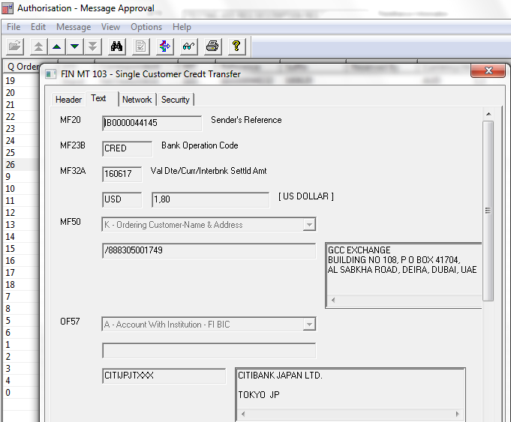
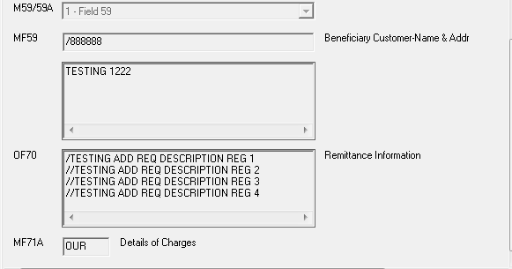

Transaction History for KFHL
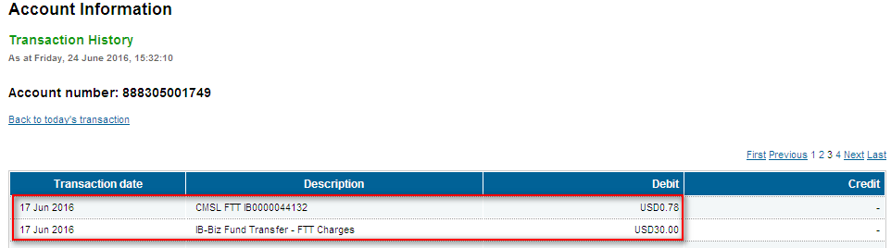
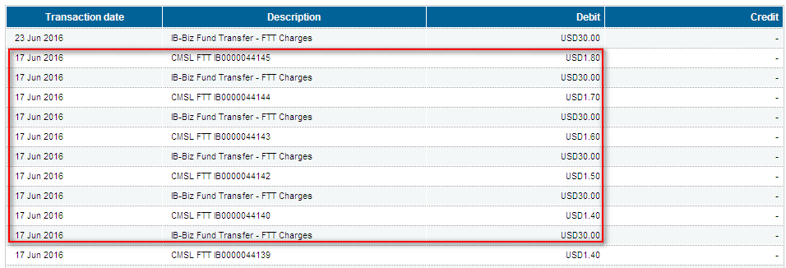
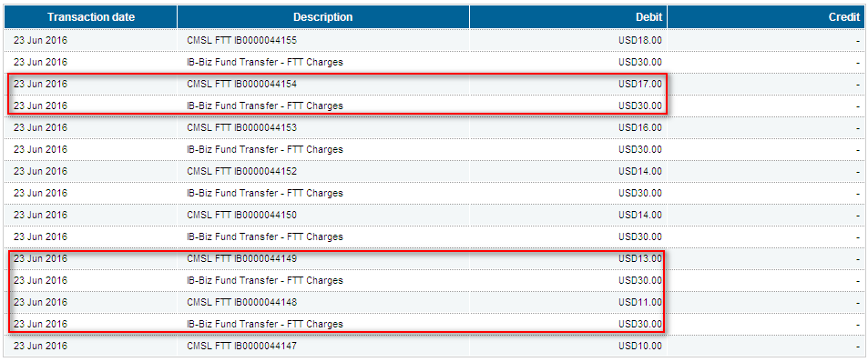
Reviewed By: (PMO)
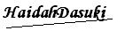 | Name/Position : NorhaidahBintiMdDasuki / Senior Manager, Quality Assurance and Support  Date :

