Test Issue Log |  |  |  |  | SCP ID# : 3421
Project Name: | MAYBANK BII INTERNET BANKING
Test Stage: | Unit Functionality Integration System Interface  Performance Regression Acceptance Pilot
Test Case Number: | Support #6710 |  | Test Started Date: |  |  | 31/10/2016
Test Title: | Failed to pay Telkom with JCB card
Test Description: | To ensure system can perform payment to utility on Telkom via JCB Card.
Test Functionality: | RIB – Bill Payment  RMBP – Bill Payment  Transaction History (Host)  - RIB  - RMBP  Online Transaction History  - RIB  - RMBP
Test Procedure: | To perform Bill Payment via JCB Card at RIB  - Login to RIB  - Access to Bill Payment  - Click On “ Utility Payment”  - Click On “ Telkom “  From Account 3562850195863008 JCB ID  Subscriber No 0251044444443  - Go to Online Transaction History to view on the transaction details  - Go to Transaction History to view on the transaction details and to check on the account balance is accurate  To perform Bill Payment via JCB Card at RMBP  - Login to RMBP  - Access to Bill Payment  - Click On “ Utility Payment”  - Click On “ Telkom “  From Account 3562850195863008 JCB ID  Subscriber No 0251044444443  - Go to Online Transaction History to view on the transaction details  - Go to Transaction History to view on the transaction details and to check on the account balance is accurate
Test Result: | Pass: Fail:  Conditional Pass: | Tested by: |  | Tommy Arryandy
Reason for Failure / Conditional Pass: | Can’t check transaction history because wahyu said the account is registered on database
TEST DESCRIPTION
- Test to perform Bill Payment via JCB Card at RIB
  - Bill Payment Details
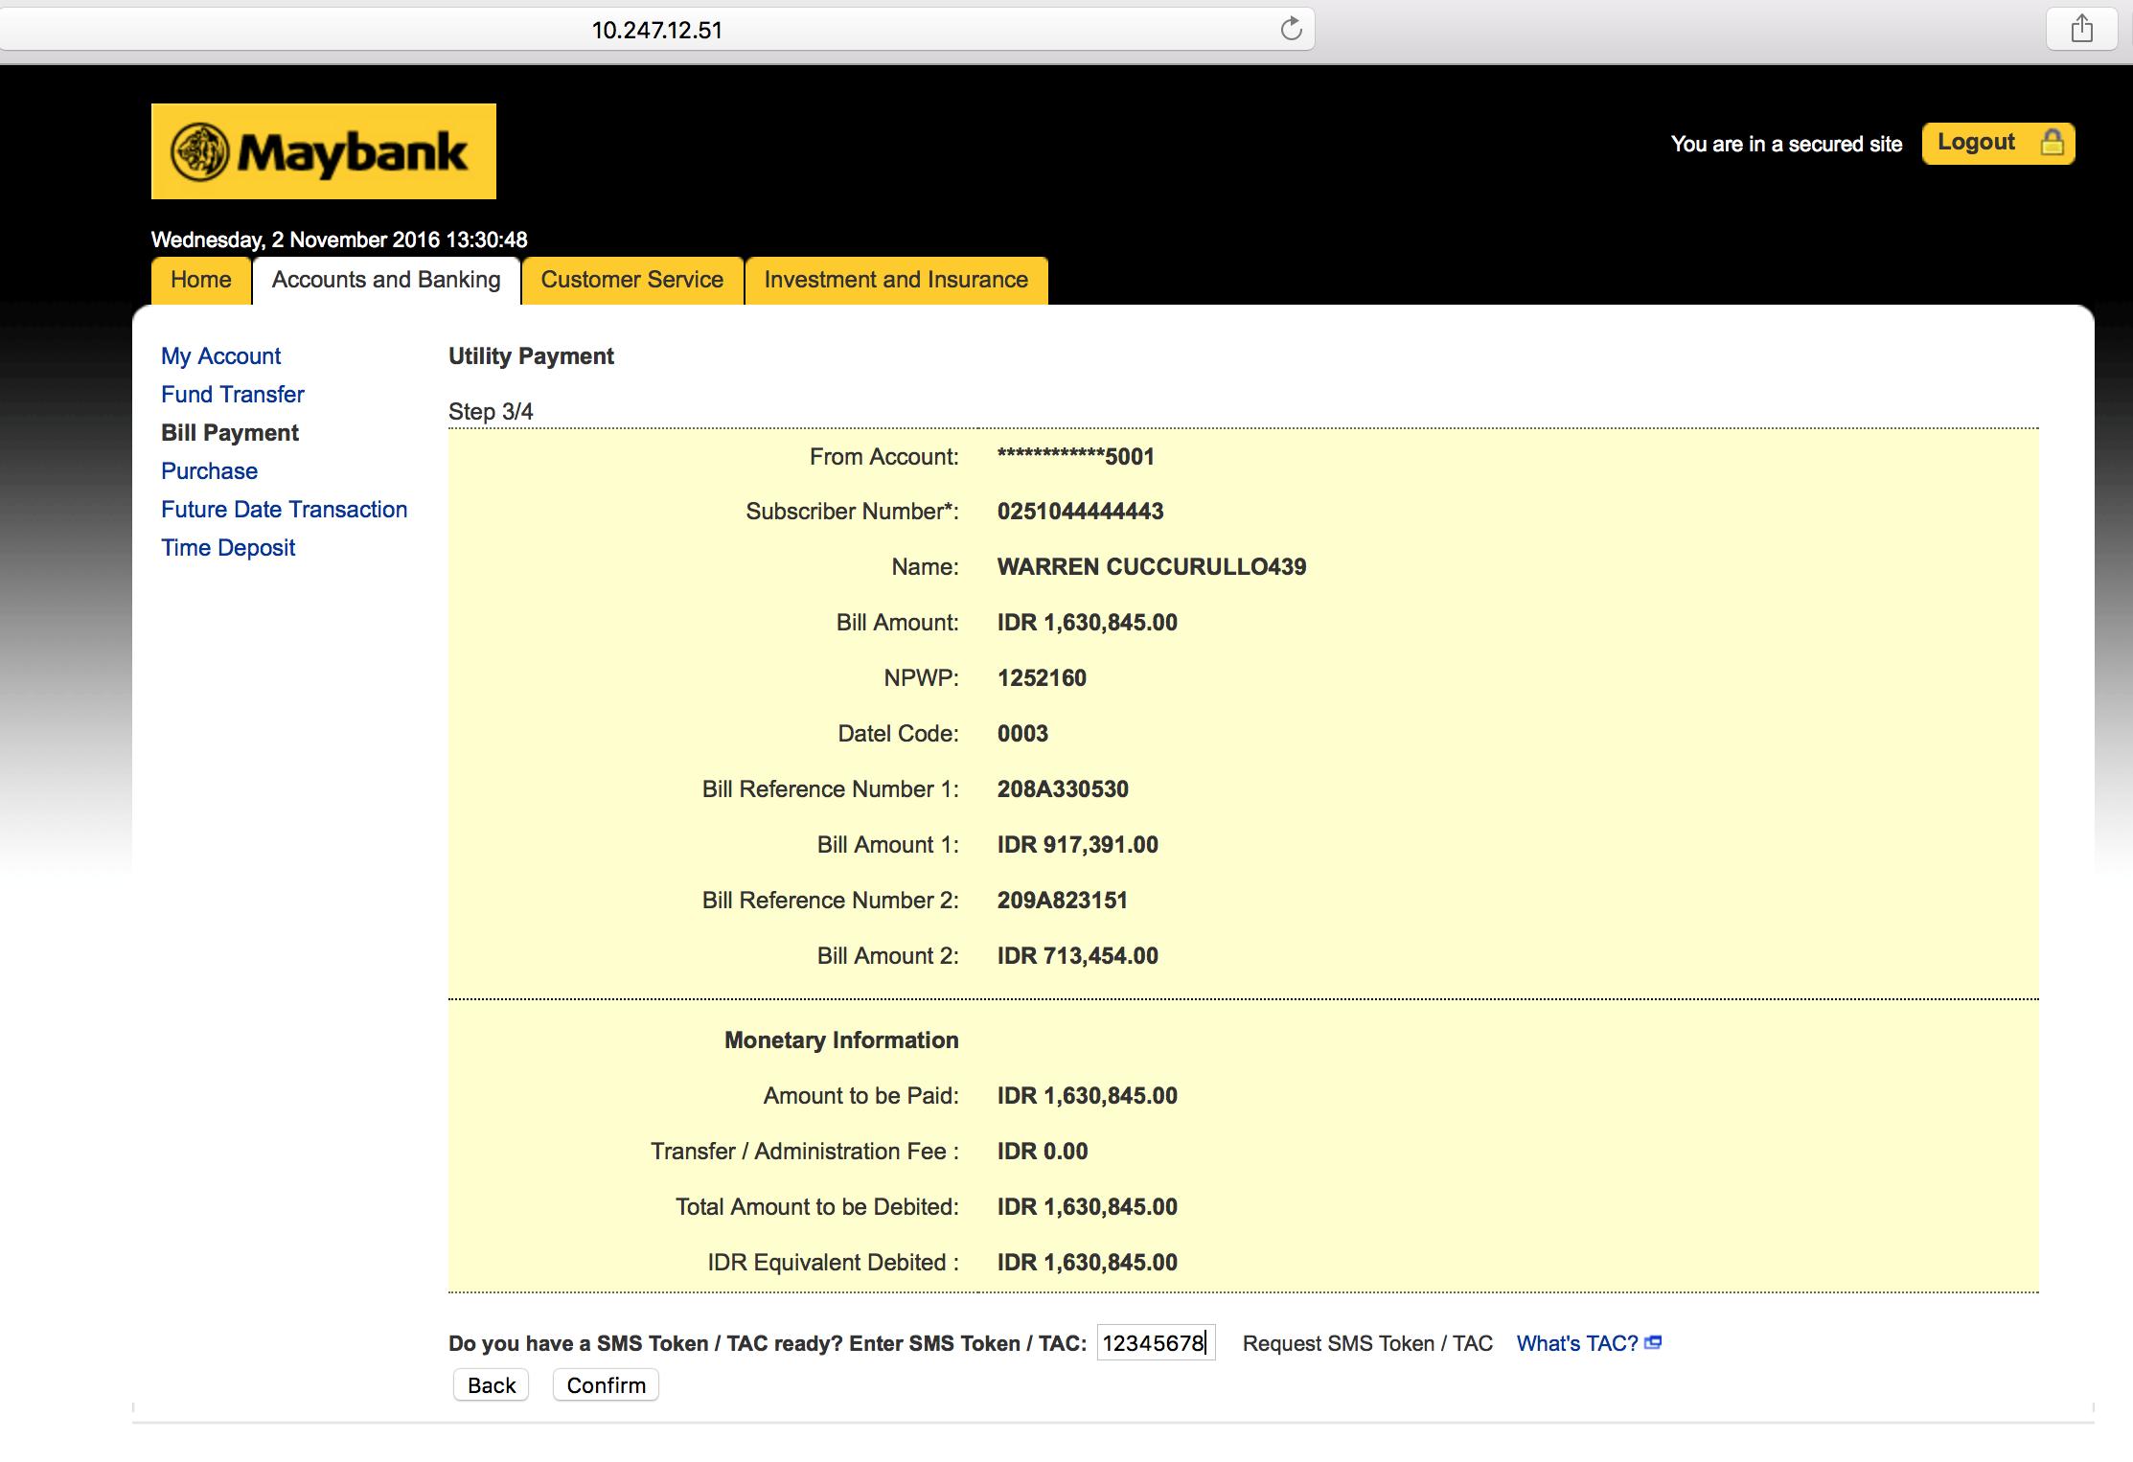

  - Bill Payment Result Page
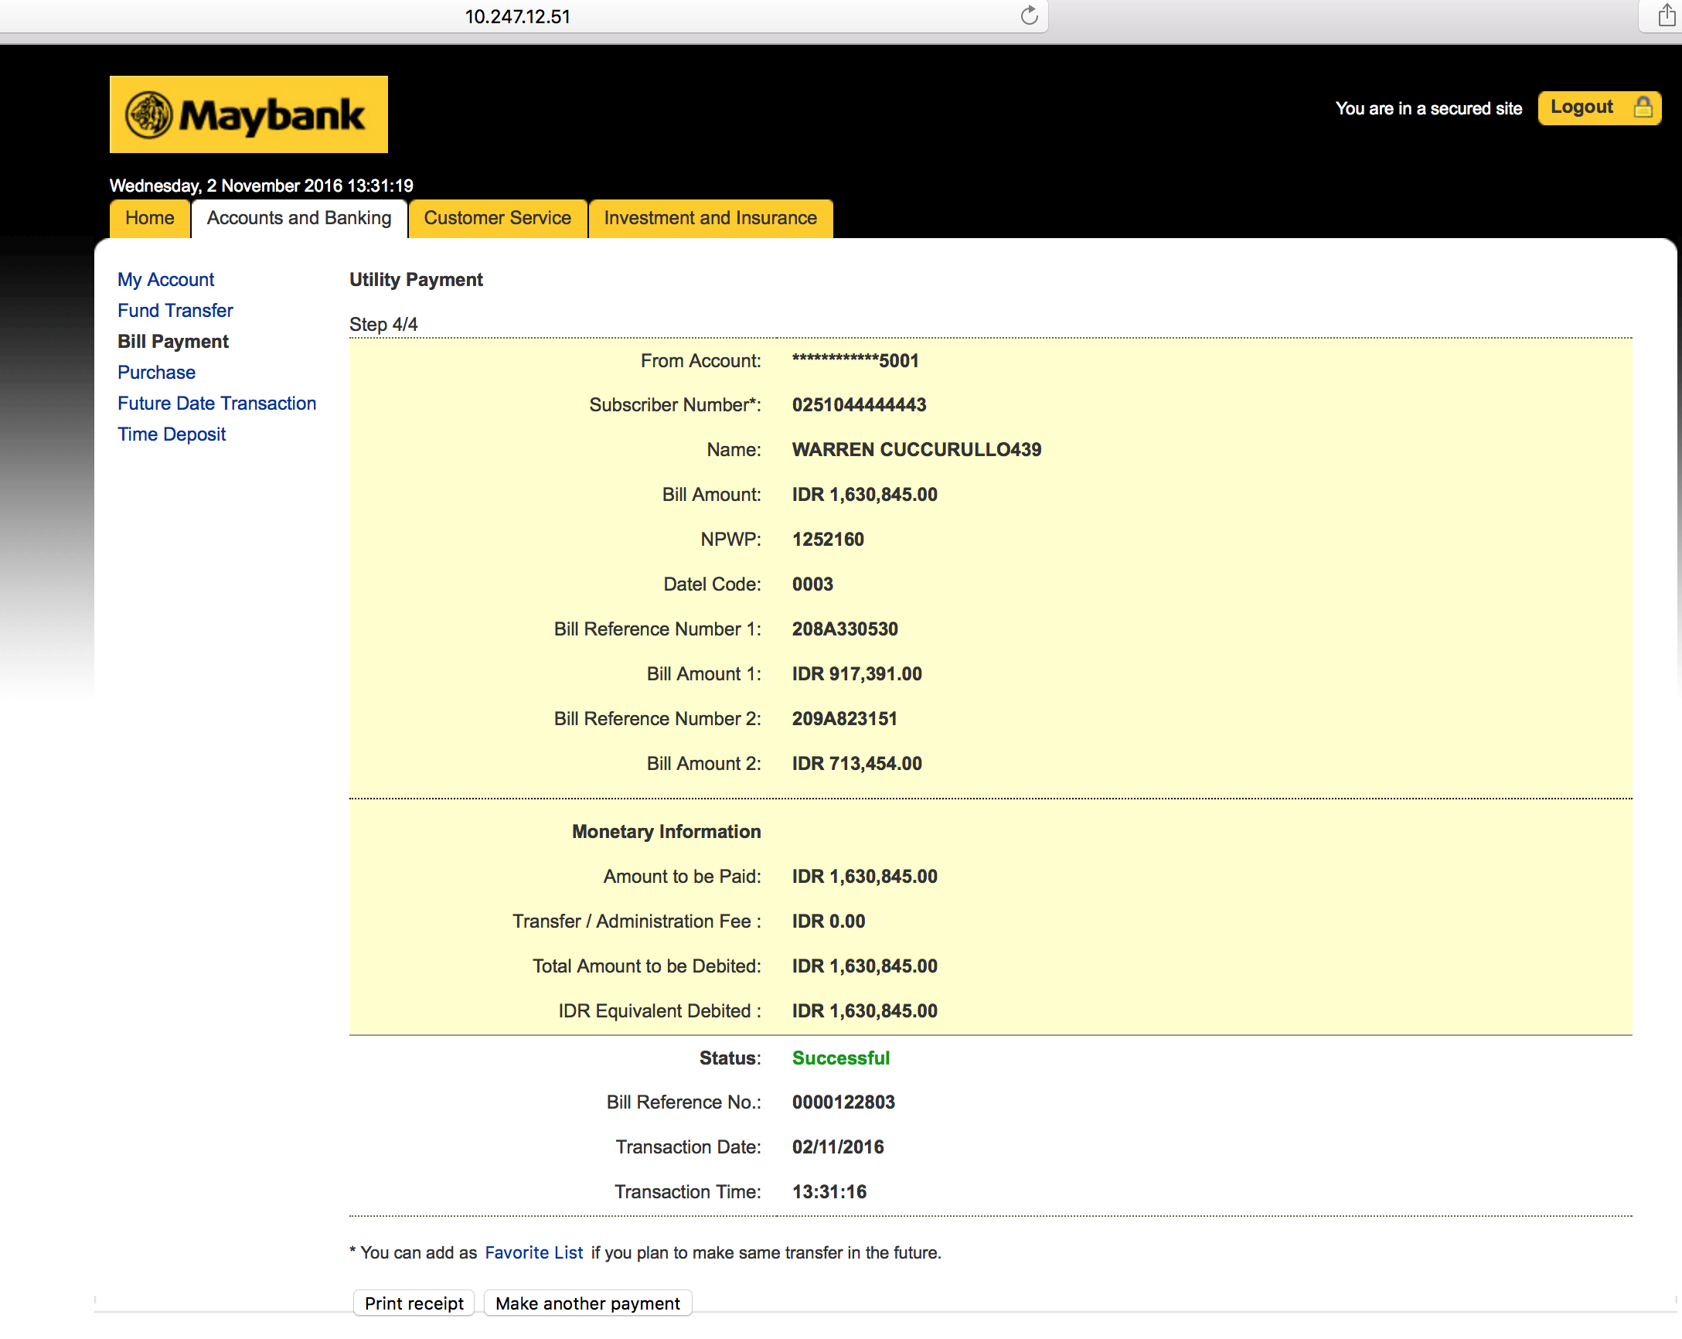

  - Online Transaction History
- Wahyu tell that the account is added database, so cant see transaction history in m2u

  - Transaction History (Host)
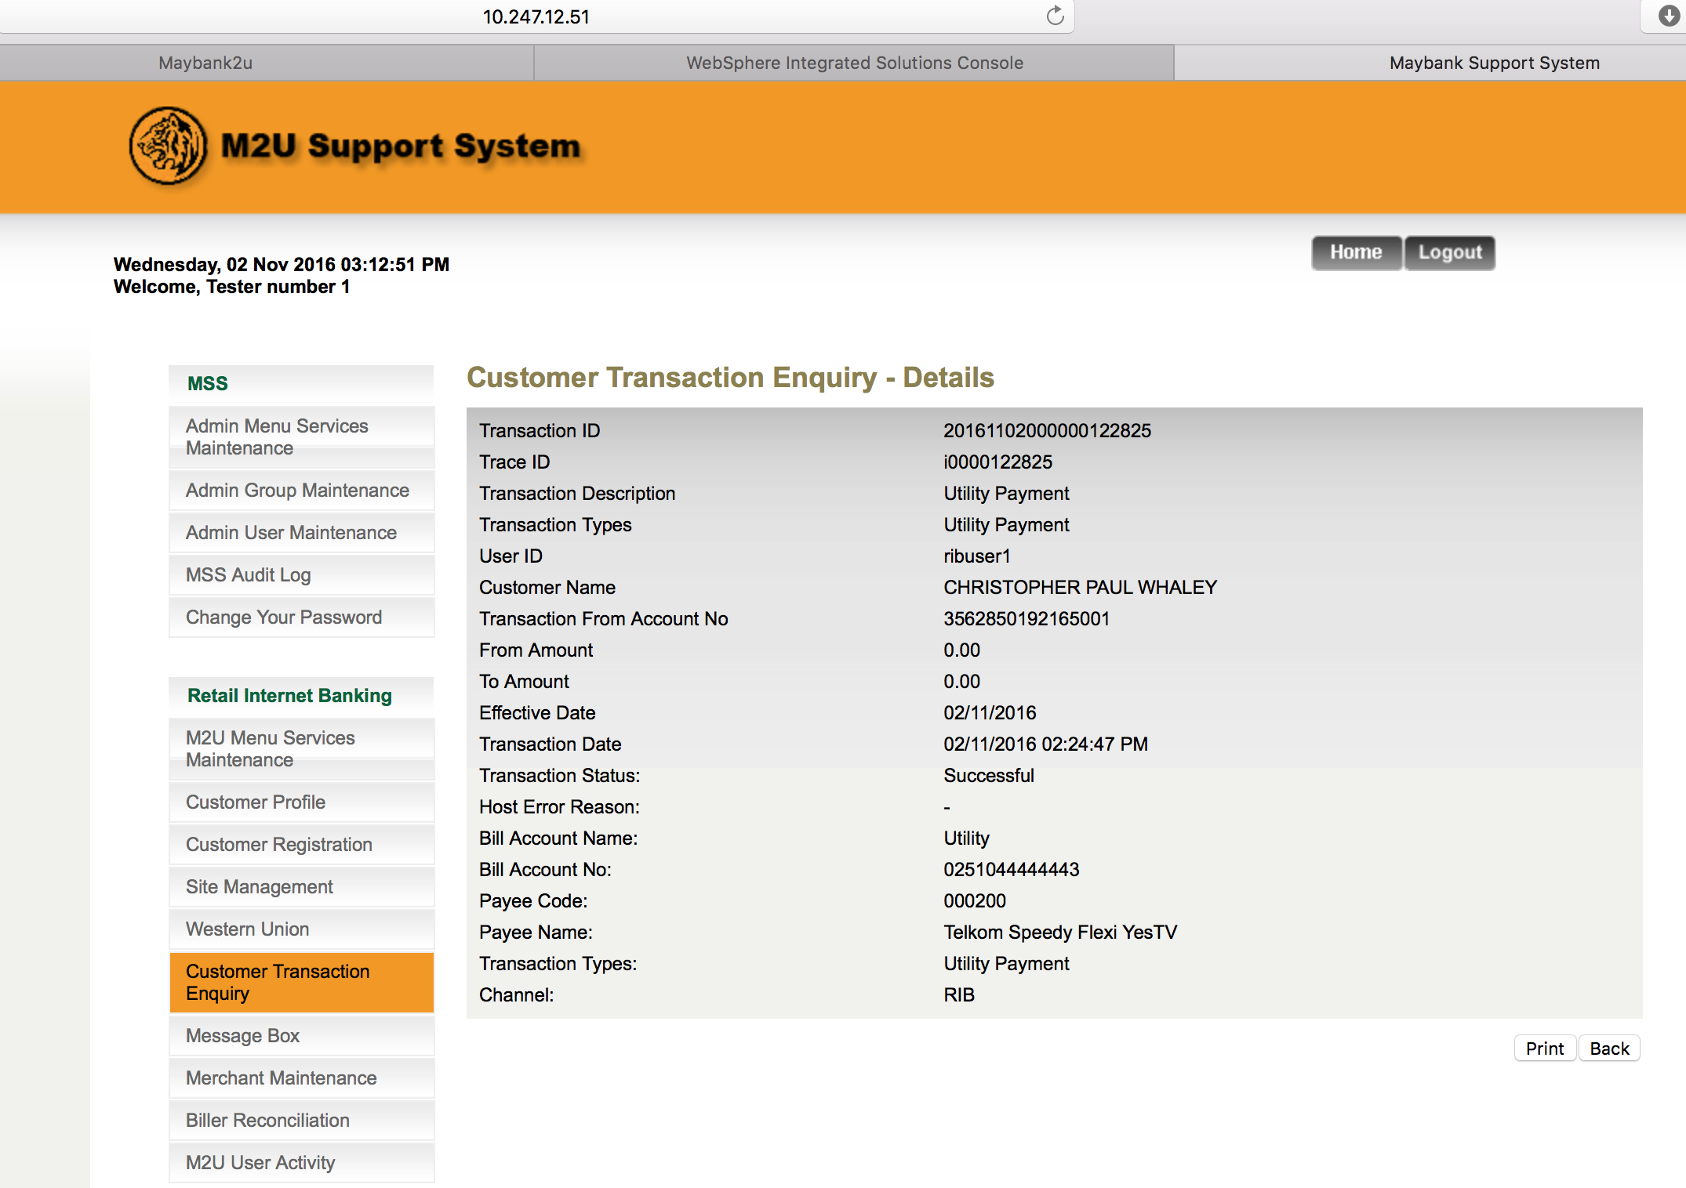

- Test to perform Bill Payment via JCB Card at RMBP

  - Bill Payment Details
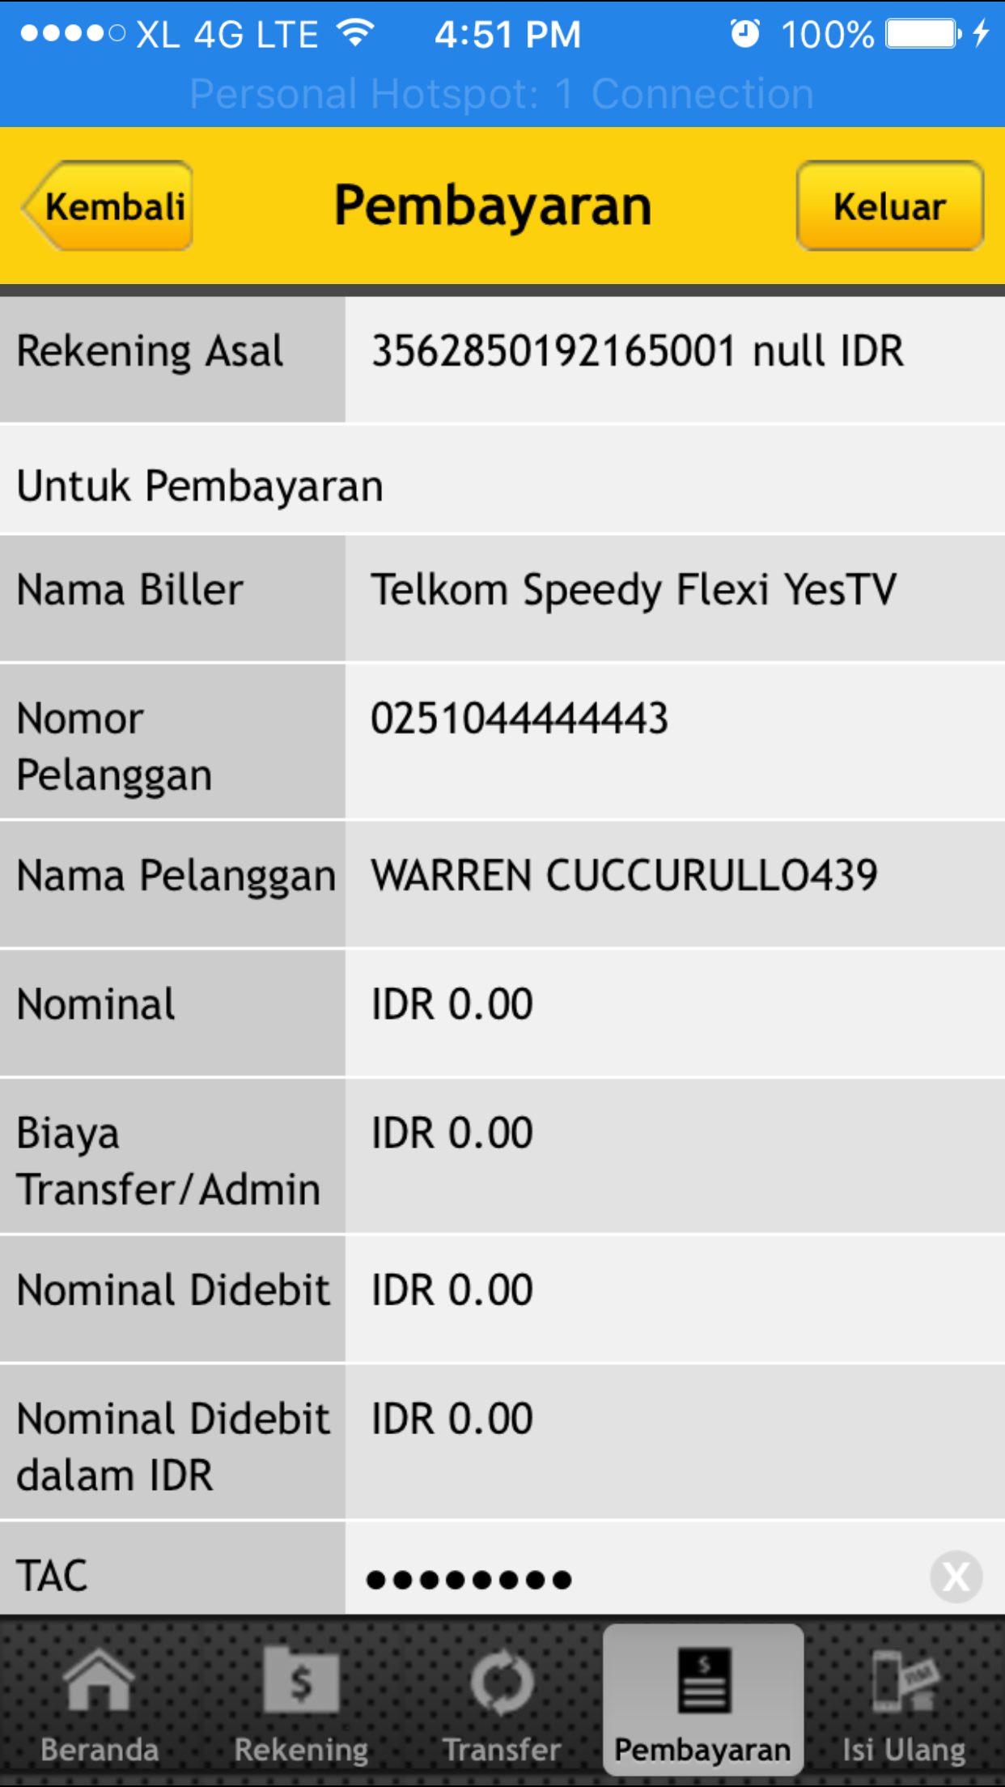
  - Bill Payment Result Page
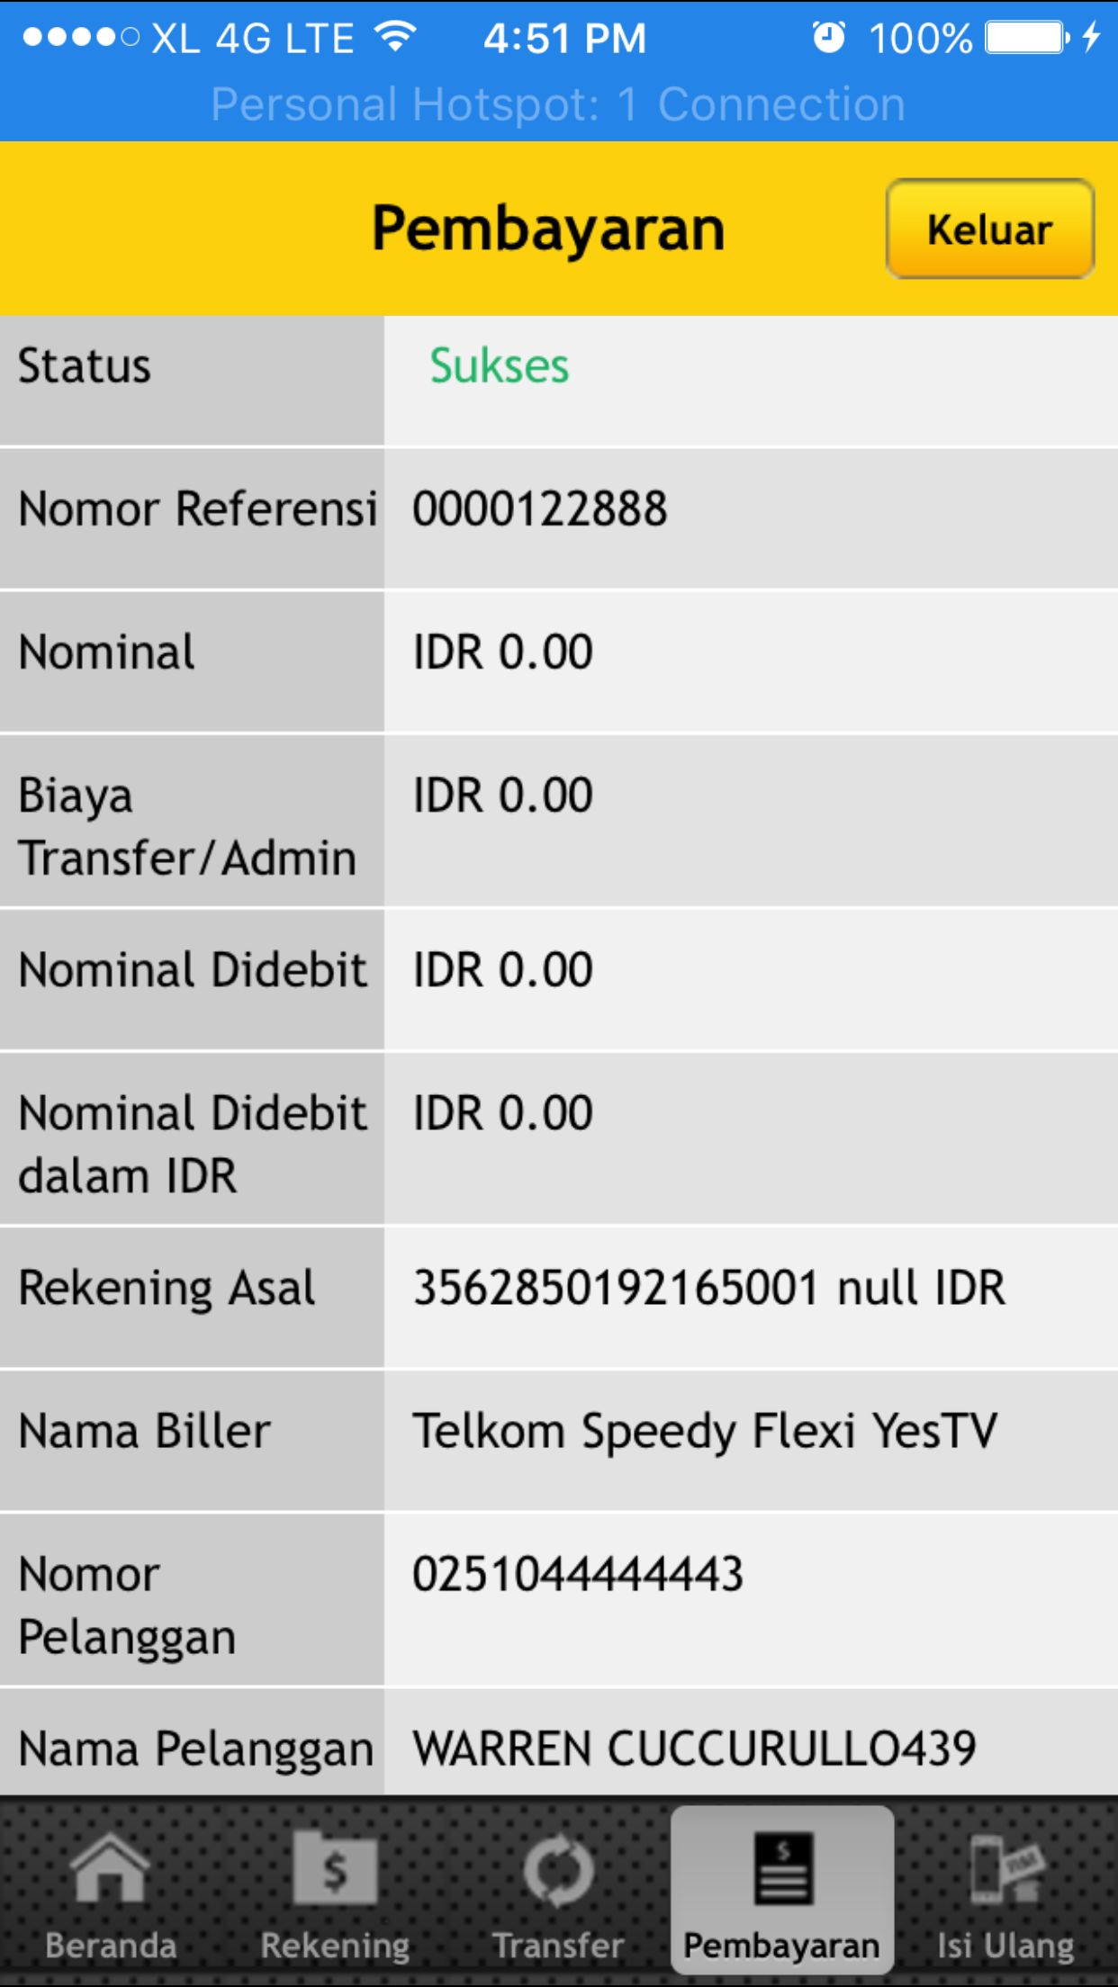
  - Online Transaction History
Wahyu tell that the account is added database, so cant see transaction history in m2u

  - Transaction History (Host)
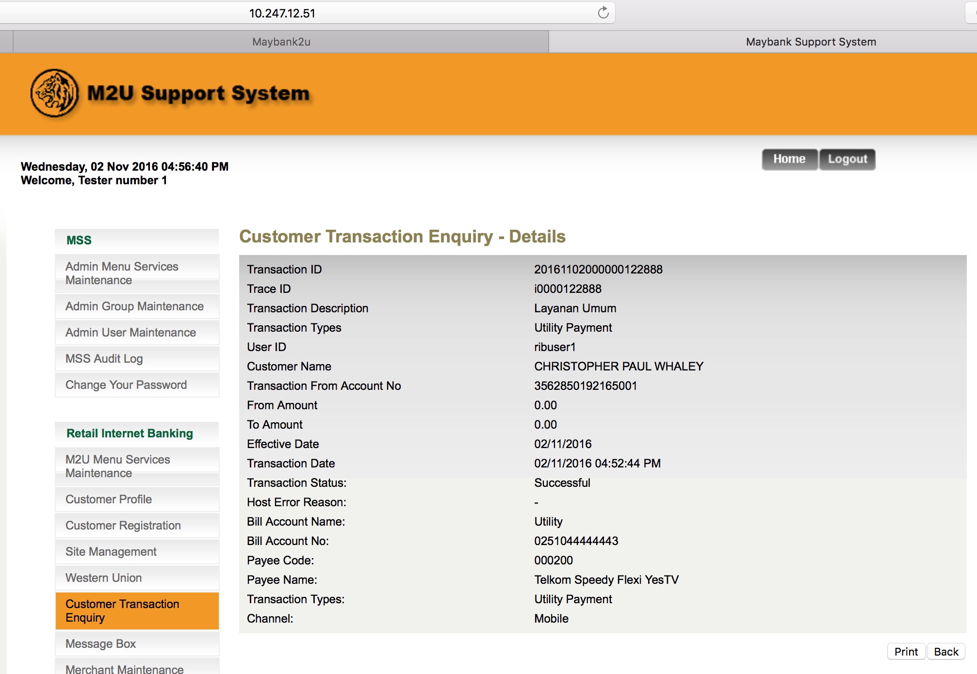
- Comfort Test: To input invalid details to the related field.
  - Input Non-numeric to Subscriber Number Field
Go to Bill Payment > Utility Payment > Telkom
Result
Subscriber Number: 123@##4225a
Error Message:

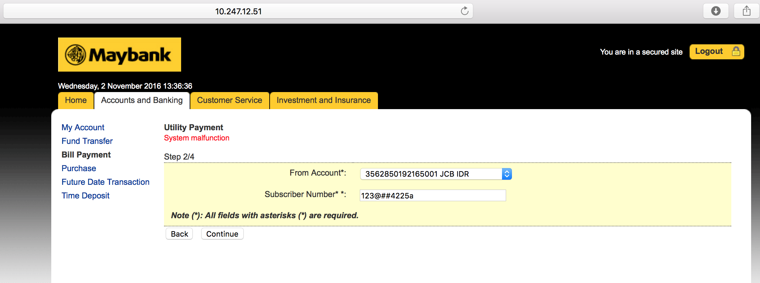

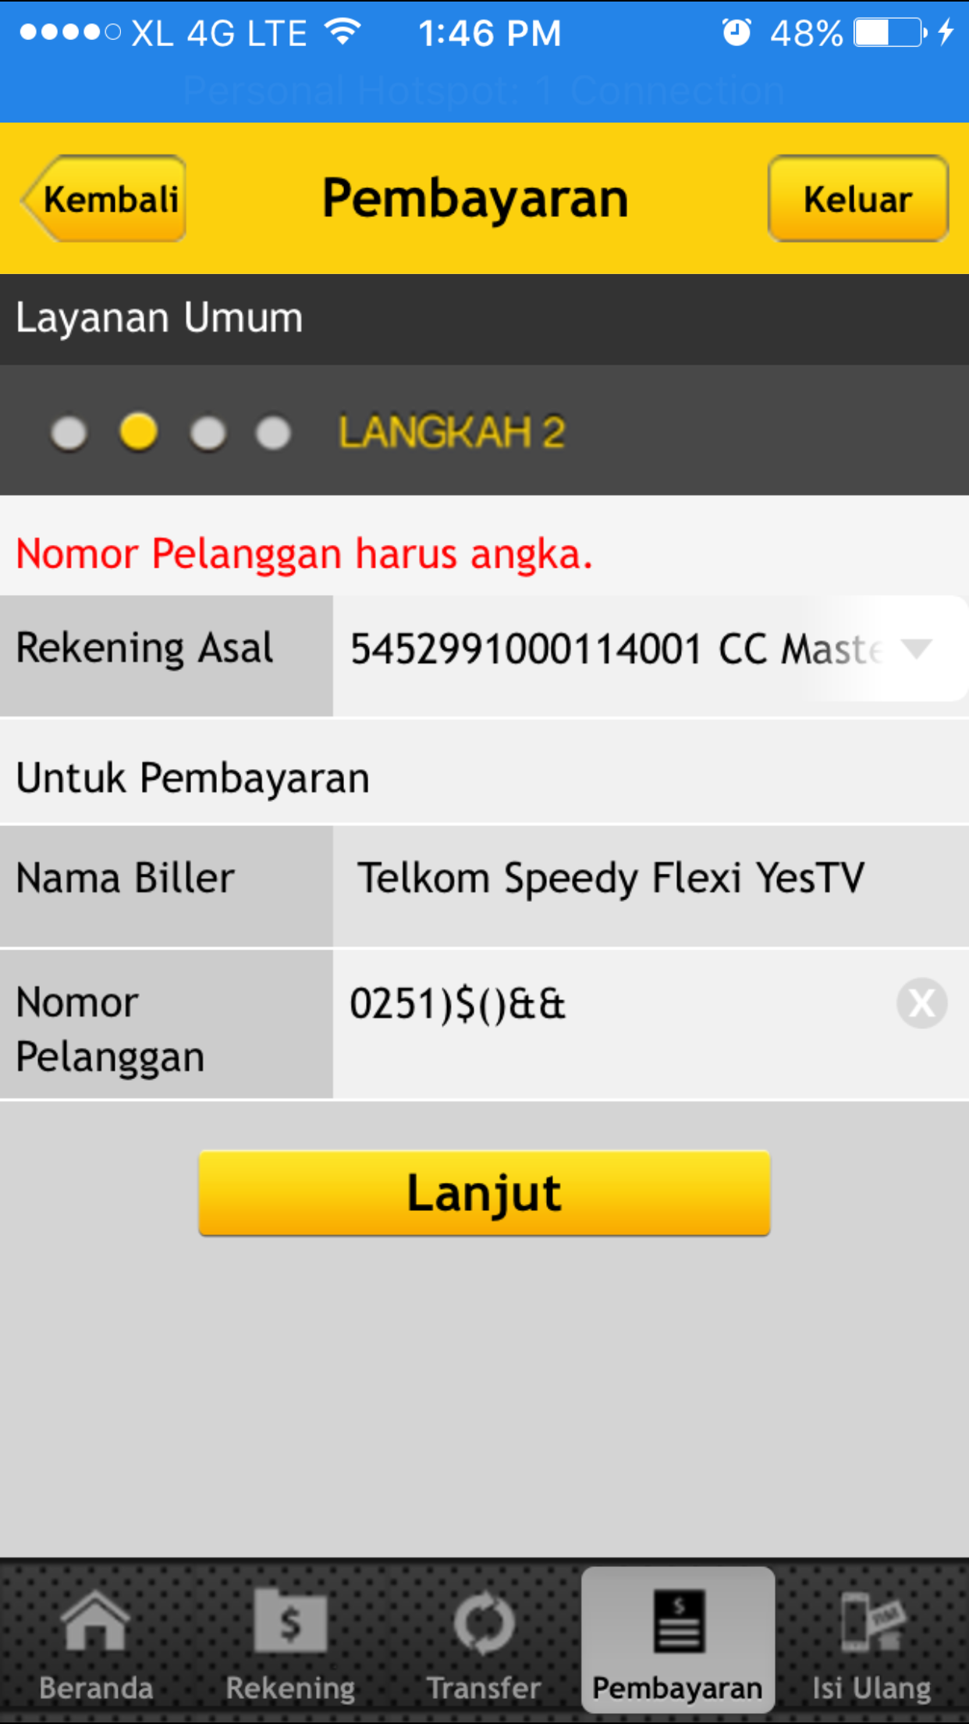
Reviewed By: (PMO)
 |  | Name/Position : Norhaidah Binti Md Dasuki / Senior Manager, Quality Assurance and Support  Date : 1/11/2016

