Test Issue Log |  |  |  |  |  | SCP ID# : UAT_Tak_005
Project Name: | AGROBANK BUSINESS INTERNET BANKING
Test Stage: | Unit Functionality Integration System Interface  Performance Regression Acceptance Pilot
Test Case Number: | Support #6749 |  |  | Test Started Date: |  |  | 02/10/2016
Test Title: | Takaful – No Service Listed on Approval Checker when approve changes made by Maker
Test Description: | To ensure that Checker can view changes made by Maker on authorization screen.  https://10.6.6.20/ibam.sit.takaful/common/Login.do
Test Functionality: | IBAM  - Role – Maker  Company Enquiry > Company Details > User Maintenance  - Role – Checker  Authentication > Approval List
Test Procedure: | IBAM - Maker  - Login to IBAM as Maker  - Go to Company Enquiry > Company Details > User Maintenance to view user list  - Choose on User to edit on allow service  - Click on selected checkbox to allow the services  - View Result Page  BIB - Checker  - Login to IBAM as Checker  - Go to Authorization > Pending to approve on changes made by Maker.  - Click on Tracking ID to approve the changes.  - View Approval Details Page.  - View Service List for user on IBAM  - View BIB User Page
Test Result: | Pass: Fail: | Tested by: |  |  | Erni Suhaireen binti Zulkifli
Reason for Failure:
TEST DESCRIPTION
- IBAM - Maker
- Login to IBAM as Maker
- Go to Company Enquiry > Company Details > User Maintenance to view user list
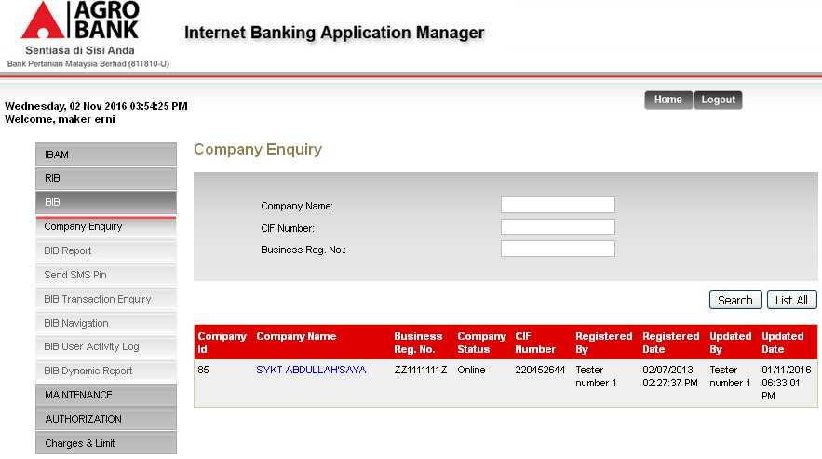

- Choose on User to edit on allow service
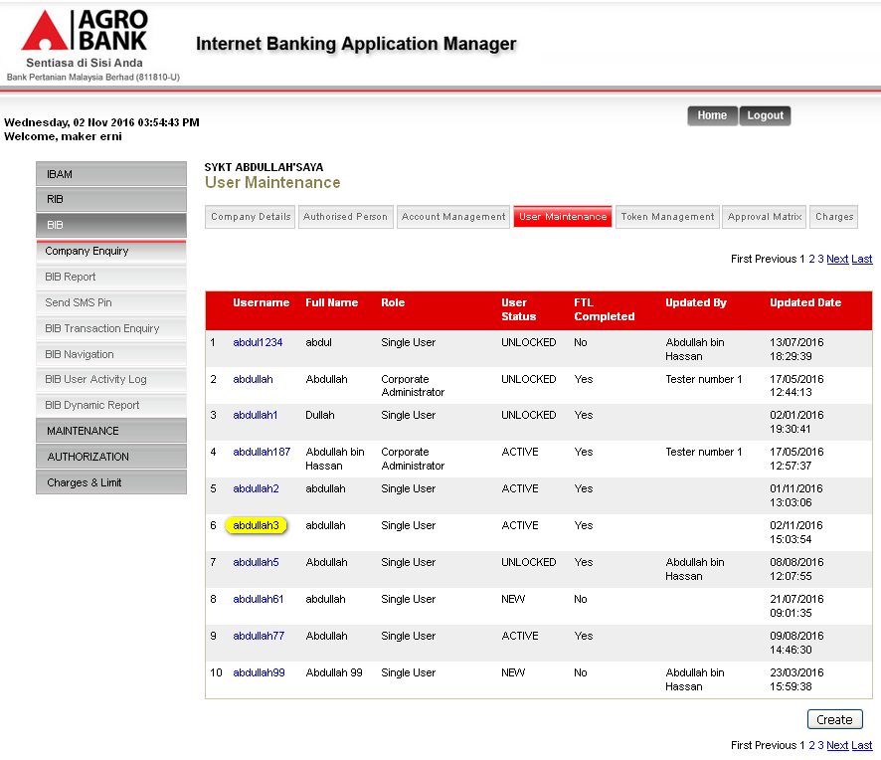

- Takaful service was not listed as allowed services. Click on “Edit” button to allow Takaful service.
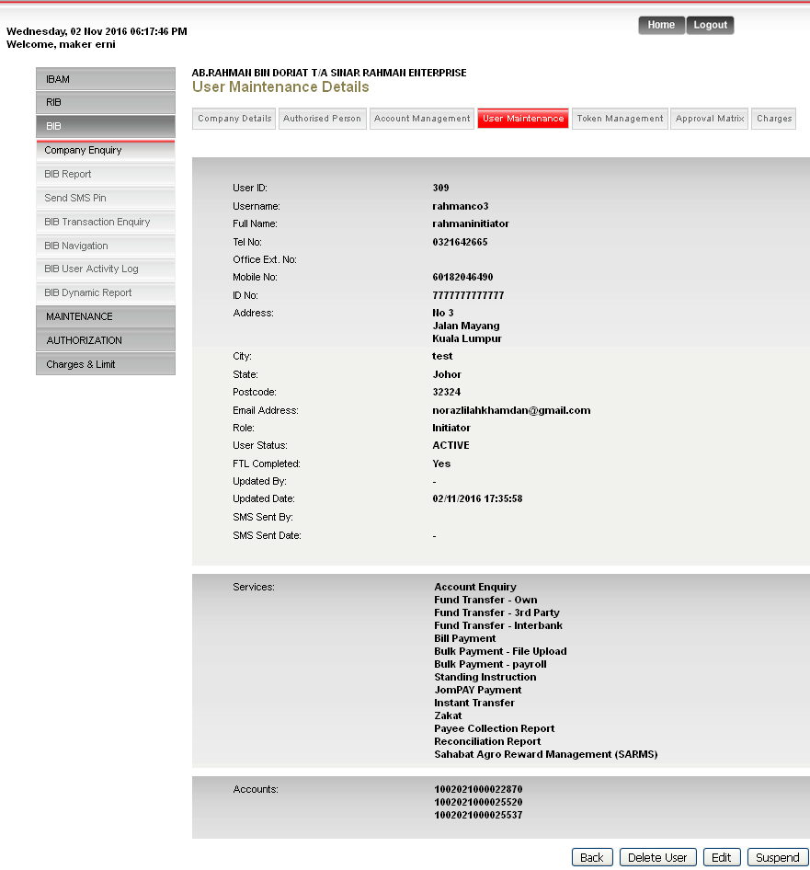

- Click on selected checkbox to allow the services
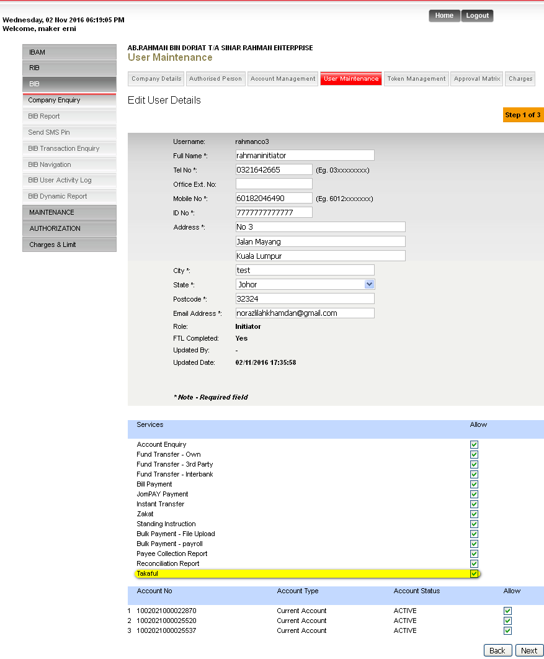

- View Result Page
  - Click on “Confirm” button on Confirm Page.
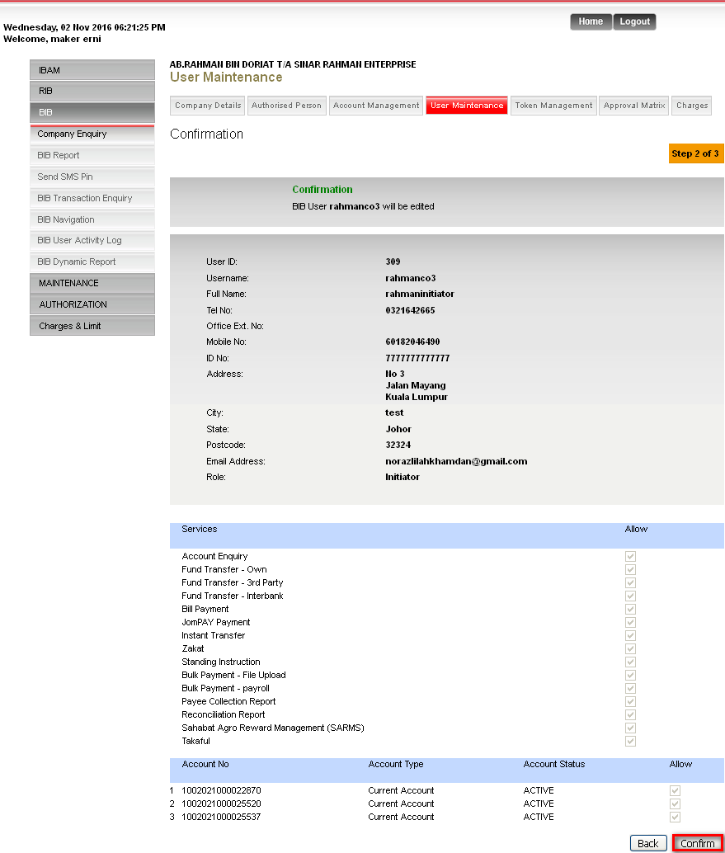

  - View Result Page
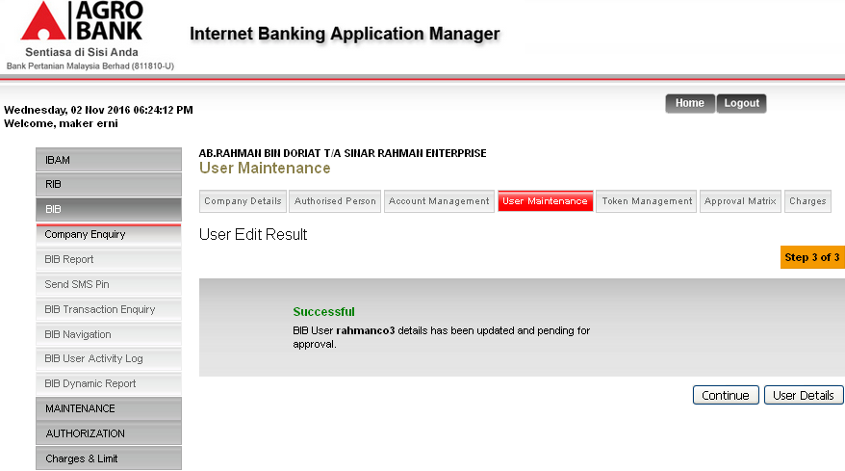
Result:
User details has been updated and pending for approval.

- IBAM - Checker
- Login to IBAM as Checker
- Go to Authorization > Approval to approve on changes made by Maker.
- Click on Tracking ID to approve the changes.
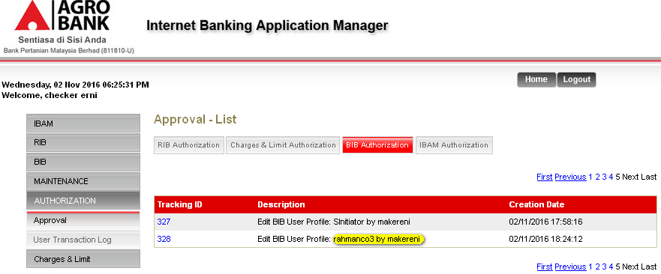

- On Approval Details Page, changes made by Maker have displayed. To proceed on approving this action. Clicks approve action. Then click on Next button.
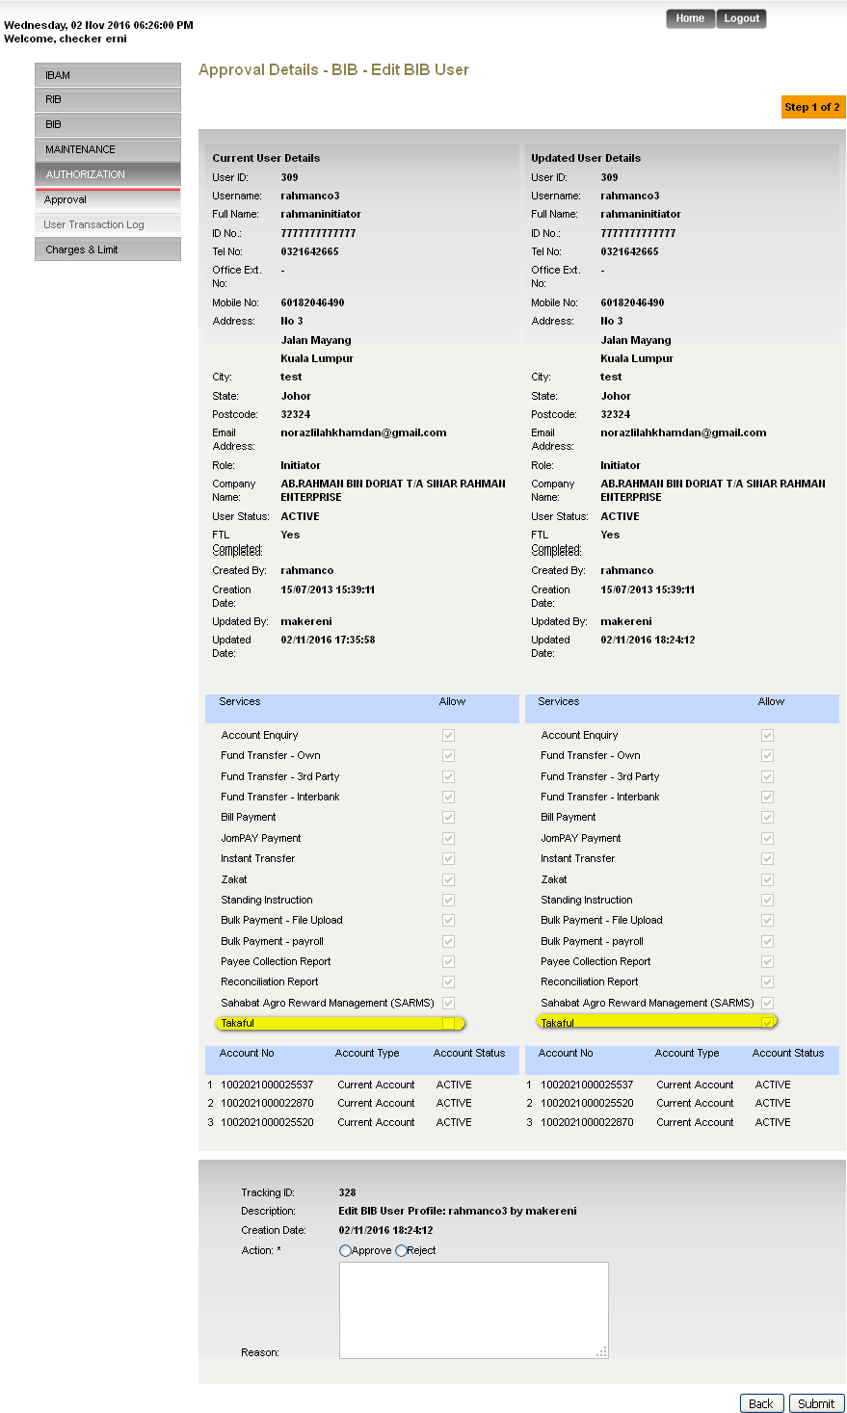
- View Result Page
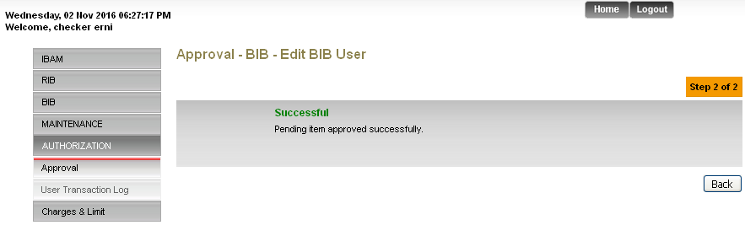
Result:
Pending item approved successfully.

- Login to Maker back to view Service List for user on IBAM.
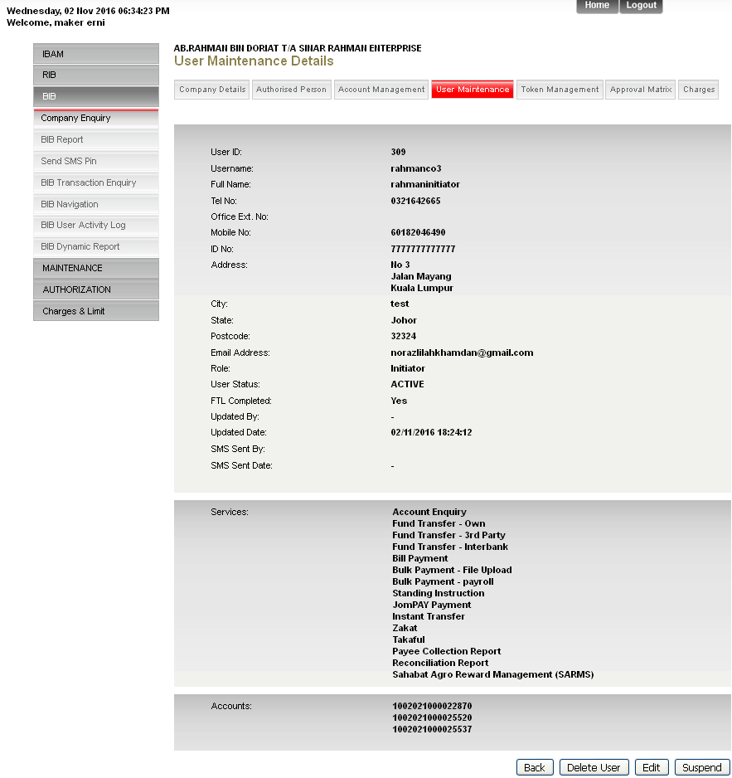

- View BIB User Page
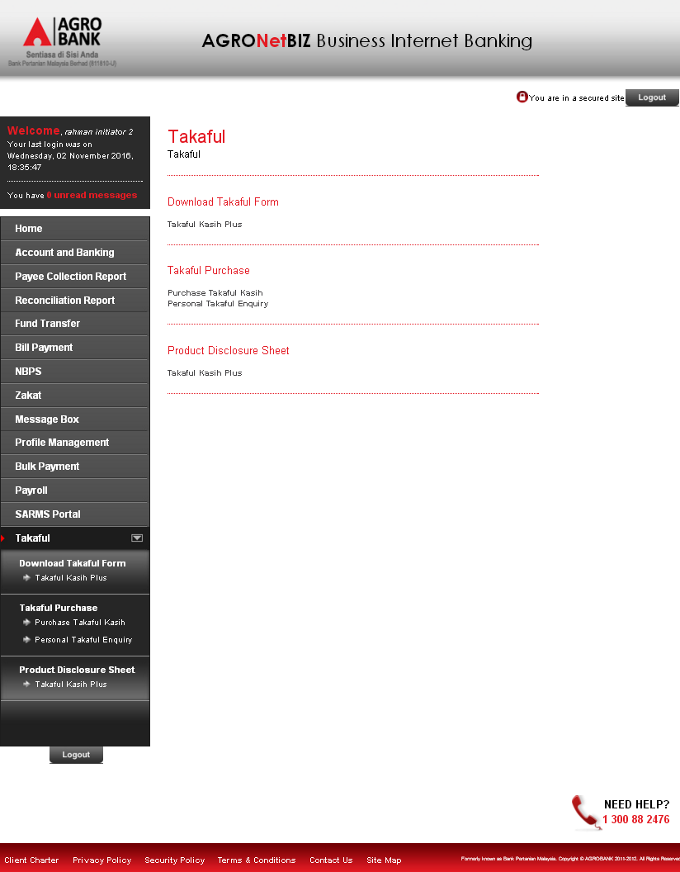
Reviewed By: (PMO)
 |  |  | Name/Position : Norhaidah Binti Md Dasuki / Senior Manager, Quality Assurance and Support  Date : 26/10/2016

