Test Issue Log |  |  |  |  |  | SCP ID# : UAT_Tak_005
Project Name: | AGROBANK BUSINESS INTERNET BANKING
Test Stage: | Unit Functionality Integration System Interface  Performance Regression Acceptance Pilot
Test Case Number: | Support #6749 |  |  | Test Started Date: |  |  | 02/10/2016
Test Title: | Takaful – No Service Listed on Approval Checker when approve changes made by Maker
Test Description: | UAT TAK 007  To ensure that no Session Expired occur.  UAT TAK 009  To ensure system can go to Result Page.  https://10.6.6.20/ibam.sit.takaful/common/Login.do
Test Functionality: | BIB  - Role – Approver  Authentication  - Role – Checker  Authentication > Approval List
Test Procedure: | UAT TAK 007  BIB - Approver  - Login to BIB as Approver.  - Go to Authorization > Authorization List.  - Click on Tracking ID to approve the changes.  - View Approval Details Page.  UAT TAK 009  BIB - Approver  - View Approval Details Page. Click on Confirm button.  - View Result Page
Test Result: | Pass: Fail: | Tested by: |  |  | Erni Suhaireen binti Zulkifli
Reason for Failure:
TEST DESCRIPTION
UAT TAK 007
BIB - Approver
- Login to BIB as Approver.
- Go to Authorization > Authorization List.
- Click on Tracking ID to approve the changes.
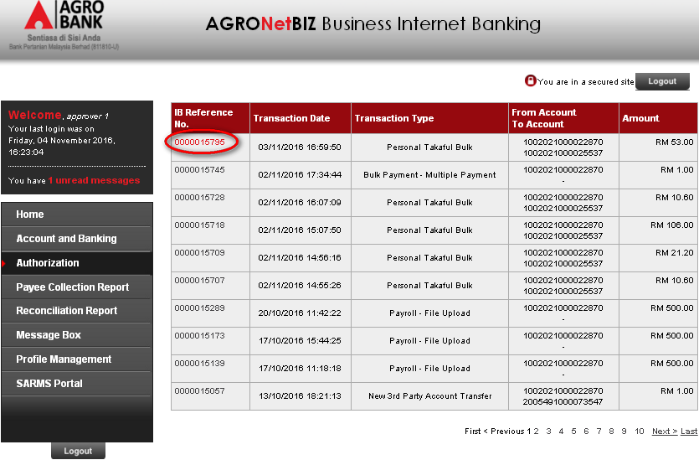

- View Approval Details Page.
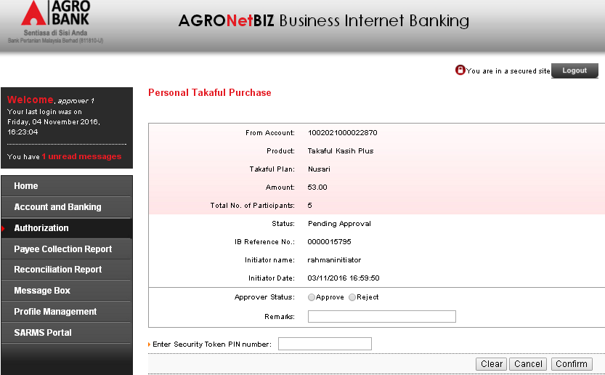

UAT TAK 009
BIB - Approver
- View Approval Details Page. Click on Confirm button.
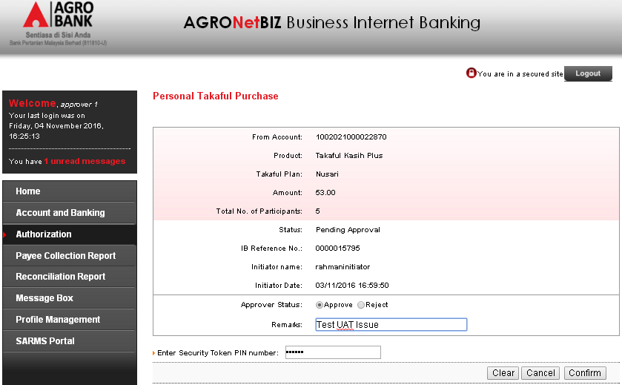
- View Result Page
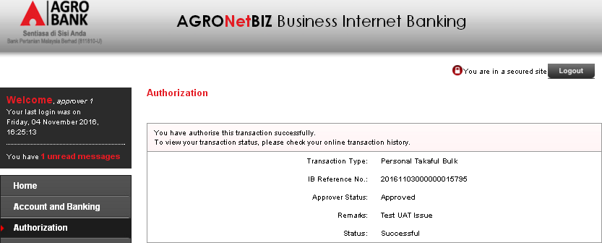
Reviewed By: (PMO)
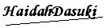 |  |  | Name/Position : Norhaidah Binti Md Dasuki / Senior Manager, Quality Assurance and Support  Date : 26/10/2016

