Test Issue Log |  |  |  |  |  | SCP ID# : UAT_Tak_006
Project Name: | AGROBANK BUSINESS INTERNET BANKING
Test Stage: | Unit Functionality Integration System Interface  Performance Regression Acceptance Pilot
Test Case Number: | Support #6756 |  |  | Test Started Date: |  |  | 02/10/2016
Test Title: | Takaful – No Service Listed on Approval Checker when approve changes made by Maker
Test Description: | To ensure certificate does not display blank when click on “Download Certificate” on Result Page.  https://10.6.6.20/ibam.sit.takaful/common/Login.do
Test Functionality: | BIB  - Role – Initiator  Takaful > Takaful Purchase > Purchase Takaful Kasih > Print Certificate
Test Procedure: | BIB - Initiator  - Login as Initiator and perform Purchase Takaful Kasih.  - View Result Page  - Click on “Download Certificate” button.
Test Result: | Pass: Fail: | Tested by: |  |  | Erni Suhaireen binti Zulkifli
Reason for Failure:
TEST DESCRIPTION
- Login as Initiator and perform Purchase Takaful Kasih.
- View Result Page
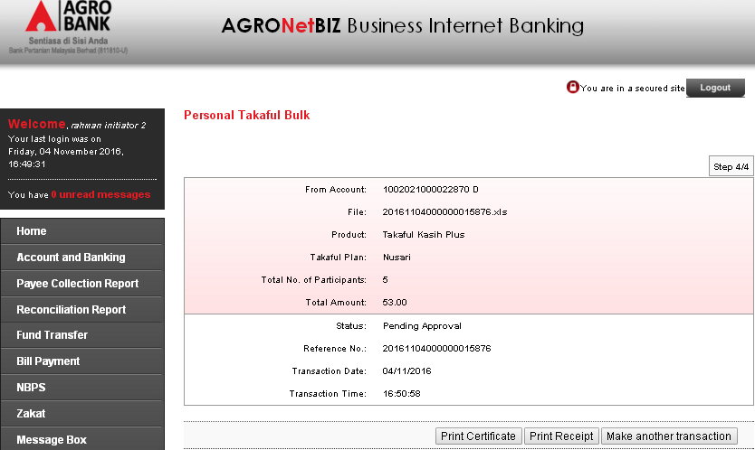
- Click on “Download Certificate” button.
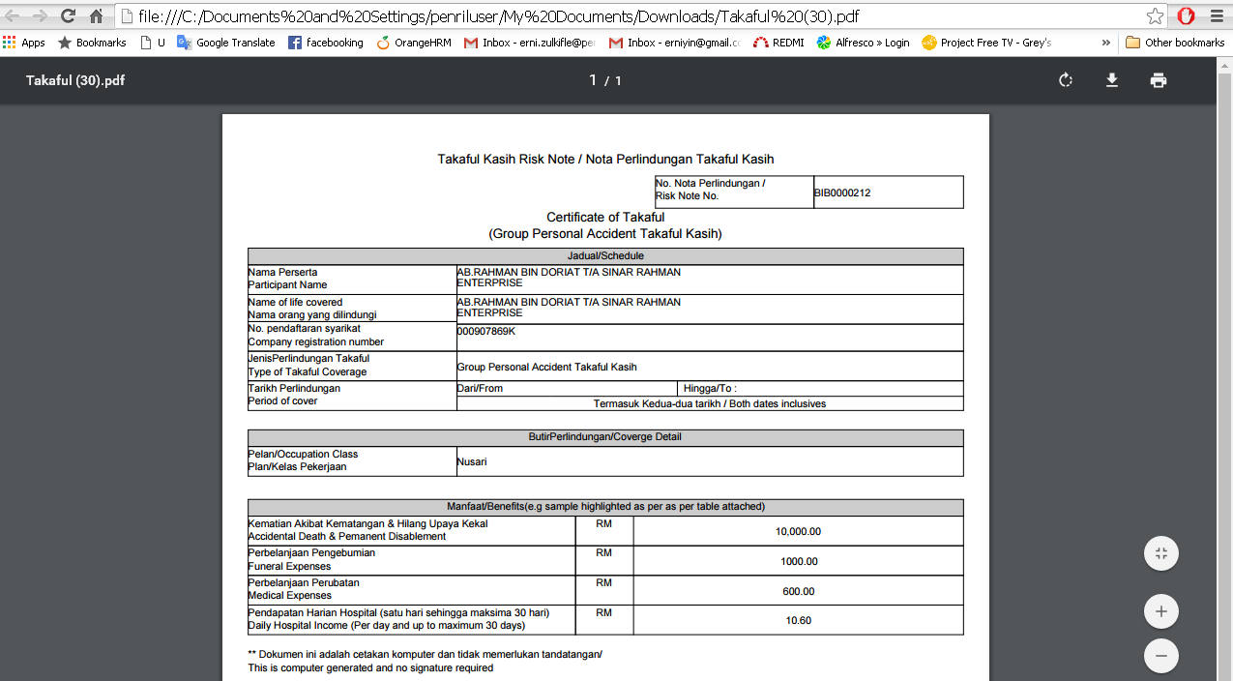
Reviewed By: (PMO)
 |  |  | Name/Position : Norhaidah Binti Md Dasuki / Senior Manager, Quality Assurance and Support  Date : 26/10/2016

