Test Issue Log
Project Name: | AGROBANK BUSINESS INTERNET BANKING
Test Stage: | Unit Functionality Integration System Interface  Performance Regression Acceptance Pilot
Test Case Number: | Bug #6752 |  |  | Test Started Date: |  |  | 01/11/2016
Test Title: | LHDN: Change Validation Error Message for Employer number
Test Description: | To ensure error message will display “Employer No. not found. Please refer to LHDN for confirmation” when company not registered with LHDN.  https://10.6.6.20/bib.sit.lhdn/common/Login.do  https://10.6.6.20/ibam.sit.lhdn/common/Login.do
Test Functionality: | IBAM  BIB > Company Enquiry > Company Details  BIB  Payroll > Statutory Bodies > LHDN
Test Procedure: | IBAM  - Login to IBAM and go to BIB > Company Enquiry > Company Details.  - Check on LHDN Employer Number.  BIB  - Edit Employer Field on the LHDN Upload File to be any number that not registered with LHDN.  - Login to BIB and perform LHDN Transfer to view the error message.
Test Result: | Pass: Fail: | Tested by: |  |  | Erni Suhaireen binti Zulkifli
Reason for Failure:
TEST DESCRIPTION
IBAM
- Login to IBAM and go to BIB > Company Enquiry > Company Details.
- Check on LHDN Employer Number.
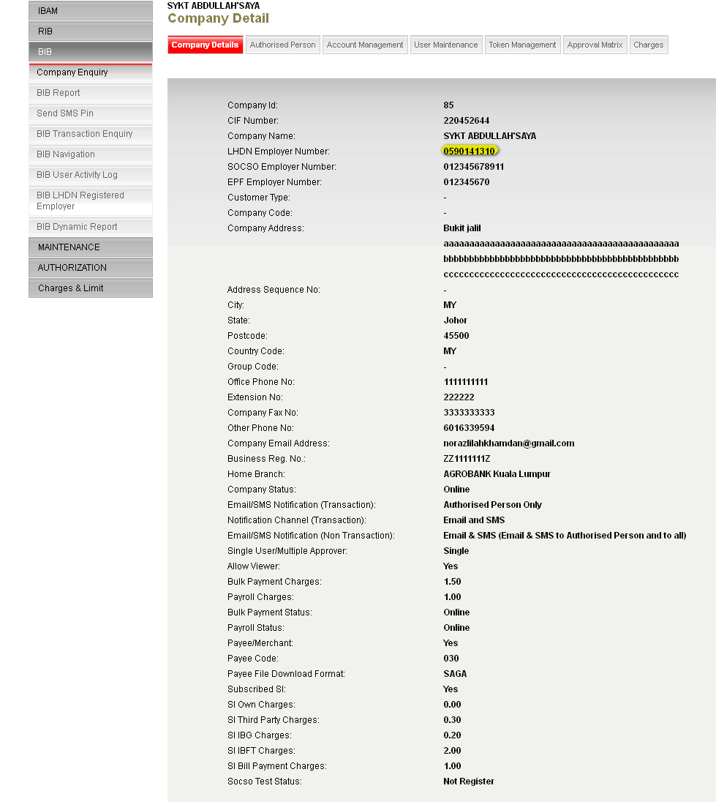

BIB
- Edit Employer Field on the LHDN Upload File to be any number that not registered with LHDN.
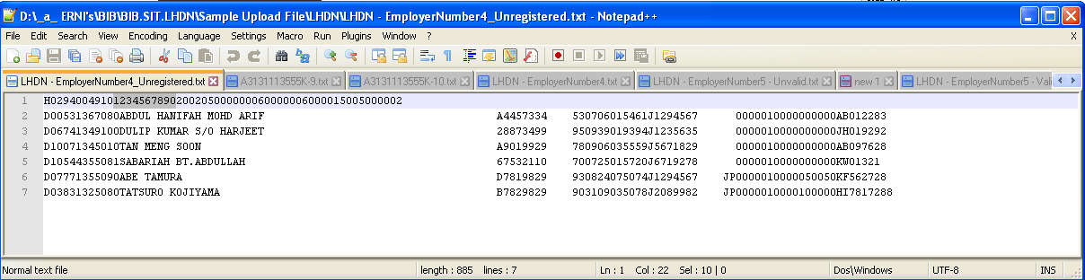
- Login to BIB and perform LHDN Transfer to view the error message.
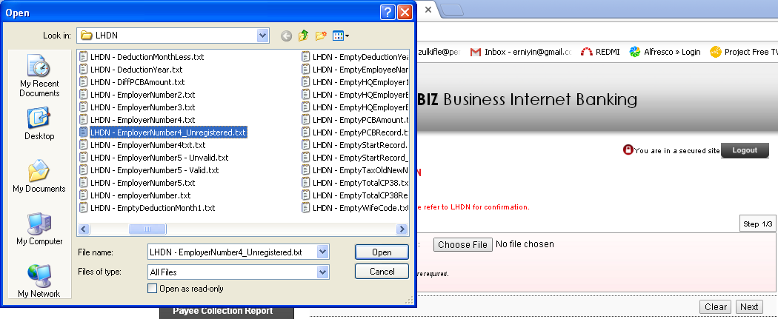
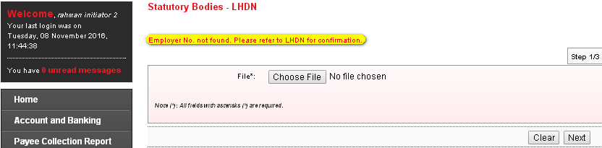
Reviewed By: (PMO)
 |  |  | Name/Position : Norhaidah Binti Md Dasuki / Senior Manager, Quality Assurance and Support  Date : 26/10/2016

