Test Issue Log |  |  |  |  |  | SCP ID# : SB_LHDN_019
Project Name: | AGROBANK BUSINESS INTERNET BANKING
Test Stage: | Unit Functionality Integration System Interface  Performance Regression Acceptance Pilot
Test Case Number: | Bug #6747 |  |  | Test Started Date: |  |  | 01/11/2016
Test Title: | LHDN – Report in TXT format
Test Description: | To ensure report does not display in TXT format
Test Functionality: | Tested on server
Test Procedure: | - Login to server.  - Go to D > opt > report_statutory_bodies  - View file format
Test Result: | Pass: Fail: | Tested by: |  |  | Erni Suhaireen binti Zulkifli
Reason for Failure:
TEST DESCRIPTION
- Login to server.
- Go to D > opt > report_statutory_bodies
- View file format
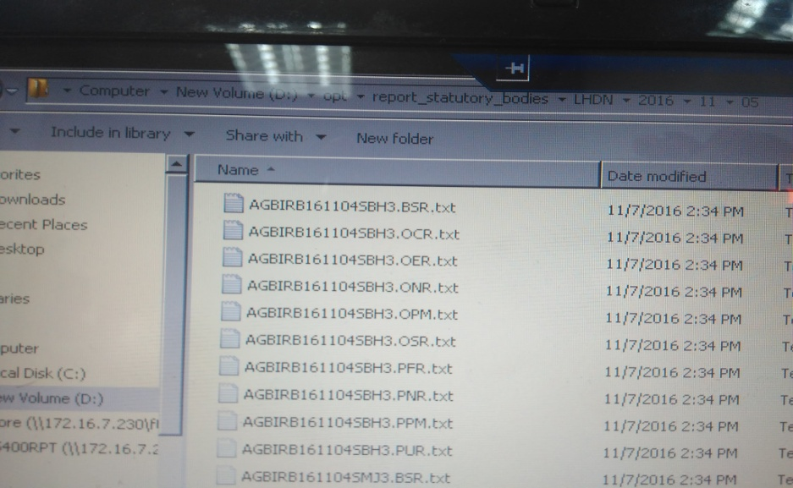
Reviewed By: (PMO)
 |  |  | Name/Position : Norhaidah Binti Md Dasuki / Senior Manager, Quality Assurance and Support  Date : 26/10/2016

