Test Issue Log |  |  |  |  |  | SCP ID# : SB_LHDN_016
Project Name: | AGROBANK BUSINESS INTERNET BANKING
Test Stage: | Unit Functionality Integration System Interface  Performance Regression Acceptance Pilot
Test Case Number: | Bug #6747 |  |  | Test Started Date: |  |  | 01/11/2016
Test Title: | LHDN – BSR, OPM, PPM, PNR, OSR and ONR
Test Description: | To ensure BSR, OPM, PPM, PNR, OSR and ONR data dated 07/11/2016 tally with the total successful transactions.  https://10.6.6.20/bib.sit.lhdn/common/Login.do
Test Functionality: | BIB  Payroll > Statutory Bodies > LHDN
Test Procedure: | BIB  - Login to BIB  - Perform two Successfully LHDN transfer and two Unsuccessfully LHDN transfer.  - Login to Squirrel tools to check on the transaction record for report BSR, OPM, PPM, PNR, OSR and ONR
Test Result: | Pass: Fail: | Tested by: |  |  | Erni Suhaireen binti Zulkifli
Reason for Failure:
TEST DESCRIPTION
- Login to BIB
- Perform three Successfully LHDN transfer.
- Multiple User:
  - View LHDN Transfer History
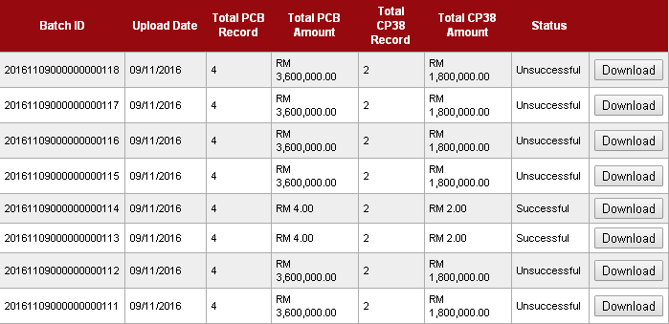

  - View AgronetBiz Transaction History
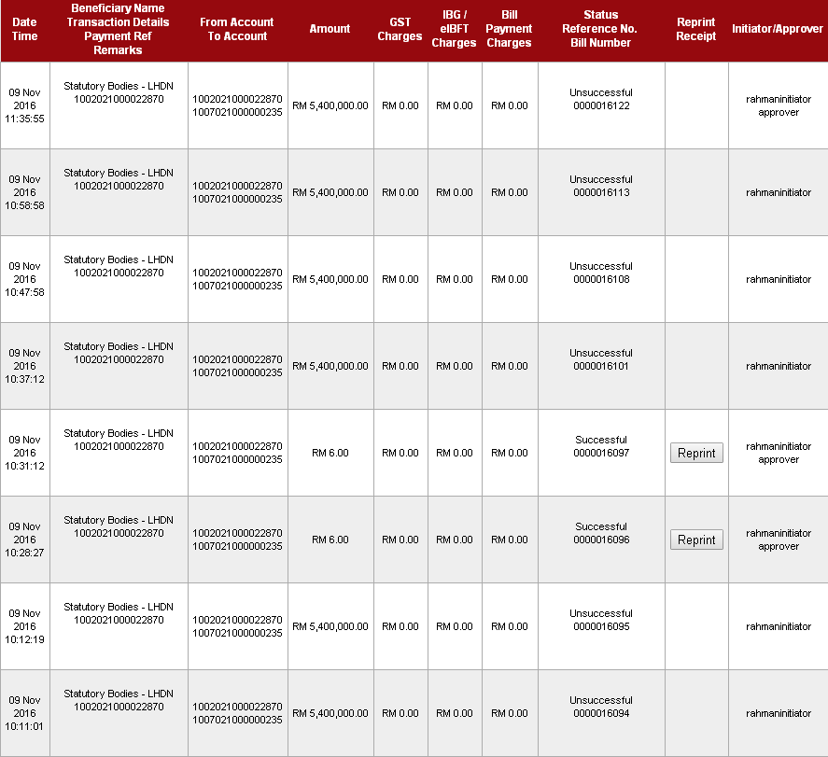
Total Successful transaction: 2
Total Unsuccessful transaction: 6

- Single User:
  - View LHDN Transfer History
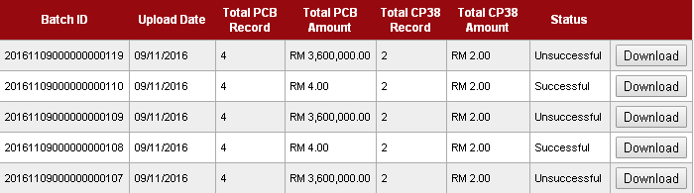
  - View AgronetBiz Transaction History
Account 1002021000002362
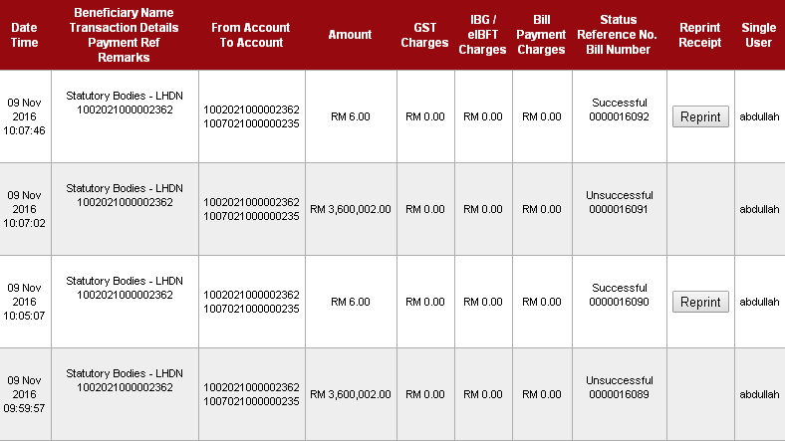
Account 1005011000000016
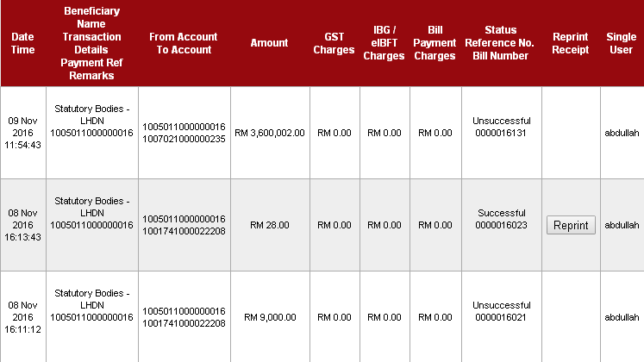
Total Successful transaction: 2
Total Unsuccessful transaction: 3
REMARKS
There are only 4 successful transaction should display on report.
- Login to Squirrel tools to check on the transaction record for report BSR, OPM, PPM, PNR, OSR and ONR
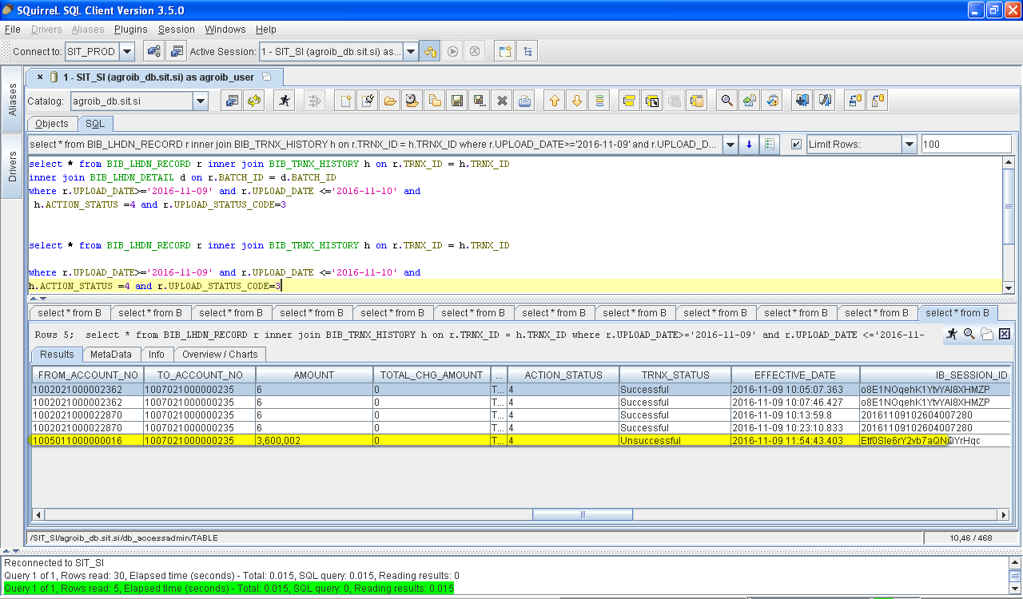
Result:
Result state that there are 5 transaction recorded on report.
The last transaction highlighted should not display on report. Kindly assist to check on this issue.

Below is the transaction details of unsuccessful status that recorded on report:
- Result Page
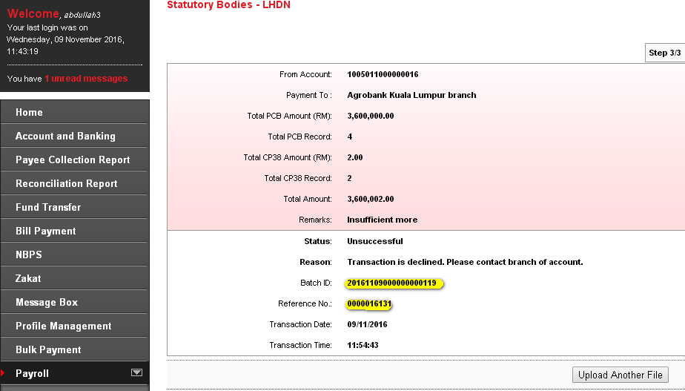
- LHDN Transfer History
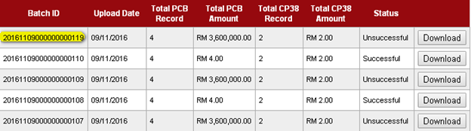
- Agronet Transaction History
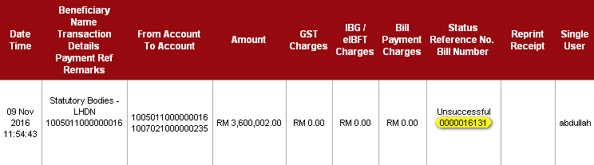

Reviewed By: (PMO)
 |  |  | Name/Position : Norhaidah Binti Md Dasuki / Senior Manager, Quality Assurance and Support  Date : 26/10/2016

