Test Issue Log |  |  |  |  |  | SCP ID# : SB_LHDN_017
Project Name: | AGROBANK BUSINESS INTERNET BANKING
Test Stage: | Unit Functionality Integration System Interface  Performance Regression Acceptance Pilot
Test Case Number: | Bug #6767 |  |  | Test Started Date: |  |  | 01/11/2016
Test Title: | LHDN – ONR,OCR,OER,
Test Description: | To ensure Report format/layout is correct.  https://10.6.6.20/bib.sit.lhdn/common/Login.do
Test Functionality: | BIB  Payroll > Statutory Bodies > LHDN
Test Procedure: | BIB  - Login to Server to check on the format  - OCR  - OER  - ONR  - OSR  - PUR  - PFR
Test Result: | Pass: Fail: | Tested by: |  |  | Erni Suhaireen binti Zulkifli
Reason for Failure:
TEST DESCRIPTION
- Login to Server to check on the transaction record
  - OCR
Sabah
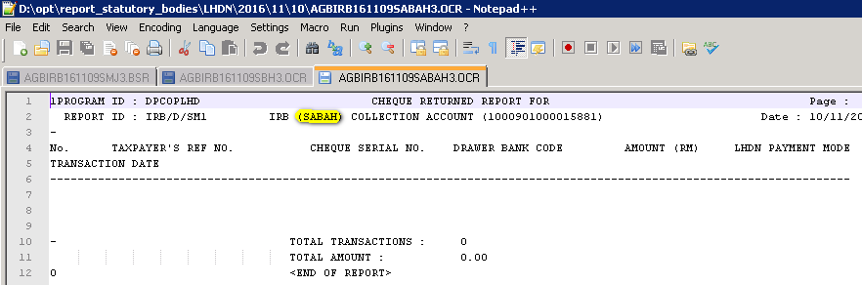
Sarawak
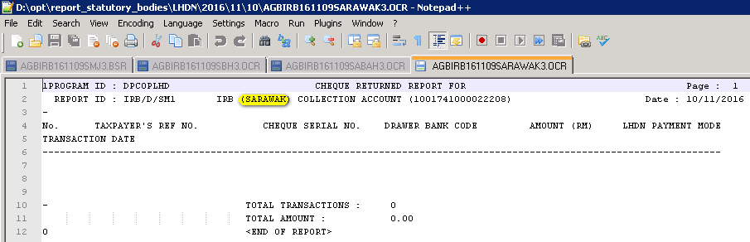
Semenanjung
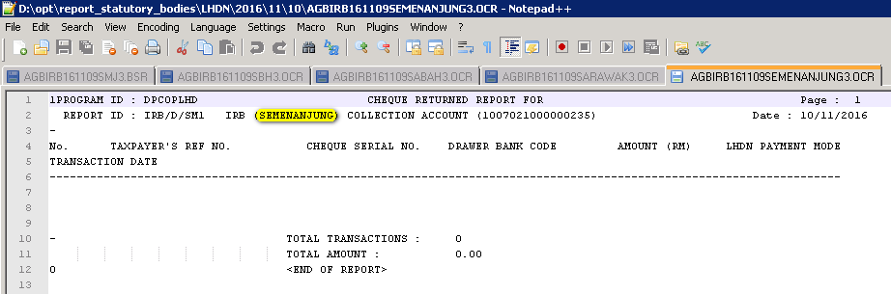

  - OER
Sabah
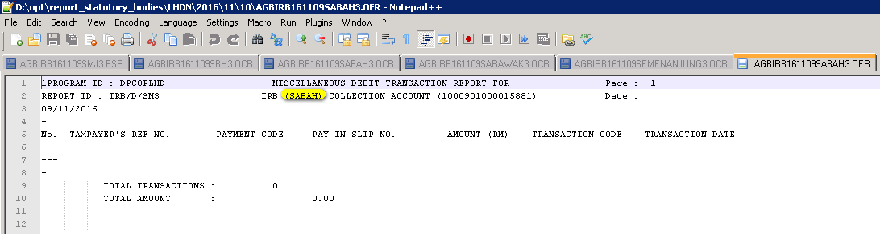
Sarawak
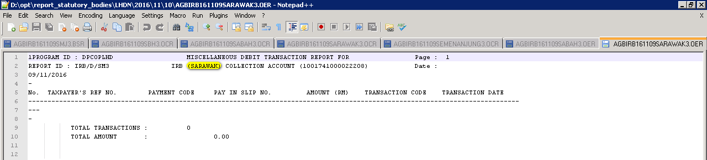
Semenanjung
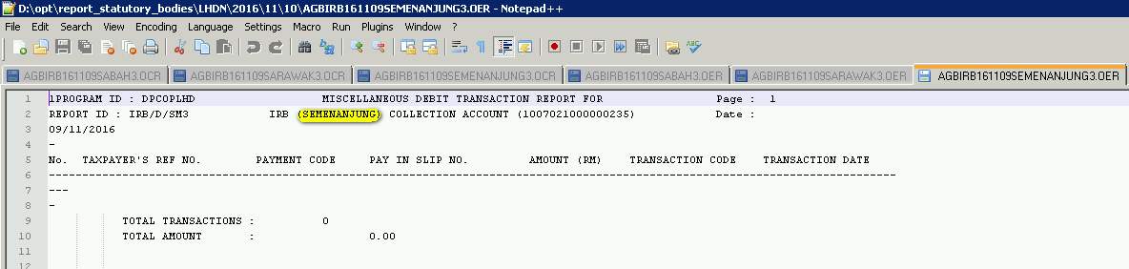

  - ONR
Sabah
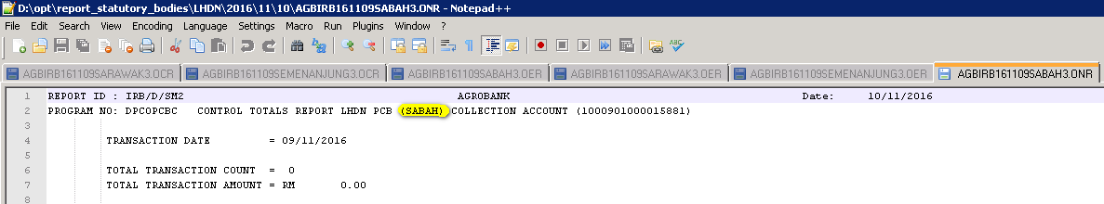
Sarawak
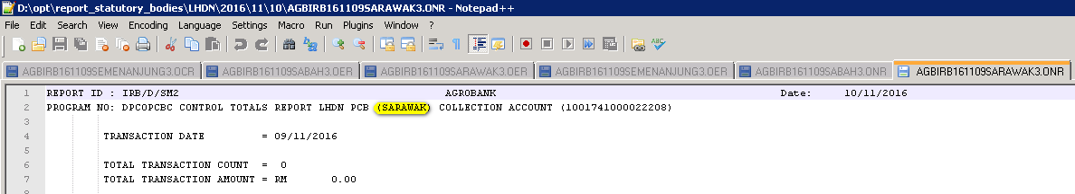
Semenanjung
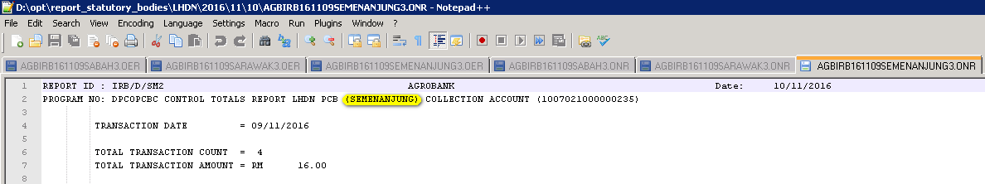

  - OSR
Sabah
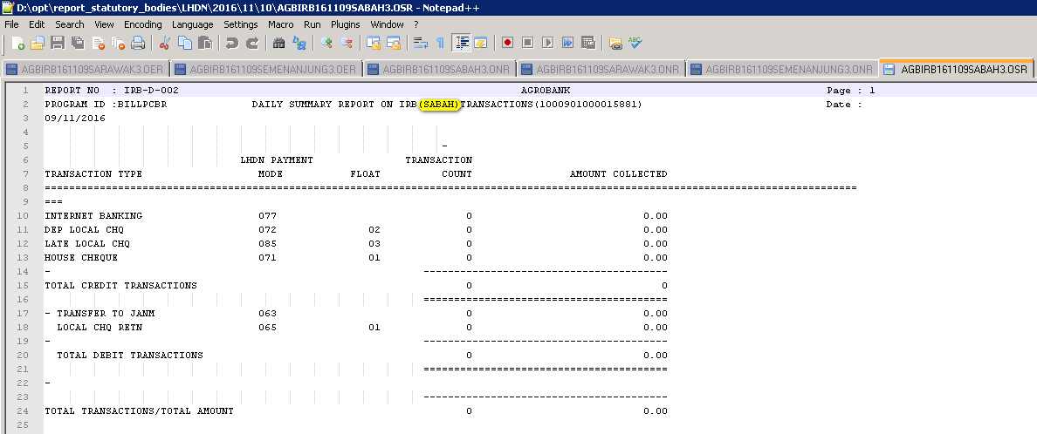
Sarawak
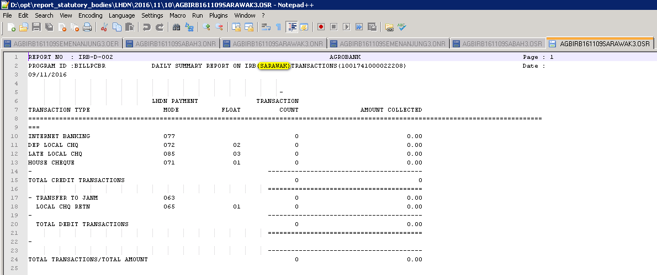

Semenanjung
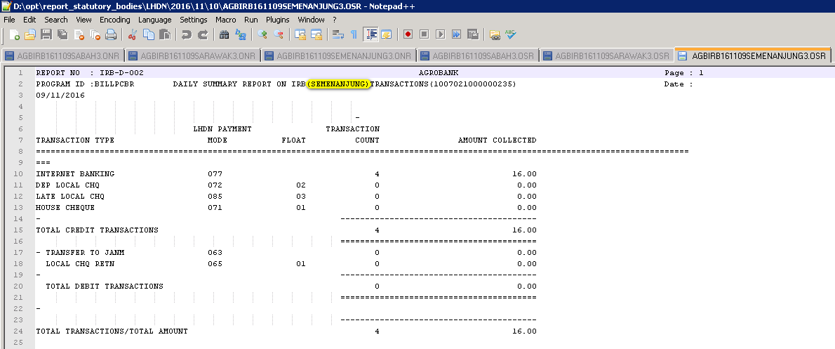

  - PUR
Sabah
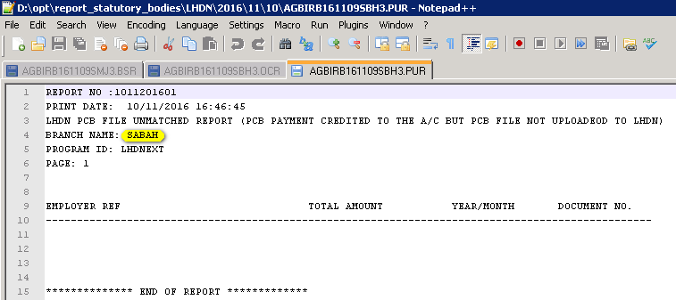
Sarawak
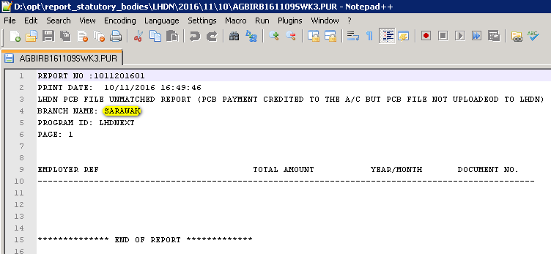

Semenanjung
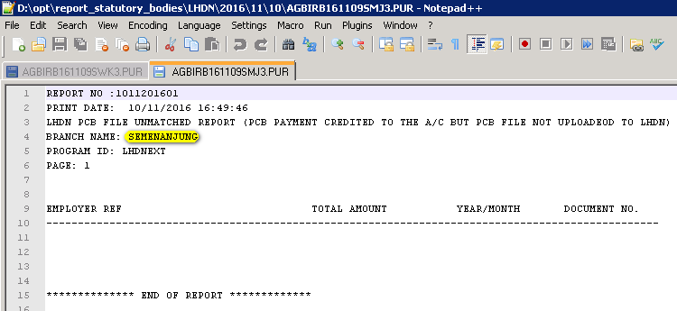

  - PFR
Sabah
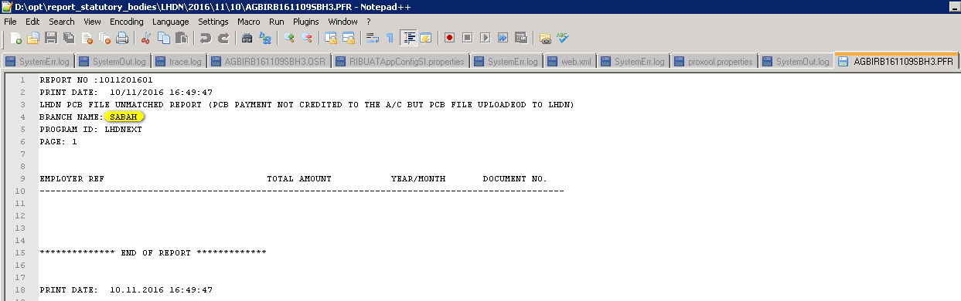
Sarawak
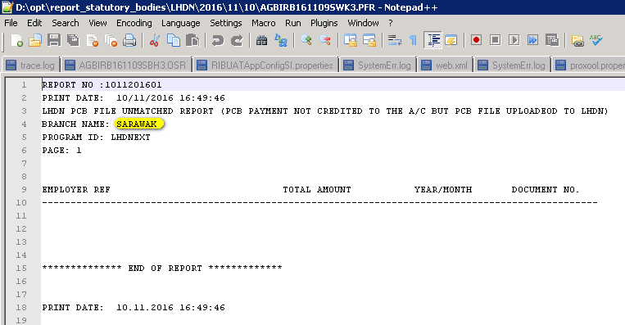

Semenanjung
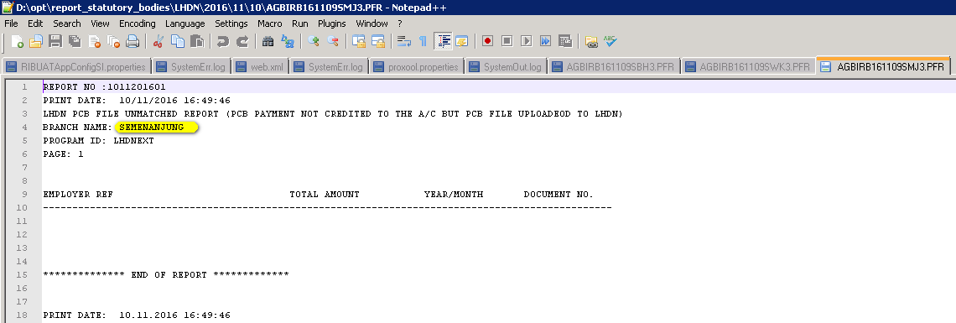
Reviewed By: (PMO)
 |  |  | Name/Position : Norhaidah Binti Md Dasuki / Senior Manager, Quality Assurance and Support  Date : 26/10/2016

