Test Issue Log |  |  |  |  |  | SCP ID# : SB_LHDN_016
Project Name: | AGROBANK BUSINESS INTERNET BANKING
Test Stage: | Unit Functionality Integration System Interface  Performance Regression Acceptance Pilot
Test Case Number: | Bug #6747 |  |  | Test Started Date: |  |  | 01/11/2016
Test Title: | LHDN – BSR, OPM, PPM, PNR, OSR and ONR
Test Description: | To ensure BSR, OPM, PPM, PNR, OSR and ONR data dated 07/11/2016 tally with the total successful transactions.  https://10.6.6.20/bib.sit.lhdn/common/Login.do
Test Functionality: | BIB  Payroll > Statutory Bodies > LHDN
Test Procedure: | BIB  - Login to BIB  - Perform Successfully LHDN transfer and Unsuccessfully LHDN transfer.  - Login to Squirrel tools to check on the transaction record for report BSR, OPM, PPM, PNR, OSR and ONR
Test Result: | Pass: Fail: | Tested by: |  |  | Erni Suhaireen binti Zulkifli
Reason for Failure:
TEST DESCRIPTION
- Login to BIB
- Perform three Successfully LHDN transfer.
- Multiple User:
  - View LHDN Transfer History
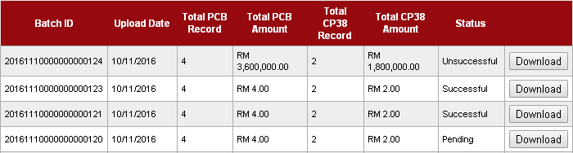
  - View AgronetBiz Transaction History
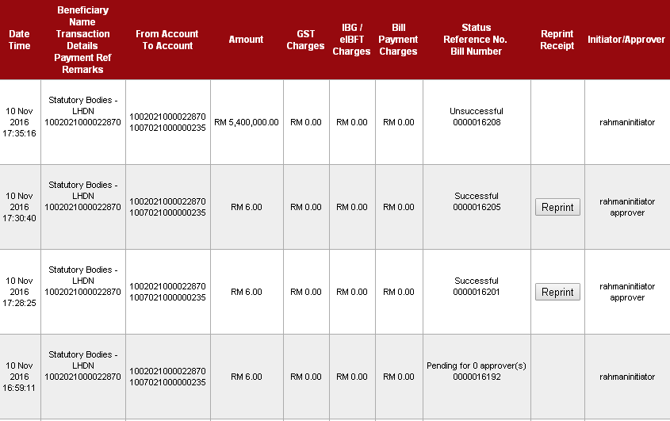
Total Successful transaction: 2
Total Unsuccessful transaction: 1
Total Pending Transaction: 1

- Single User:
  - View LHDN Transfer History
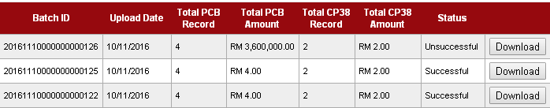
  - View AgronetBiz Transaction History
Account 1002021000002362
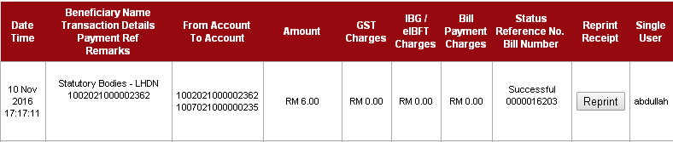
Account 1005011000000016
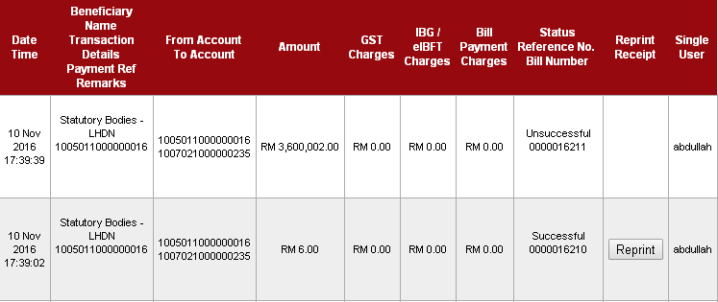
Total Successful transaction: 2
Total Unsuccessful transaction: 1

REMARKS
There are only 4 successful transaction should display on report.
- Login to Squirrel tools to check on the transaction record for report BSR, OPM, PPM, PNR, OSR and ONR
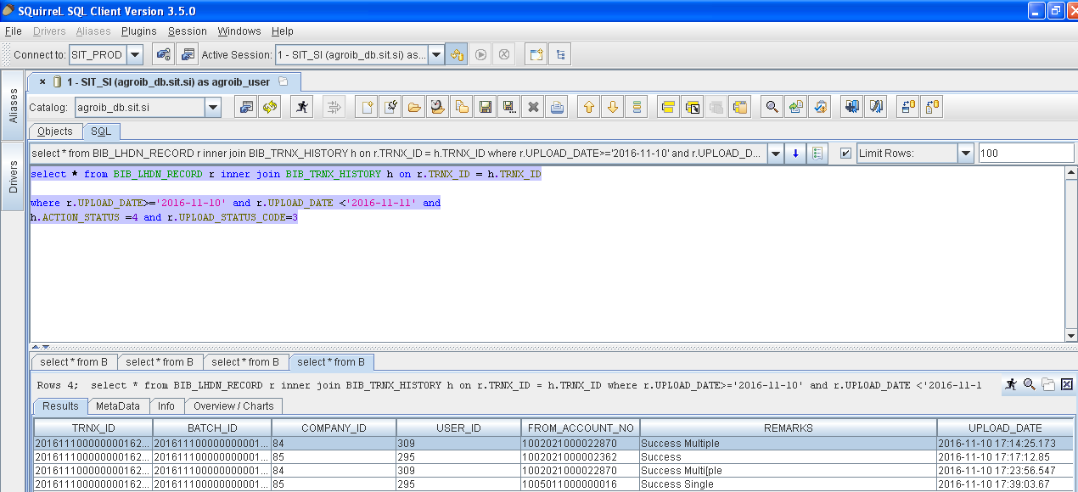
Result:
Successfully displayed the 4 Successful transaction

Reviewed By: (PMO)
 |  |  | Name/Position : Norhaidah Binti Md Dasuki / Senior Manager, Quality Assurance and Support  Date : 26/10/2016

