Test Issue Log |  |  |  |  |  | SCP ID# : 6689
Project Name: | [Internal Testing] IBAM Report – LHDN & SOCSO
Test Stage: | Unit Functionality Integration System Interface  Performance Regression Acceptance Pilot
Test Case Number: |  |  |  | Test Started Date: |  |  | 11/11/2016
Test Title: | [Internal Testing] BIB Report
Test Description: | - To ensure BIB Report display on current system meets the requirement needs.
Test Functionality: | - BIB Statutory Body LHDN Report Daily  -PDF  -EXCEL
Test Procedure: | - BIB Statutory Body LHDN Report Daily  - Login as Administrator and go to BIB Report to download the report.
Test Result: | Pass: Fail: | Tested by: |  |  | Erni Suhaireen binti Zulkifli
Reason for Failure: | BIB Statutory Body LHDN Report Daily  No Report Found
TEST DESCRIPTION
BIB Statutory Body LHDN Report Daily
- Check whether these successful transactions were recorded on BIB Report IBAM.
  - Single User
    - View LHDN Transfer History
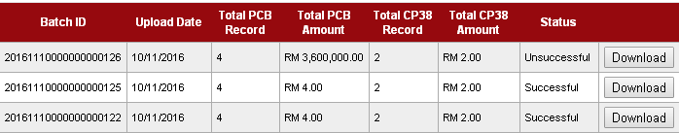
    - View AgronetBiz Transaction History
Account 1002021000002362
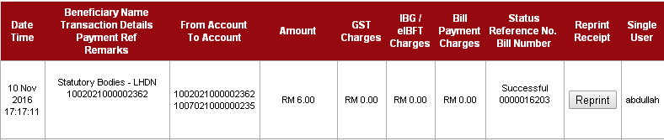
Account 1005011000000016
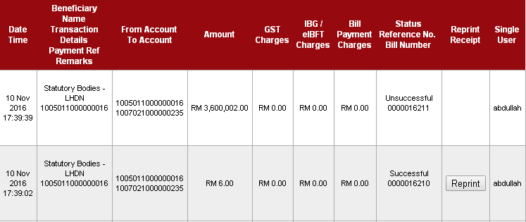
Total Successful transaction: 2
Total Unsuccessful transaction: 1

  - Multiple User
    - View LHDN Transfer History
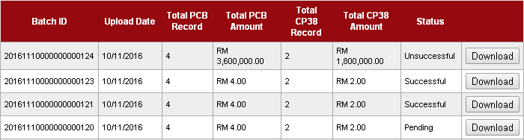
    - View AgronetBiz Transaction History
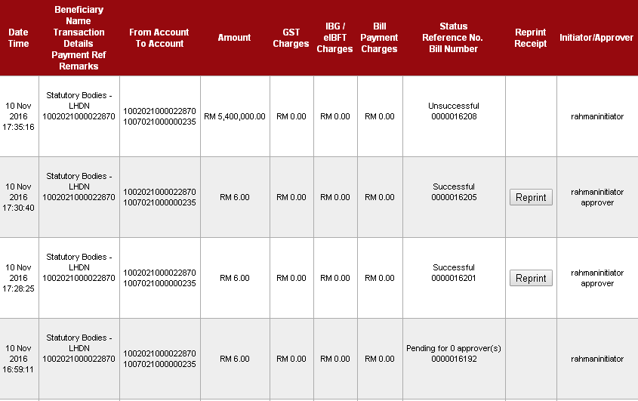
Total Successful transaction: 2
Total Unsuccessful transaction: 1
Total Pending Transaction: 1

PDF Format
- On BIB Report page, Choose BIB Statutory Bodies LHDN Report Daily on Report Type, PDF on File Type, October on Month and 2016 on Year. Then click on “Search” button.
- Click on “Save” button of the selected report.
Result:
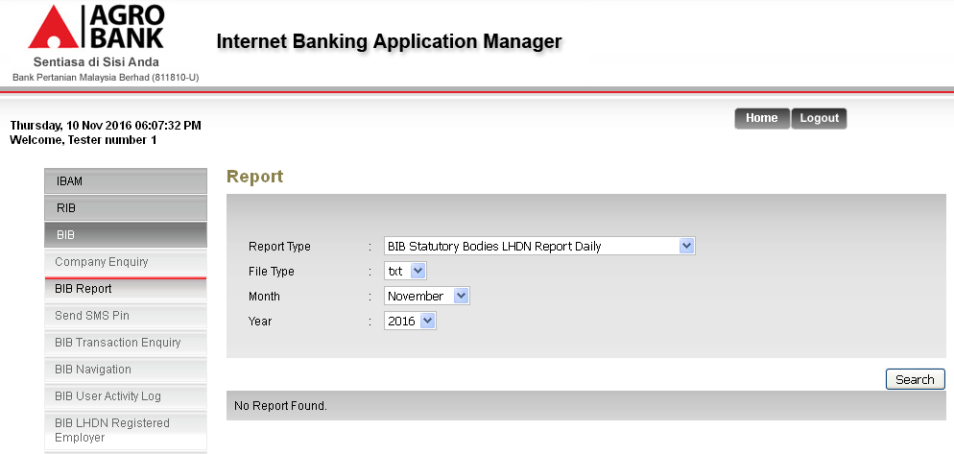
Bug Found:
No Report Found
Reviewed By: (PMO)
Lizahwati |  |  | Name/Position : Lizahwati binti Basirun  Date :

