Test Issue Log |  |  |  |  | SCP ID# : 3421
Project Name: | MAYBANK BII INTERNET BANKING
Test Stage: | Unit Functionality Integration System Interface  Performance Regression Acceptance Pilot
Test Case Number: | Support #6710 |  | Test Started Date: |  |  | 31/10/2016
Test Title: | Failed to pay Telkom with JCB card
Test Description: | To ensure system can perform payment to utility on Telkom via JCB Card.
Test Functionality: | RIB – Bill Payment  RMBP – Bill Payment  Transaction History (Host)  - RIB  - RMBP  Online Transaction History  - RIB  - RMBP
Test Procedure: | To perform Bill Payment via JCB Card at RIB  - Login to RIB  - Access to Bill Payment  - Click On “ Utility Payment”  - Click On “ Telkom “  From Account 3562850195863008 JCB ID  Subscriber No 0251044444443  - Go to Online Transaction History to view on the transaction details  - Go to Transaction History to view on the transaction details and to check on the account balance is accurate  To perform Bill Payment via JCB Card at RMBP  - Login to RMBP  - Access to Bill Payment  - Click On “ Utility Payment”  - Click On “ Telkom “  From Account 3562850195863008 JCB ID  Subscriber No 0251044444443  - Go to Online Transaction History to view on the transaction details  - Go to Transaction History to view on the transaction details and to check on the account balance is accurate
Test Result: | Pass: Fail:  Conditional Pass: | Tested by: |  | Tommy Arryandy
Reason for Failure / Conditional Pass: | Data issue from host, can’t check transaction history in RMBP because no proper account linked from host
TEST DESCRIPTION
- Test to perform Bill Payment via JCB Card at RIB
  - Bill Payment Details
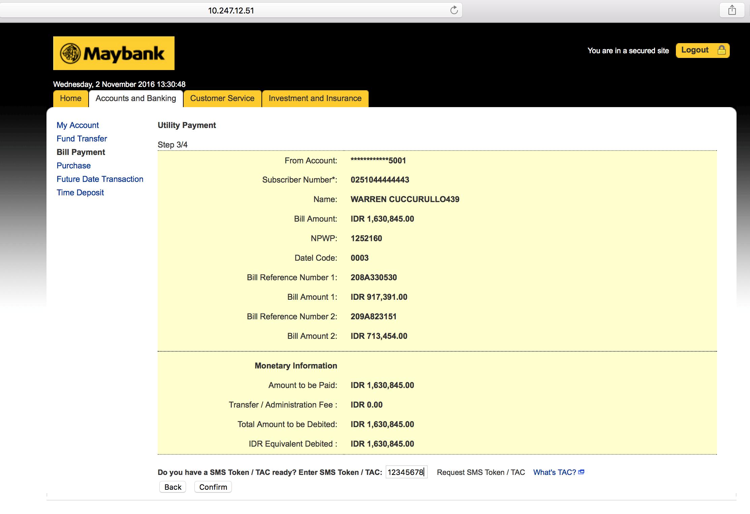

  - Bill Payment Result Page
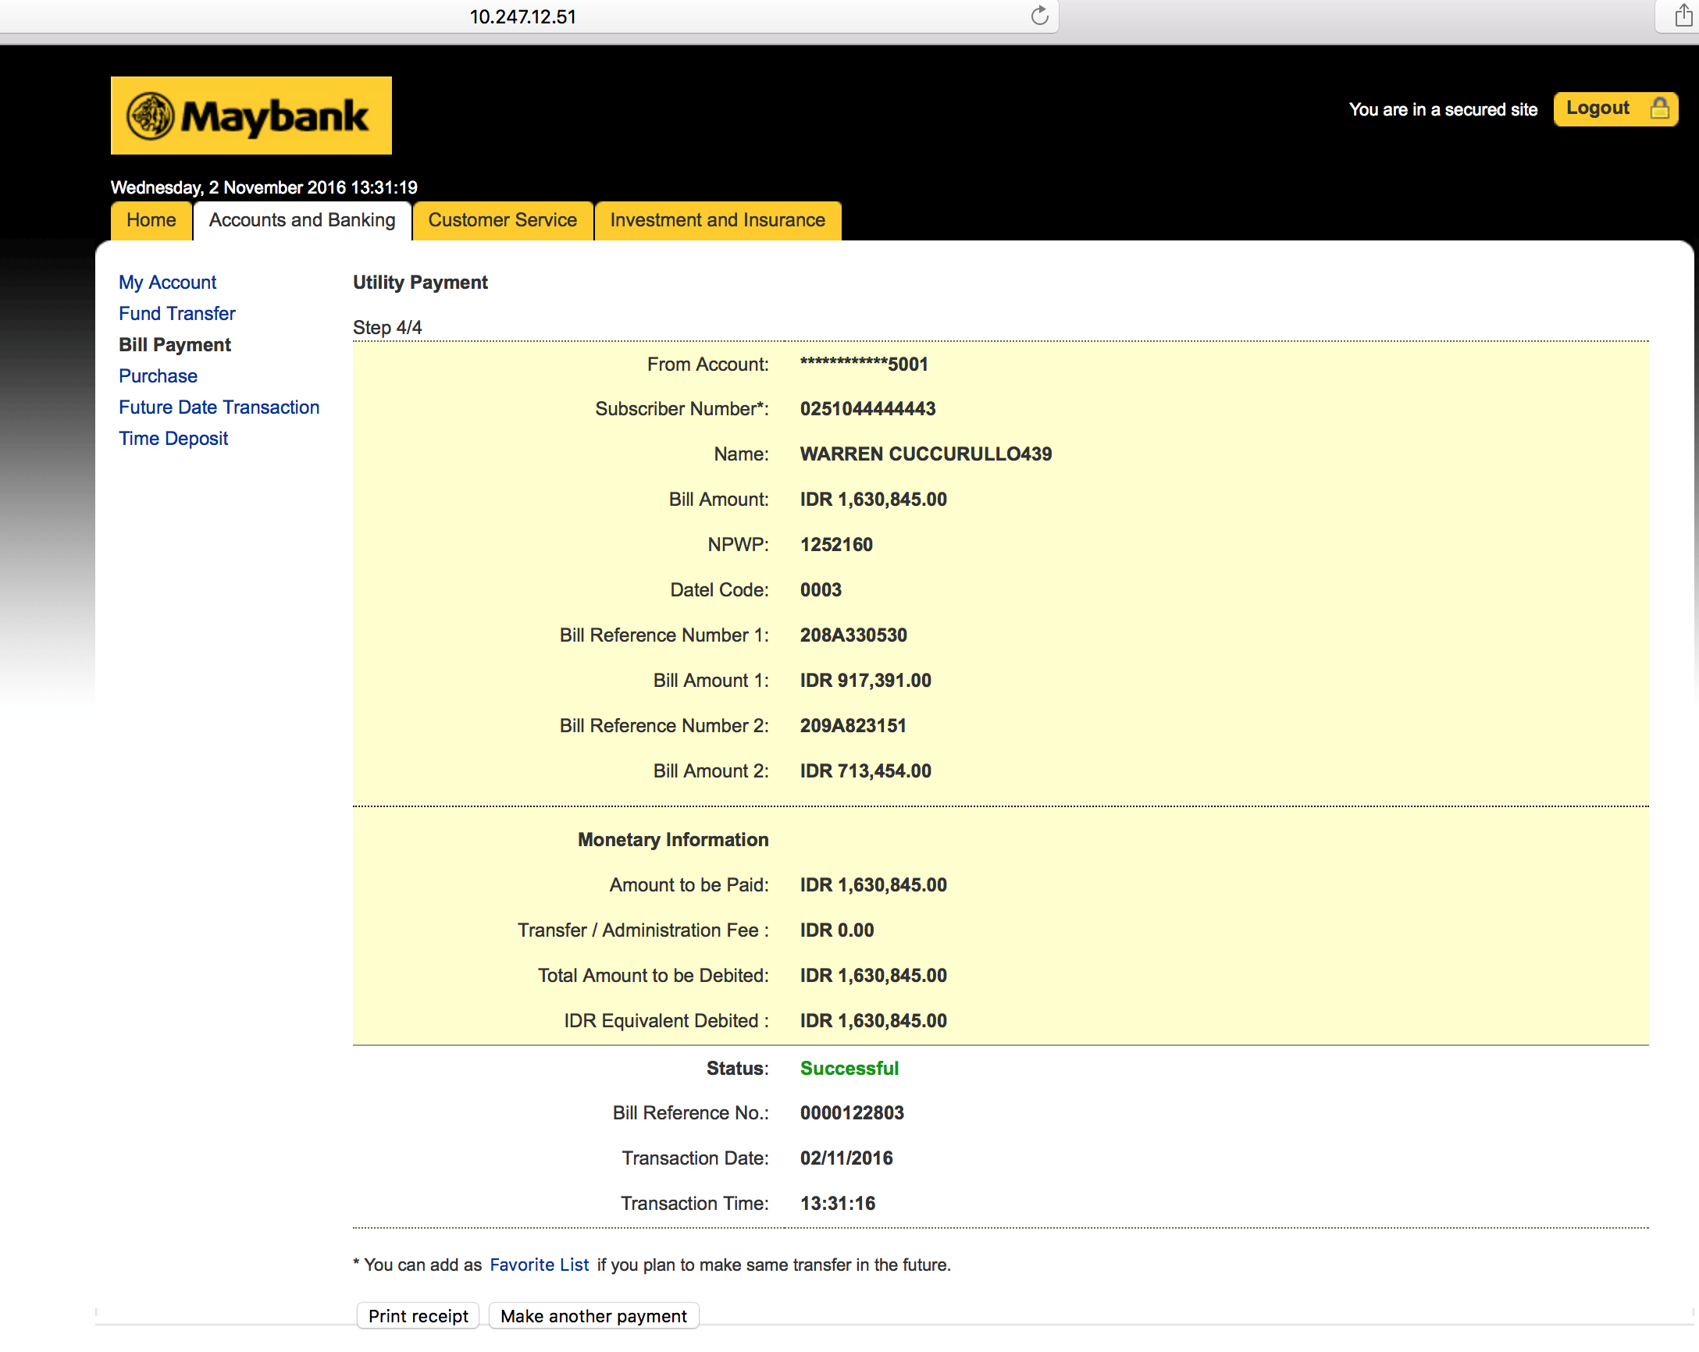

  - Online Transaction History
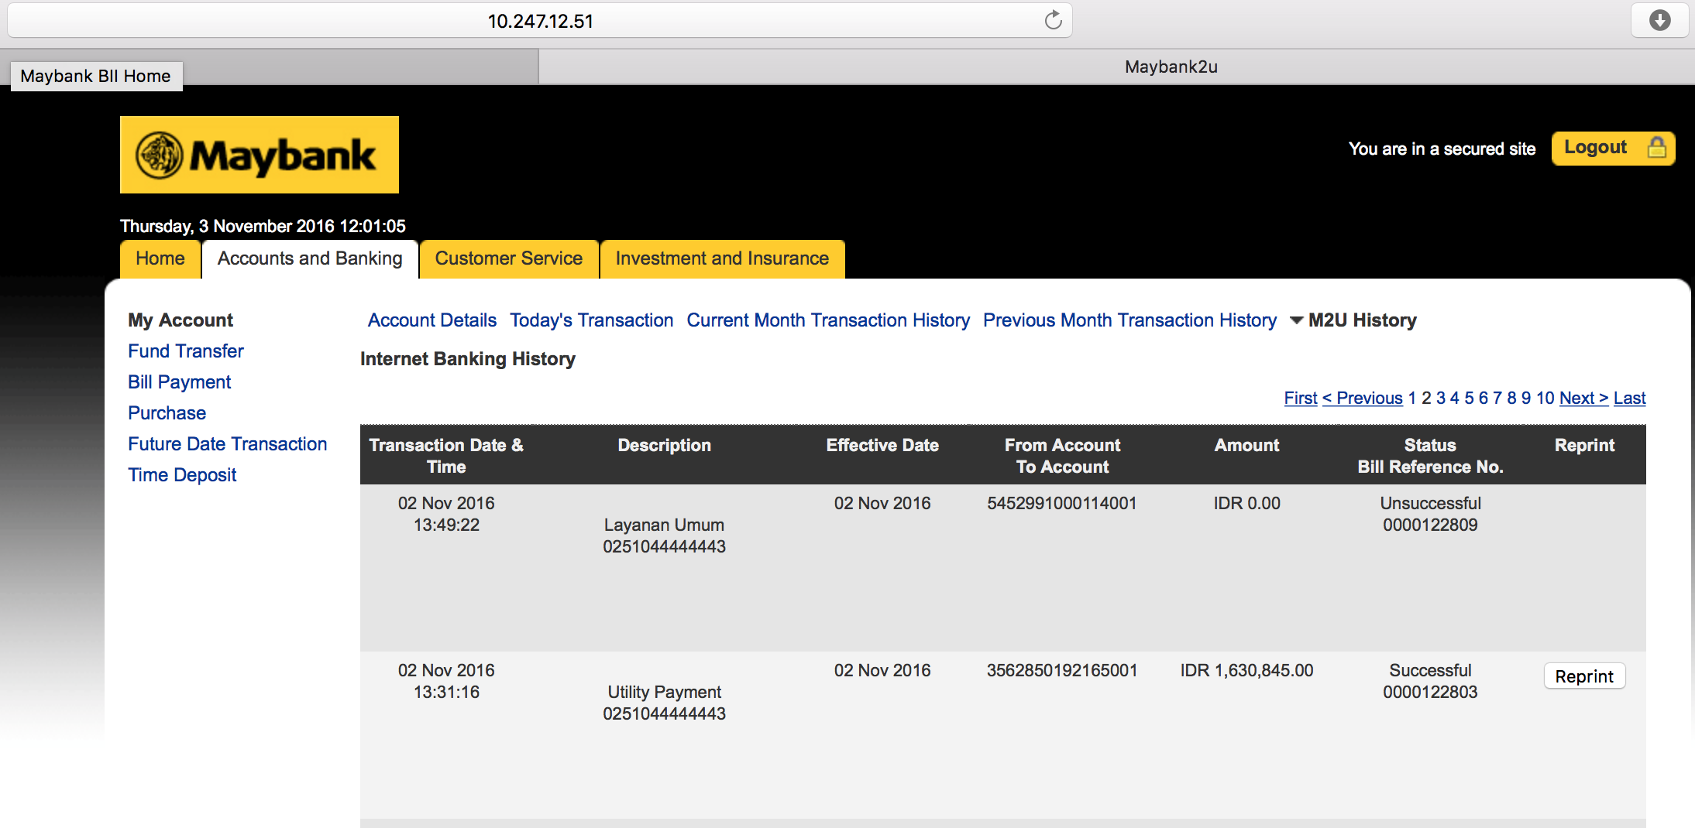

  - Transaction History (Host)
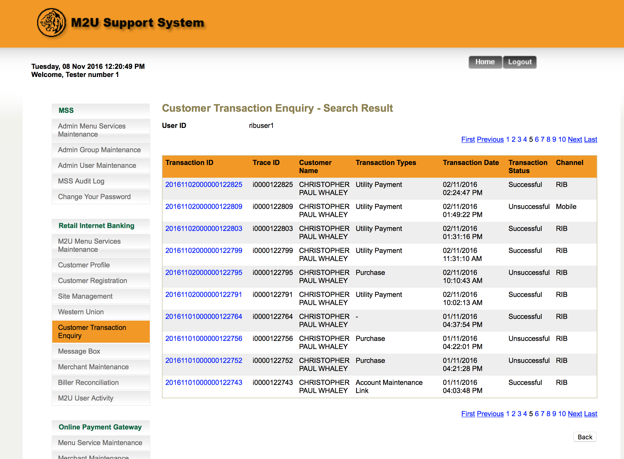
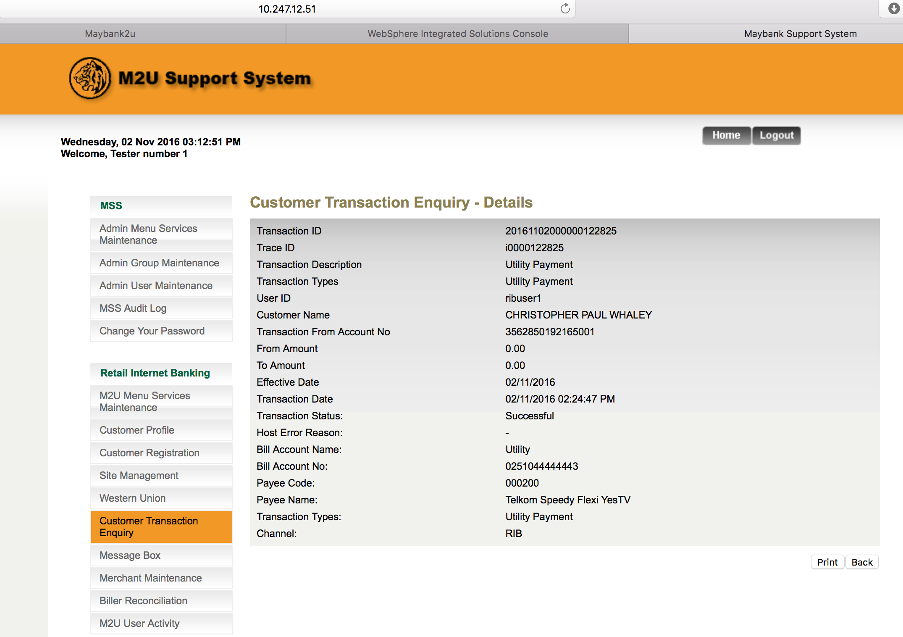

- Test to perform Bill Payment via JCB Card at RMBP

  - Bill Payment Details
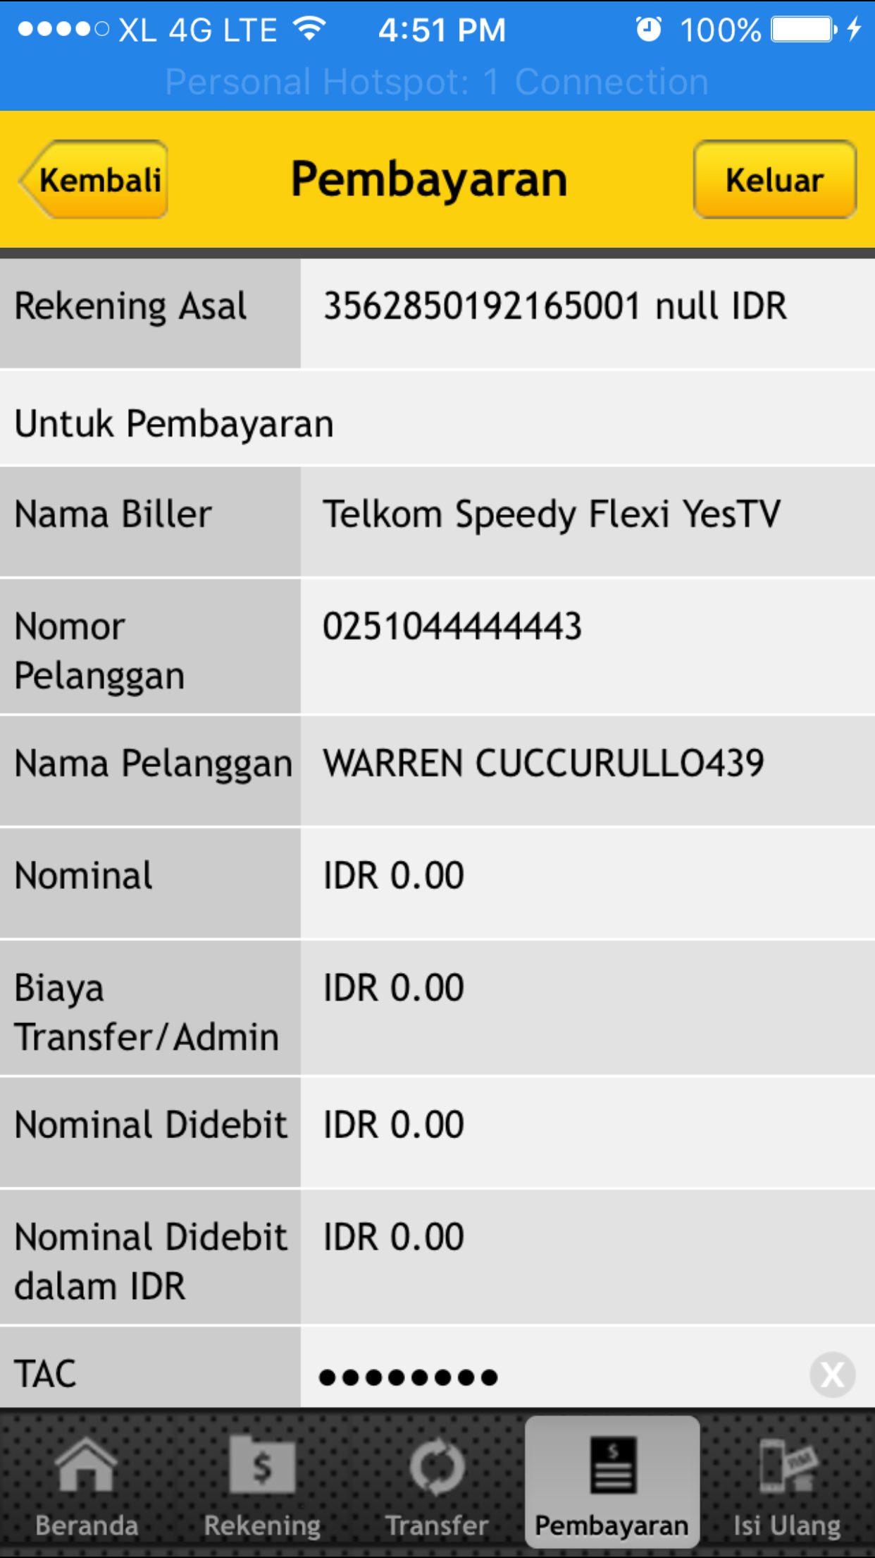

  - Bill Payment Result Page
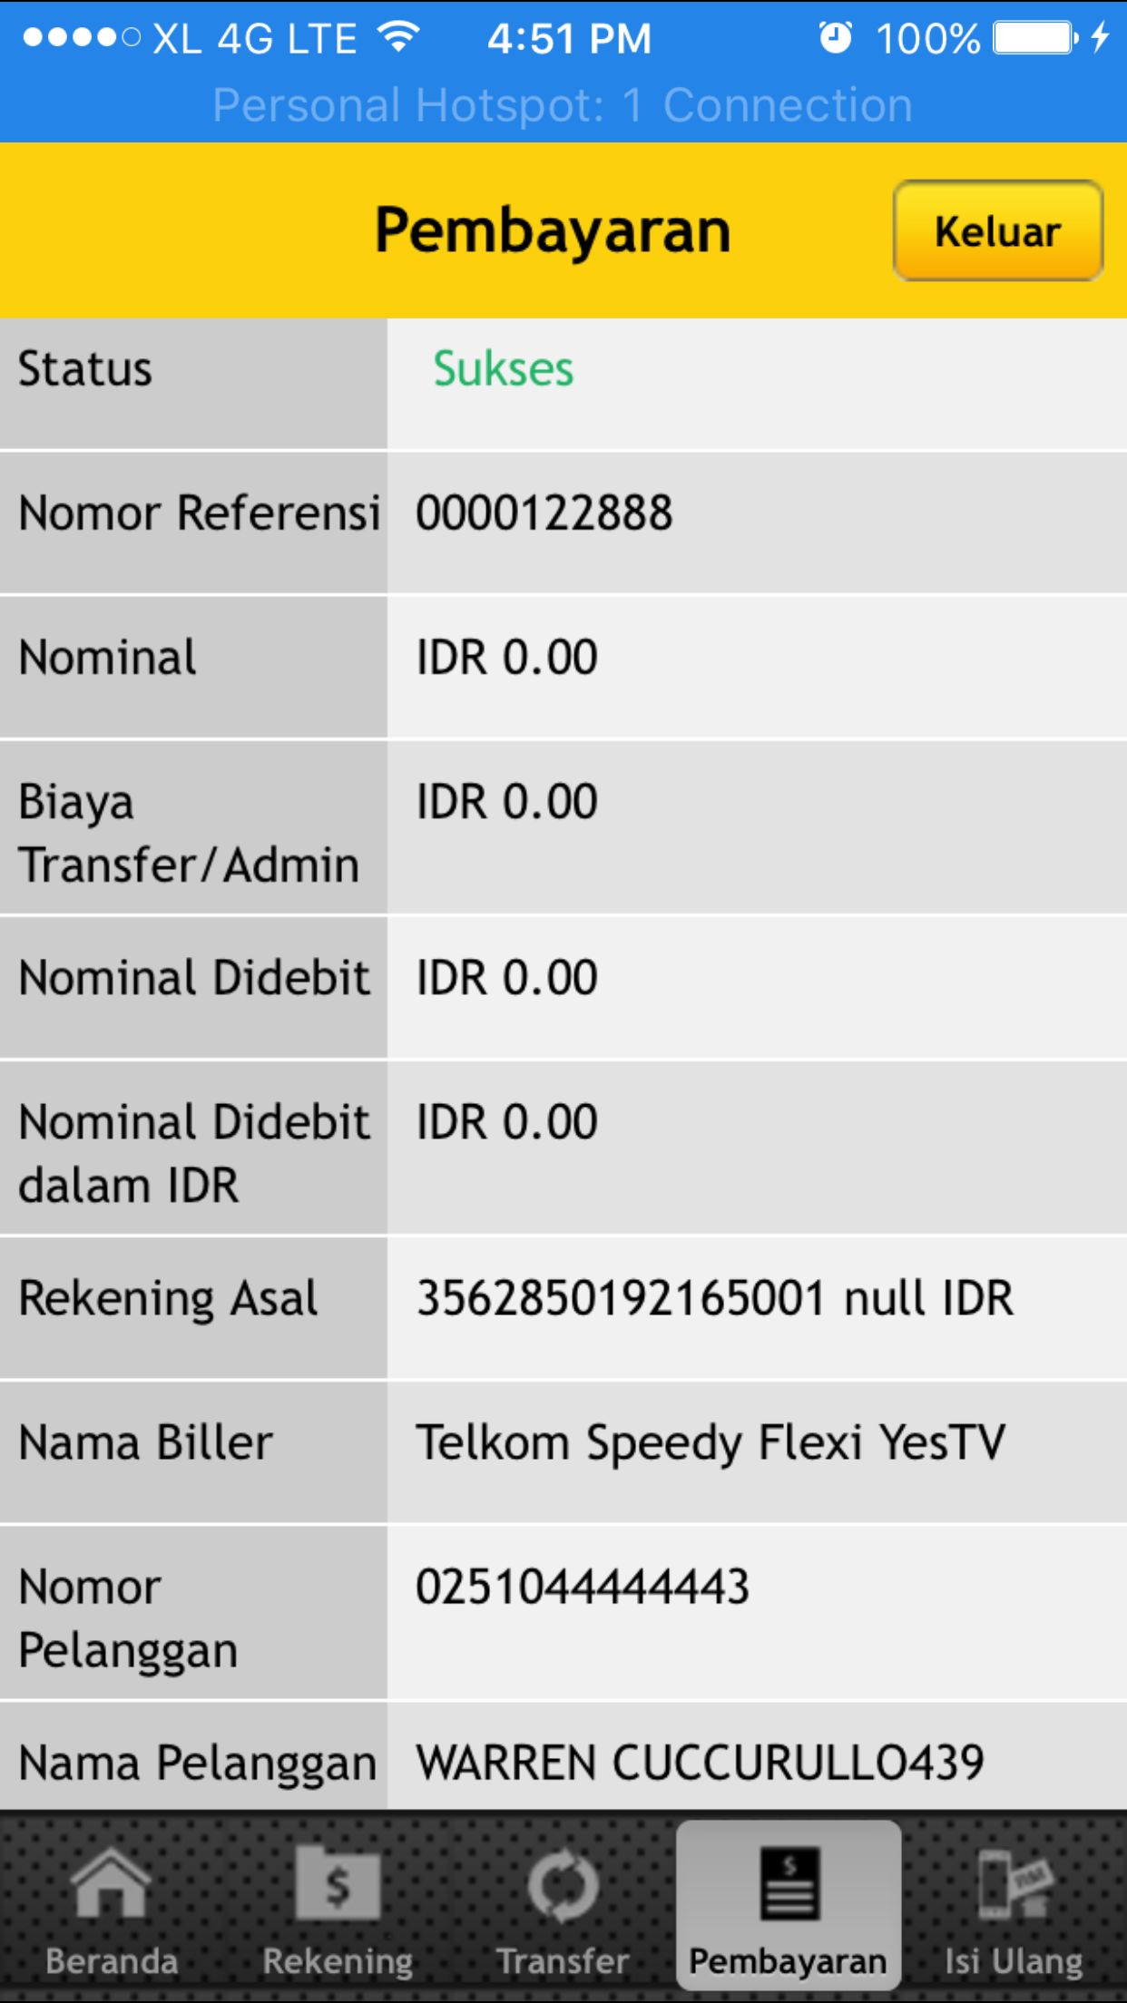

  - Online Transaction History
Web can view all account transaction history regardless of which account is selected. RMBP only shows transaction history of the selected account. This is data issue because no proper account linked from host

  - Transaction History (Host)
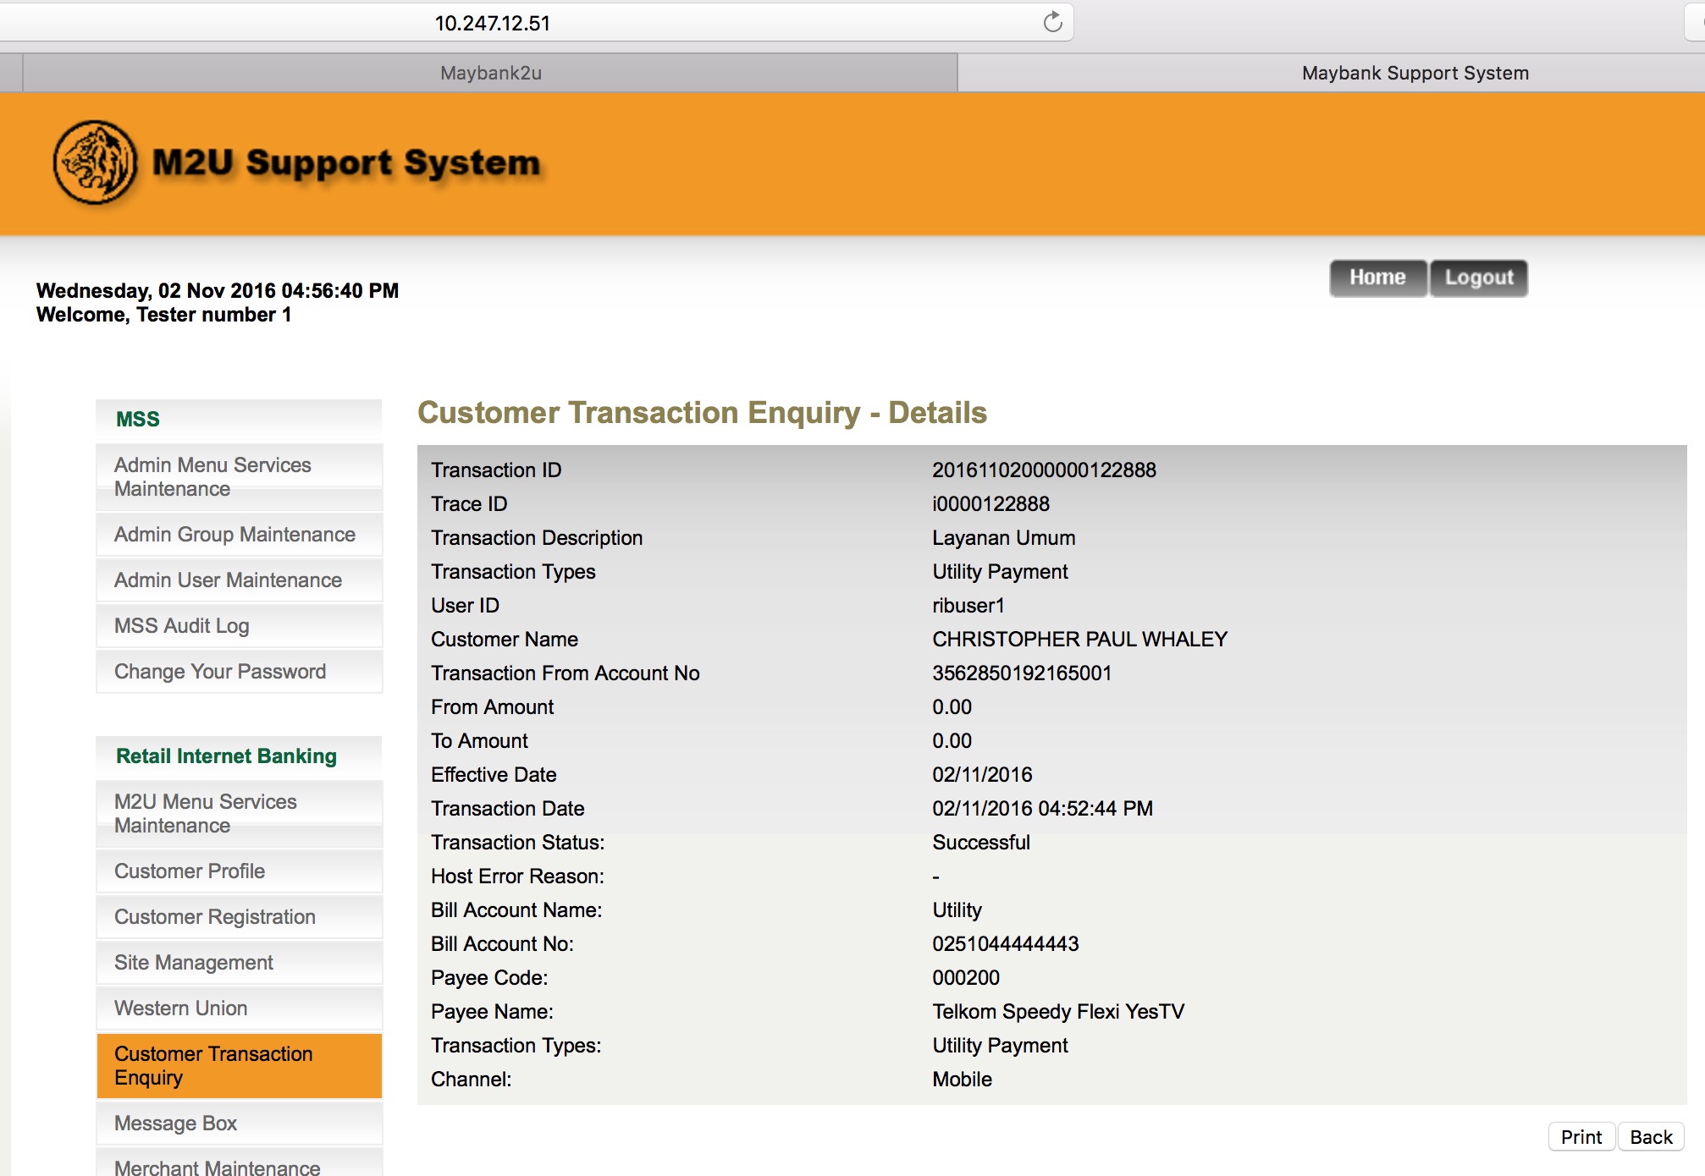
- Comfort Test: To input invalid details to the related field.
  - Input Non-numeric to Subscriber Number Field
Go to Bill Payment > Utility Payment > Telkom
Result
Subscriber Number: 123@##4225a
Error Message:

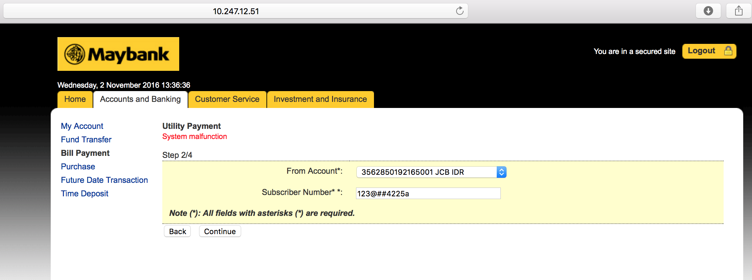

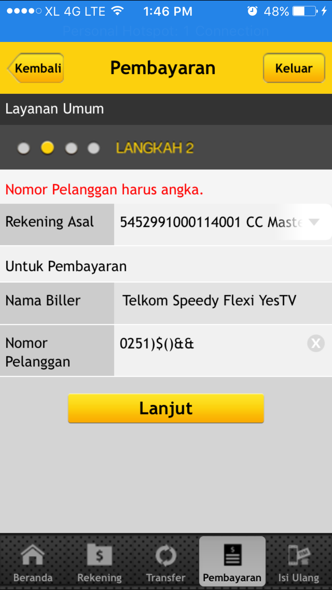
Reviewed By: (PMO)
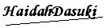 |  | Name/Position : Norhaidah Binti Md Dasuki / Senior Manager, Quality Assurance and Support  Date : 1/11/2016

