Test Issue Log |  |  |  |  |  | SCP ID# : UAT_Tak_010
Project Name: | AGROBANK BUSINESS INTERNET BANKING
Test Stage: | Unit Functionality Integration System Interface  Performance Regression Acceptance Pilot
Test Case Number: | Support #6765 |  |  | Test Started Date: |  |  | 08/10/2016
Test Title: | [UAT_Tak_010] – Changes on Certificate
Test Description: | To ensure certificate displays as requirement needs  https://10.6.6.20/ibam.sit.takaful/common/Login.do
Test Functionality: | BIB  - Role – Initiator/Single User  Takaful > Takaful Purchase > Purchase Takaful Kasih
Test Procedure: | BIB – Initiator/Single User  - Login as Initiator and perform Purchase Takaful Kasih.  - View Result Page  - Download Certificate (For Initiator: After Approver approve the transaction).  - Takaful Kasih change to Takaful Kasih Plus  - Period of cover change to (example from 11/4/16 to 10/4/17)  - Plan/Occupation Class change to delete “occupation class” and change “type of plan”  - Accidental Death & Permanent Disablement change to Accidental Death/ Permanent Disablement  - Daily hospital income (Per day and up to maximum 30 days )-RM10.60 change to RM10.00  BIB - Approver  - Login as Approver and approve the transaction.
Test Result: | Pass: Fail: | Tested by: |  |  | Nurul Akmal binti Yusof
Reason for Failure:
TEST DESCRIPTION

Role: single user

Confirm Page
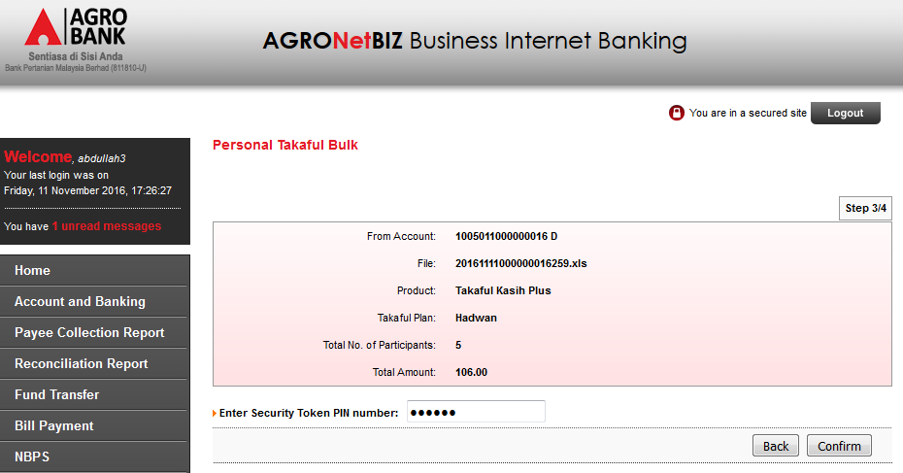

Result Page
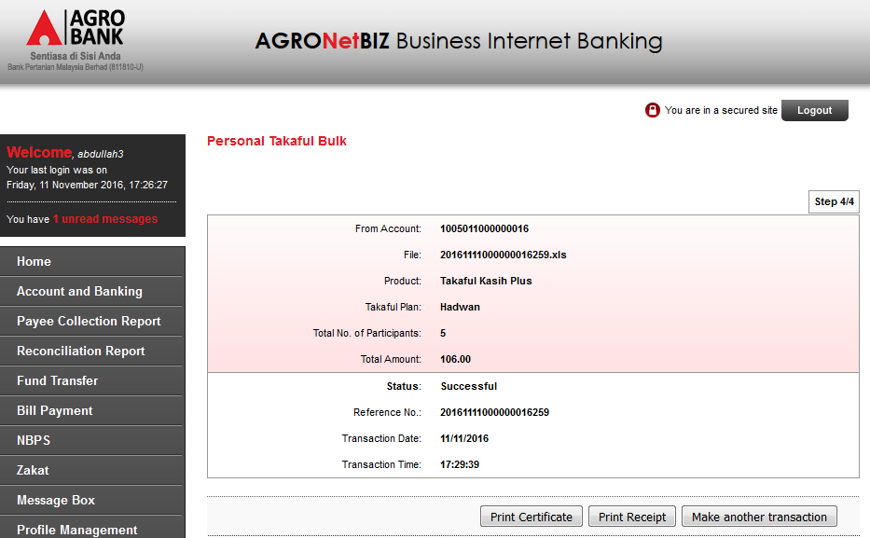

Print Receipt
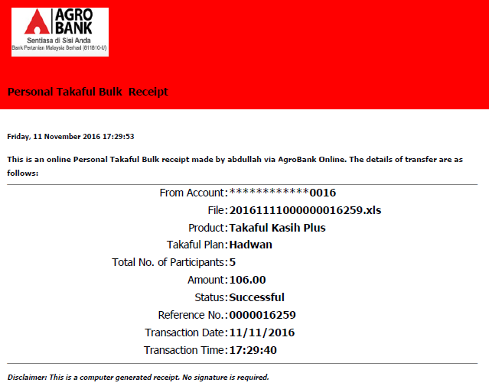

Print Certificate
View below items:
  - Takaful Kasih change to Takaful Kasih Plus
  - Period of cover change to (example from 11/4/16 to 10/4/17)
  - Plan/Occupation Class change to delete “occupation class” and change “type of plan”
  - Accidental Death & Permanent Disablement change to Accidental Death/ Permanent Disablement
  - Daily hospital income (Per day and up to maximum 30 days )-RM10.60 change to RM10.00
  - "ButirPerlindungan" to "Butir Perlindungan"
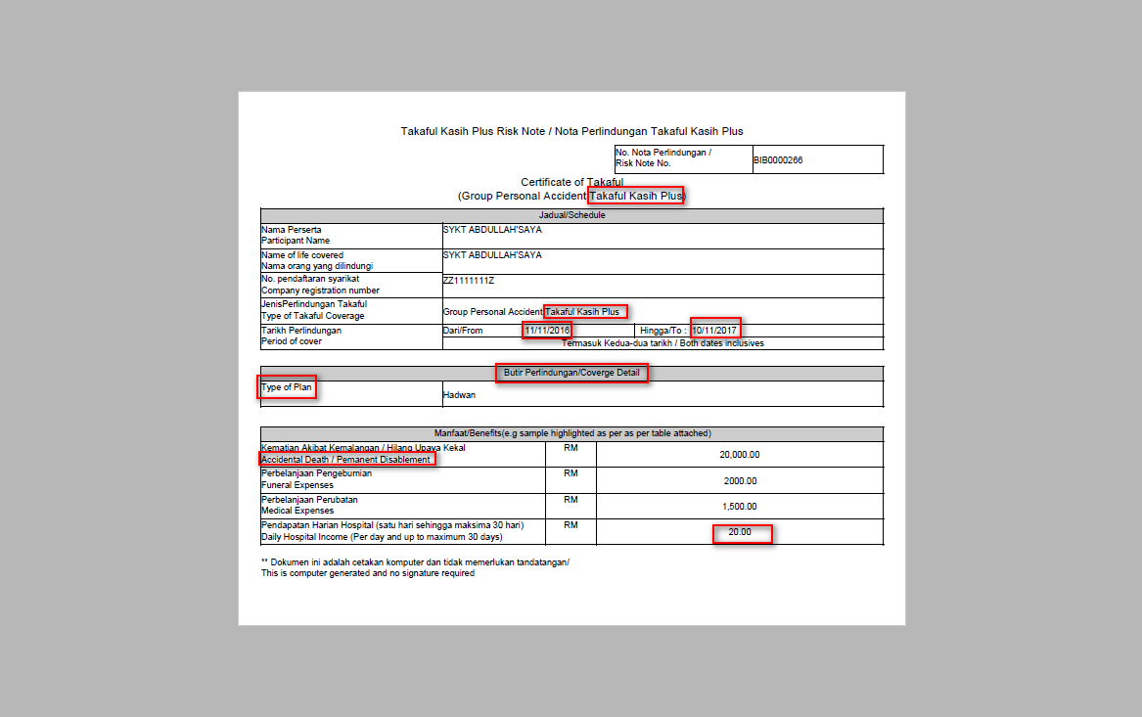

Role: Initiator

Confirm Page
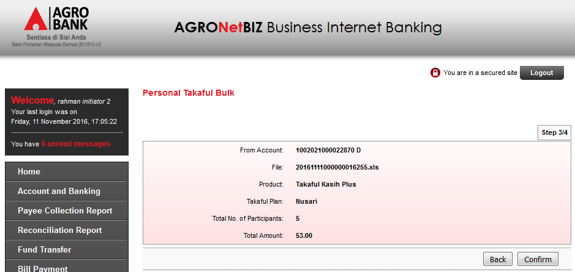

Result Page
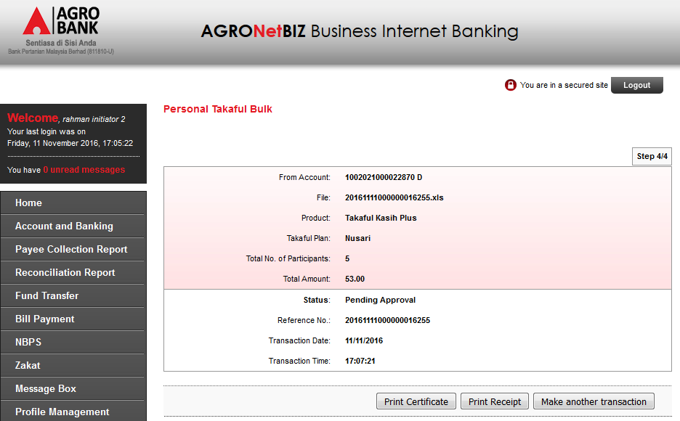

Print Receipt
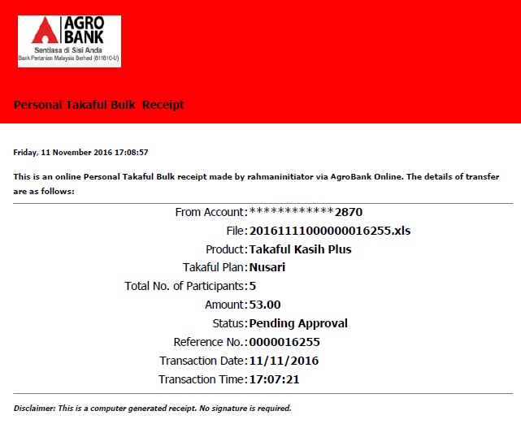

Role: Approver

Confirm Page
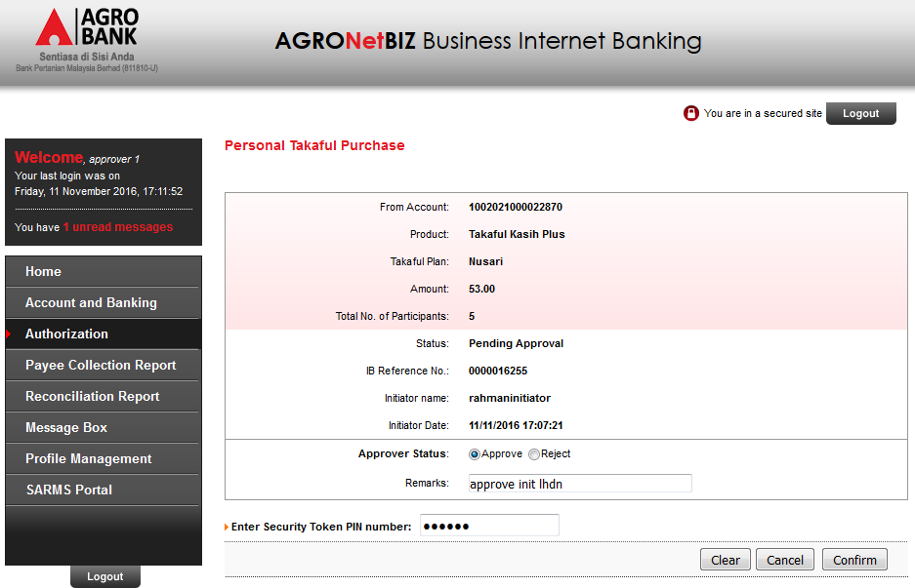

Result Page
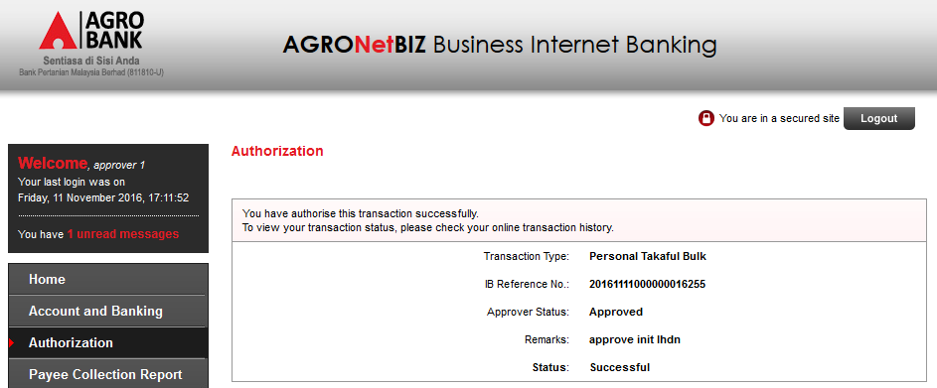

Role: Initiator

Print Certificate
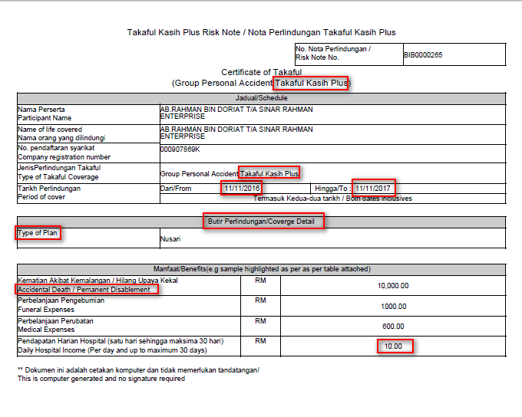
View below items:
- Takaful Kasih change to Takaful Kasih Plus
- Period of cover change to (example from 11/4/16 to 10/4/17)
- Plan/Occupation Class change to delete “occupation class” and change “type of plan”
- Accidental Death & Permanent Disablement change to Accidental Death/ Permanent Disablement
- Daily hospital income (Per day and up to maximum 30 days )-RM10.60 change to RM10.00
- "ButirPerlindungan" to "Butir Perlindungan"
Reviewed By: (PMO)
 |  |  | Name/Position : Norhaidah Binti Md Dasuki / Senior Manager, Quality Assurance and Support  Date : 08/11/2016

