First time login

UserName is not text input

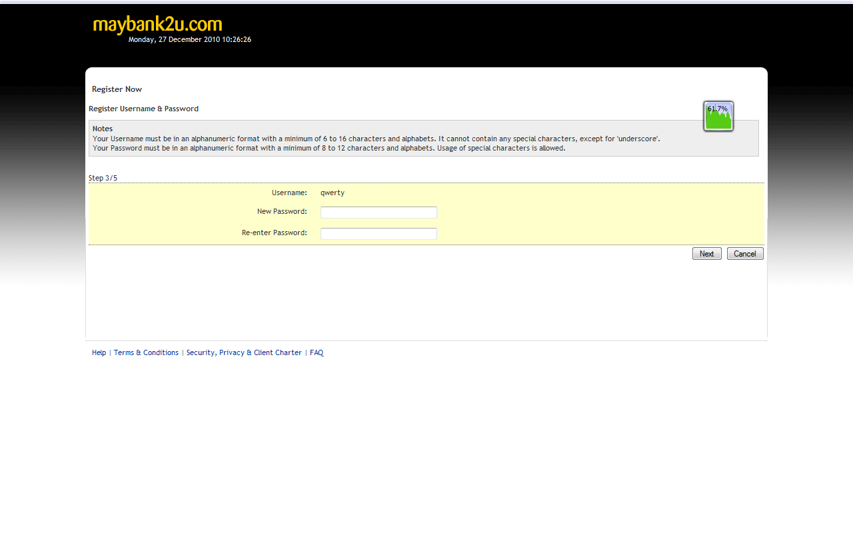

Get this error after click next (Enter password & re-enter password)

