Test Issue Log |  |  |  |  |  | SCP ID# : 6774
Project Name: | AGROBANK BUSINESS INTERNET BANKING
Test Stage: | Unit Functionality Integration System Interface  Performance Regression Acceptance Pilot
Test Case Number: |  |  |  | Test Started Date: |  |  | 16/11/2016
Test Title: | [Internal Testing] UAT_SB_LHDN_013
Test Description: | - To ensure BIB Report display on current system meets the requirement needs.
Test Functionality: | - BIB Statutory Body LHDN Report Daily  -PDF  -EXCEL
Test Procedure: | - BIB Statutory Body LHDN Report Daily  - Perform Successful and Unsuccessful transaction for both Single User and Multiple User.  - Login as Administrator and go to BIB Report to download the report.
Test Result: | Pass: Fail: | Tested by: |  |  | Erni Suhaireen binti Zulkifli
Reason for Failure:
TEST DESCRIPTION
BIB Statutory Body LHDN Report Daily
- Check whether these successful transactions were recorded on BIB Report IBAM.
  - Single User
    - View LHDN Transfer History
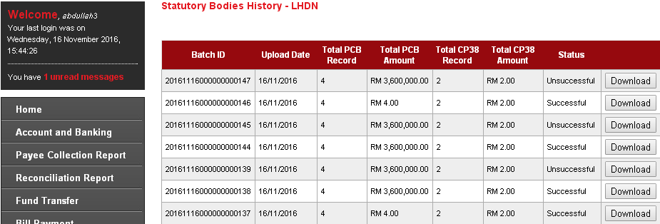
    - View AgronetBiz Transaction History
Account 1002021000002362
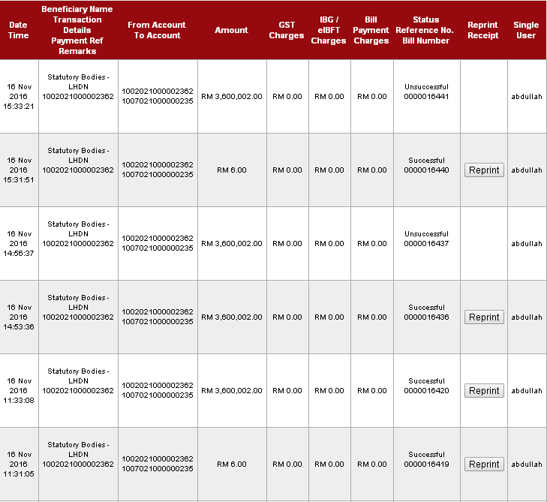
Account 1005011000000016
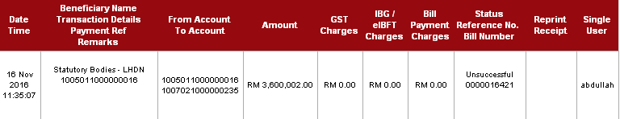
Total Successful transaction: 4
Total Unsuccessful transaction: 3

  - Multiple User
    - View LHDN Transfer History
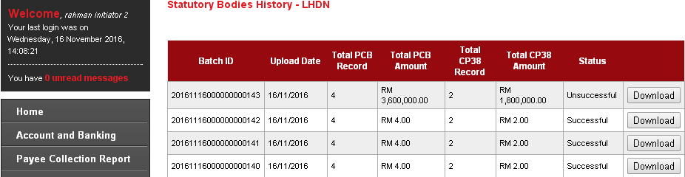
    - View AgronetBiz Transaction History
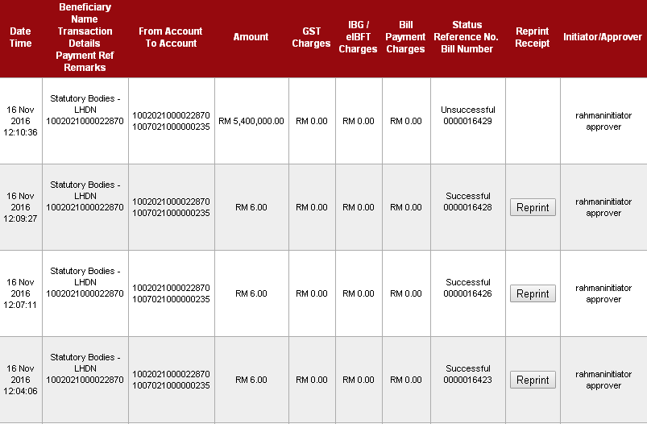
Total Successful transaction: 3
Total Unsuccessful transaction: 1

PDF Format
- On BIB Report page, Choose BIB Statutory Bodies LHDN Report Daily on Report Type, PDF on File Type, November on Month and 2016 on Year. Then click on “Search” button.
- Click on “Save” button of the selected report.
- Report should display 7 Successful Transaction (4:Single User, 3: Multiple User) and 4 Unsuccessful Transaction (3: Single User, 1: Multiple User)
Result:
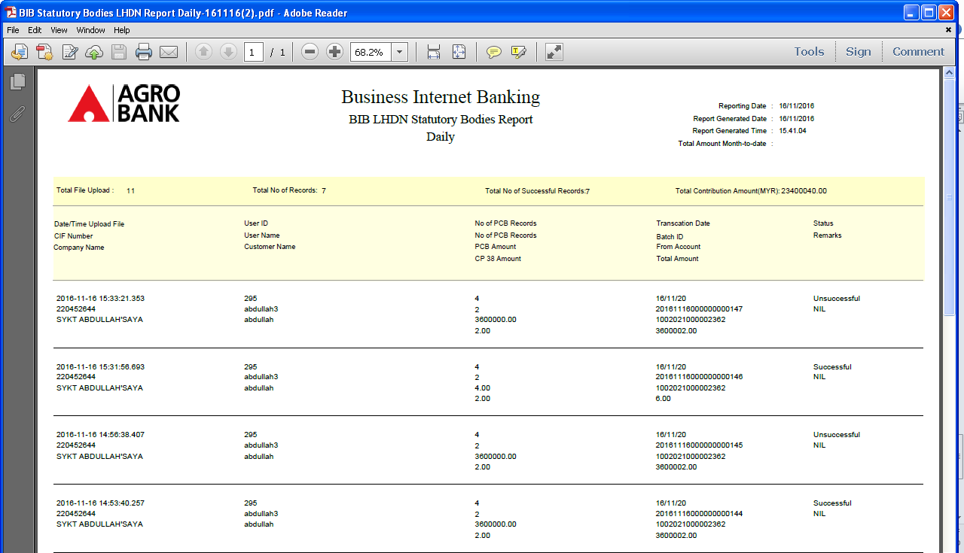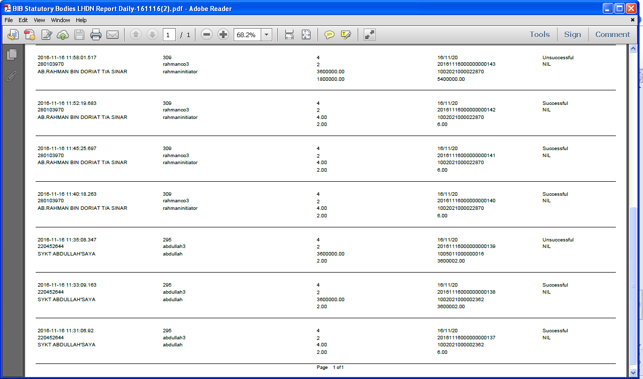

EXCEL Format
- On BIB Report page, Choose BIB Statutory Bodies LHDN Report Daily on Report Type, Excel on File Type, November on Month and 2016 on Year. Then click on “Search” button.
- Click on “Save” button of the selected report.
- Report should display 7 Successful Transaction (4:Single User, 3: Multiple User) and 4 Unsuccessful Transaction (3: Single User, 1: Multiple User)
Result:
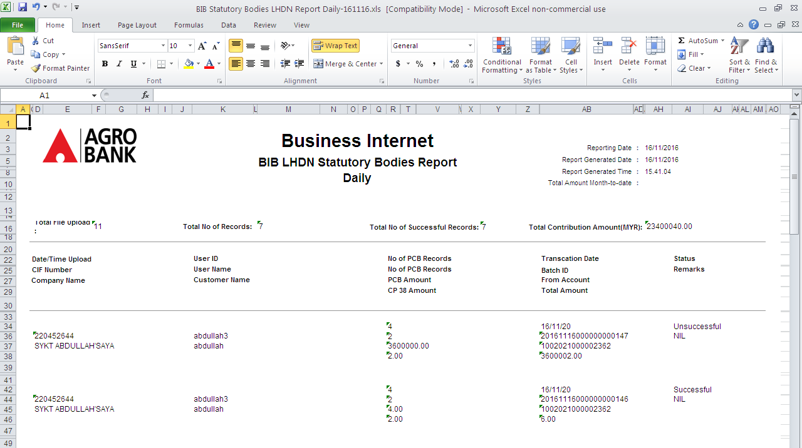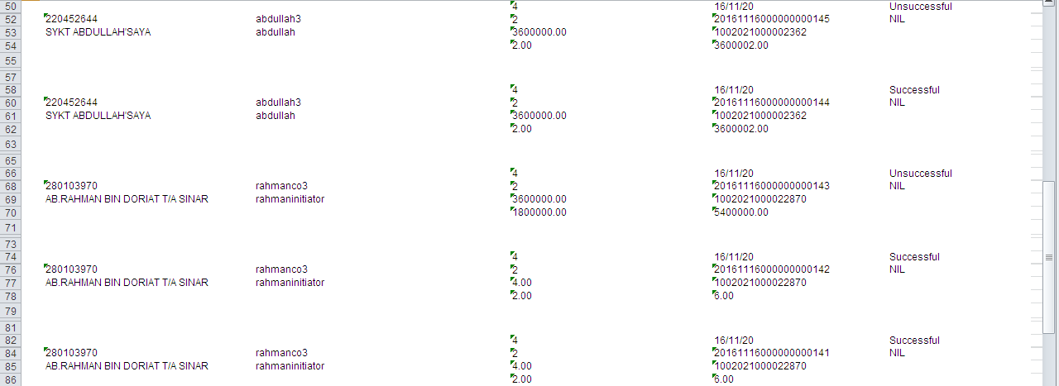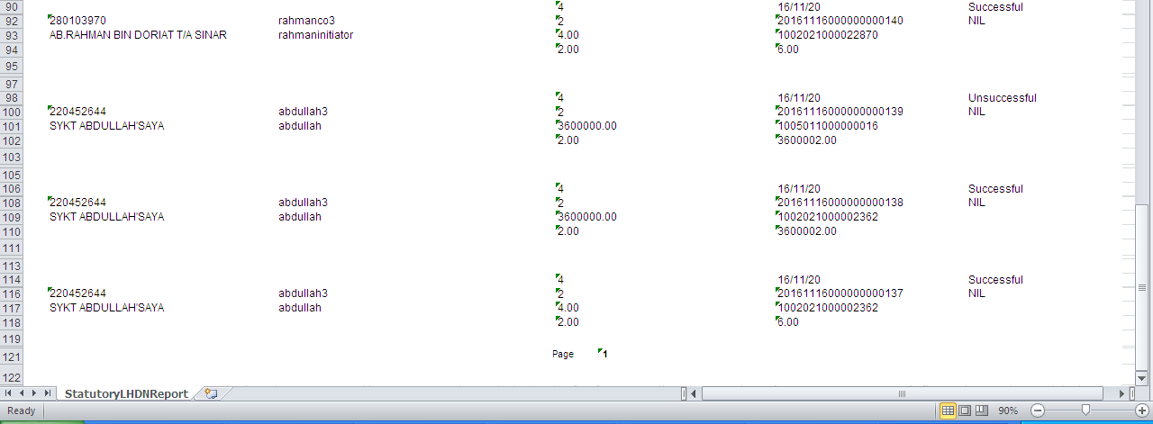
Reviewed By: (PMO)
Name/Position :
Date :

