Test Issue Log |  |  |  |  |  | SCP ID# : UAT_SB_SOCSO-005
Project Name: | AGROBANK BUSINESS INTERNET BANKING
Test Stage: | Unit Functionality Integration System Interface  Performance Regression Acceptance Pilot
Test Case Number: | Support #6704 |  |  | Test Started Date: |  |  | 16/11/2016
Test Title: | [UAT_SB_SOCSO-005] : Add new validation rule on SOCSO File
Test Description: | To ensure SOCSO file follow the new validation rules.
Test Functionality: | Initiator  Single User
Test Procedure: | BIB  - Employer Code – Upload SOCSO file with Employer Code different from the Employer code registered in IBAM  - Contribution Month – Upload SOCSO file with Contribution Month set to number greater than 12 or greater than current month.  - Contribution Year – Upload SOCSO file with Contribution Year set to greater than current year.  - Contribution Amount - Upload SOSCO file with Contribution Amount is not numeric.  - Payment Date – Upload SOCSO file with advance Contribution Month or/and Contribution Year  - IC Number – Upload SOCSO file contains same IC number.
Test Result: | Pass: Fail: | Tested by: |  |  | Nurul Akmal binti Yusof
Reason for Failure:
TEST DESCRIPTION
- Test Item No 1: Employer Code – Upload SOCSO file with Employer Code different from the Employer code registered in IBAM

Single user
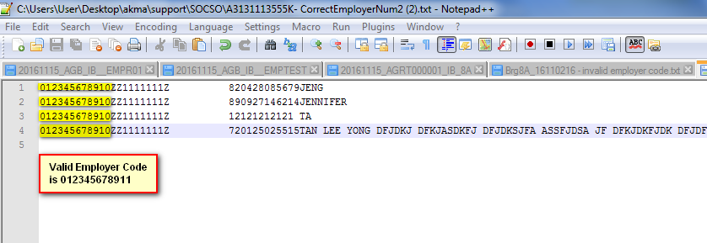
Error Message
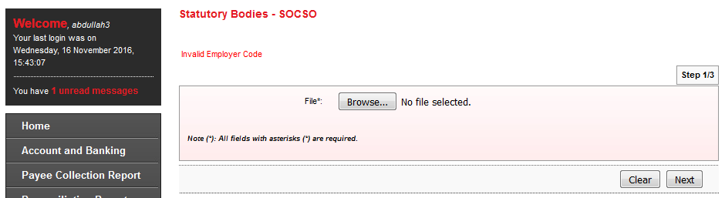

Initiator
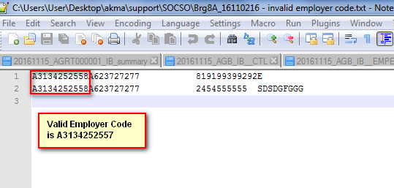

Error Message
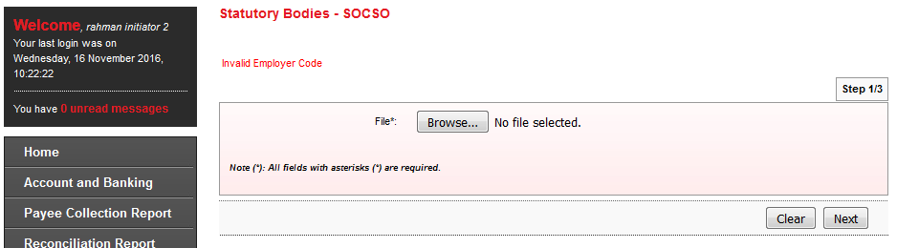
- Test Item No 2: Contribution Month – Upload SOCSO file with Contribution Month set to number greater than 12 or greater than current month.

Single User
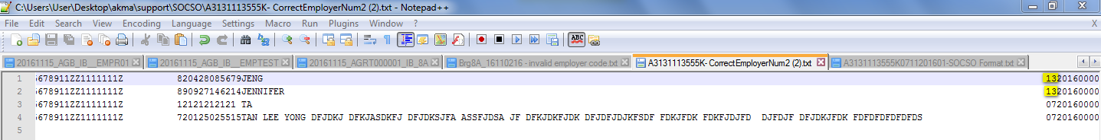

Error Message
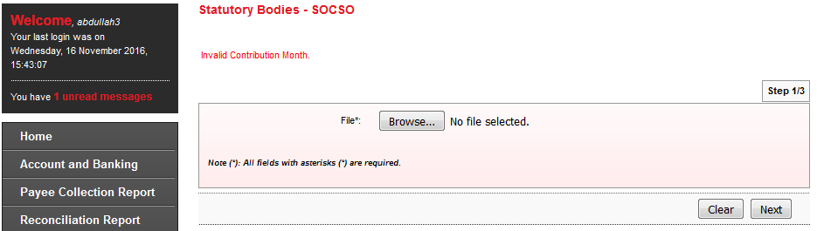

Initiator
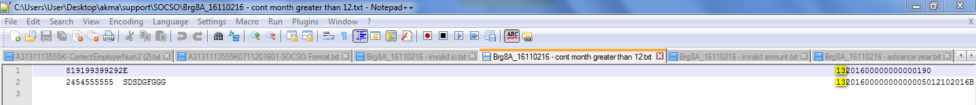
Error Message
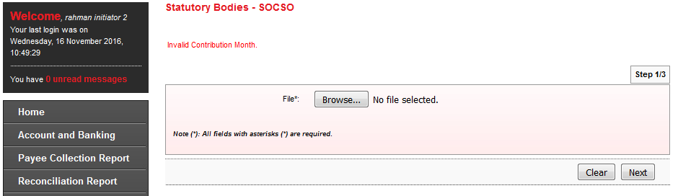

- Test Item No 3: Contribution Year – Upload SOCSO file with Contribution Year set to greater than current year.

Single User
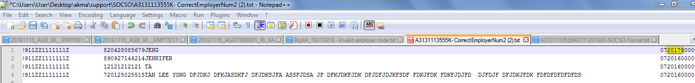
Error Message
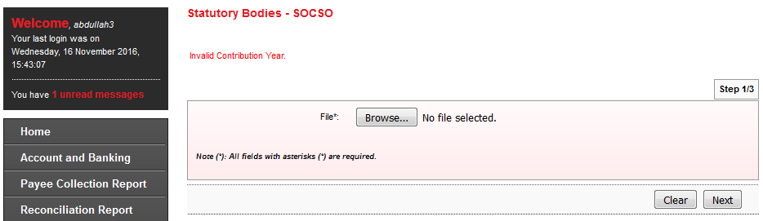

Initiator
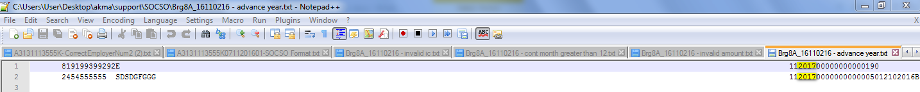
Error Message
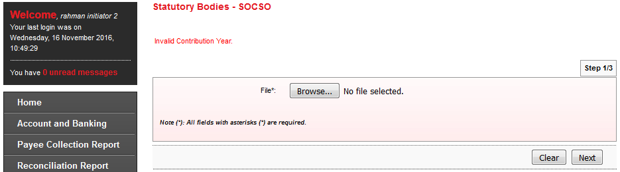

- Test Item No 4: Contribution Amount - Upload SOSCO file with Contribution Amount is not numeric.

Single User
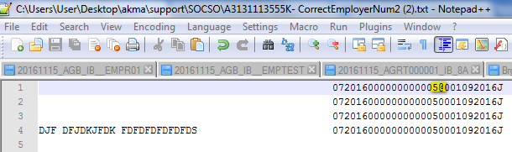
Error Message
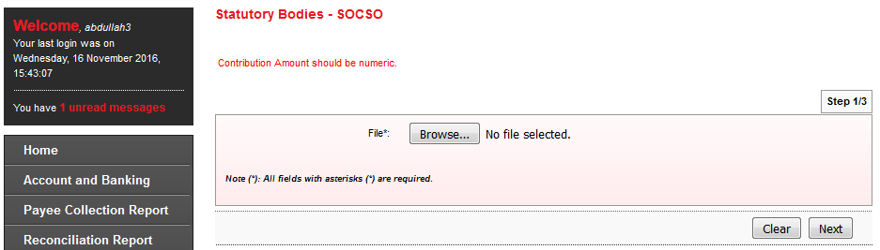

Initiator
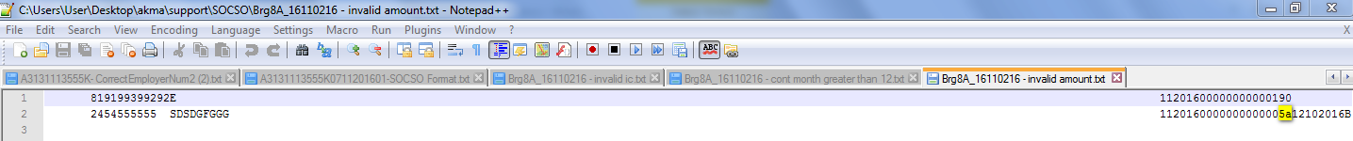
Error Message
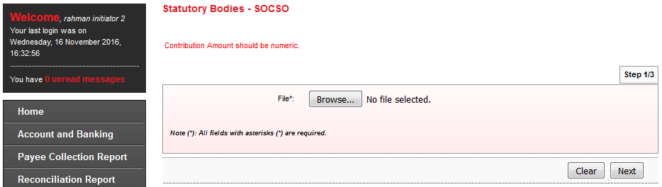

- Test Item No 5: Payment Date – Upload SOCSO file with advance Contribution Month or/and Contribution Year
Single User
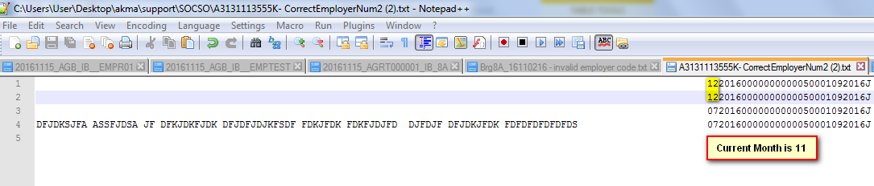
Error Message
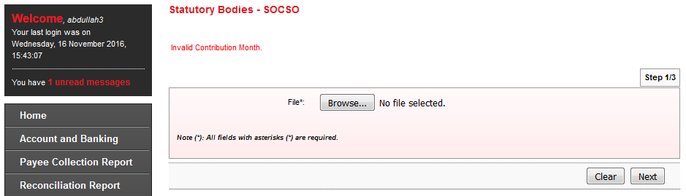

Initiator
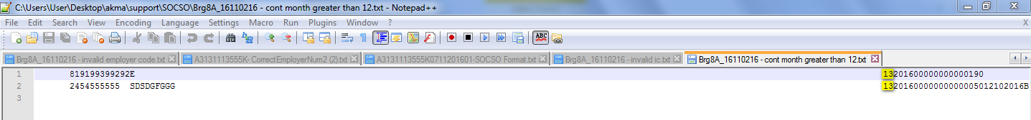
Error Message
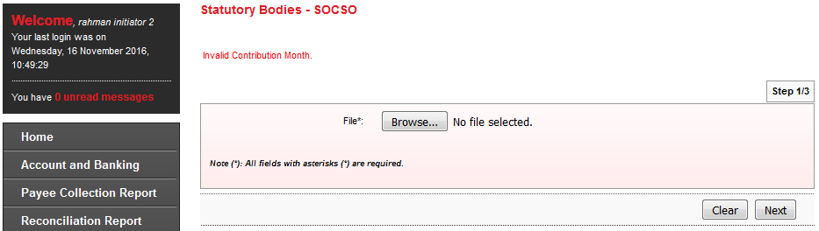

- Test Item No 6: IC Number – Upload SOCSO file contains same IC number.
Single User
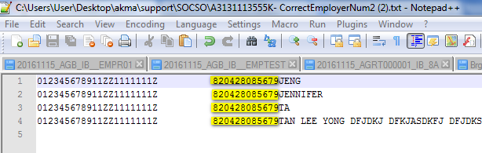
Error Message
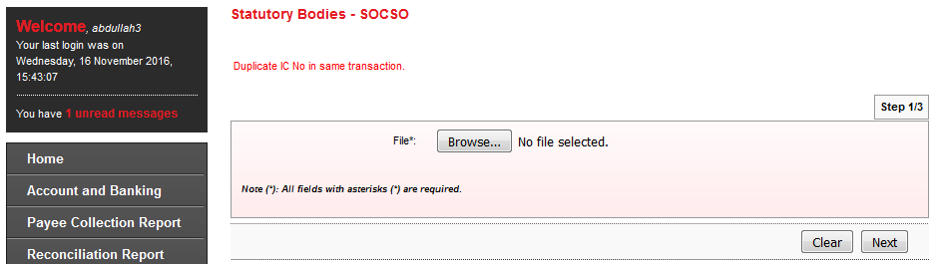

Initiator
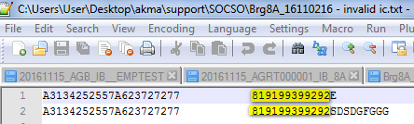
Error Message
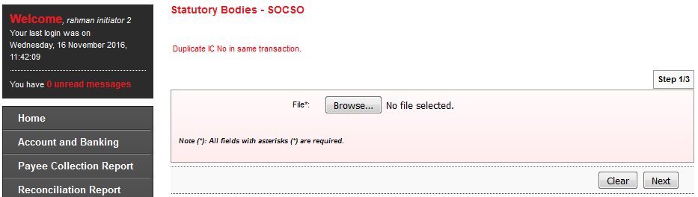
Reviewed By: (PMO)
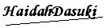 |  |  | Name/Position : Norhaidah Binti Md Dasuki / Senior Manager, Quality Assurance and Support  Date : 16/11/2016

