1.BSR :

1. Transfer date of file – should be T+1 (Refer Specification)

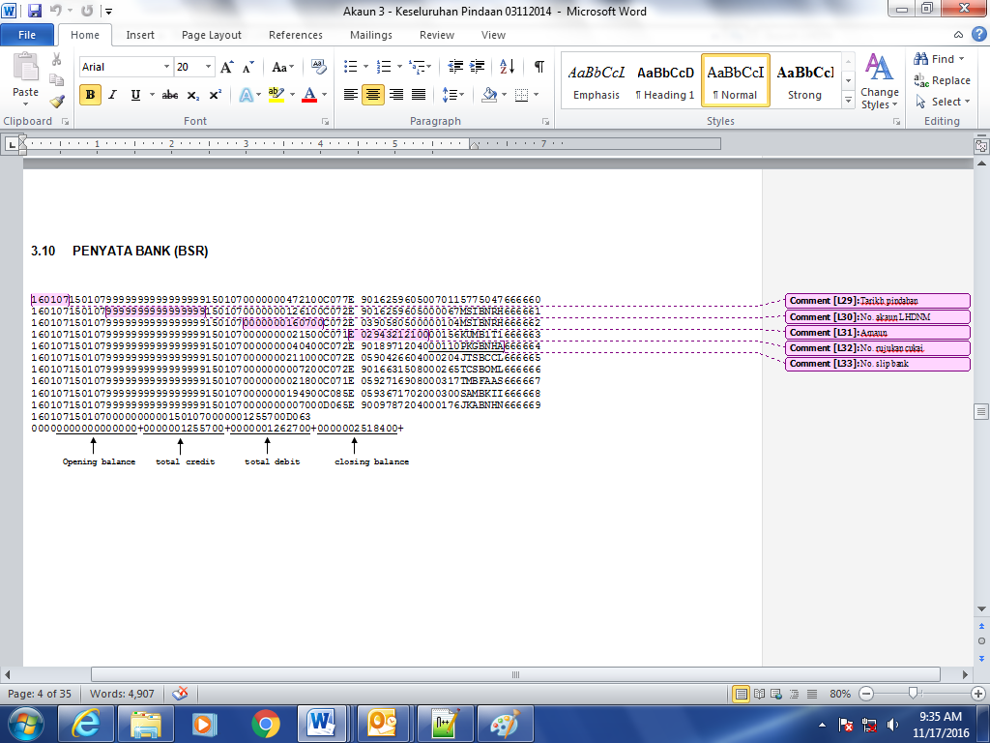

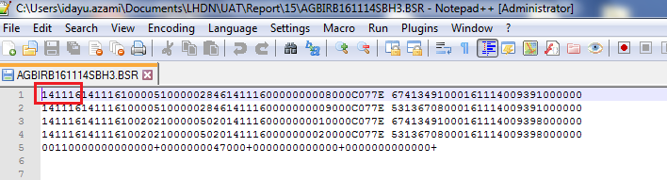

2. Field Name : Bank Account No. – consist of other LHDN A/C No. One report cater for one LHDN A/C No.

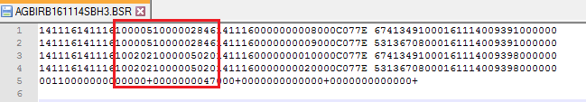

3. The amount is Total Amount of PCB & CP38

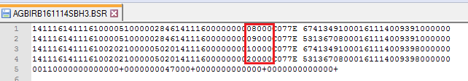

4. The pay-in slip no must be unique for each transaction. It also reflect at OPM, PPM

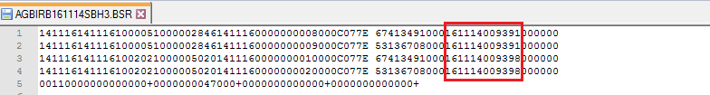

2. OPM

Specification :

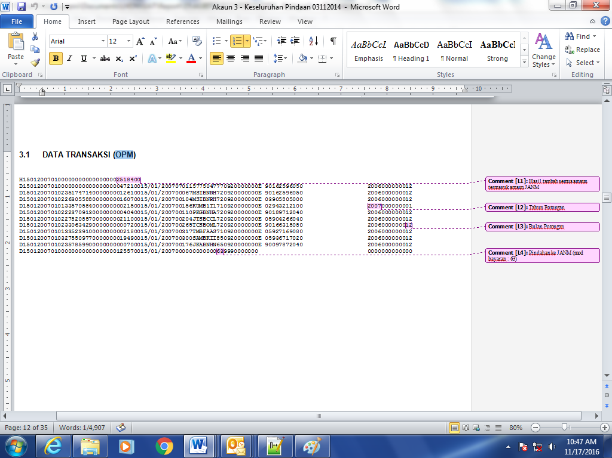

1. Field Batch Number and BBMC_batch_number should be same.

2. The serial number not running : Refer specification below :

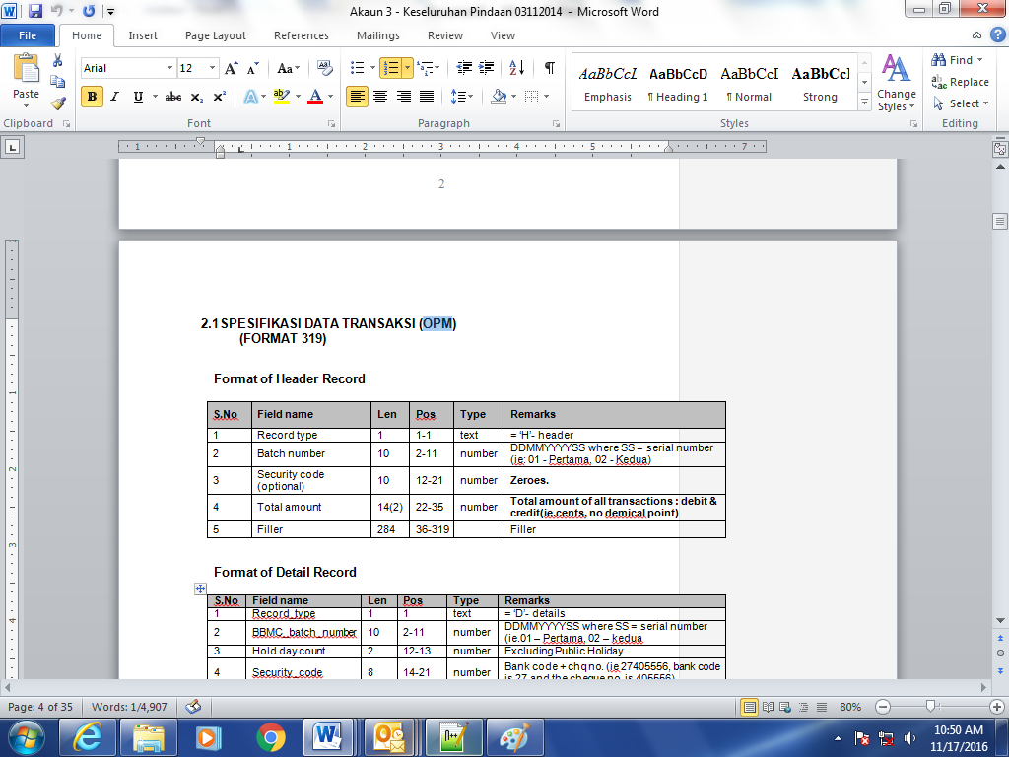

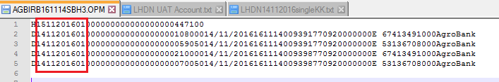

3. Where is the last line which referring to Pindahan ke JANM

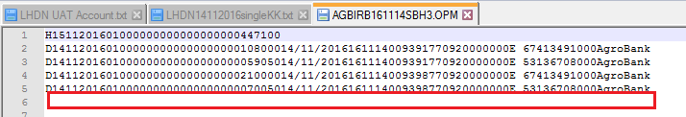

3. ONR :

1. The transaction amount is total amount of PCB and CP38

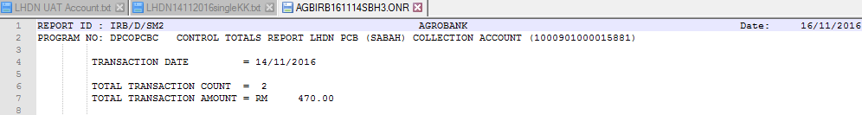

4. OSR

1. OPM shows 4 transactions. The details not match

