Bugs found in Banker’s Cheque

1. Insert Alphanumeric in Amount field.

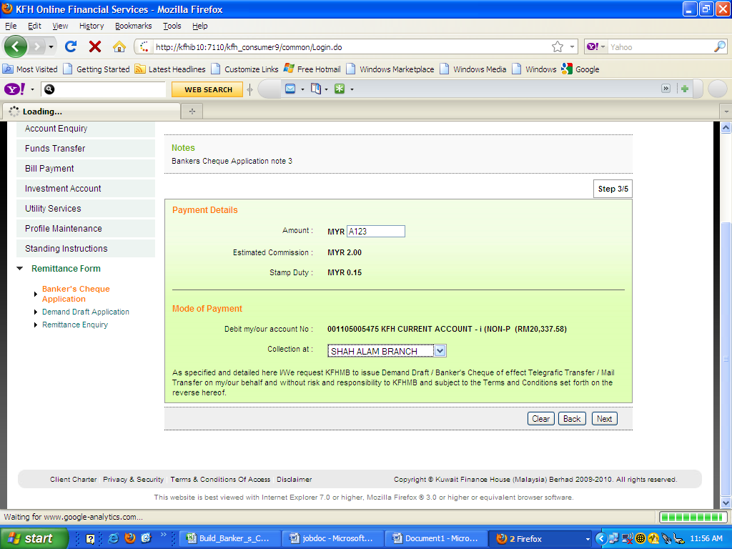

1. Failed to Confirmation Page.

