Test Issue Log |  |  |  |  |  | SCP ID# : 6774
Project Name: | AGROBANK BUSINESS INTERNET BANKING
Test Stage: | Unit Functionality Integration System Interface  Performance Regression Acceptance Pilot
Test Case Number: |  |  |  | Test Started Date: |  |  | 17/11/2016
Test Title: | [Internal Testing] UAT_SB_LHDN_013
Test Description: | - To ensure BIB Report display on current system meets the requirement needs.
Test Functionality: | - BIB Statutory Body LHDN Report Daily  -PDF  -EXCEL
Test Procedure: | - BIB Statutory Body LHDN Report Daily  - Perform Successful and Unsuccessful transaction for both Single User and Multiple User.  - Login as Administrator and go to BIB Report to download the report.
Test Result: | Pass: Fail: | Tested by: |  |  | Erni Suhaireen binti Zulkifli
Reason for Failure: | - PDF Format  - Total No. of Record on Header should display the total record of No. of PCB Record and No. of CP38 Record for all the transaction status. Current result display Total No. of Report: 5. Expected result is to display Total No. of Report: 36.  - Total No. of Successful Record on Header should display the total record of No. of PCB Record and No. of CP38 Record for successful transaction only. Current result display Total No. of Successful Record: 3. Expected result is to display Total No. of Report: 18.  - EXCEL Format  - Total Contribution Amount should display the total amount of successful transaction. Current result display no value on Total Contribution Amount.  - Total No. of Record on Header should display the total record of No. of PCB Record and No. of CP38 Record for all the transaction status. Current result display Total No. of Report: 5. Expected result is to display Total No. of Report: 36.  - Total No. of Successful Record on Header should display the total record of No. of PCB Record and No. of CP38 Record for successful transaction only. Current result display Total No. of Successful Record: 3. Expected result is to display Total No. of Report: 18.  - Date/Time Upload File should display as [2016-11-17 12:54:46.257].Current result display no value on this field.
TEST DESCRIPTION
BIB Statutory Body LHDN Report Daily
- Check whether these successful transactions were recorded on BIB Report IBAM.
  - Single User
    - View LHDN Transfer History
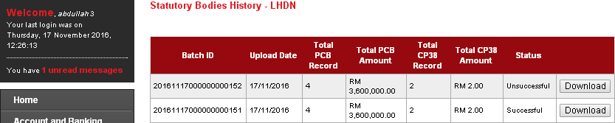
    - View AgronetBiz Transaction History
Account 1002021000002362
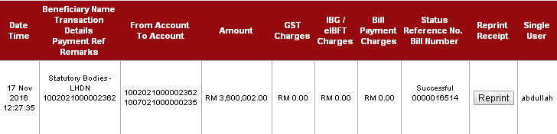
Account 1005011000000016
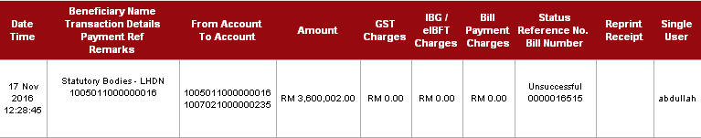
Total Successful transaction: 1
Total Unsuccessful transaction: 1

  - Multiple User
    - View LHDN Transfer History
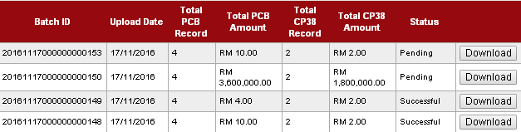
    - View AgronetBiz Transaction History
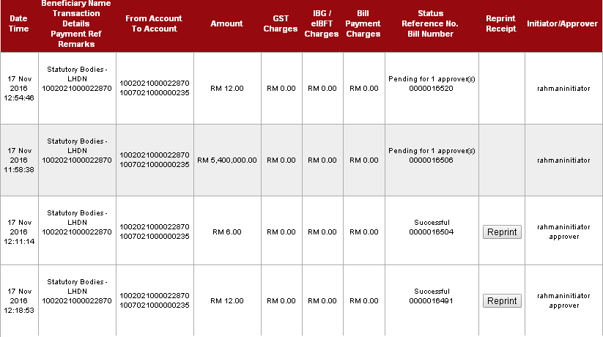
Total Successful transaction: 2
Total Pending Approval transaction: 2

PDF Format
- On BIB Report page, Choose BIB Statutory Bodies LHDN Report Daily on Report Type, PDF on File Type, November on Month and 2016 on Year. Then click on “Search” button.
- Click on “Save” button of the selected report.
- Report should display 3 Successful Transaction (1:Single User, 2: Multiple User) and 1 Unsuccessful Transaction (1: Single User)
- The expected result should be:
  - Total contribution Amount : RM3,600,020.00
  - Total File Upload : 6
  - Total No. of Record : 36
  - Total No. of Successful Records: 3
Result:
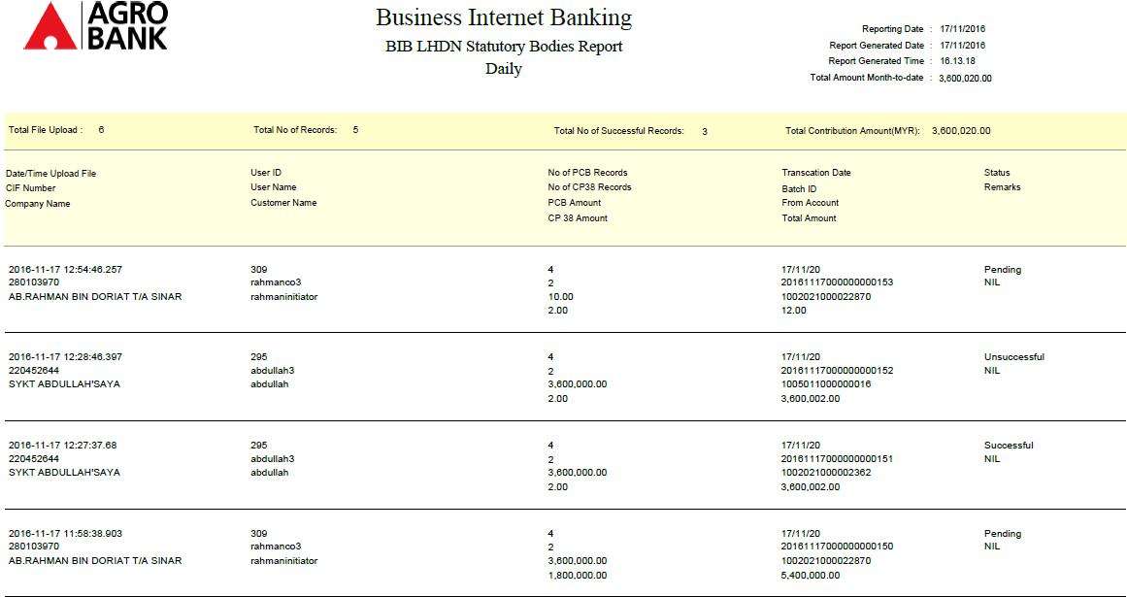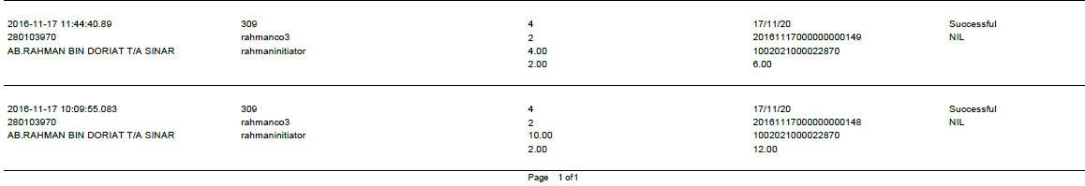

Bug Found:
    - Total No. of Record on Header should display the total record of No. of PCB Record and No. of CP38 Record for all the transaction status. Current result display Total No. of Report: 5. Expected result is to display Total No. of Report: 36.
    - Total No. of Successful Record on Header should display the total record of No. of PCB Record and No. of CP38 Record for successful transaction only. Current result display Total No. of Successful Record: 3. Expected result is to display Total No. of Report: 18.
EXCEL Format
- On BIB Report page, Choose BIB Statutory Bodies LHDN Report Daily on Report Type, PDF on File Type, November on Month and 2016 on Year. Then click on “Search” button.
- Click on “Save” button of the selected report.
- Report should display 3 Successful Transaction (1:Single User, 2: Multiple User) and 1 Unsuccessful Transaction (1: Single User)
- The expected result should be:
  - Total contribution Amount : RM3,600,020.00
  - Total File Upload : 6
  - Total No. of Record : 36
  - Total No. of Successful Records: 3
Result:
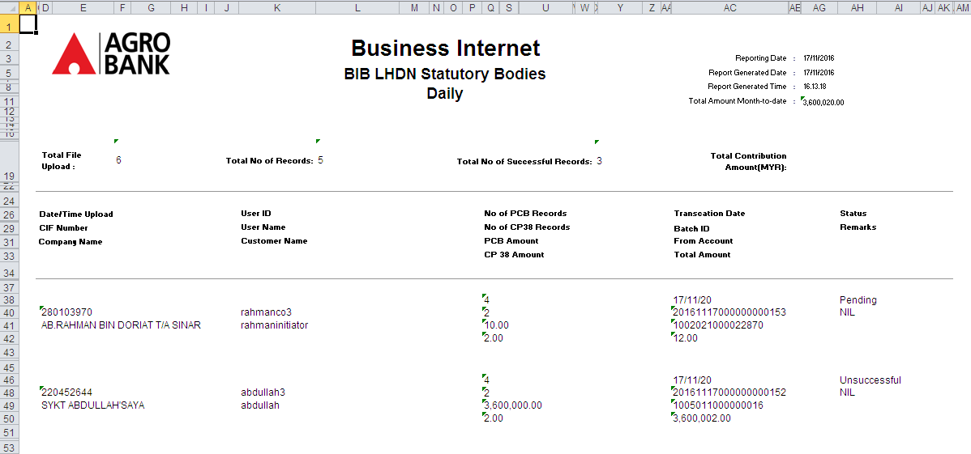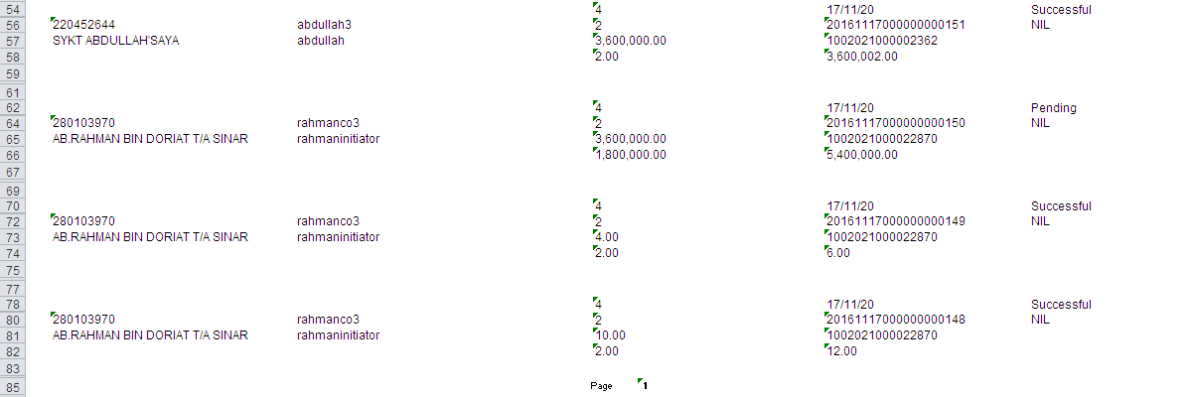
Bug Found:
    - Total Contribution Amount should display the total amount of successful transaction. Current result display no value on Total Contribution Amount.
    - Total No. of Record on Header should display the total record of No. of PCB Record and No. of CP38 Record for all the transaction status. Current result display Total No. of Report: 5. Expected result is to display Total No. of Report: 36.
    - Total No. of Successful Record on Header should display the total record of No. of PCB Record and No. of CP38 Record for successful transaction only. Current result display Total No. of Successful Record: 3. Expected result is to display Total No. of Report: 18.
    - Date/Time Upload File should display as [2016-11-17 12:54:46.257].Current result display no value on this field.
Reviewed By: (PMO)
Name/Position :
Date :

