1. Data Bayaran Majikan (EMPR01.txt)

1. Total Employer Record : 1

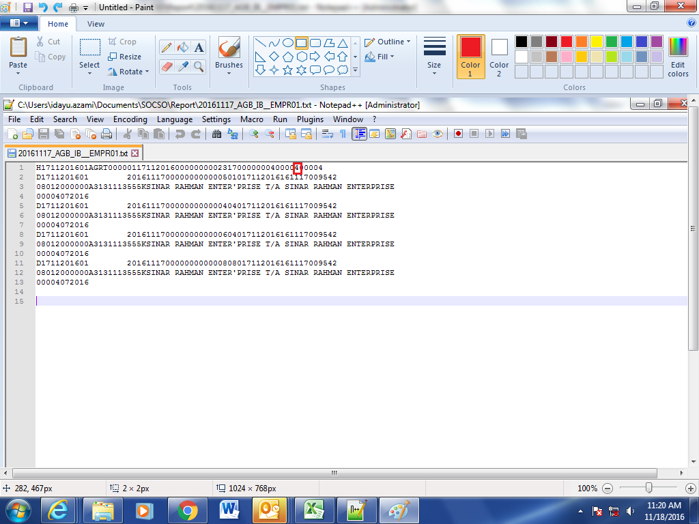

2. Data Pekerja (EMPE01.txt)

1. Total Employer - 1

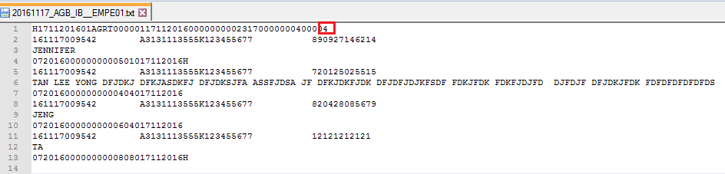

2. Pay in slip no – Unique Number

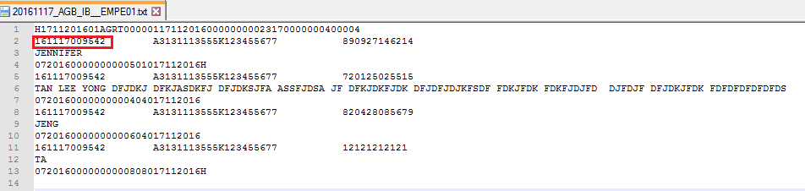

3. Employment date : A date customer keyed in at SOCSO application:

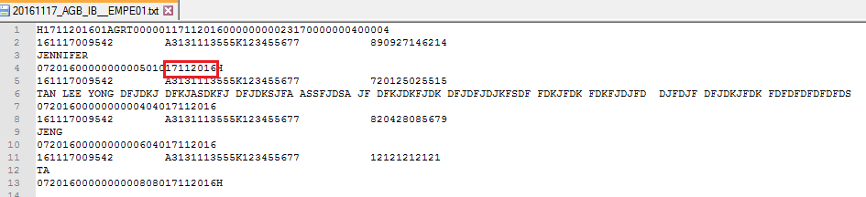

Socso application :

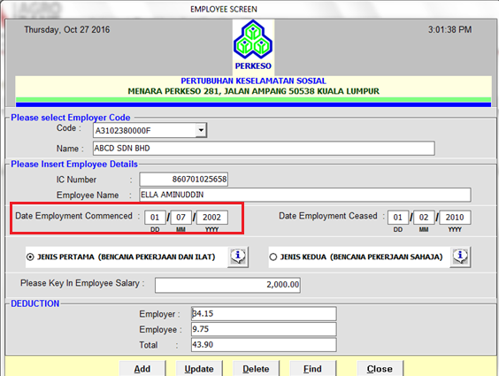

3. Statement Bank (BSC)

1. PERKESO Account Number : 1007021000049571

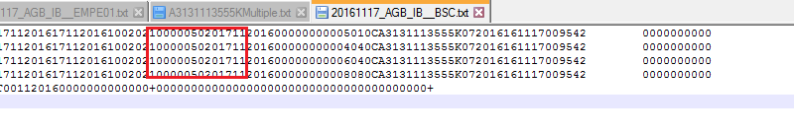

2. Pay in slip no must unique

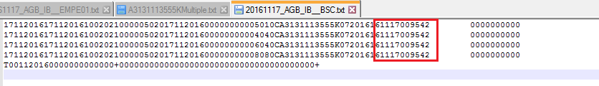

3. No total Credit and Debit

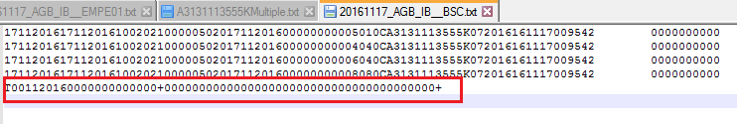

4. Testing File (EMPETEST.txt)

1. Total Employer - 1

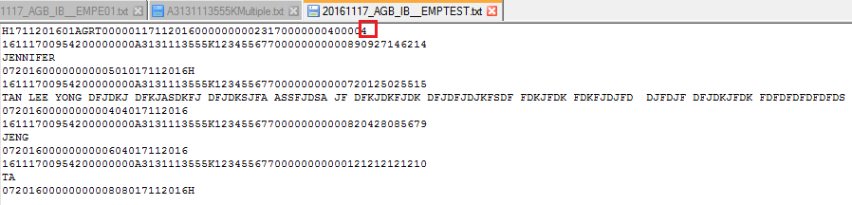

2. Pay in Slip No - unique

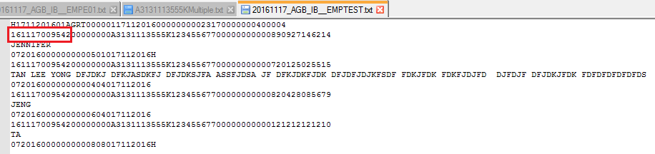

5. Laporan Mod Bayaran

1. Transaction Type : Should E-Banking?

2. Perkeso Payment Mode : Should 08

3. Amount Collected : Total transaction amount 17/11/2016 is **231.70**

