Test Issue Log |  |  |  |  |  | SCP ID# : 3474
Project Name: | Retail Internet Banking
Test Stage: | Unit Functionality Integration System Interface  Performance Regression Acceptance Pilot
Test Case Number: | Support #6795 |  |  | Test Started Date: |  | 18/11/2016
Test Title: | BIB 3rd Party Transaction session expired
Test Description: | To ensure that both Single User & Multiple User able to perform New/Registered 3rd Party Transfer.
Test Functionality: | BIB>Fund Transfer>New/Favorite 3rd Party Account Transfer.
Test Procedure: | Fund Transfer  - Login to Single User/Multiple User.  - Perform
Test Result: | Pass: Fail: | Tested by: |  |  | Nurul Akmal binti Yusof
Reason for Failure:
TEST DESCRIPTION

New 3rd Party Transfer

Single User

Confirm Page
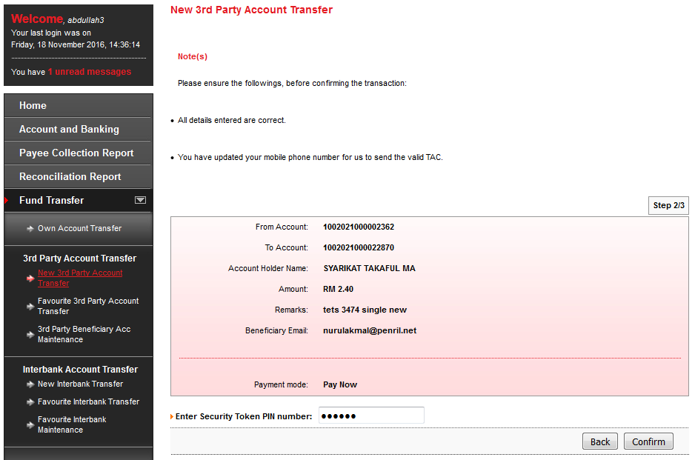

Result Page
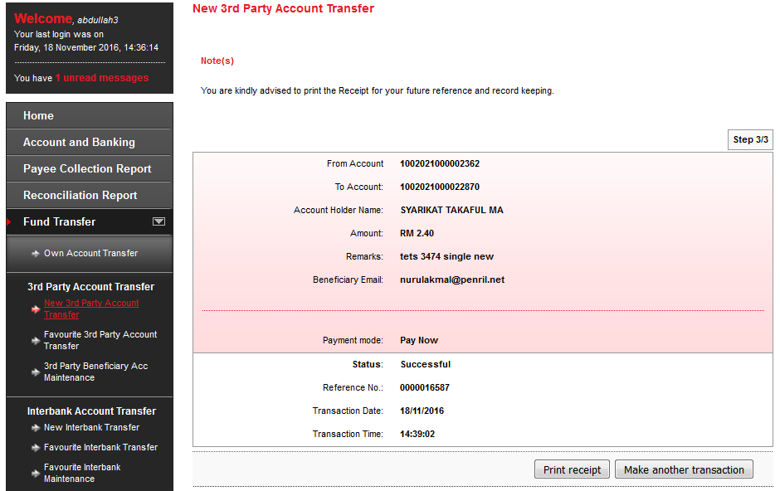

Print Receipt
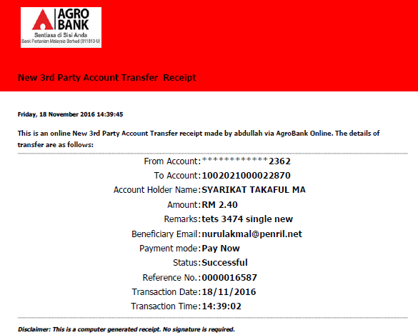

Transaction History
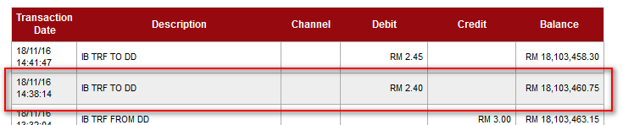

Agronet Transaction History
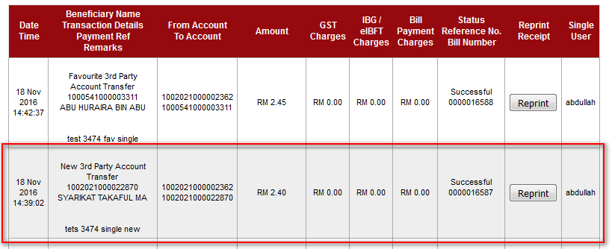

Initiator

Confirm Page
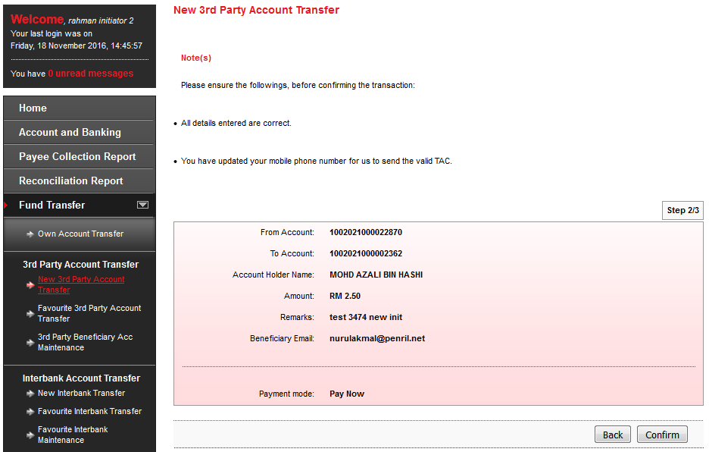

Result Page
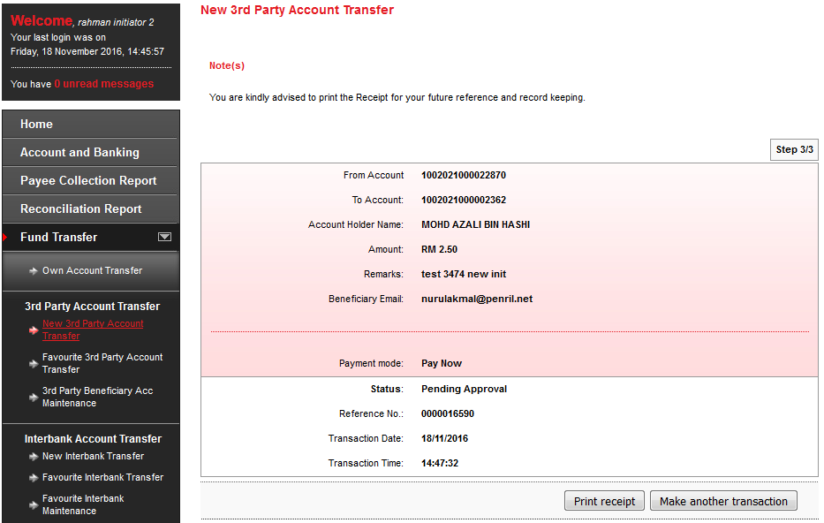

Print Receipt
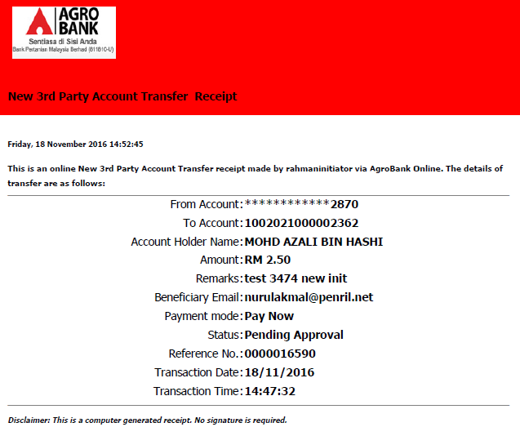

Approver

Confirm Page
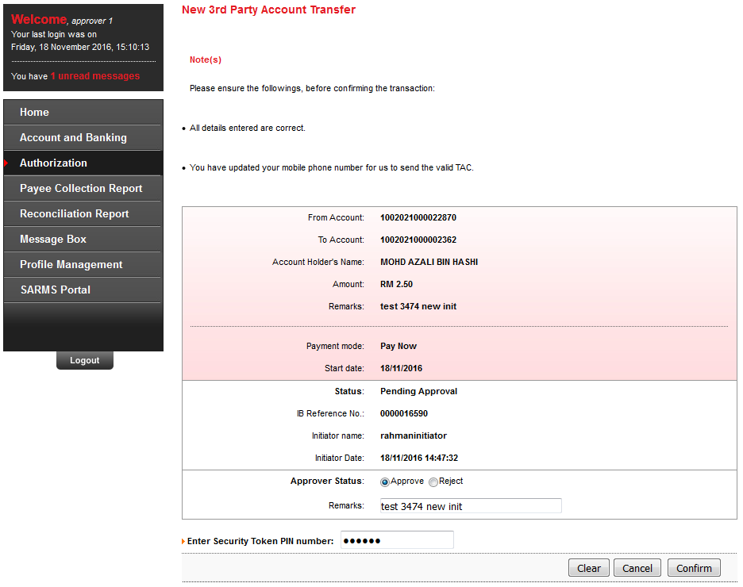

Result Page
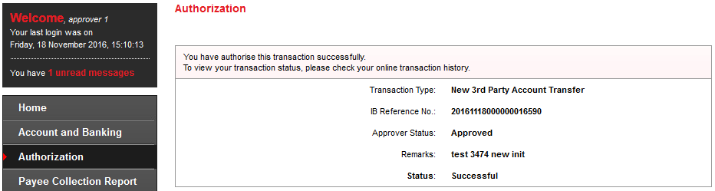

Transaction History
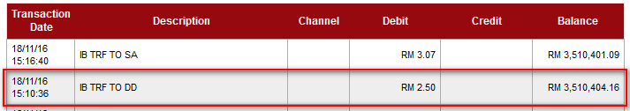

Agronet Transaction History
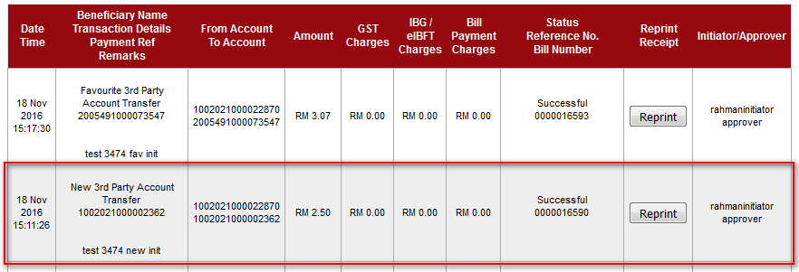

Fav 3rd Party Transfer

Single User

Confirm Page
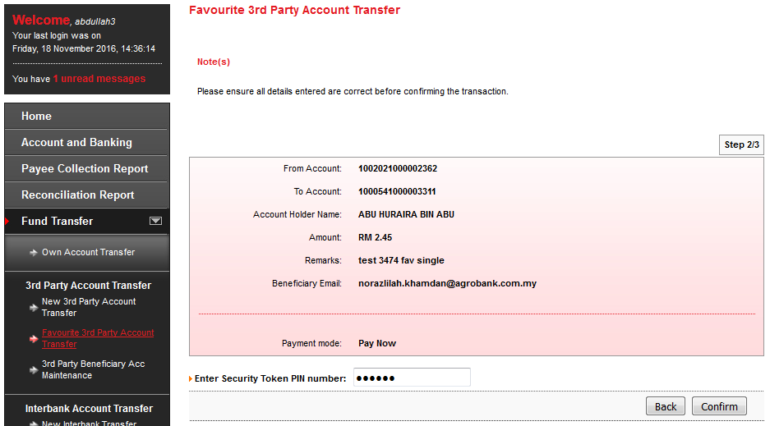

Result Page
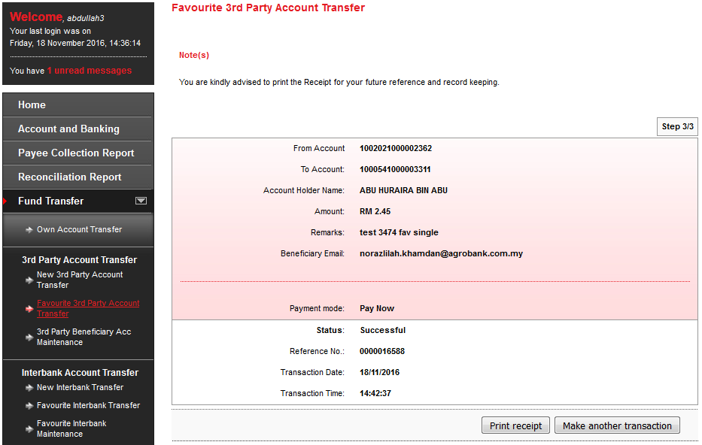

Print Receipt
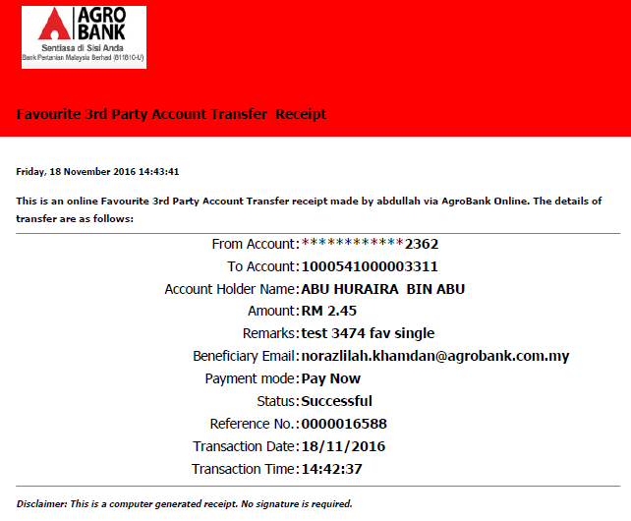

Transaction History
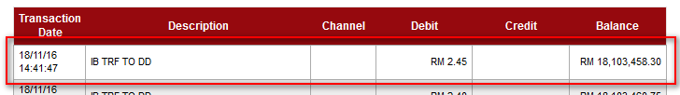

Agronet Transaction History
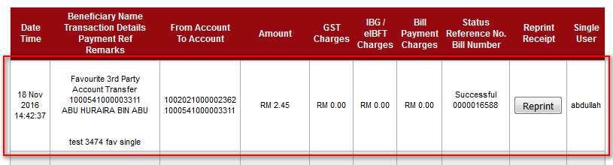

Initiator

Confirm Page
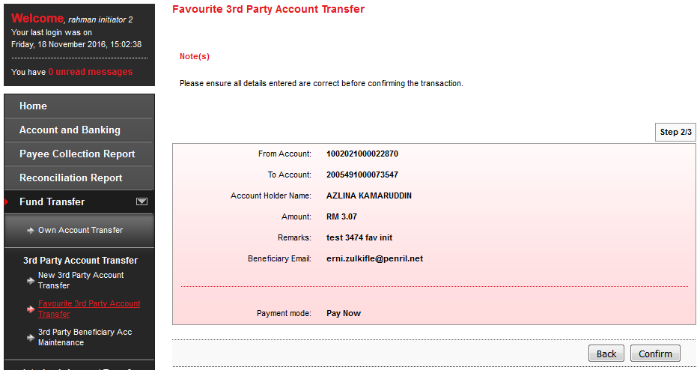

Result Page
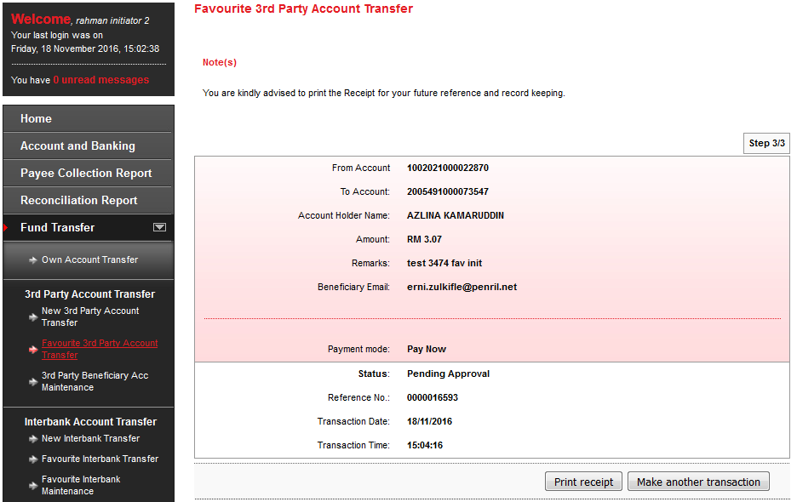

Print Receipt
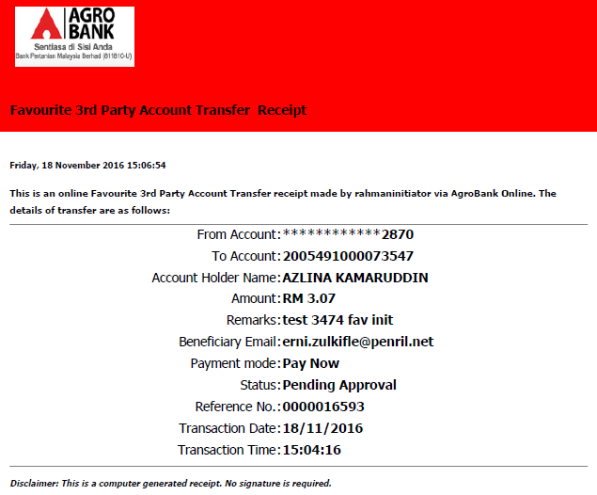

Approver

Confirm Page
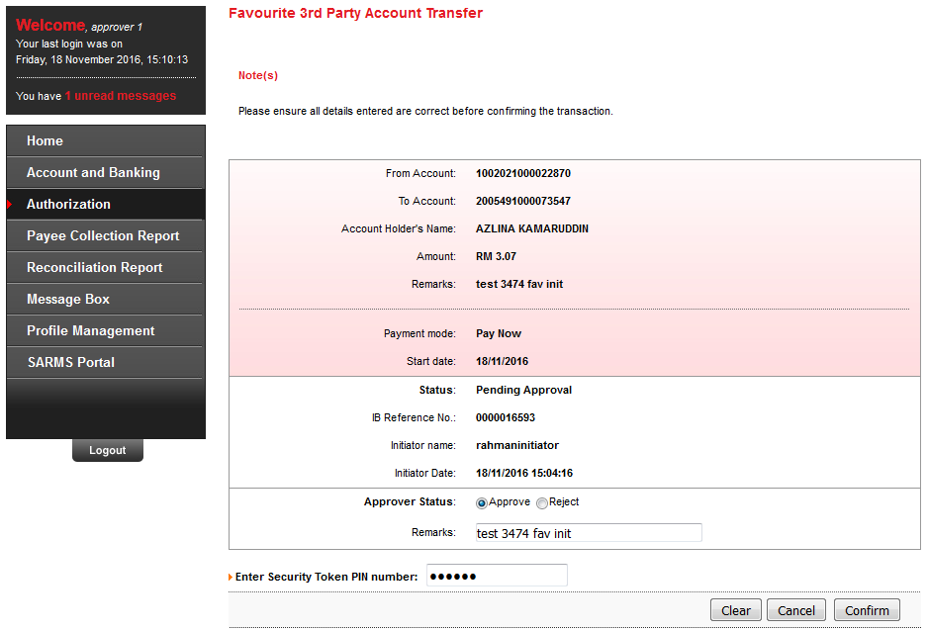

Result Page
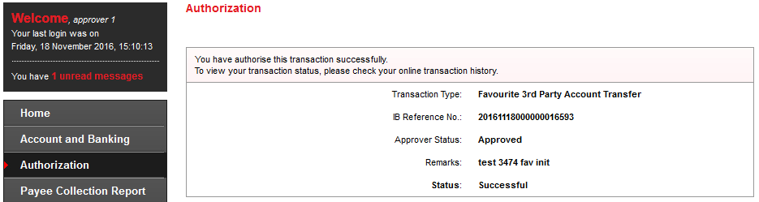

Transaction History
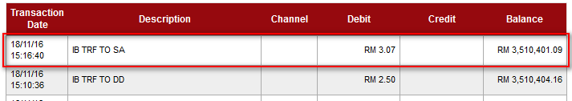

Agronet Transaction History
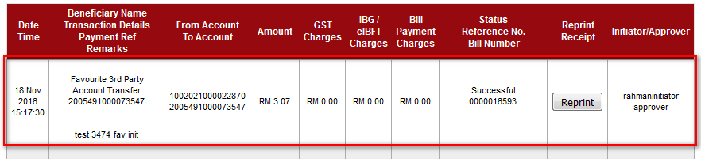
Reviewed By: (PMO
 |  |  | Name/Position : Norhaidah Binti Md Dasuki / Senior Manager, Quality Assurance and Support  Date : 18/11/2016

