Test Issue Log |  |  |  |  |  | SCP ID# : UAT_SB_LHDN-021
Project Name: | AGROBANK BUSINESS INTERNET BANKING
Test Stage: | Unit Functionality Integration System Interface  Performance Regression Acceptance Pilot
Test Case Number: | Support #6775 |  |  | Test Started Date: |  |  | 11/11/2016
Test Title: | [UAT_SB_LHDN-021] - LHDN 10 Report
Test Description: | To ensure report displays as requirement needs.
Test Functionality: | BIB  - Role – Initiator & Approver  - Role – Single User
Test Procedure: | BIB  - Perform Statutory Bodies - LHDN transactions.  - View report.
Test Result: | Pass: Fail: | Tested by: |  |  | Nurul Akmal binti Yusof
Reason for Failure:
TEST DESCRIPTION
Test Item No 1: OPM File – It should be 1 header for all six transactions.
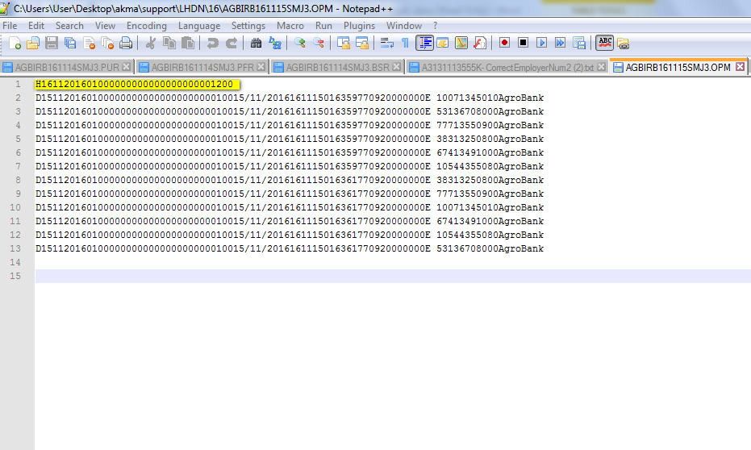
Test Item No 2: PPM File – It should be only 1 F.
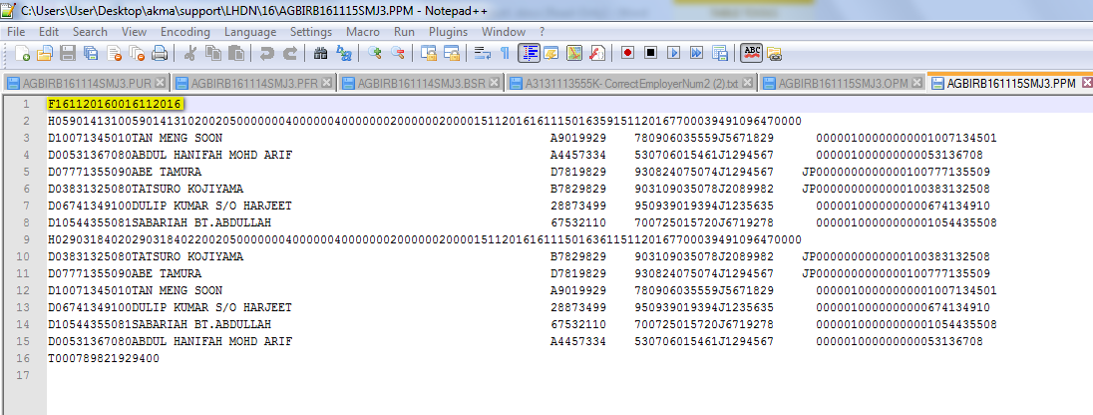

Test Item No 3: LHDN request to exclude the space in between
OPM report
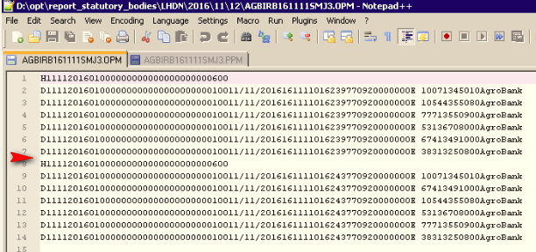

PPM report
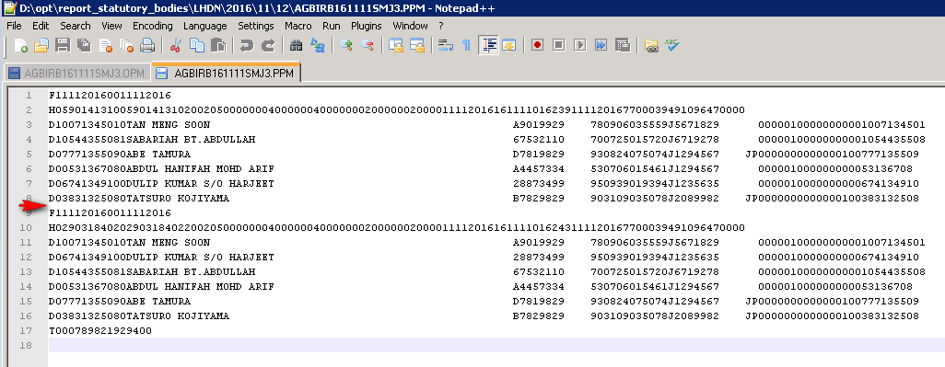
Test Item No 4: Pay in slip no must unique.
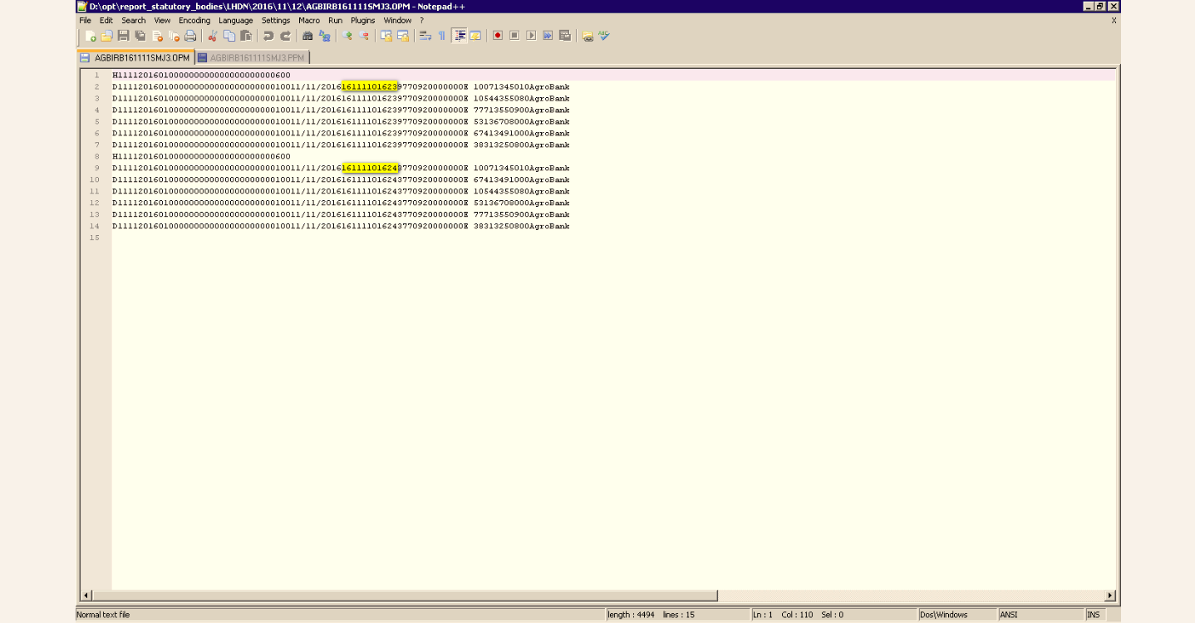

Test Item No 5: Field Name: Bank Account No. – consist of other LHDN A/C No. One report cater for one LHDN A/C No.
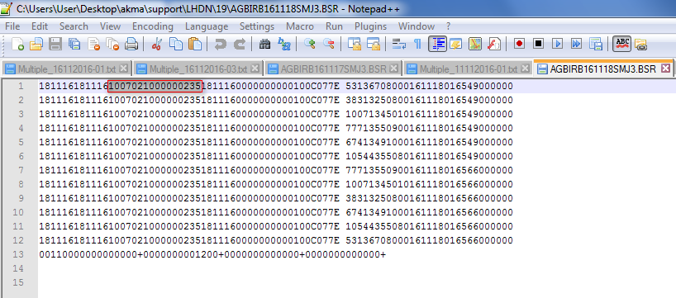
Check LHDN account no:
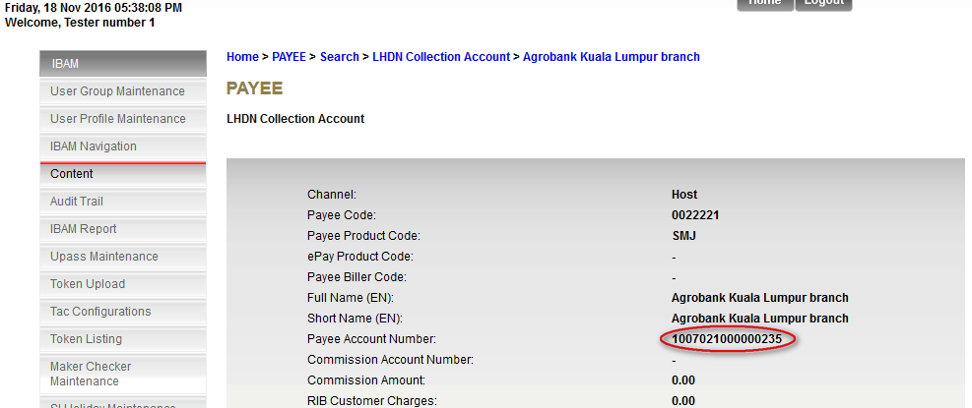

Test Item No 6: The amount is Total Amount of PCB & CP38
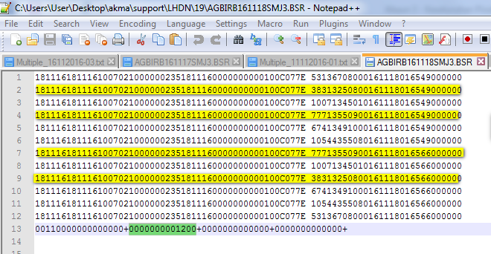

File Uploaded as below:
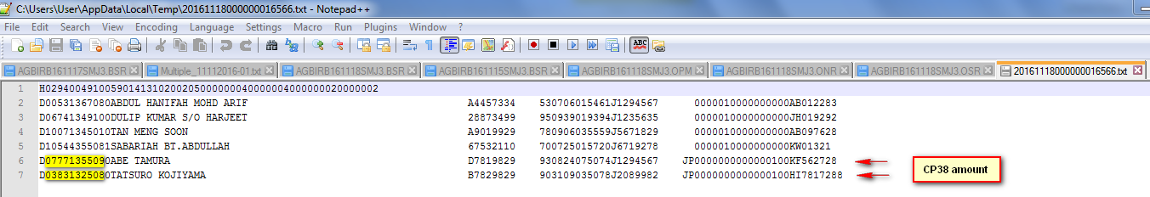

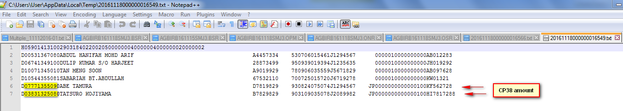

Test Item No 6: The pay-in slip no must be unique for each transaction.

BSR
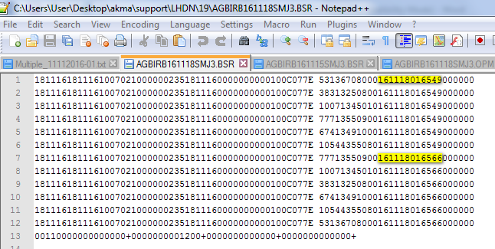

OPM
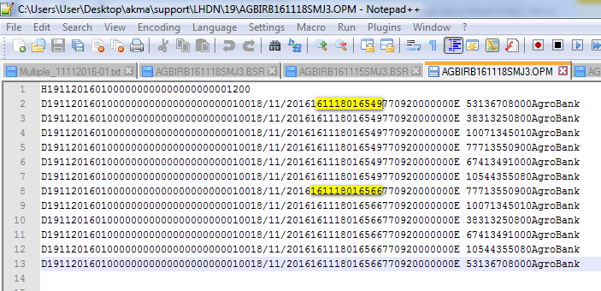

PPM
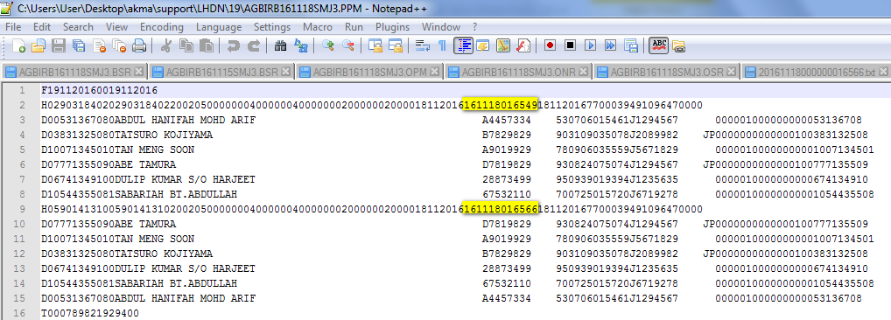
Test Item No 7: Field Batch Number and BBMC_batch_number should be same (OPM)
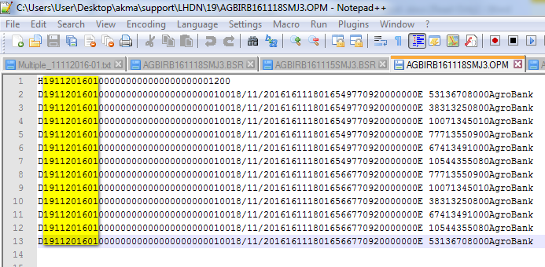
Test Item No 8: The transaction amount is total amount of PCB and CP38 (ONR)
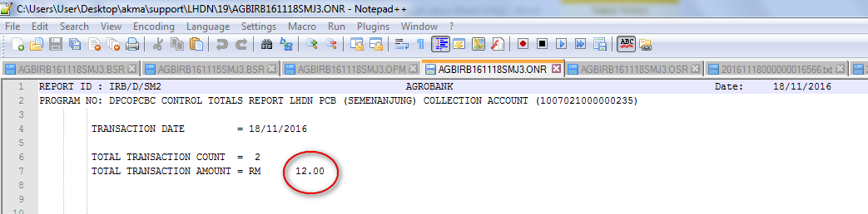

Reviewed By: (PMO)
 |  |  | Name/Position : Norhaidah Binti Md Dasuki / Senior Manager, Quality Assurance and Support  Date : 11/11/2016

