Test Issue Log |  |  |  |  |  | SCP ID# : 6826
Project Name: | AGROBANK BUSINESS INTERNET BANKING
Test Stage: | Unit Functionality Integration System Interface  Performance Regression Acceptance Pilot
Test Case Number: |  |  |  | Test Started Date: |  |  | 22/11/2016
Test Title: | [Internal Testing] UAT_SB_LHDN_009
Test Description: | - To ensure Total No. of Record has been removed from Header.  - To ensure Total Amount Month-to-date is accumulated from 1st date of Month to current date.
Test Functionality: | - BIB Statutory Body LHDN Report Daily  -PDF  -EXCEL
Test Procedure: | - BIB Statutory Body LHDN Report Daily  - Login to IBAM and download the LHDN Report Daily in PDF format and EXCEL format.
Test Result: | Pass: Fail: | Tested by: |  |  | Erni Suhaireen binti Zulkifli
Reason for Failure:
TEST DESCRIPTION
BIB Statutory Body LHDN Report Daily
- To ensure Total No. of Record has been removed from Header.
- To ensure Total Amount Month-to-date is accumulated from 1st date of Month to current date.
  - PDF Format
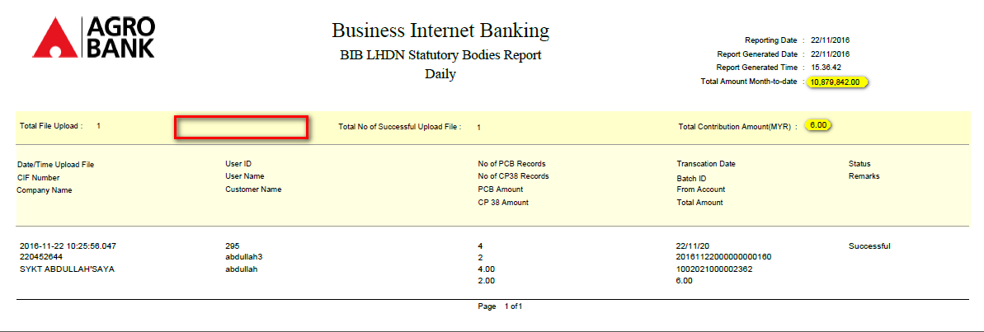
  - Excel Format
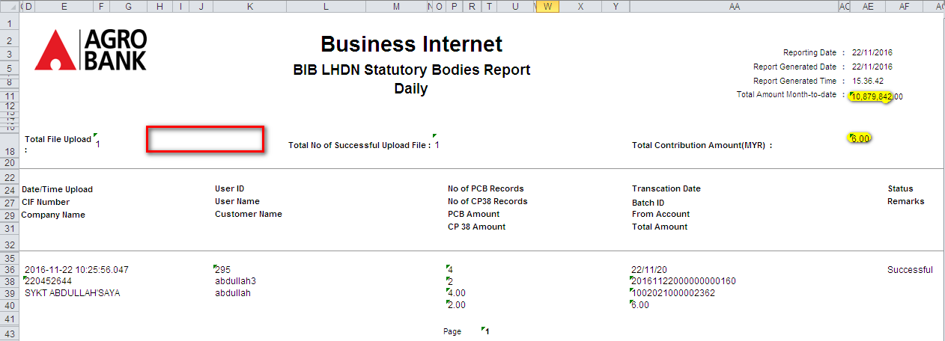
Reviewed By: (PMO)
Name/Position :
Date :

