Test Issue Log |  |  |  |  |  | SCP ID# : 3485
Project Name: | Retail Internet Banking
Test Stage: | Unit Functionality Integration System Interface  Performance Regression Acceptance Pilot
Test Case Number: | Support #6849 |  |  | Test Started Date: |  | 22/11/2016
Test Title: | Approver unable to approve bulk payment transaction
Test Description: | To ensure that both Single User & Multiple User able to perform below transactions:  - Own Account Transfer  - New 3rd Party Account Transfer  - Favourite 3rd Party Account Transfer  - Bulk Payment
Test Functionality: | BIB>Fund Transfer>Own Account Transfer (Pay Now, Pay Later, Recurring)  BIB>Fund Transfer>New/Favorite 3rd Party Account Transfer (Pay Now, Pay Later, Recurring)  BIB>Bulk Payment>Bulk Upload  BIB>Bulk Payment>Multiple Payment
Test Procedure: | Fund Transfer  - Login to BIB as an Initiator/Single User role.  - Perform each transaction for all payment mode Pay Now, Pay Later and Recurring.  - Login to BIB as an Approver role to approve each of transactions.
Test Result: | Pass: Fail: | Tested by: |  |  | Nurul Akmal binti Yusof
Reason for Failure:
TEST DESCRIPTION

own account Transfer (pay now)

Single User

Confirm Page
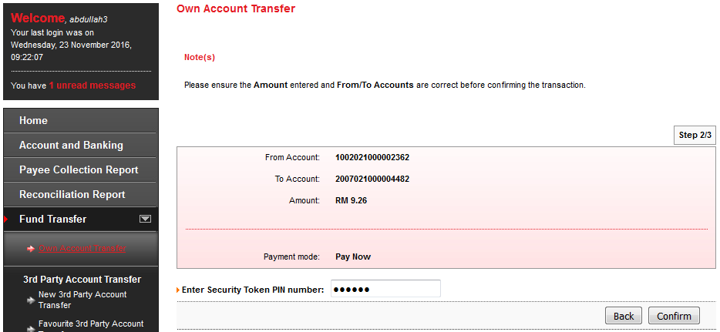

Result Page
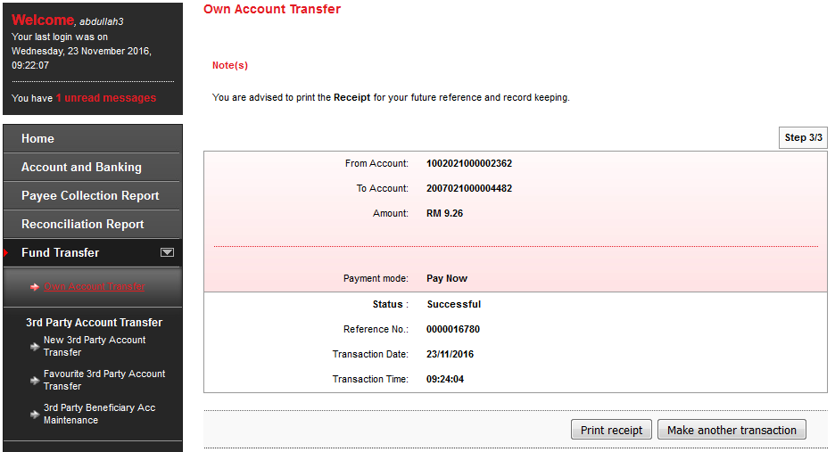

Print Receipt
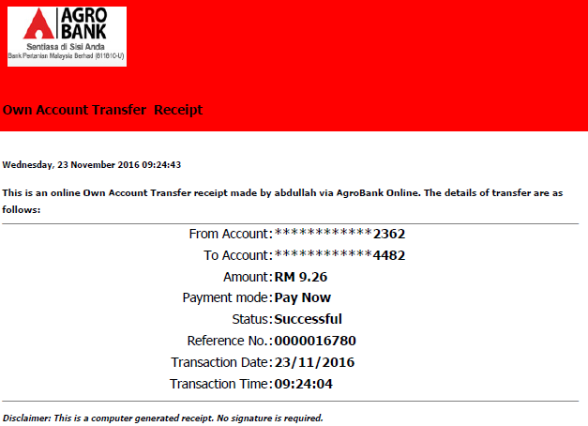

Transaction History
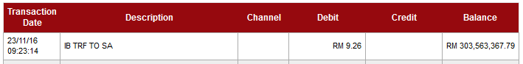

Agronet Transaction History
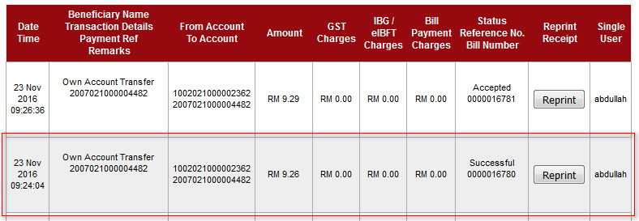

Initiator

Confirm Page
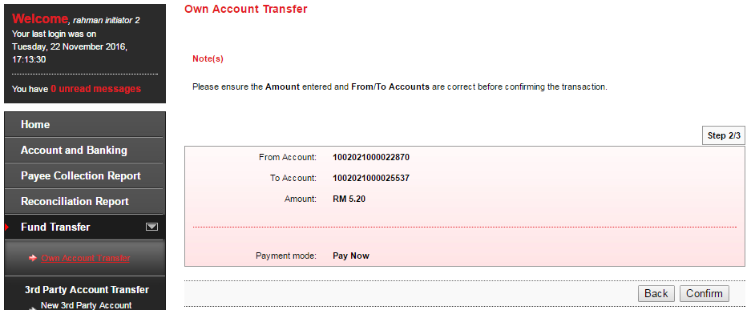

Result Page
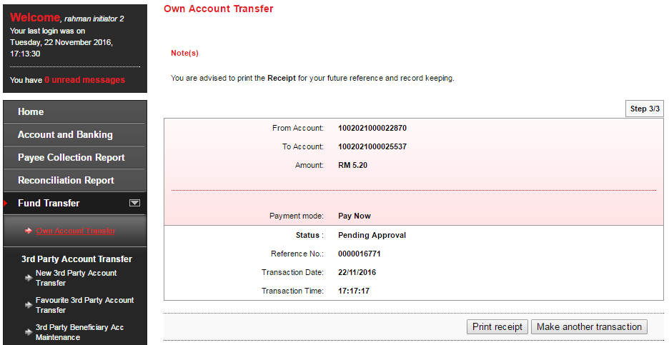

Print Receipt
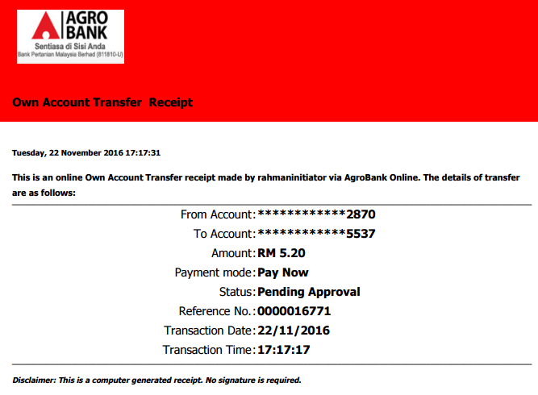

Approver

Confirm Page
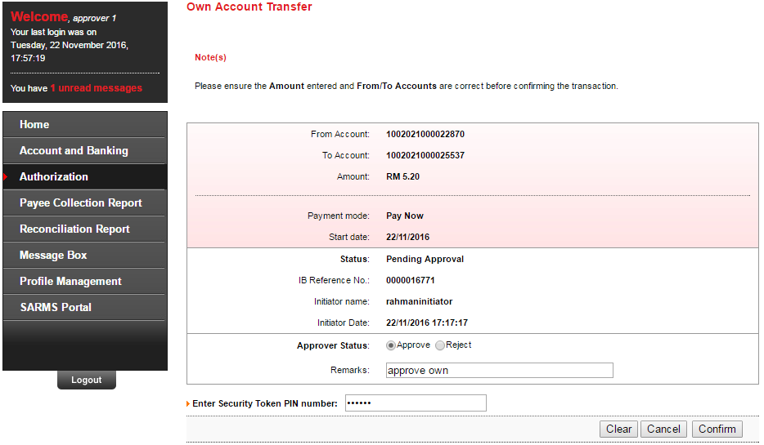

Result Page
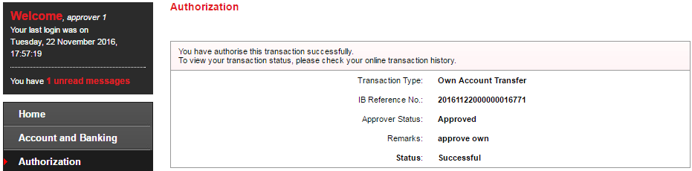

Transaction History
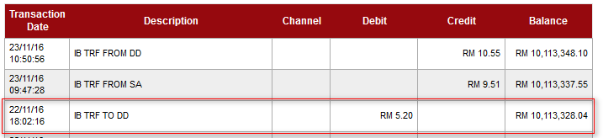

Agronet Transaction History
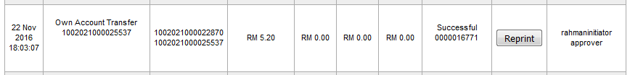

own account Transfer (pay later)

Single User

Confirm Page
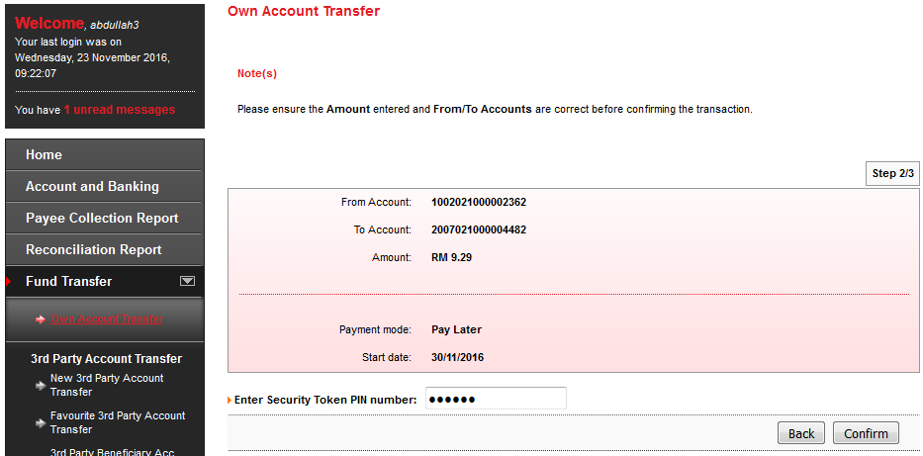

Result Page
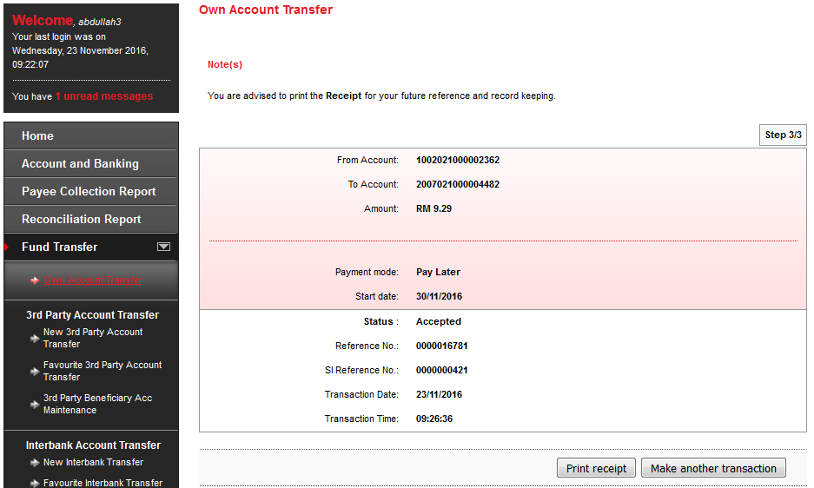

Print Receipt
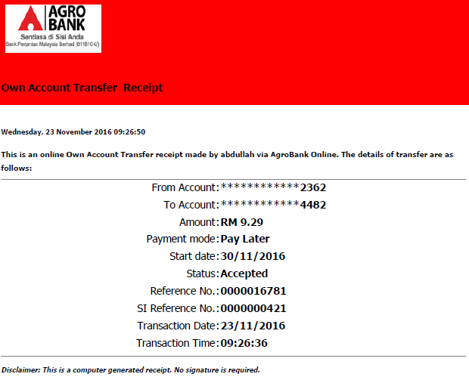

Transaction History
N/A for SI transaction

Agronet Transaction History
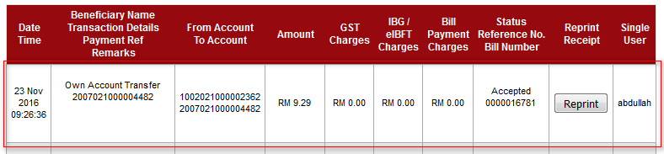

Initiator

Confirm Page
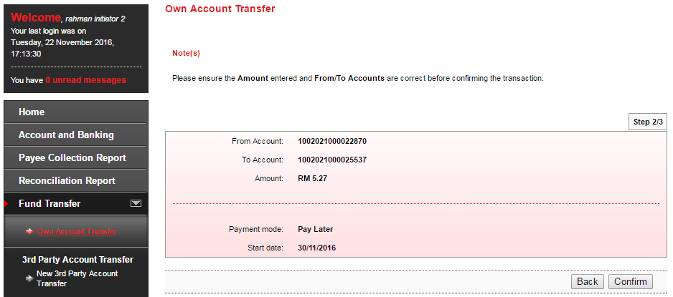

Result Page
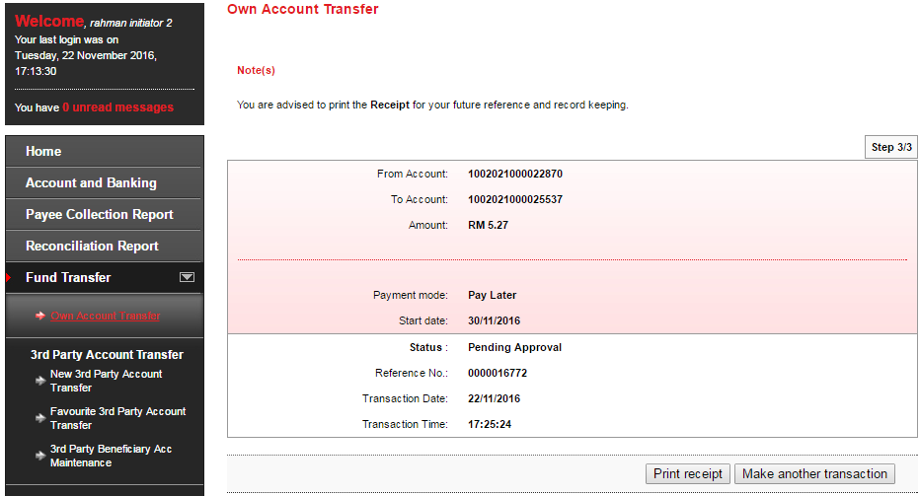

Print Receipt
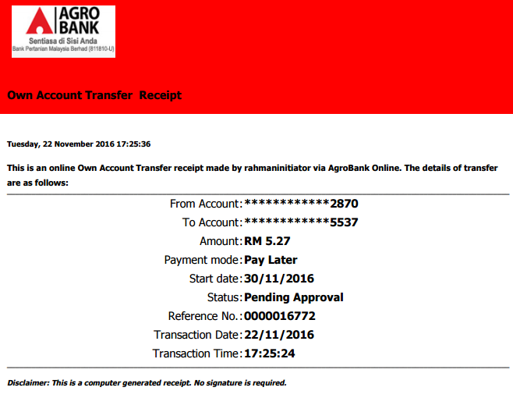

Approver

Confirm Page
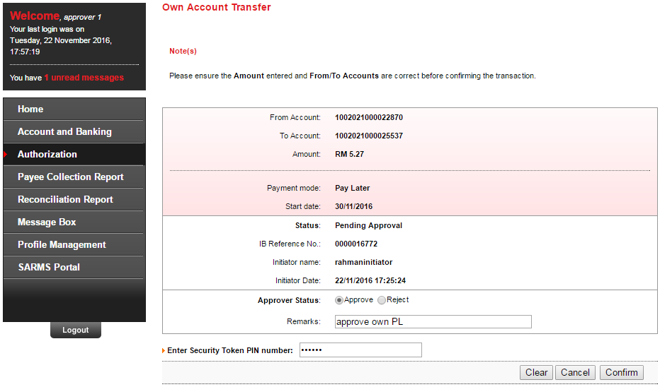

Result Page
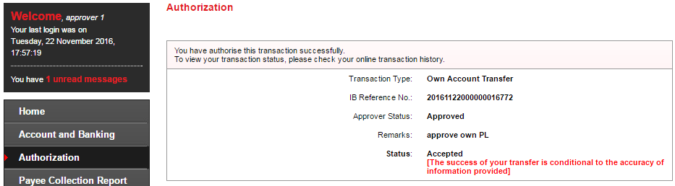

Transaction History
N/A for SI transaction

Agronet Transaction History
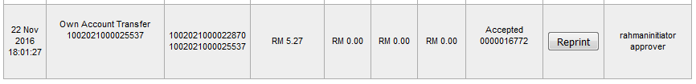

own account Transfer (recurring)

Single User

Confirm Page
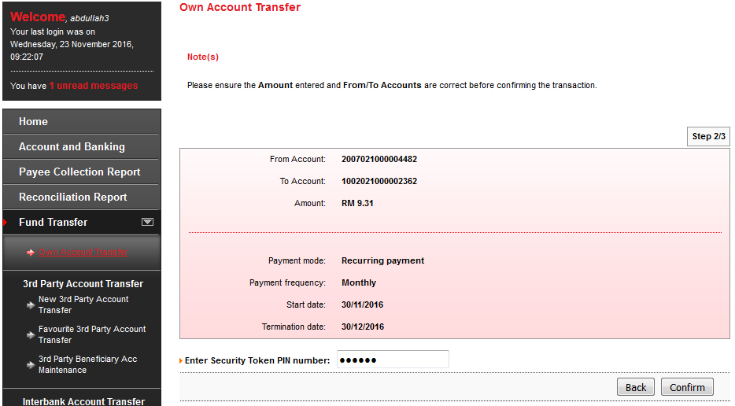

Result Page
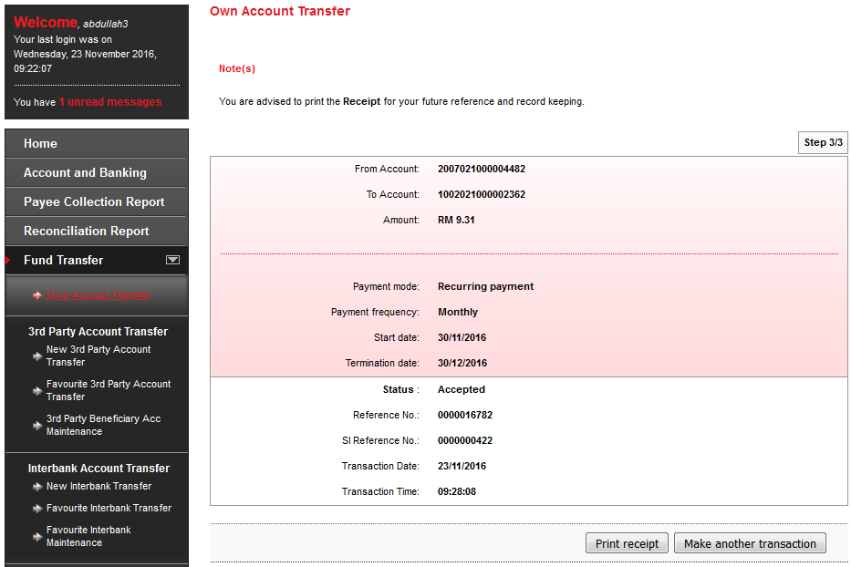

Print Receipt
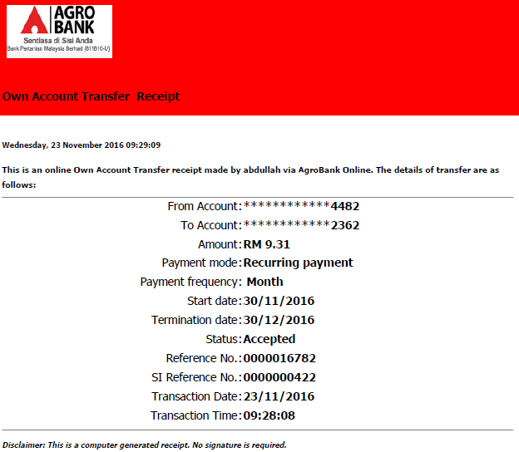

Transaction History
N/A for SI transaction

Agronet Transaction History
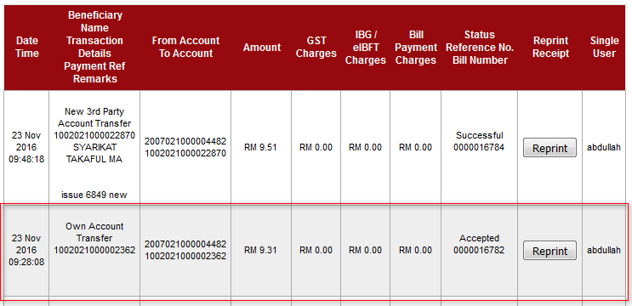

Initiator

Confirm Page
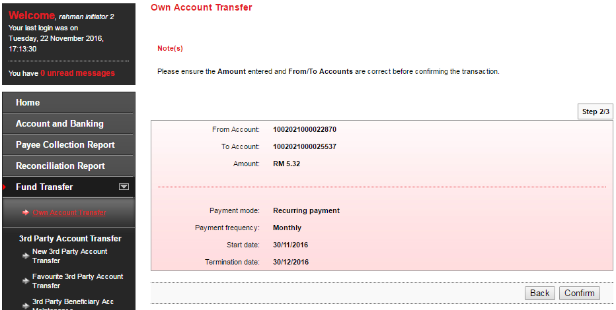

Result Page
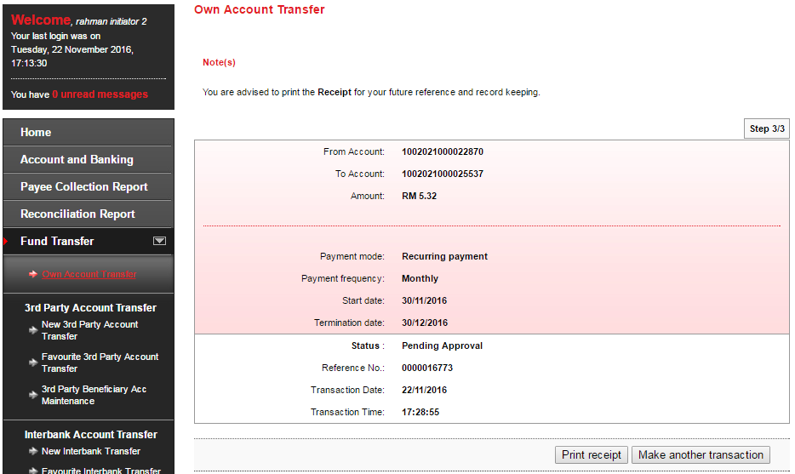

Print Receipt
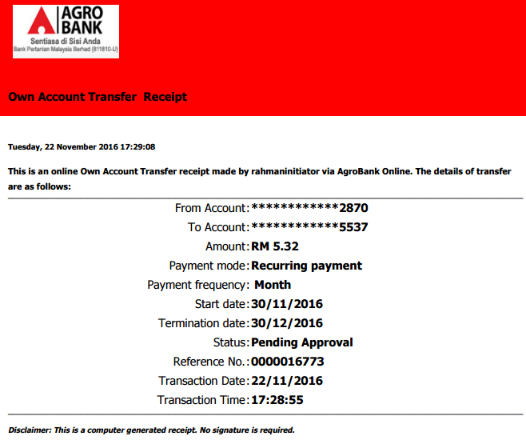

Approver

Confirm Page
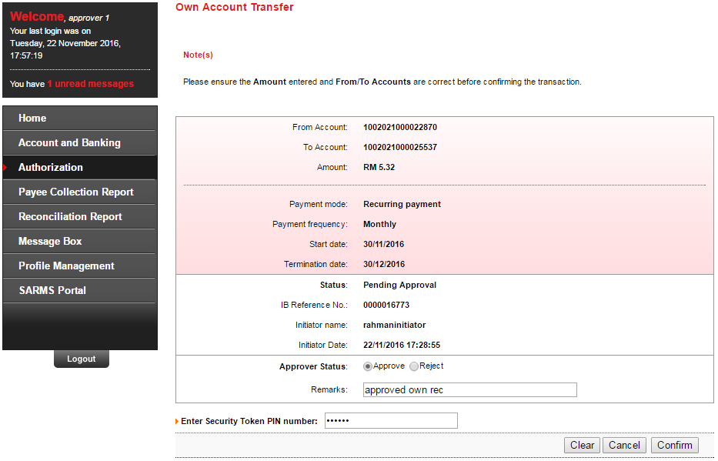

Result Page
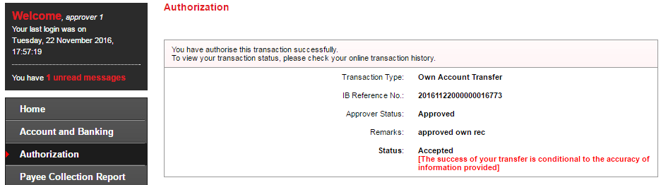

Transaction History
N/A for SI transaction

Agronet Transaction History
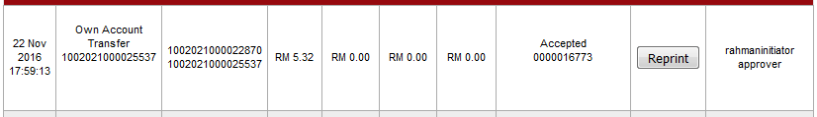

New 3rd Party Transfer (pay now)

Single User

Confirm Page
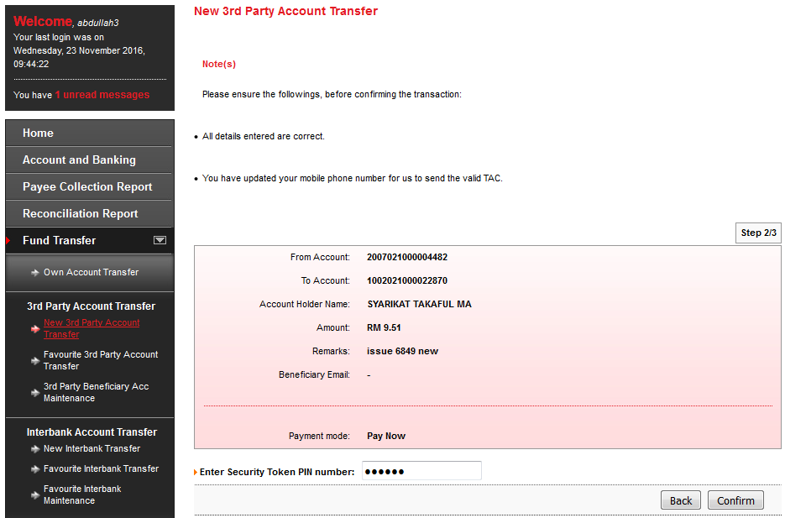

Result Page
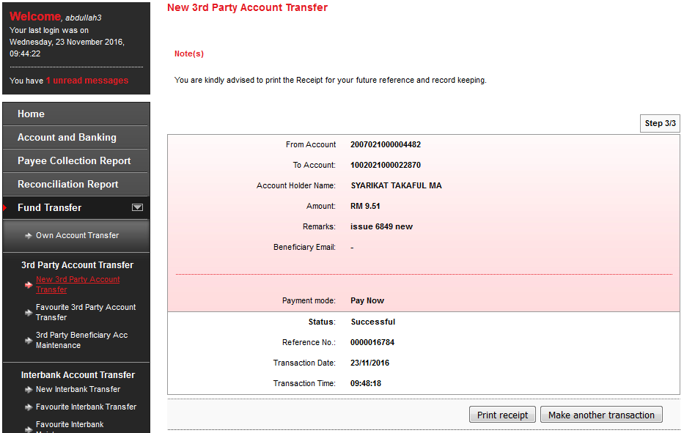

Print Receipt
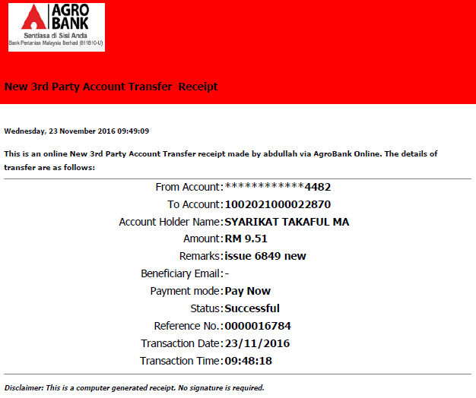

Transaction History
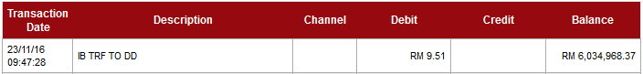

Agronet Transaction History
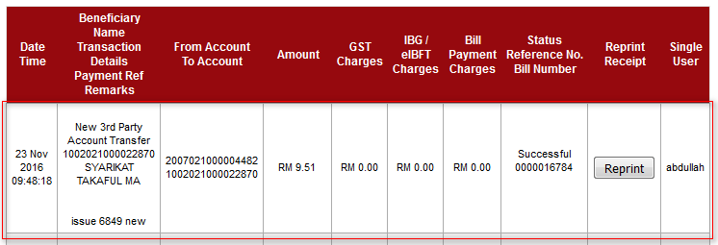

Initiator

Confirm Page
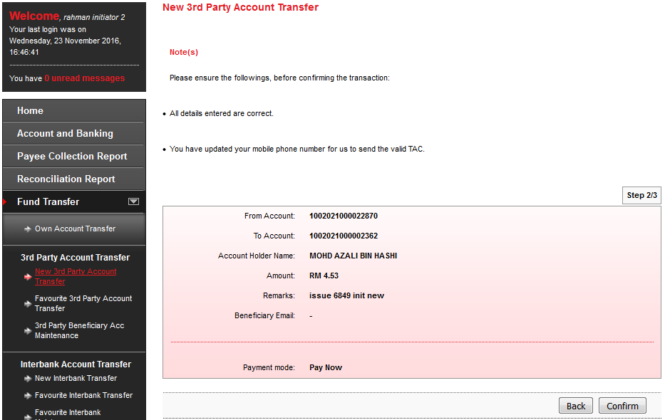

Result Page
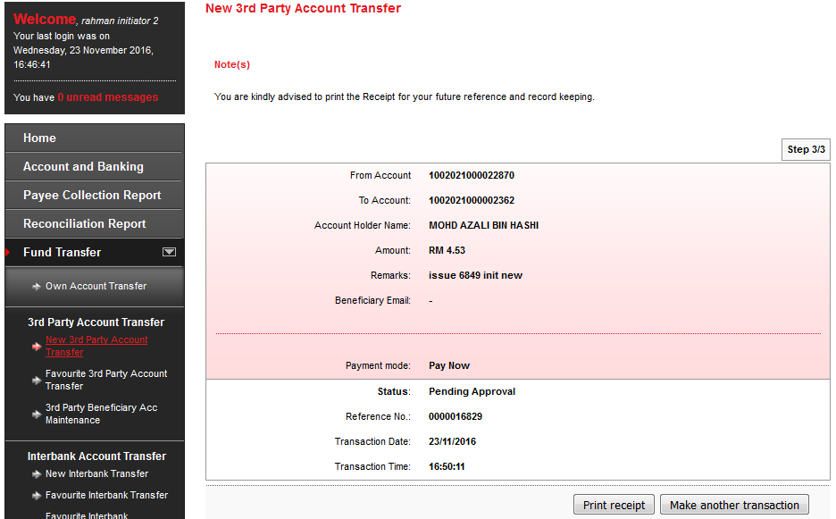

Print Receipt
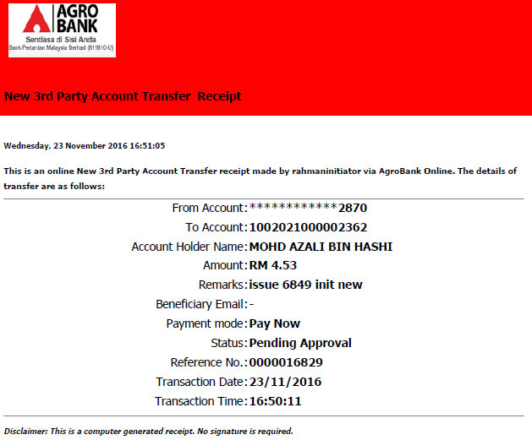

Approver

Confirm Page
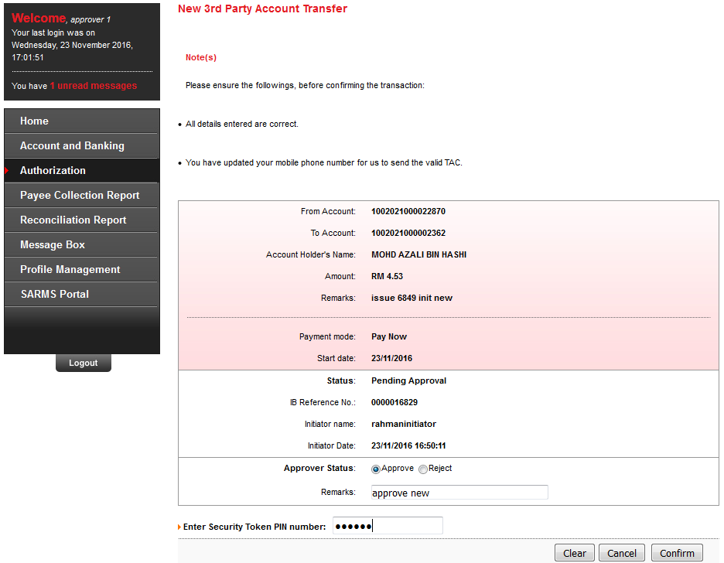

Result Page
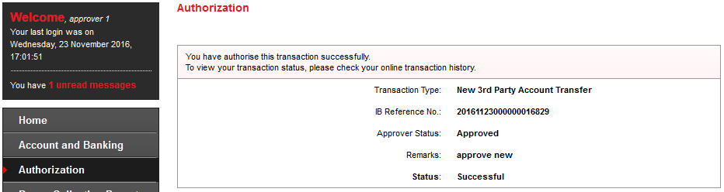

Transaction History
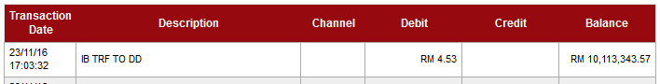

Agronet Transaction History
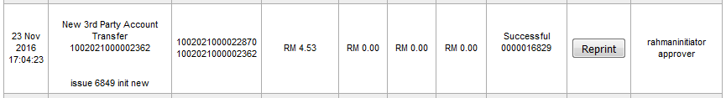

New 3rd Party Transfer (pay later)

Single User

Confirm Page
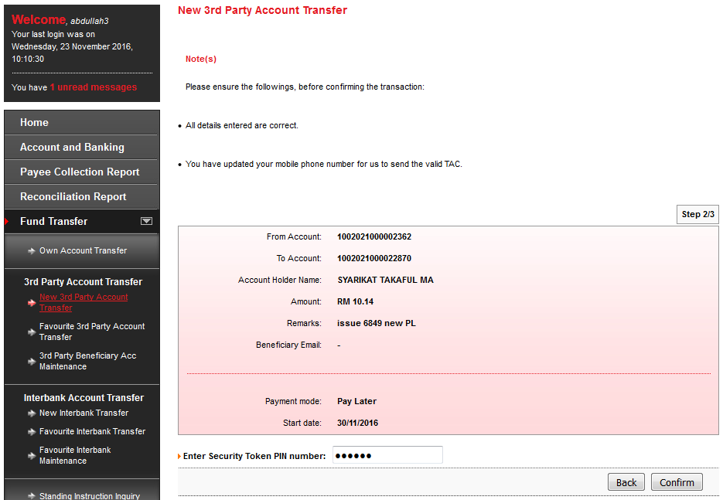

Result Page
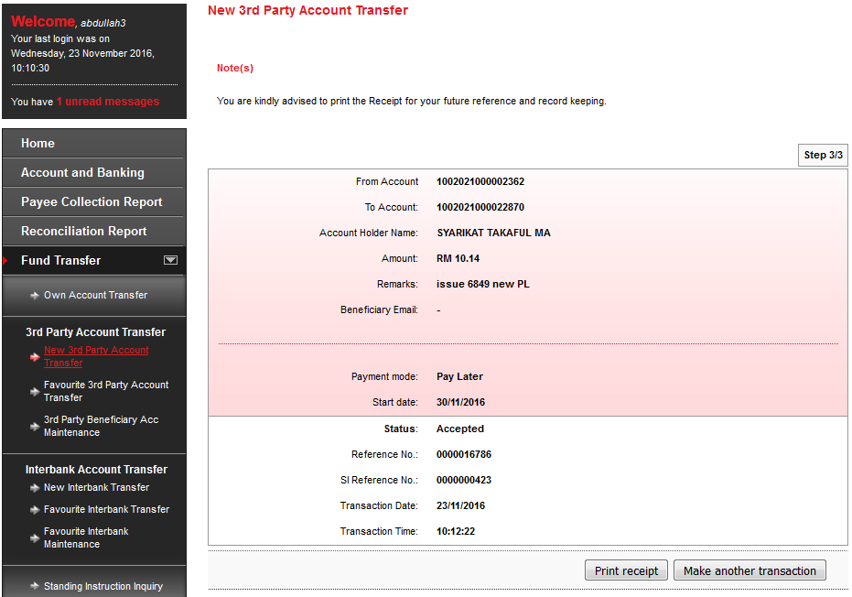

Print Receipt
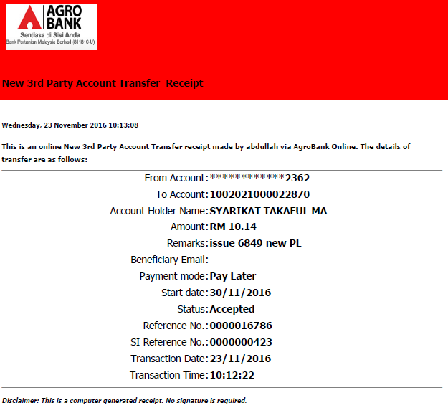

Transaction History
N/A for SI transaction

Agronet Transaction History
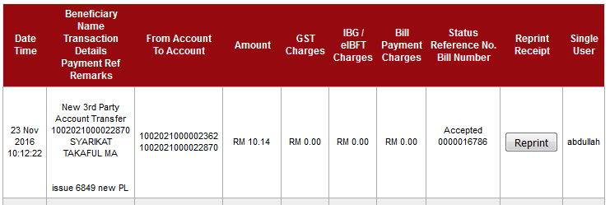

Initiator

Confirm Page
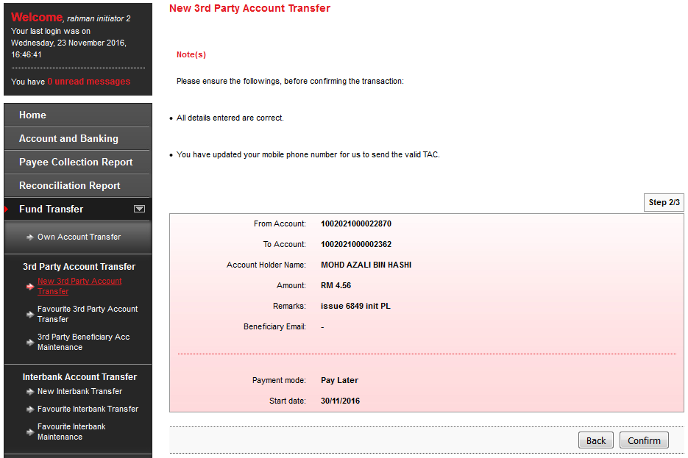

Result Page
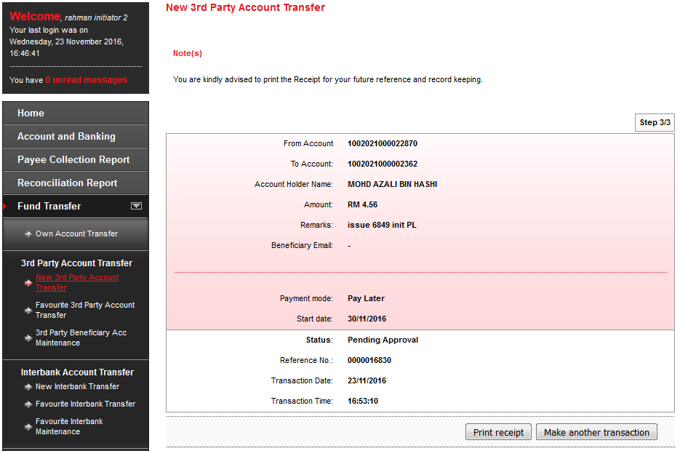

Print Receipt
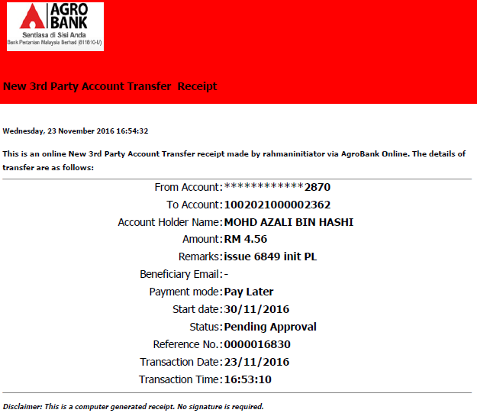

Approver

Confirm Page
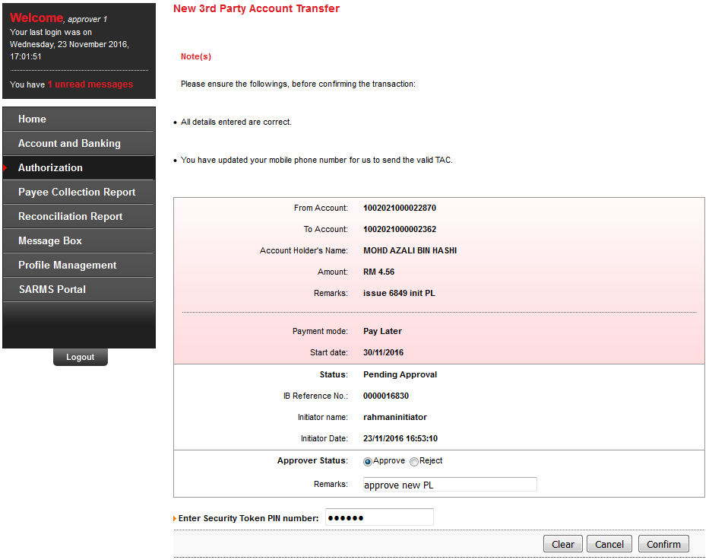

Result Page
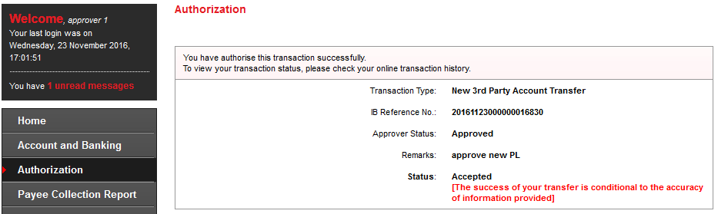

Transaction History
N/A for SI transaction

Agronet Transaction History
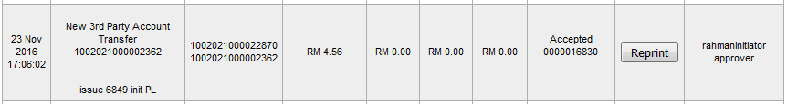

New 3rd Party Transfer (recurring)

Single User

Confirm Page
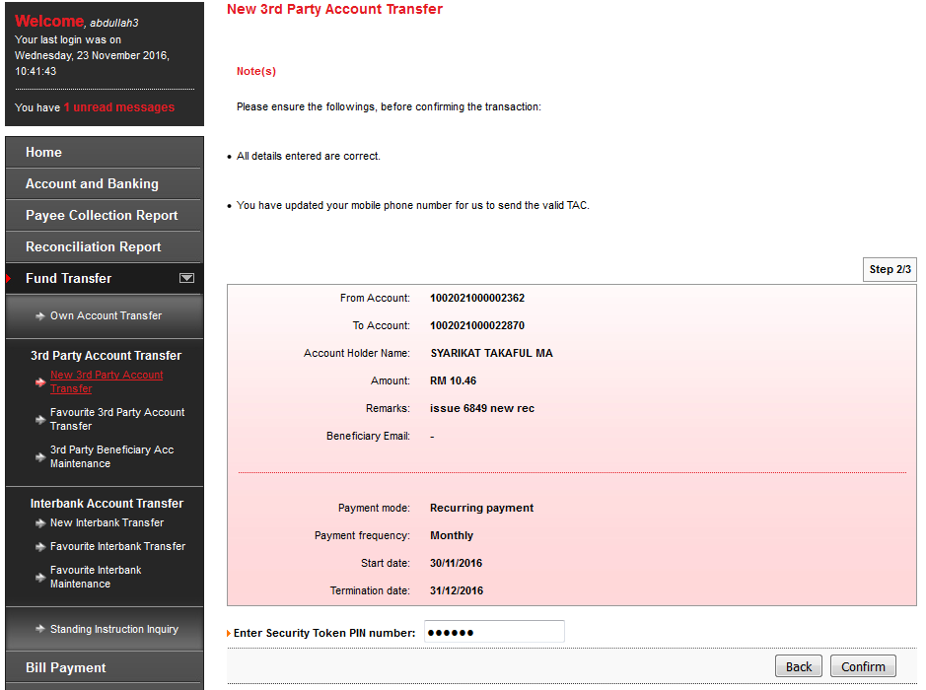

Result Page
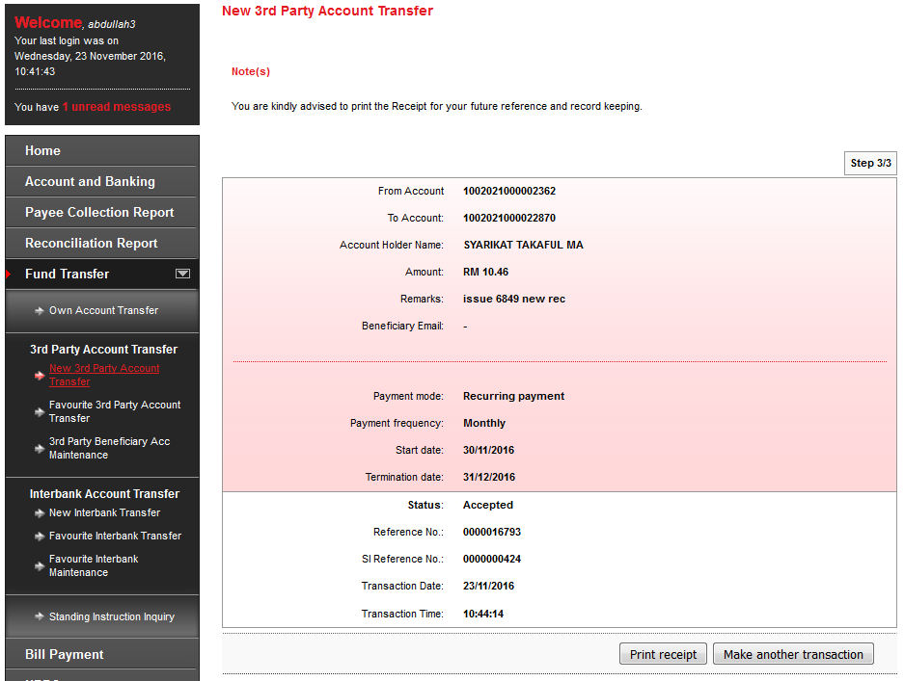

Print Receipt
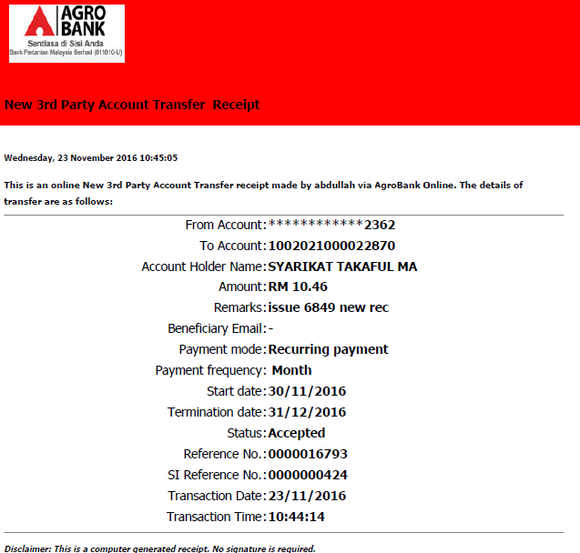

Transaction History
N/A for SI transaction

Agronet Transaction History
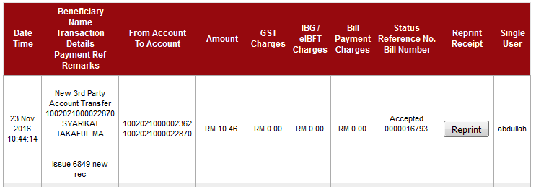

Initiator

Confirm Page
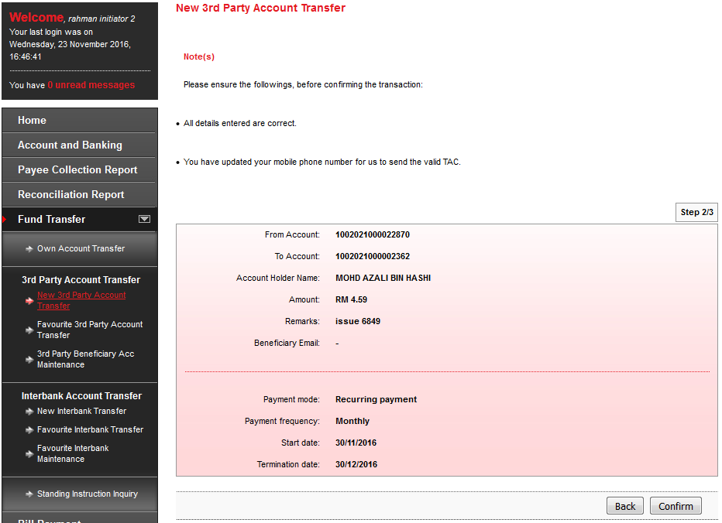

Result Page
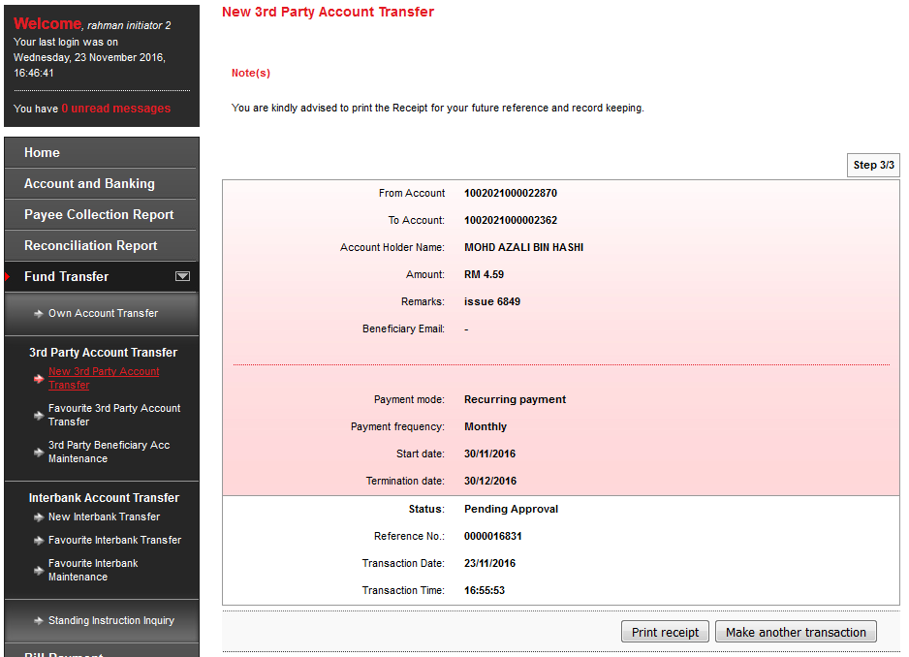

Print Receipt
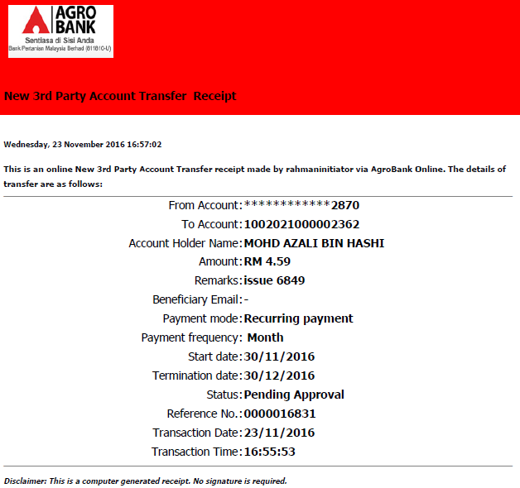

Approver

Confirm Page
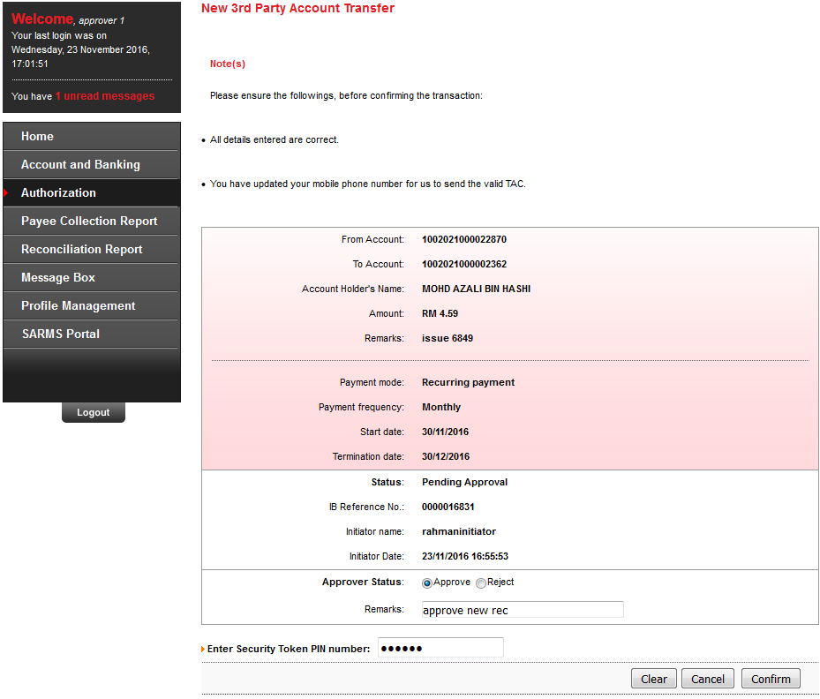

Result Page
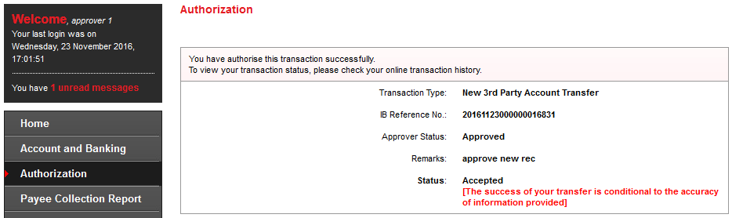

Transaction History
N/A for SI transaction

Agronet Transaction History
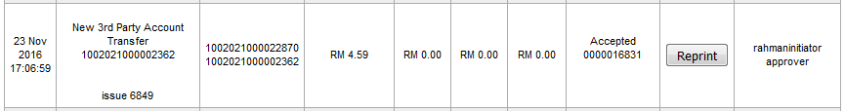

Fav 3rd Party Transfer (pay now)

Single User

Confirm Page
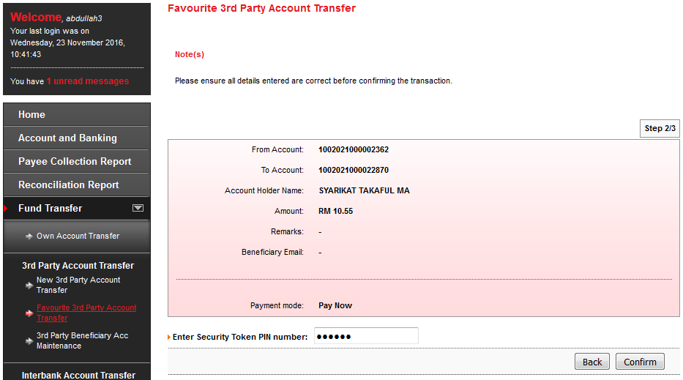

Result Page
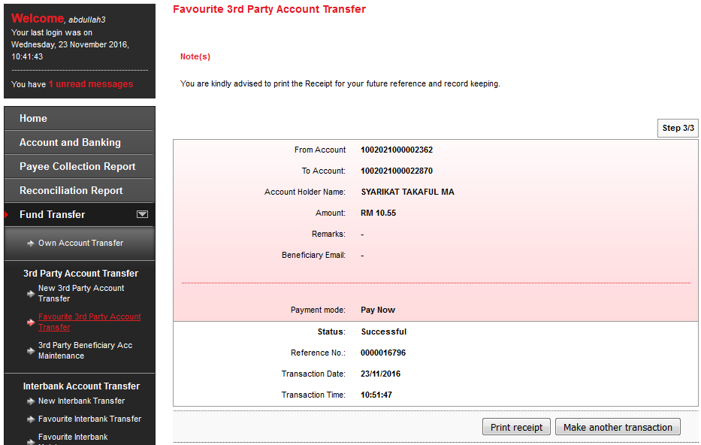

Print Receipt
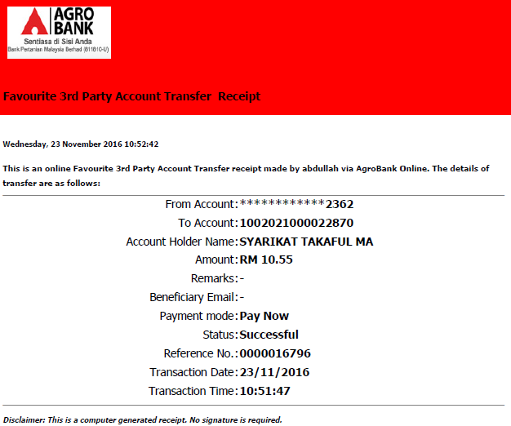

Transaction History
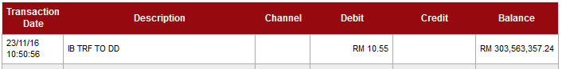

Agronet Transaction History
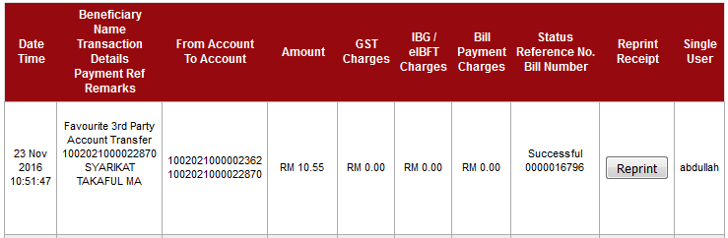

Initiator

Confirm Page
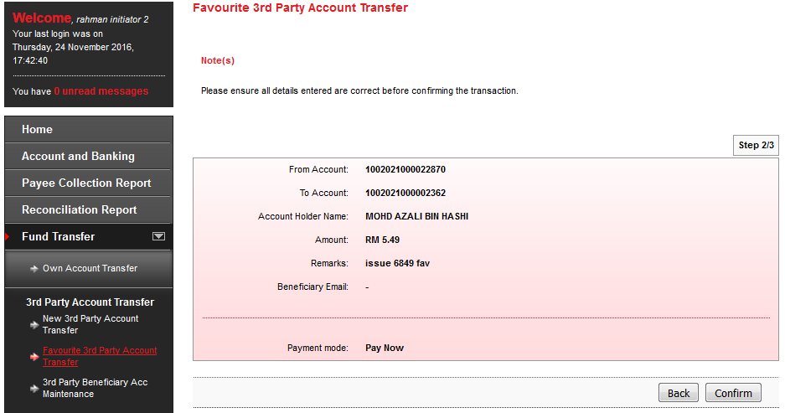

Result Page
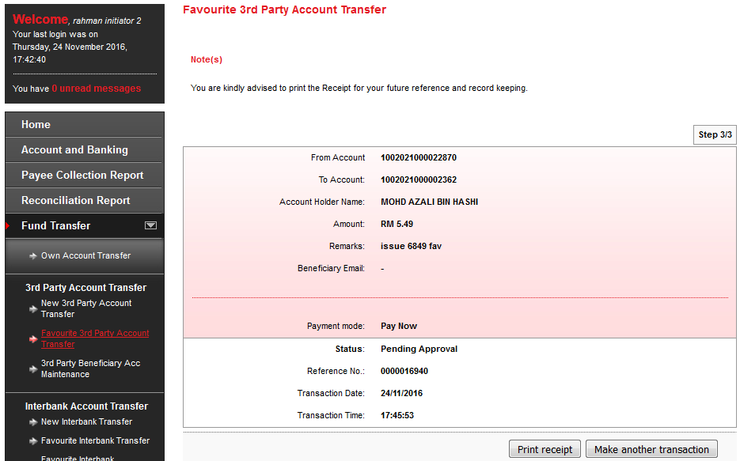

Print Receipt
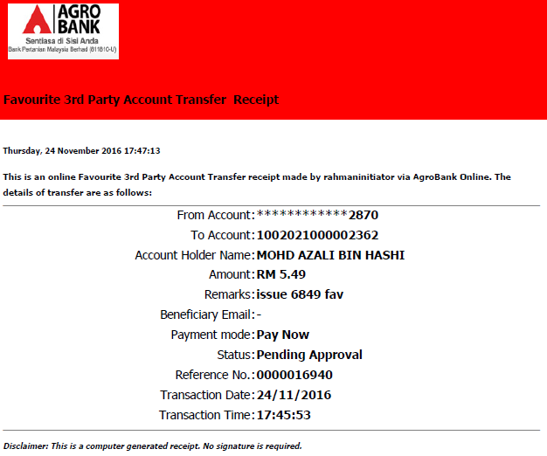

Approver

Confirm Page
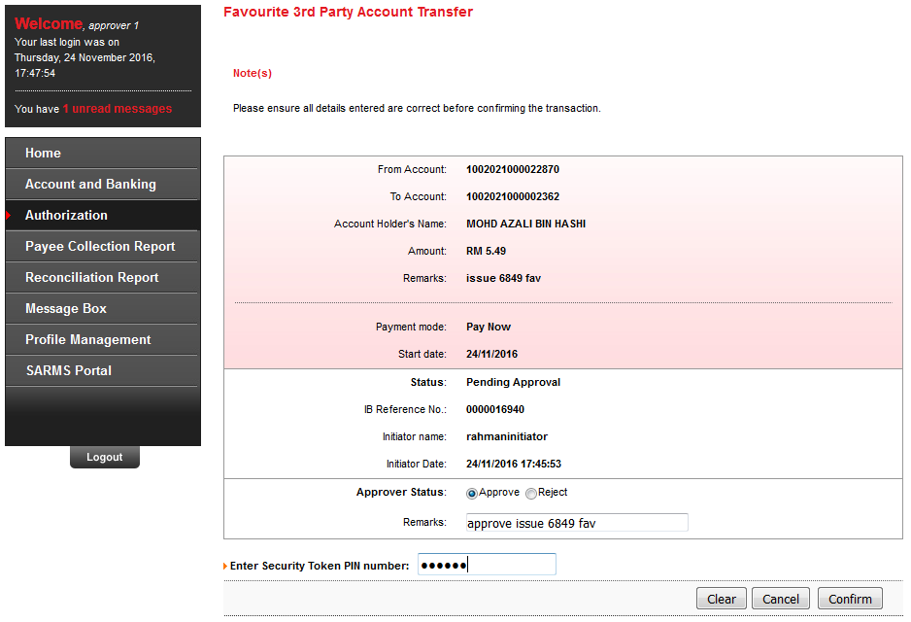

Result Page
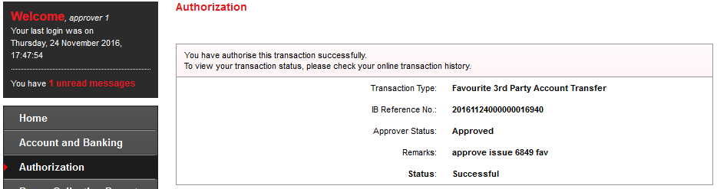

Transaction History
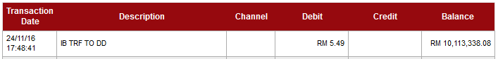

Agronet Transaction History
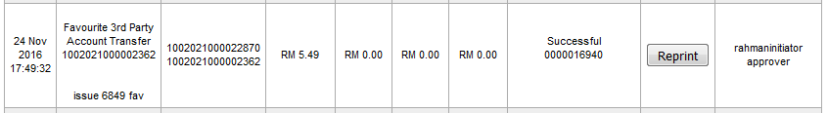

Fav 3rd Party Transfer (pay later)

Single User

Confirm Page
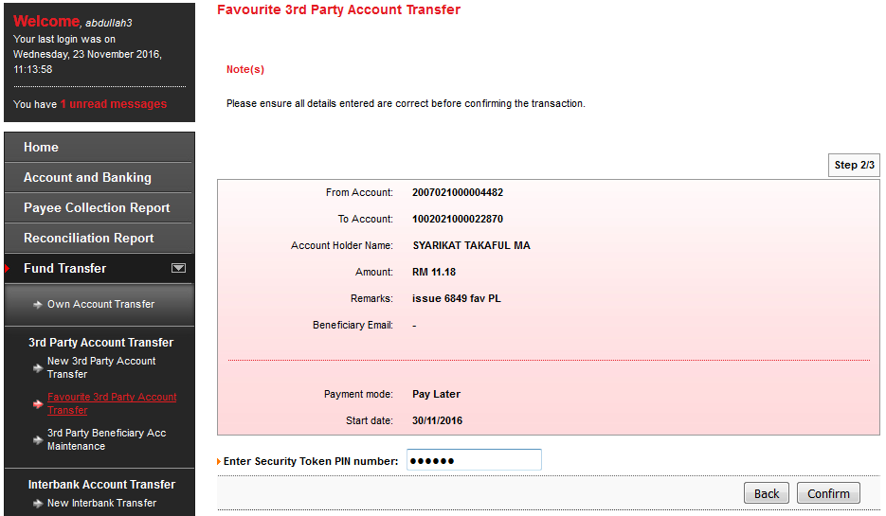

Result Page
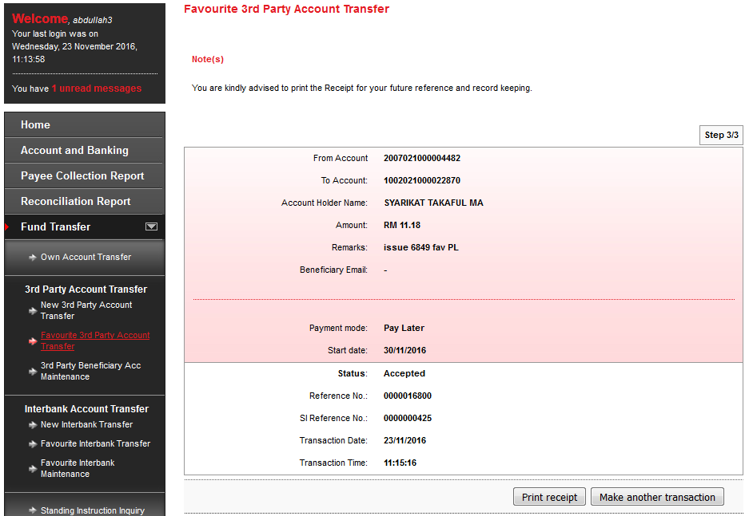

Print Receipt
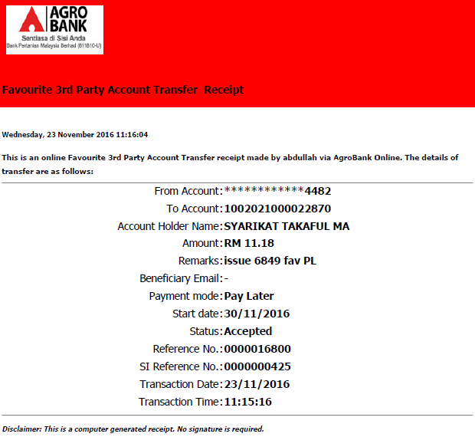

Transaction History
N/A for SI transaction

Agronet Transaction History
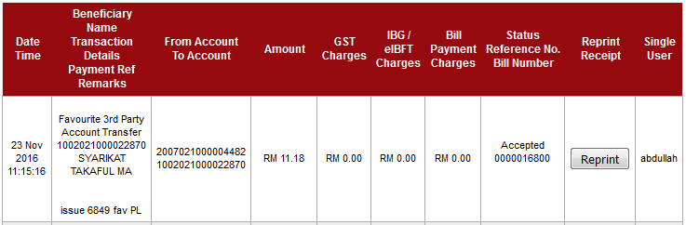

Initiator

Confirm Page
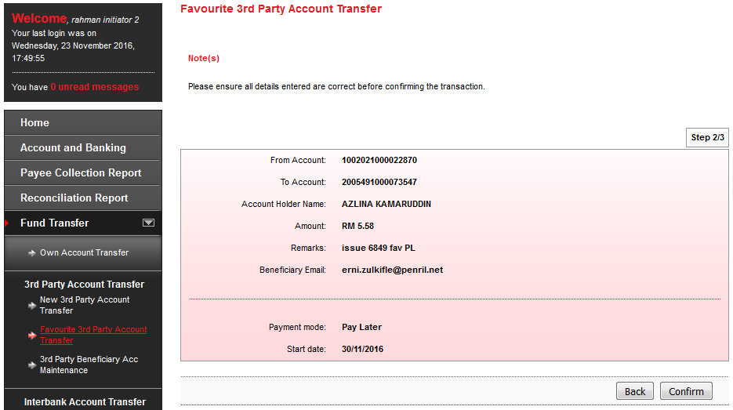

Result Page
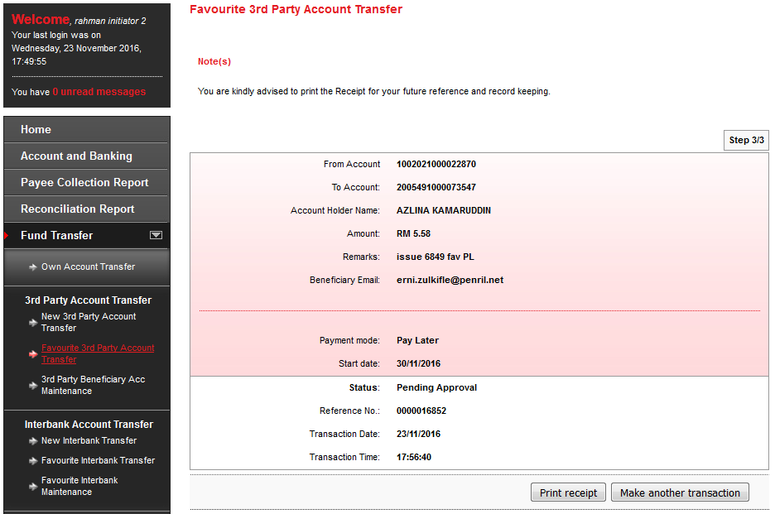

Print Receipt
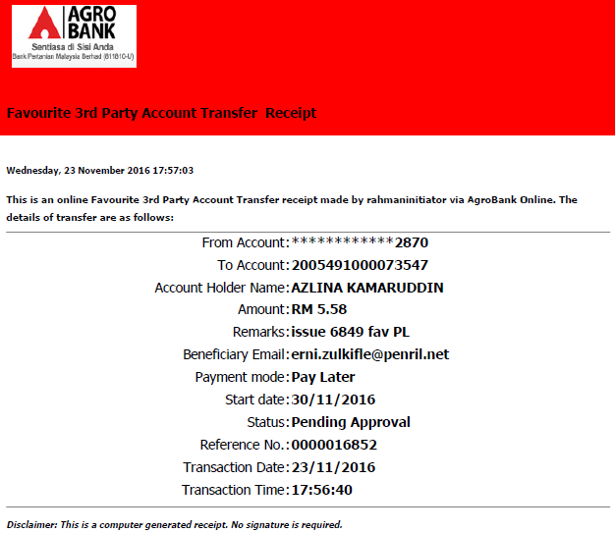

Approver

Confirm Page
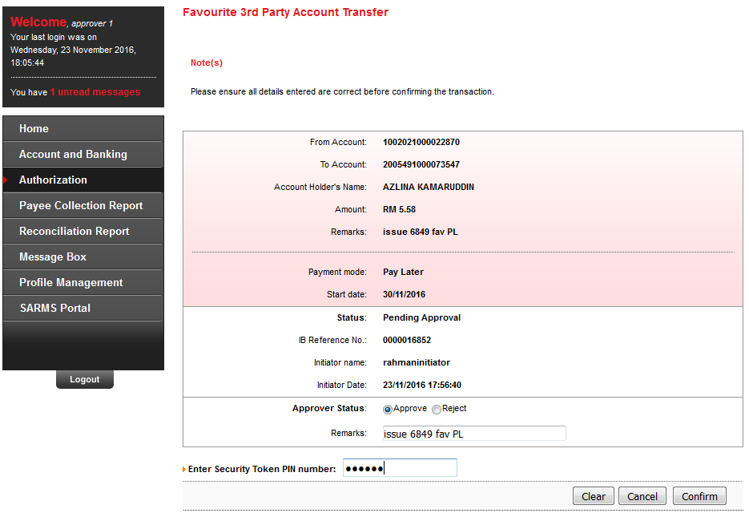

Result Page
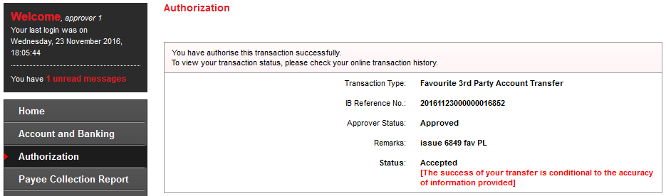

Transaction History
N/A for SI transaction

Agronet Transaction History
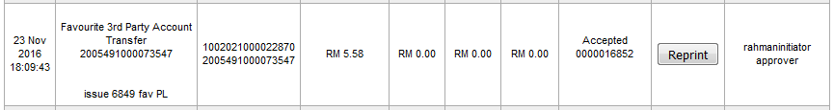

Fav 3rd Party Transfer (recurring)

Single User

Confirm Page
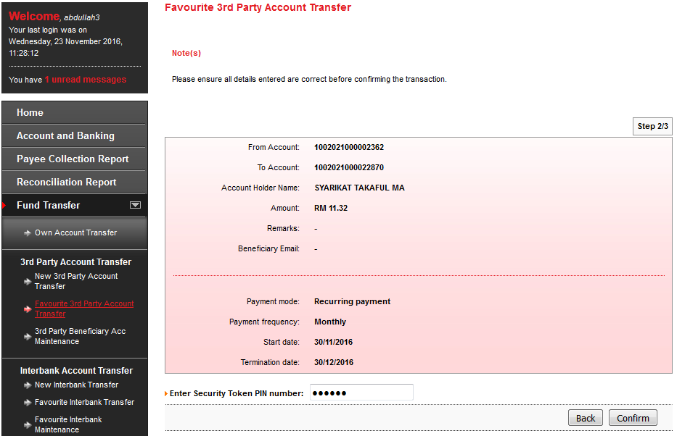

Result Page
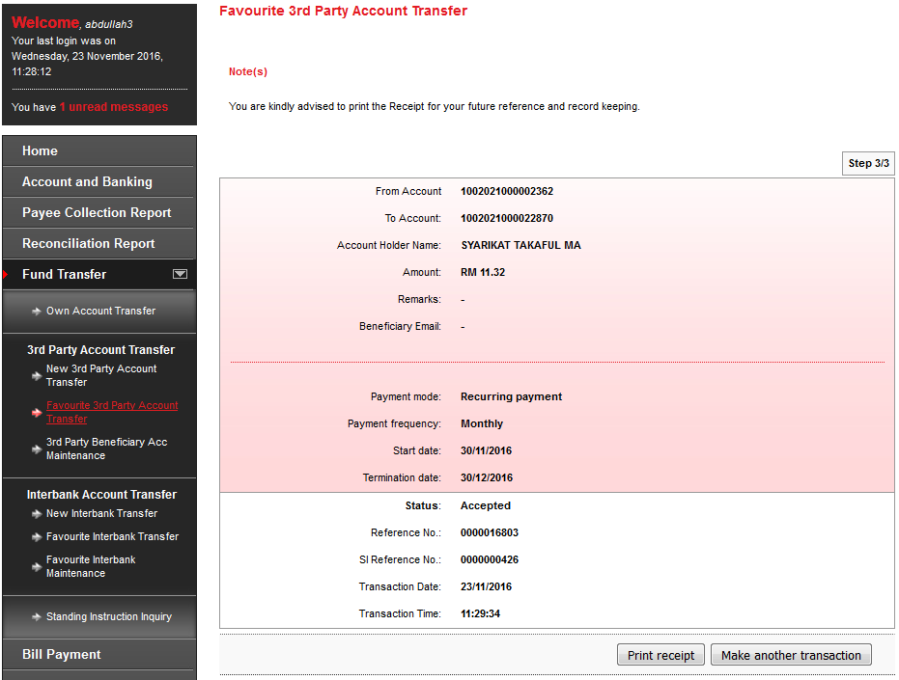

Print Receipt
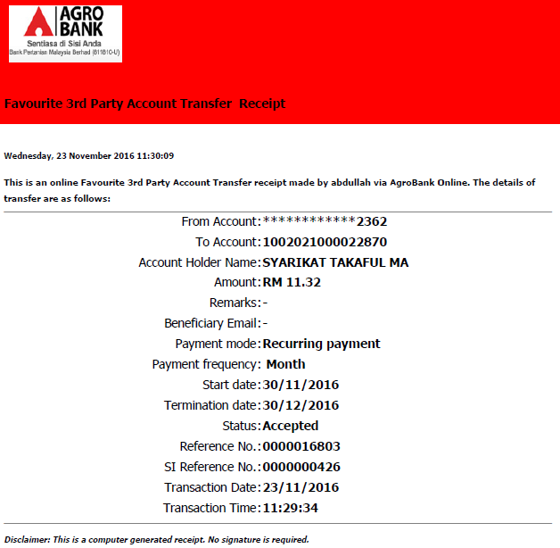

Transaction History
N/A for SI transaction

Agronet Transaction History
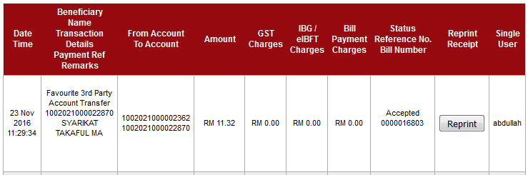

Initiator

Confirm Page
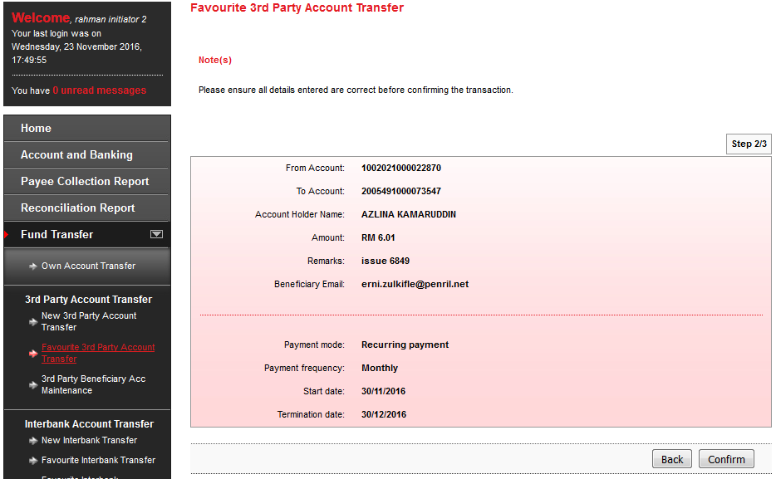

Result Page
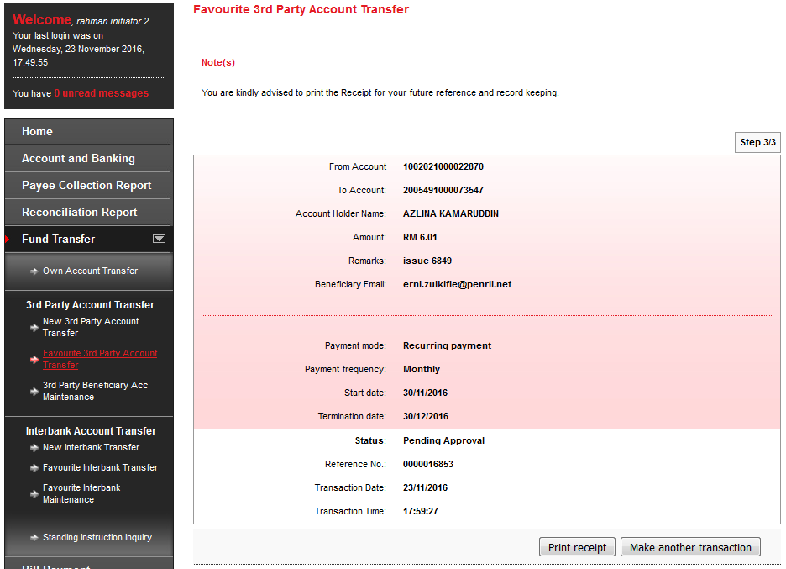

Print Receipt
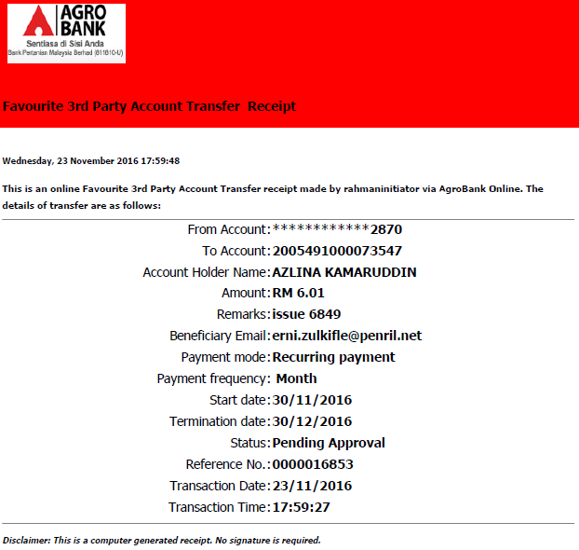

Approver

Confirm Page
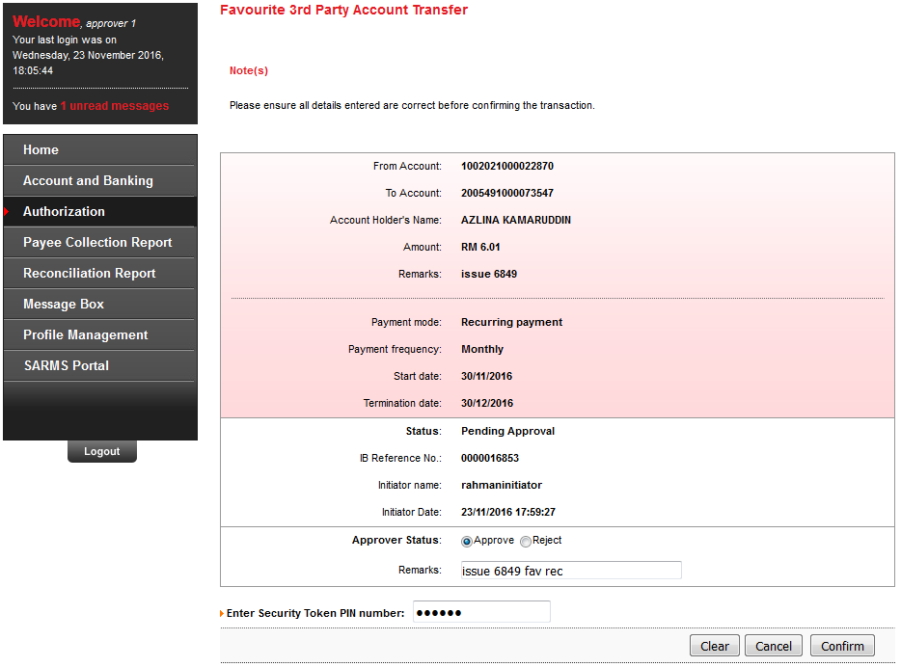

Result Page
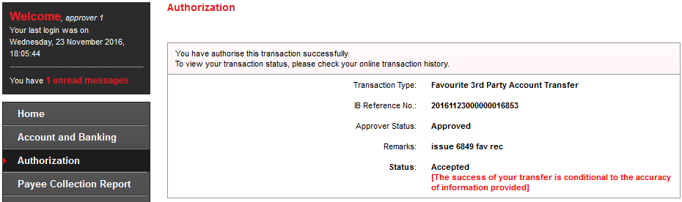

Transaction History
N/A for SI transaction

Agronet Transaction History
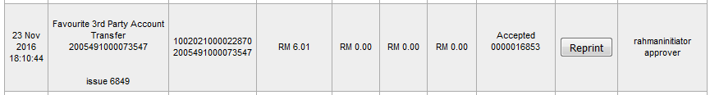

Bulk payment upload

Single User

Confirm Page
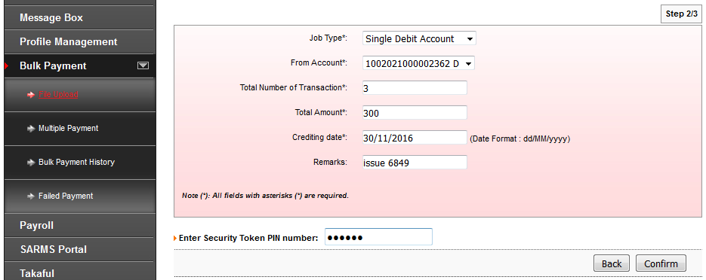

Result Page
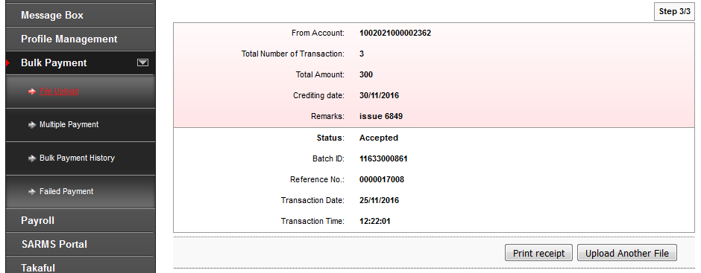

Print Receipt
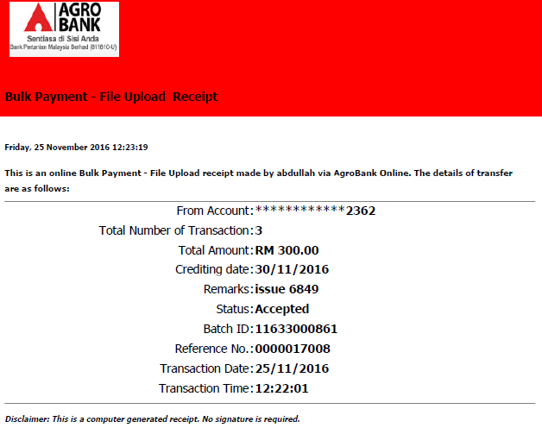

Transaction History
N/A

Agronet Transaction History
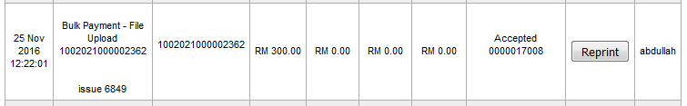

Initiator

Detail Page
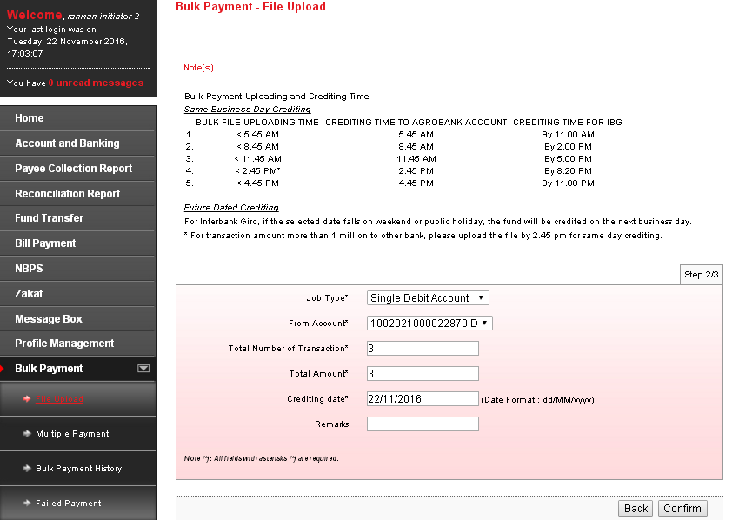

Confirm Page
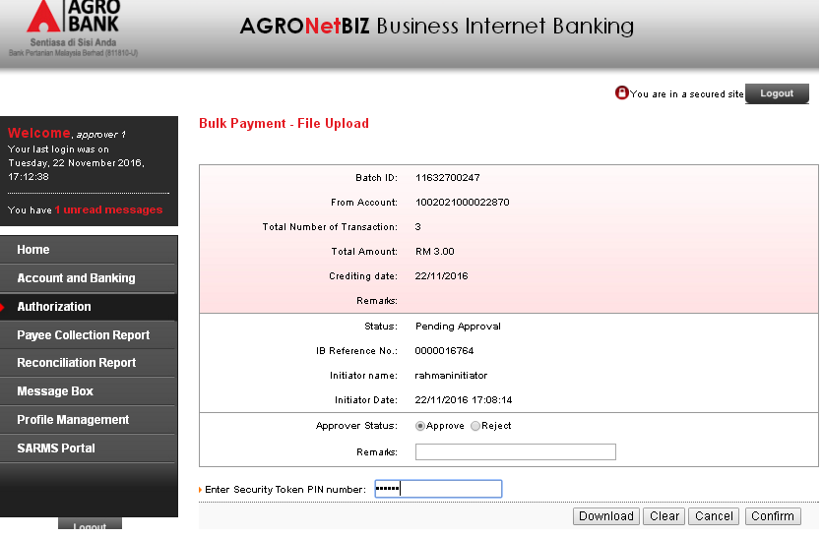

Result Page
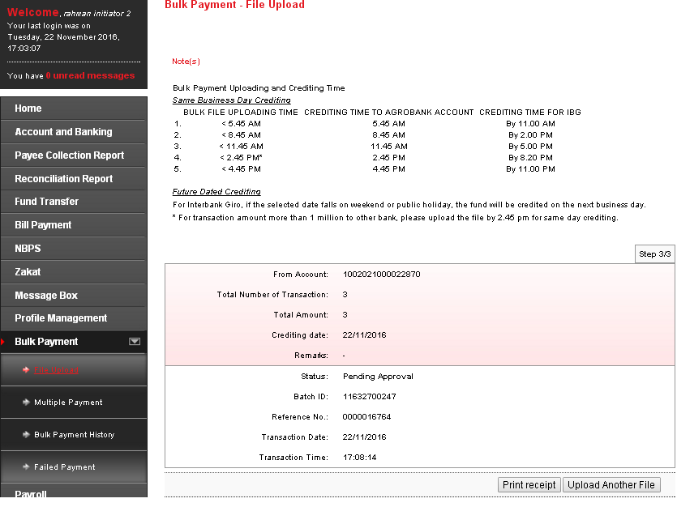

Print Receipt
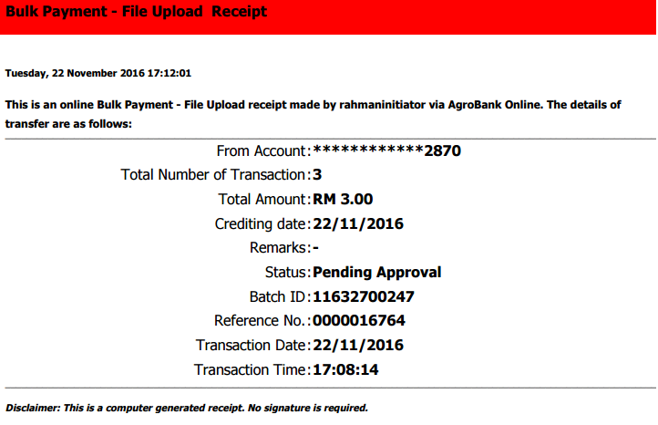

Approver

Confirm Page
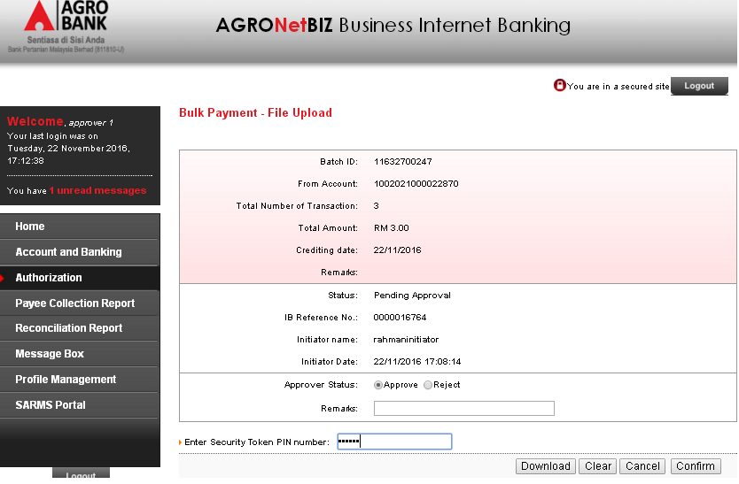

Result Page
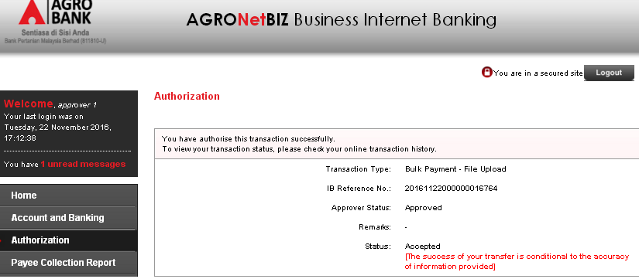

Transaction History
N/A

Agronet Transaction History
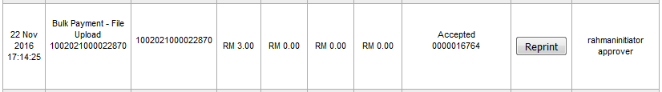

Bulk payment – multiple payment

Single User

Confirm Page
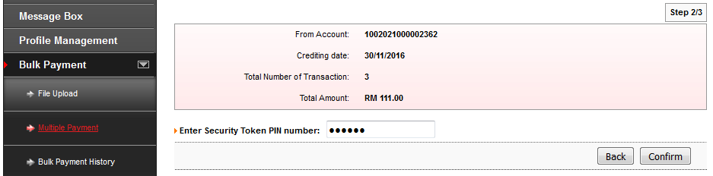

Result Page
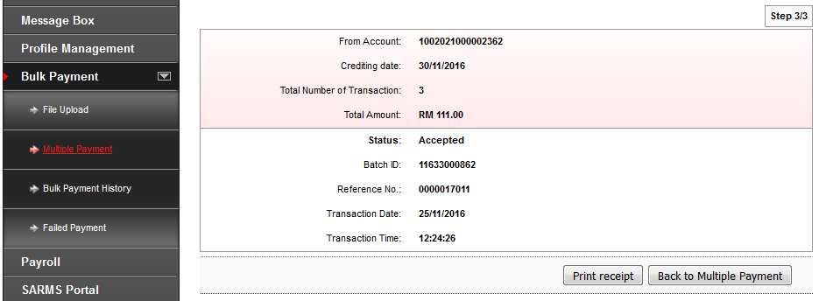

Print Receipt
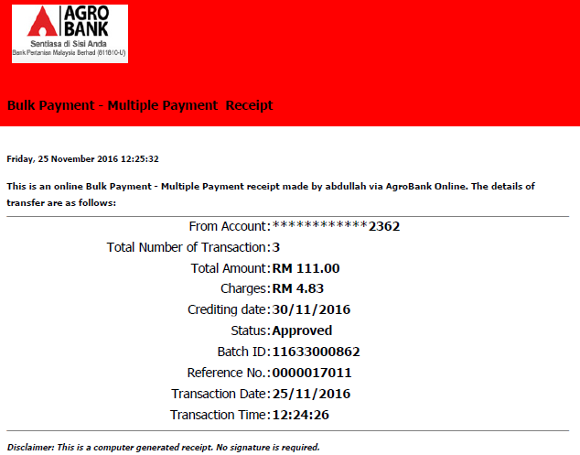

Transaction History
N/A

Agronet Transaction History
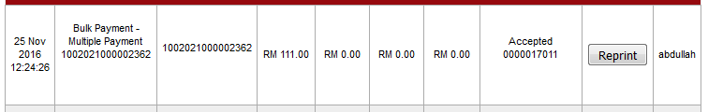

Initiator

Confirm Page
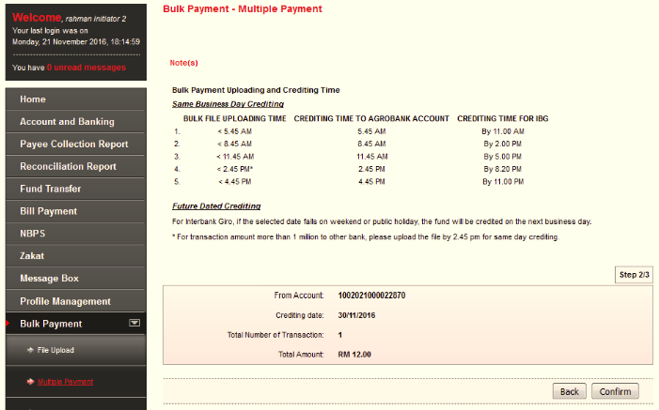

Result Page
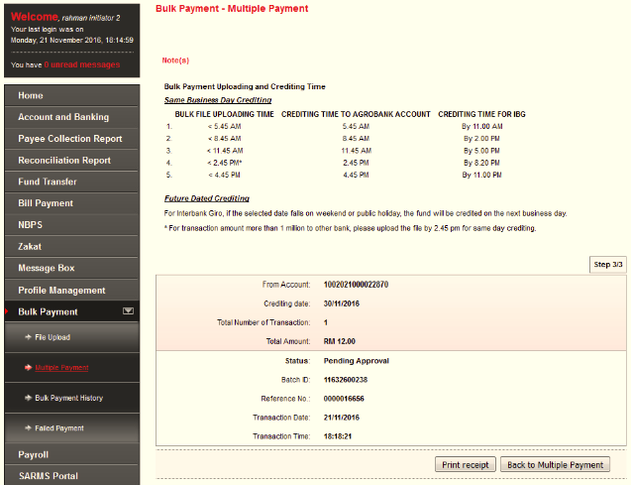

Print Receipt
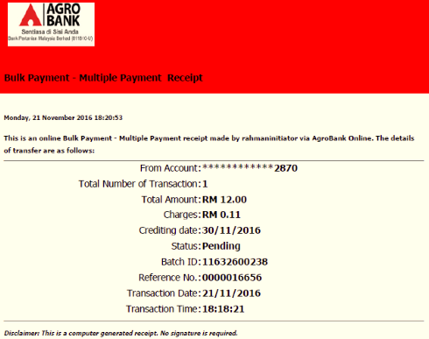

Approver

Confirm Page
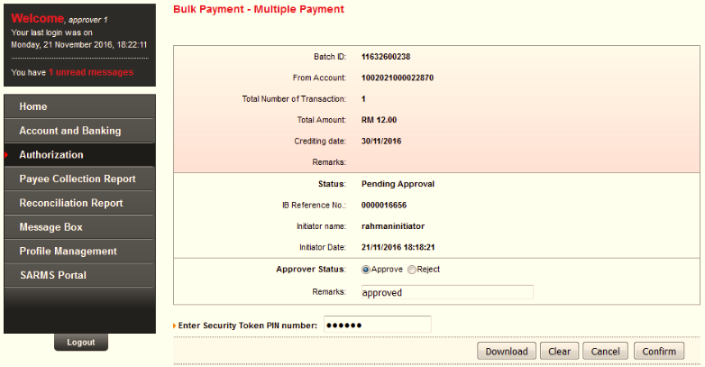

Result Page
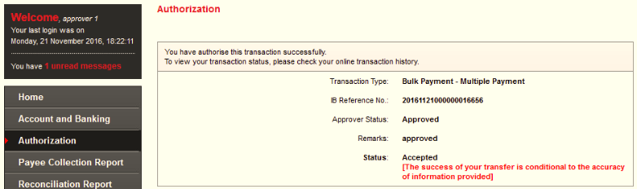

Transaction History
N/A

Agronet Transaction History
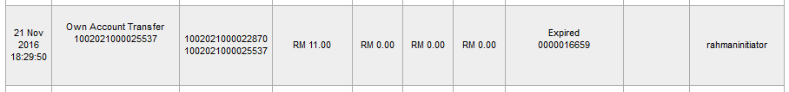
Reviewed By: (PMO
 |  |  | Name/Position : Norhaidah Binti Md Dasuki / Senior Manager, Quality Assurance and Support  Date : 18/11/2016

