Test Issue Log
Project Name: | Business Internet Banking
Test Stage: | Unit Functionality Integration System Interface  Performance Regression Acceptance Pilot
Test Case Number: | Support #6401 |  |  | Test Started Date: |  | 14/07/2016
Test Title: | Auto Sweeping 8 items enhancement
Test Description: | To ensure that enhancement done accordingly.
Test Functionality: | BIB>Sweep Funds
Test Procedure: | Fund Transfer  - Login to Single User/Multiple User.  - Perform Sweep Funds – Add  - View:  - Main account - change status to Accepted at AGRONET TRX HISTORY (sweep fund - add)  - Main account - able to print receipt for Accepted status at AGRONET TRX HISTORY (sweep fund - add)  - Main account - design print receipt for Accepted status at AGRONET TRX HISTORY (sweep fund - add)  - Edit step 1 to 4: Sweeping Amount To Main Account (Start)  - Edit step 1 to 4: Sweeping Amount From Main Account (End)  - Rearrange position step 1 to 4: 1) Sweeping Amount To Main Account (Start) ; 2) Sweeping Amount From Main Account (End)  - GST & BIB Commission (Charges) : Deduct from Main Account for Sweeping Amount To Main  Account (Start) & Sweeping Amount From Main Account (End)
Test Result: | Pass: Fail: | Tested by: |  |  | Nurul Akmal binti Yusof
Reason for Failure:
TEST DESCRIPTION

Auto Sweeping – Add

Single User

Step 1:
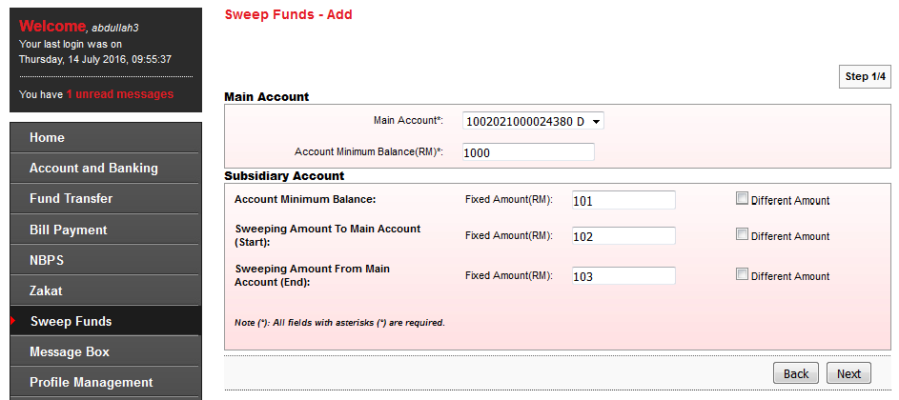

Step 2:
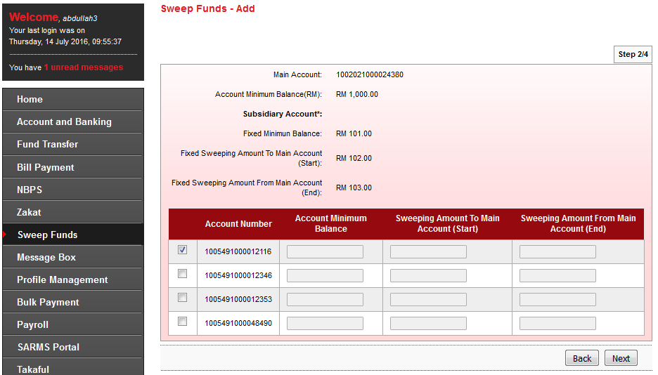

Step 3:
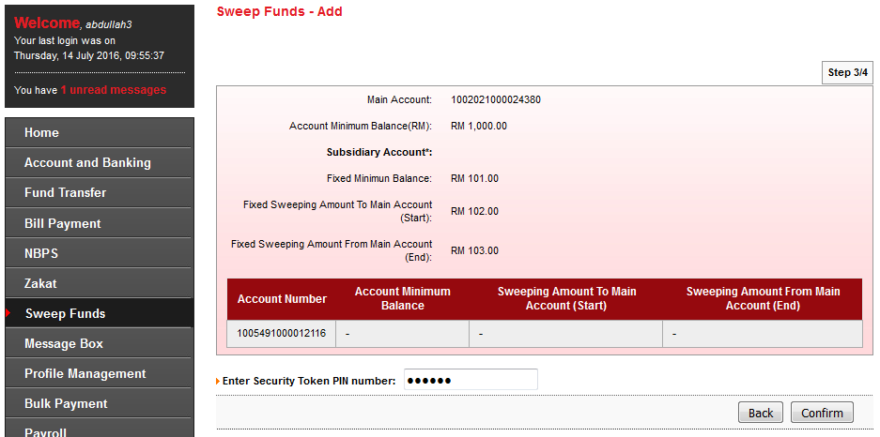

Step 4:
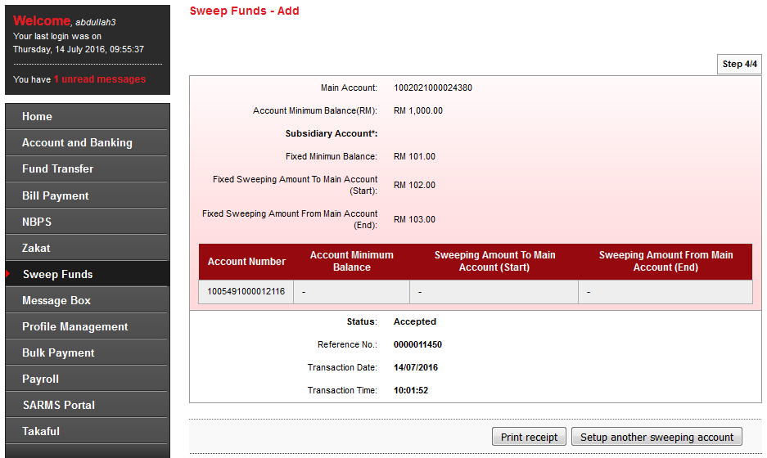
Item No 1: Status changed to Accepted.
Item No 4: Edit step 1 to 4: Sweeping Amount To Main Account (Start)
Item No 5: Edit step 1 to 4: Sweeping Amount From Main Account (End)
Item No 6: Rearrange position step 1 to 4:
1) Sweeping Amount To Main Account (Start) ;
2) Sweeping Amount From Main Account (End)

Print Receipt
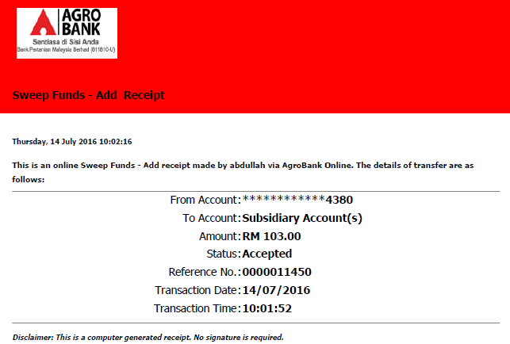

Item No 2 & No 3: Design & Print receipt for Accepted status.

Agronet Transaction History
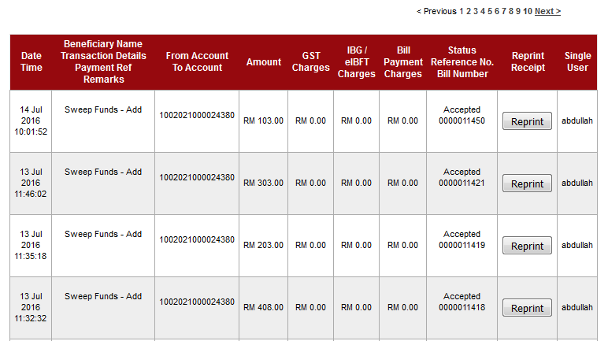

Reprint Receipt
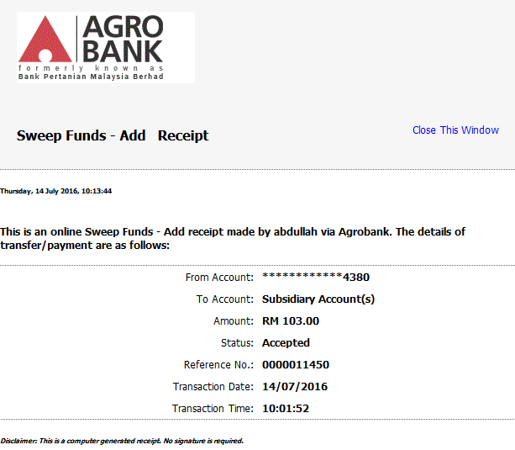

Initiator

Step 1:
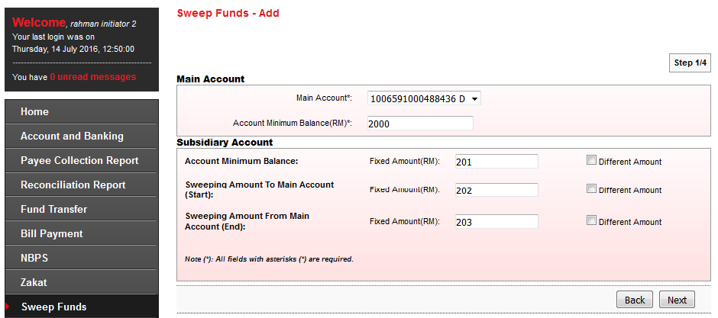

Step 2:
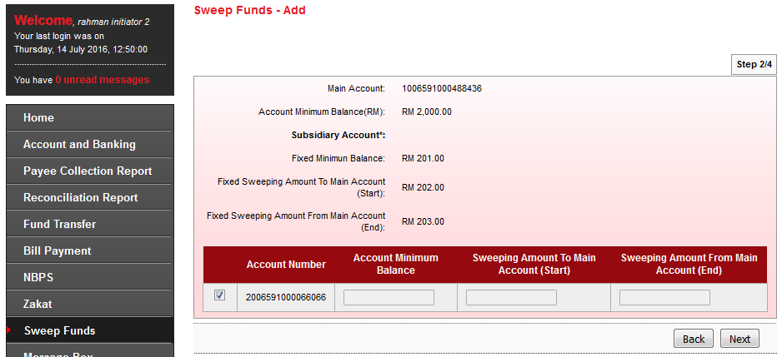

Step 3:
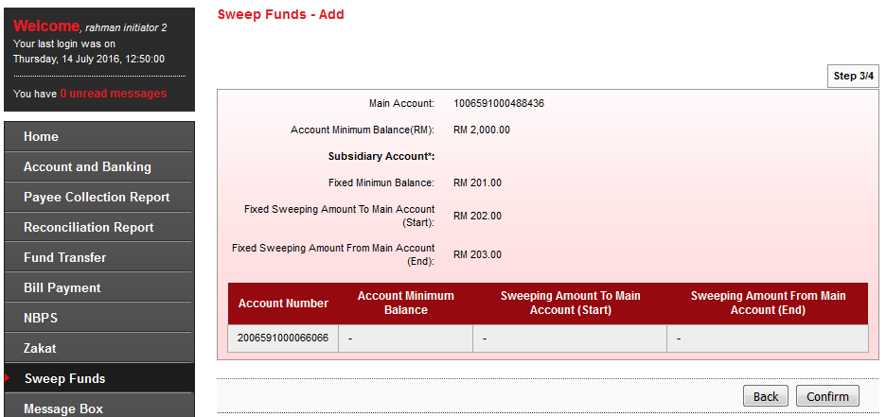

Step 4:
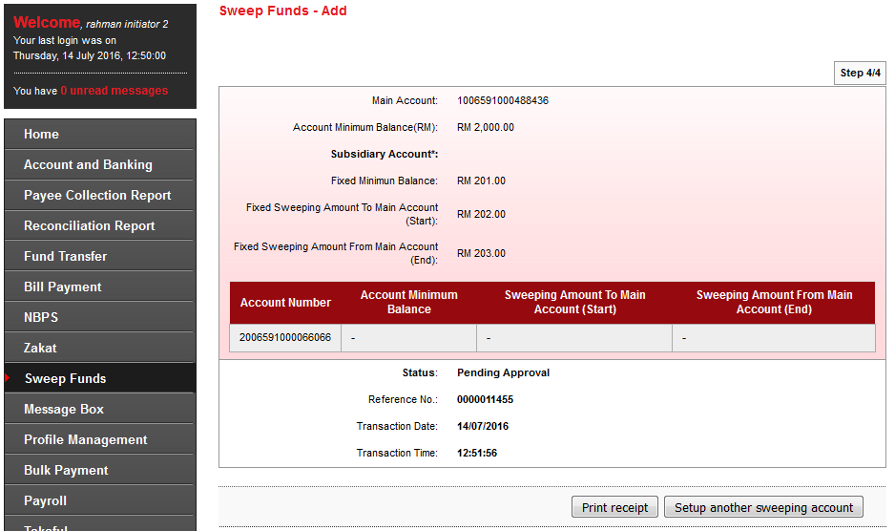
Item No 4: Edit step 1 to 4: Sweeping Amount To Main Account (Start)
Item No 5: Edit step 1 to 4: Sweeping Amount From Main Account (End)
Item No 6: Rearrange position step 1 to 4:
1) Sweeping Amount To Main Account (Start) ;
2) Sweeping Amount From Main Account (End)

Print Receipt
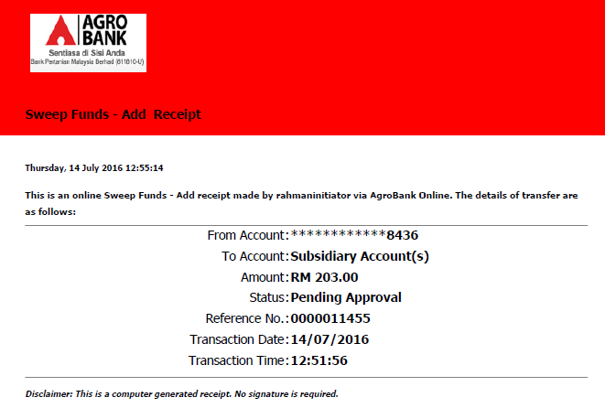

Approver

Authorization List
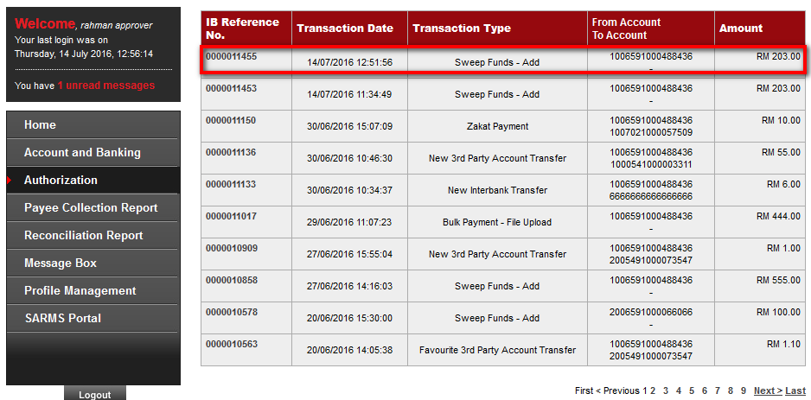

Confirm Screen
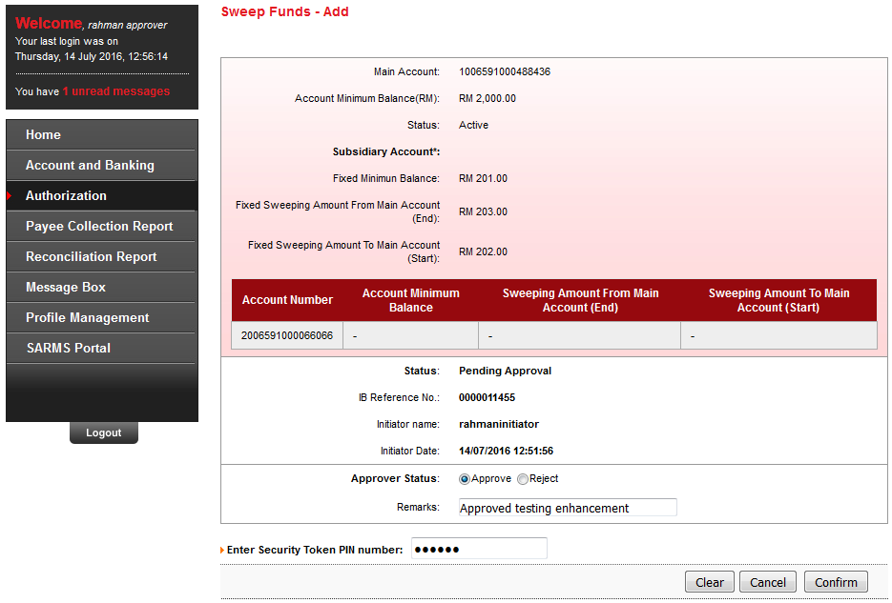

Result Screen
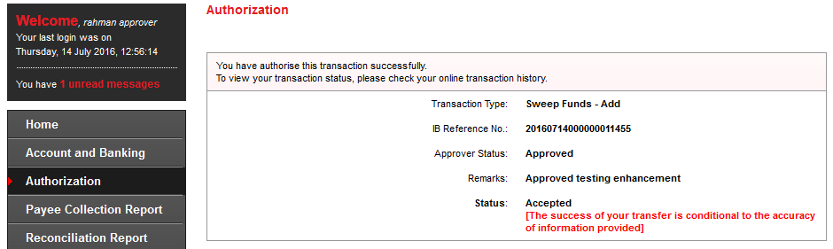
Item No 1: Status changed to Accepted.

Agronet Transaction History
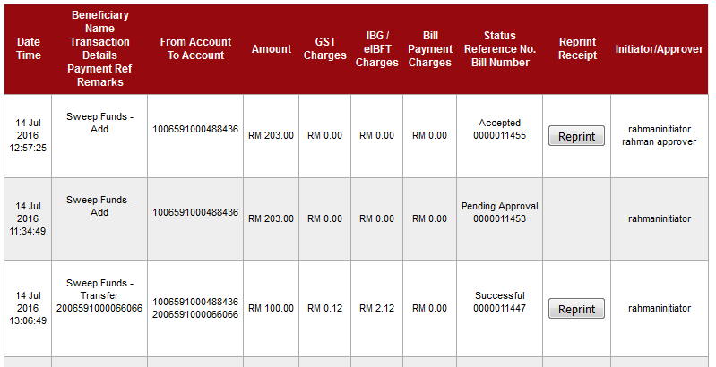

Reprint Receipt
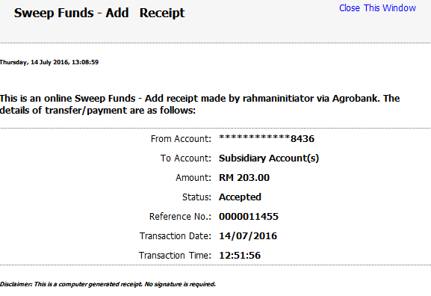
Item No 2 & No 3: Design & Print receipt for Accepted status.
Reviewed By: (PMO
 |  |  | Name/Position : Norhaidah Binti Md Dasuki / Senior Manager, Quality Assurance and Support  Date : 15/07/2016

