Test Issue Log |  |  |  |  |  | SCP ID# : 3483
Project Name: | Business Internet Banking
Test Stage: | Unit Functionality Integration System Interface  Performance Regression Acceptance Pilot
Test Case Number: | Support #6847 |  |  | Test Started Date: |  | 30/11/2016
Test Title: | BIB report problem – BIB eIBFT Report Daily
Test Description: | To ensure that both BIB report header is correct.
Test Functionality: | BIB>Fund Transfer>Interbank Account Transfer>eIBFT
Test Procedure: | Fund Transfer  - Login to BIB.  - Perform eIBFT transaction.  - Generate BIB eIBFT Report Daily.
Test Result: | Pass: Fail: | Tested by: |  |  | Nurul Akmal binti Yusof
Reason for Failure:
TEST DESCRIPTION

BIB eIBFT Report Daily with Data
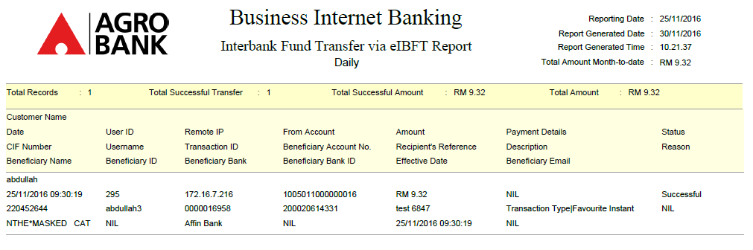

BIB eIBFT Report Daily no Data
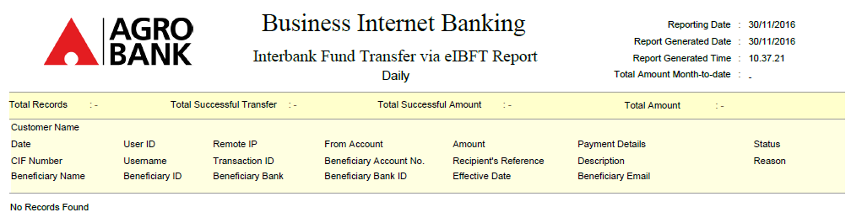

Reviewed By: (PMO
 |  |  | Name/Position : Norhaidah Binti Md Dasuki / Senior Manager, Quality Assurance and Support  Date : 30/11/2016

