Test Issue Log |  |  |  |  |  | SCP ID# : 3510
Project Name: | AGROBANK BUSINESS INTERNET BANKING
Test Stage: | Unit Functionality Integration System Interface  Performance Regression Acceptance Pilot
Test Case Number: | Support #6911 |  |  | Test Started Date: |  |  | 06/12/2016
Test Title: | KADA ISSUE
Test Description: | To ensure the Reconciliation search date function can successfully perform.  https://10.6.6.20/bib.it.kada/common/Login.do
Test Functionality: | BIB  Reconciliation Report
Test Procedure: | BIB – Multiple User  - Login to BIB as Initiator  - Choose on Display Report by Date.  - Choose on Display Report by Month  - Click on ‘Go’ button.  BIB – Single User  - Login to BIB as Initiator  - Choose on Display Report by Date.  - Choose on Display Report by Month  - Click on ‘Go’ button.
Test Result: | Pass: Fail: | Tested by: |  |  | Erni Suhaireen binti Zulkifli
Reason for Failure:
TEST DESCRIPTION
BIB – Multiple User
- Login to BIB as Initiator
- Choose on Display Report by Date.
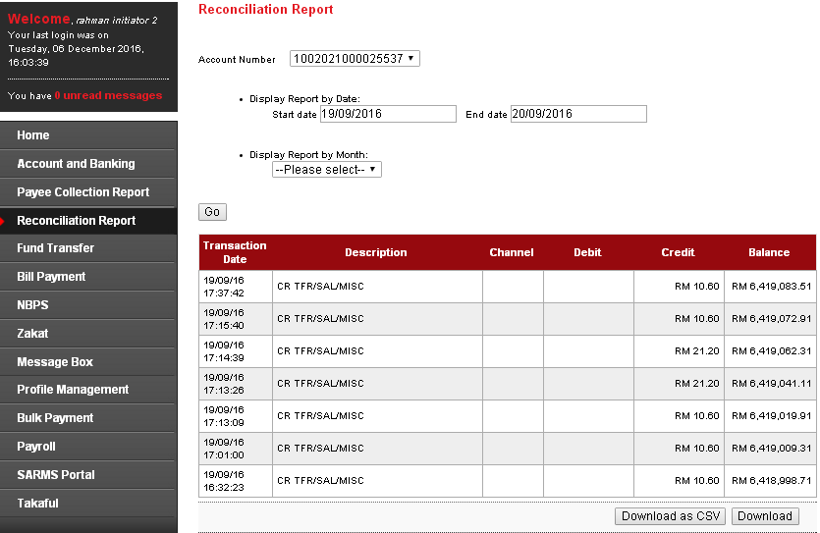
  - Download as CSV
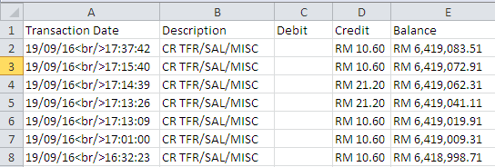
  - Download
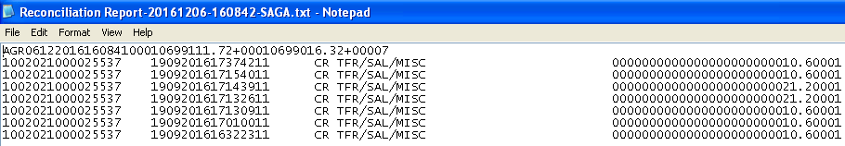

- Choose on Display Report by Month
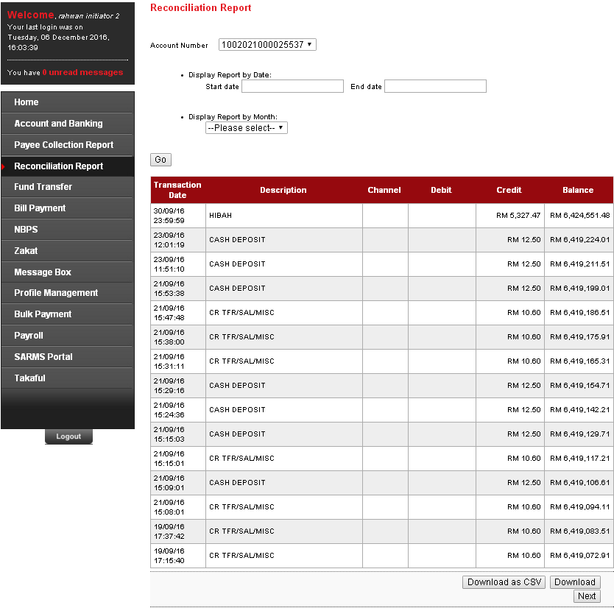

Download as CSV
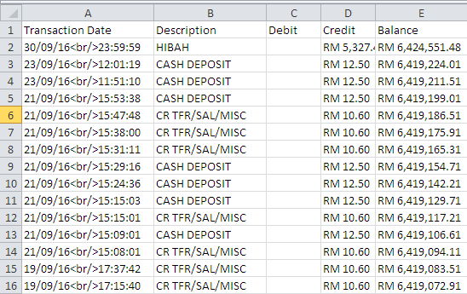

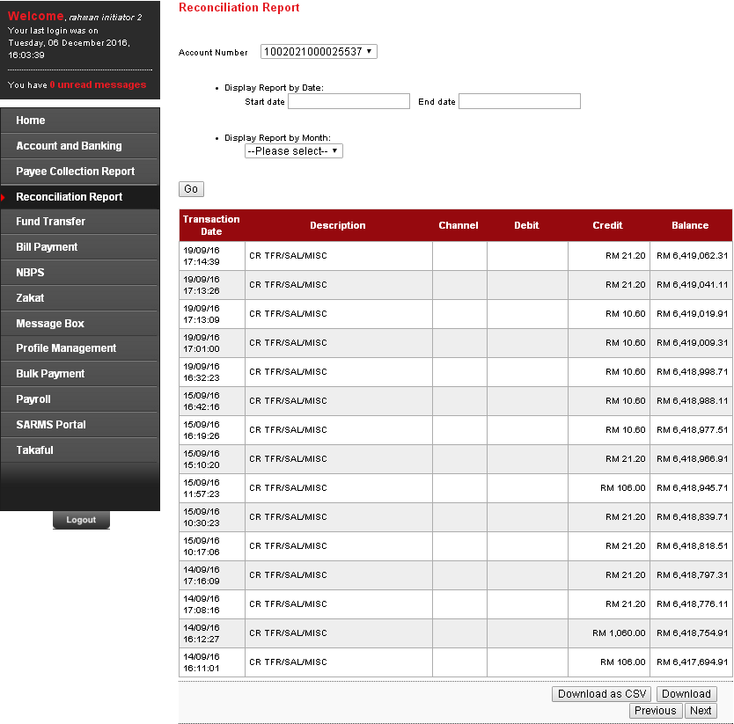

Download as CSV
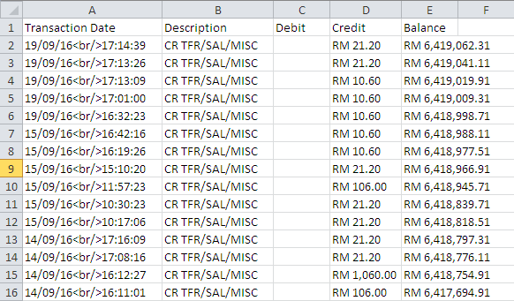
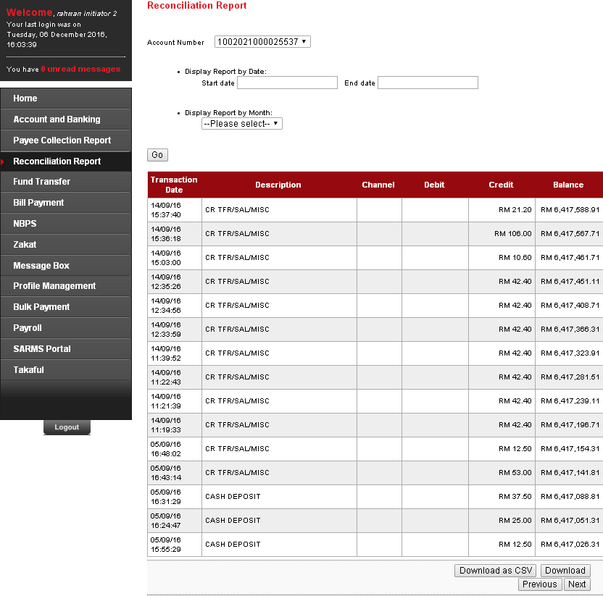

Download as CSV
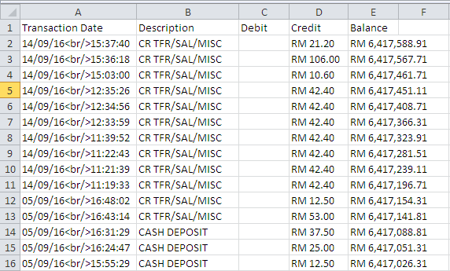

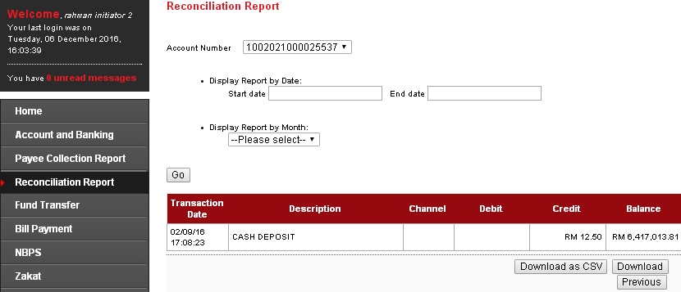
Download as CSV
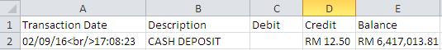
  - Download
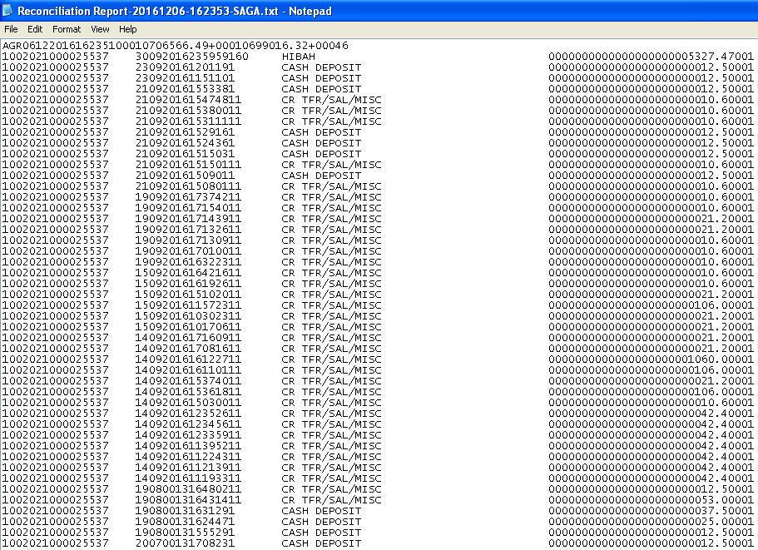
BIB – Single User
- Login to BIB as Single User
- Choose on Display Report by Date.
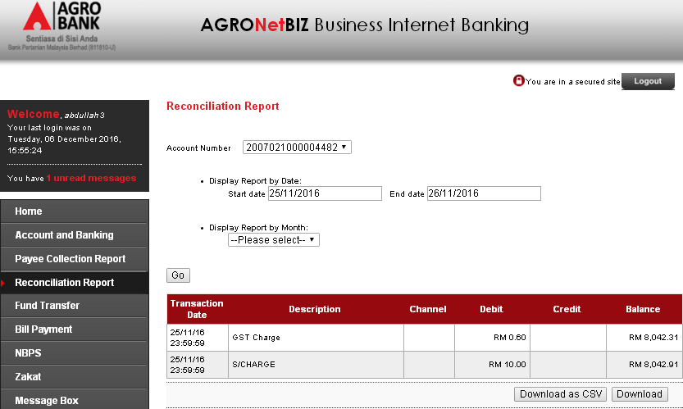
  - Download as CSV
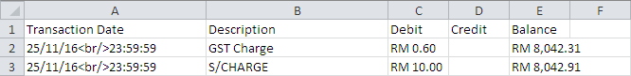
  - Download
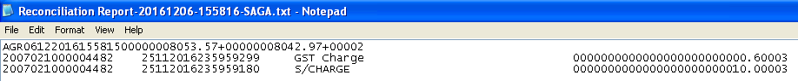

- Choose on Display Report by Month
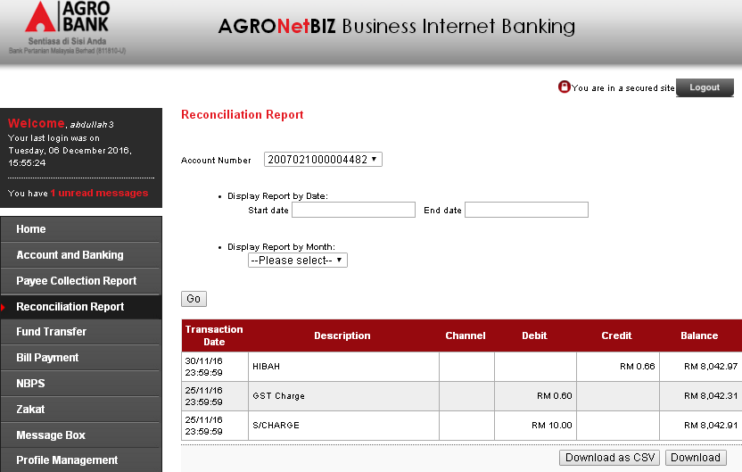
  - Download as CSV
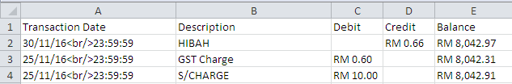
  - Download
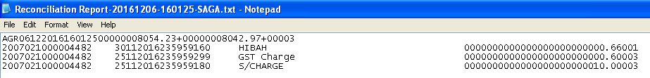

Reviewed By: (PMO)
 |  |  | Name/Position : Norhaidah Binti Md Dasuki / Senior Manager, Quality Assurance and Support  Date :

