Test Issue Log |  |  |  |  |  | SCP ID# :
Project Name: | AGROBANK BUSINESS INTERNET BANKING
Test Stage: | Unit Functionality Integration System Interface  Performance Regression Acceptance Pilot
Test Case Number: | Support #6753 |  |  | Test Started Date: |  |  | 04/11/2016
Test Title: | [Comfort Test] - LHDN and SOCSO file upload
Test Description: | - To ensure system not crash if customer actively upload file in the same time.  - To test on optimization of upload speeds  https://10.6.6.20/bib.sit.lhdn/common/Login.do
Test Functionality: | - LHDN: Payroll > LHDN
Test Procedure: | - LHDN  - Perform LHDN payment with 300 records.  - View Result Page  - View LHDN Transfer History  - View AgronetBiz Transaction History
Test Result: | Pass: Fail: | Tested by: |  |  | Erni Suhaireen binti Zulkifli
Reason for Failure:
TEST DESCRIPTION
- LHDN
Sample file upload for LHDN
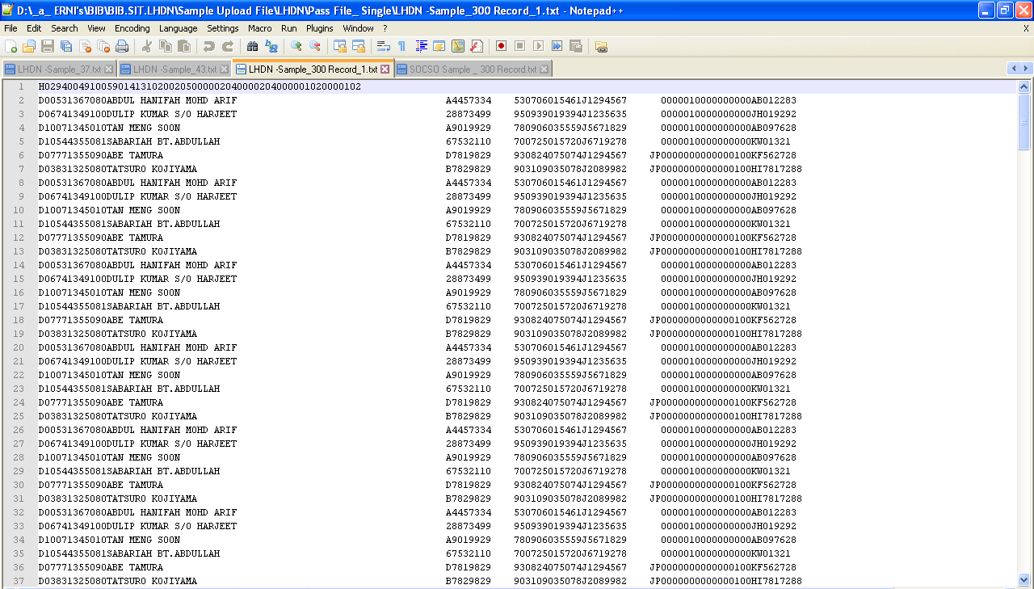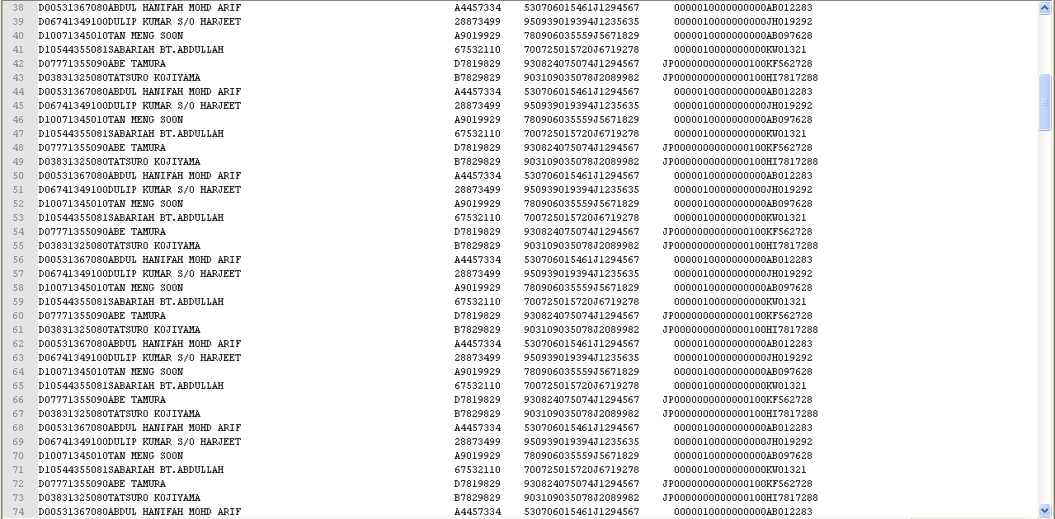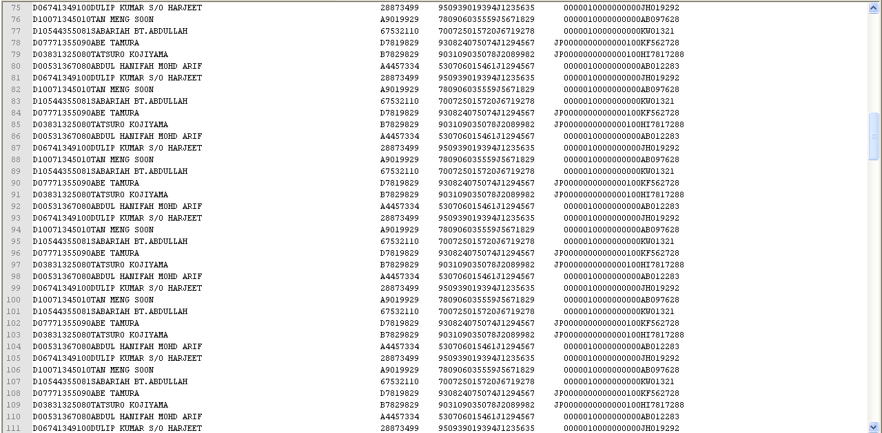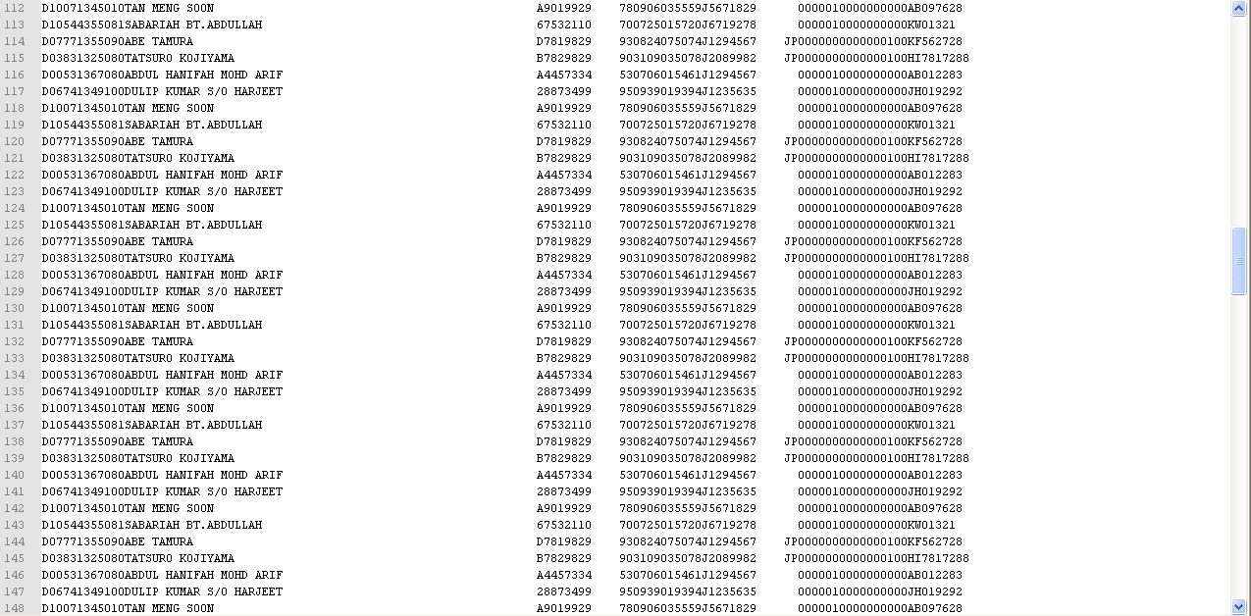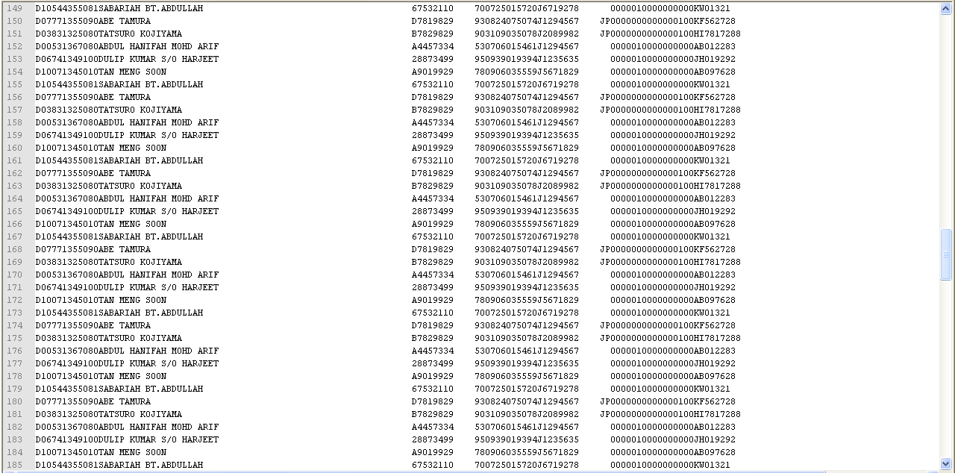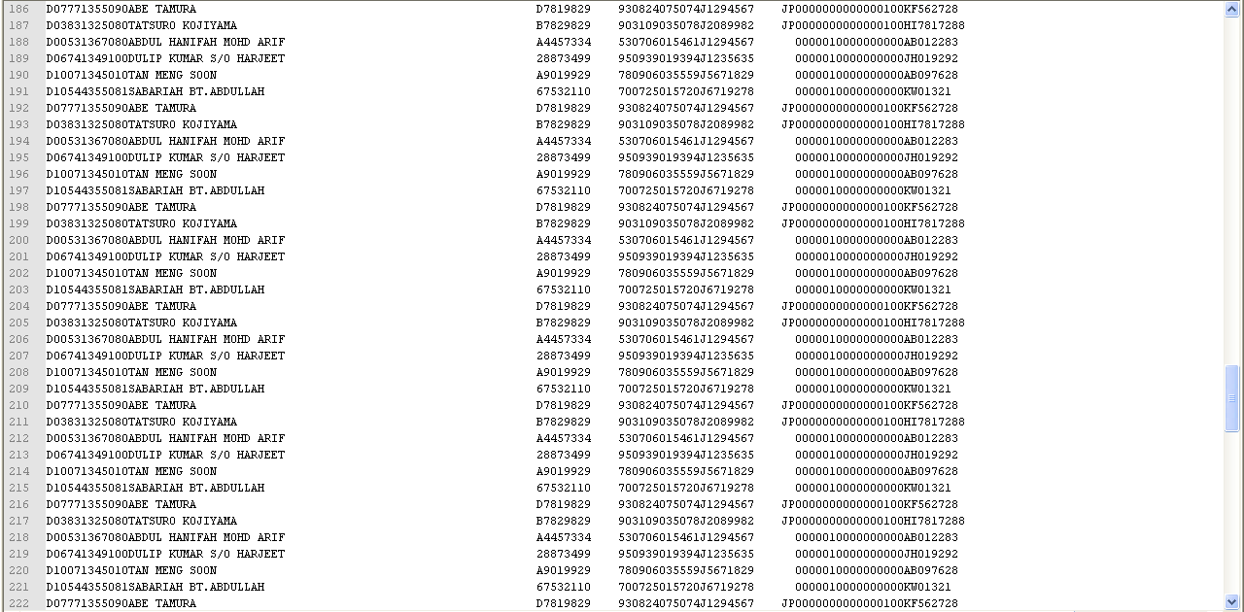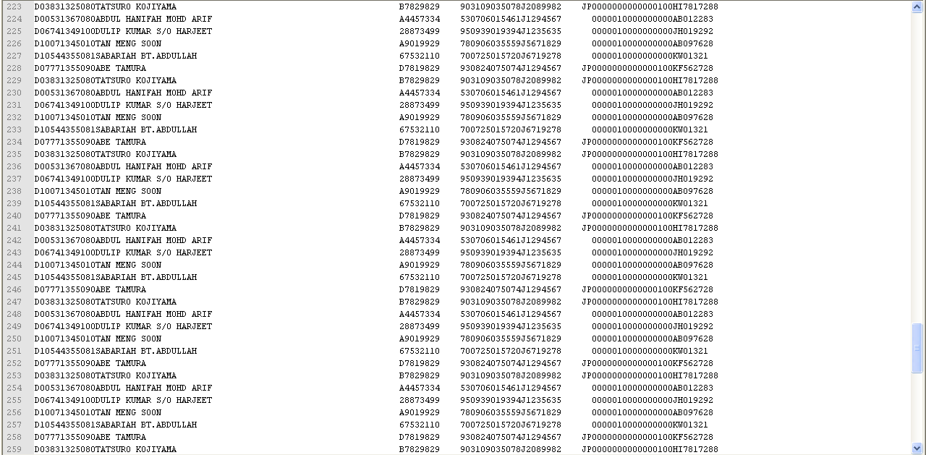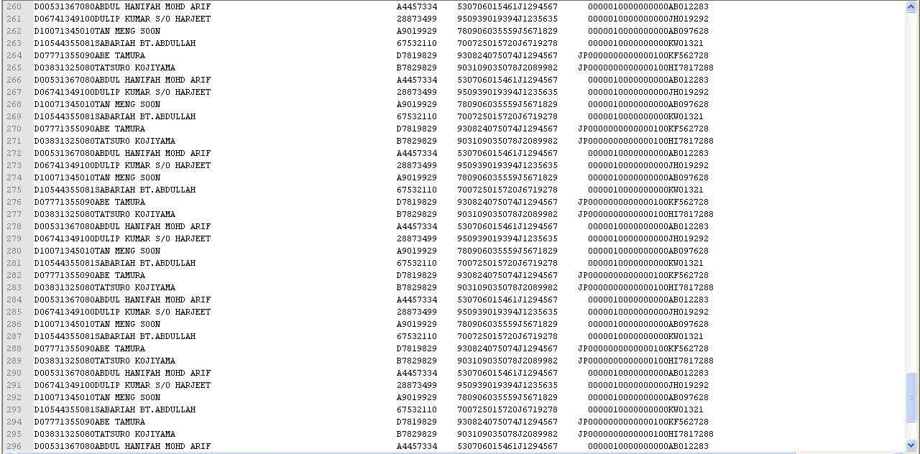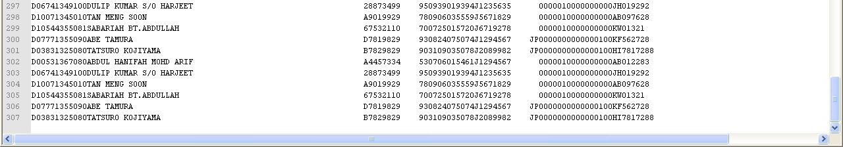

- Perform LHDN payment with 300 records.
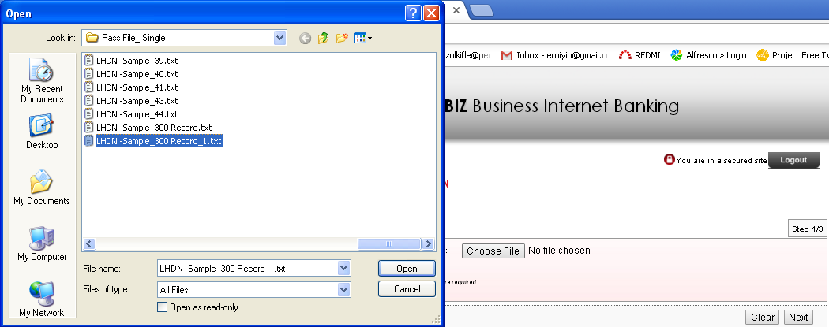
  - View Result Page
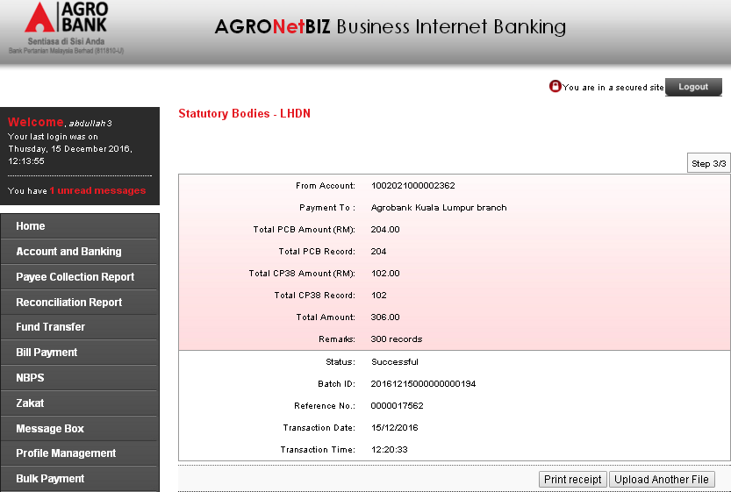

  - View LHDN Transfer History
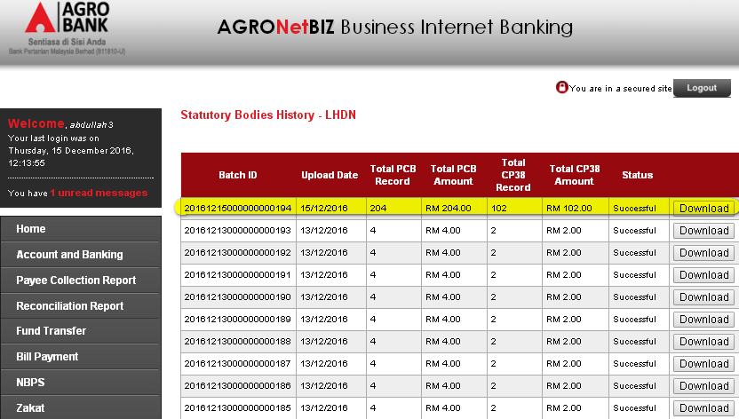
  - View AgronetBiz Transaction History
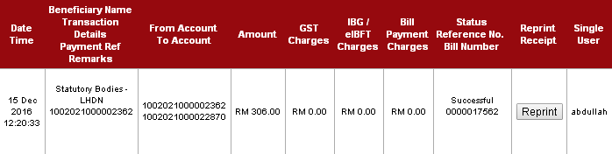

Reviewed By: (PMO)
 |  |  | Name/Position : Norhaidah Binti Md Dasuki / Senior Manager, Quality Assurance and Support  Date : 26/10/2016

