# IBAM Content – Payee

|  |  |
| --- | --- |
| **Redmine ID** | Support #6759 |
| **Test ID** | [SCP ID :##3453##] : Bill Payment SYABAS issue |
| **Test Description** | To list down all payee that need to be tested |
| **Module Involved** | IBAM: Content - Payee |
| **Test Steps** | 1. Access on IBAM Content Payee 2. Set Payee commission/charges or modify service info in ‘FUNOEIBFT’ & ‘ FUNFEIBFT” 3. Perform Bill Payment transaction for BIB 4. Verify transaction in Transaction History (AGRONetBiz and Host) |
| **Verification Details** | Test Field  **Step 1) Payee at IBAM**   * Modify a **Charges/Commission fo**r **Business Internet Banking**  |  |  |  | | --- | --- | --- | | **Modify Content** | Payee Name 1 | *<Fill in with standard value>* | | Charges | *<Fill in with standard value>* | | Commission | *<Fill in with standard value>* | | Payee Name 2 | *<Fill in with standard value>* | | Charges | *<Fill in with standard value>* | | Commission | *<Fill in with standard value>* | | Payee Name 3 | *<Fill in with standard value>* | | Charges | *<Fill in with standard value>* | | Commission | *<Fill in with standard value>* | |

**UTILITIES**

|  |  |  |
| --- | --- | --- |
|  |  | Payee Name |
| **Modify Content**  **Modify Content**  **Modify Content** | Payee Name 1 | Dewan Bandaraya Kuala Lumpur (DBKL) |
| Payee Code | 607 |
| BIB Charges | RM 0.00 |
| RIB Charges | RM 0.00 |
| Commission | RM 0.00 |
| Payee Name 2 | Majlis Perbandaran Seberang Perai (MPSP) |
| Payee Code | 606 |
| BIB Charges | RM 1.00 |
| RIB Charges | RM 0.00 |
| Commission | RM 0.70 |
| Payee Name 3 | Majlis Perbandaran Pulau Pinang (MPPP) |
| Payee Code | 605 |
| BIB Charges | RM 1.00 |
| RIB Charges | RM 0.00 |
| Commission | RM 0.50 |
| Payee Name 10 | Majlis Perbandaran Selayang (MPS) |
| Payee Code | 604 |
| BIB Charges | RM 1.00 |
| RIB Charges | RM 0.00 |
| Commission | RM 0.30 |
| Payee Name 11 | Majlis Bandaraya Shah Alam (MBSA) |
| Payee Code | 603 |
| BIB Charges | RM 1.00 |
| RIB Charges | RM 0.00 |
| Commission | RM 0.50 |
| Payee Name 12 | Majlis Perbandaran Ampang Jaya (MPAJ) |
| Payee Code | 602 |
| BIB Charges | RM 1.00 |
| RIB Charges | RM 0.00 |
| Commission | RM 0.50 |
| Payee Name 13 | Majlis Perbandaran Kuantan (MPK) |
| Payee Code | 601 |
| BIB Charges | RM 1.00 |
| RIB Charges | RM 0.00 |
| Commission | RM 0.50 |
| Payee Name 14 | Majlis Perbandaran Johor Baru Tengah (MPJBT) |
| Payee Code | 600 |
| BIB Charges | RM 1.00 |
| RIB Charges | RM 0.00 |
| Commission | RM 0.40 |
| Payee Name 15 | Jabatan Air Negeri Sabah (JANS) |
| Payee Code | 510 |
| BIB Charges | RM 1.00 |
| RIB Charges | RM 0.00 |
| Commission | RM 0.00 |
| Payee Name 17 | Syarikat Air Negeri Sembilan (SAINS) |
| Payee Code | 509 |
| BIB Charges | RM 1.00 |
| RIB Charges | RM 0.00 |
| Commission | RM 0.00 |
| Payee Name 18 | Syarikat Air Melaka Bhd (SAMB) |
| Payee Code | 508 |
| BIB Charges | RM 1.00 |
| RIB Charges | RM 0.00 |
| Commission | RM 0.50 |
| Payee Name 19 | Syarikat Air Darul Aman (SADA) |
| Payee Code | 507 |
| BIB Charges | RM 1.00 |
| RIB Charges | RM 0.00 |
| Commission | RM 0.30 |
| Payee Name 20 | Pengurusan Air Pahang (PAIP) |
| Payee Code | 506 |
| BIB Charges | RM 1.00 |
| RIB Charges | RM 0.00 |
| Commission | RM 0.00 |
| Payee Name 21 | Syarikat Bekalan Air Selangor (SYABAS) |
| Payee Code | 505 |
| BIB Charges | RM 1.00 |
| RIB Charges | RM 0.00 |
| Commission | RM 0.00 |
| Payee Name 22 | Air Kelantan Sdn Bhd (AKSB) |
| Payee Code | 504 |
| BIB Charges | RM 1.00 |
| RIB Charges | RM 0.00 |
| Commission | RM 0.50 |
| Payee Name 23 | Lembaga Air Perak (LAP) |
| Payee Code | 503 |
| BIB Charges | RM 1.00 |
| RIB Charges | RM 0.00 |
| Commission | RM 0.30 |
| Payee Name 24 | Perbadanan Bekalan Air Pulau Pinang (PBAPP) |
| Payee Code | 502 |
| BIB Charges | RM 1.00 |
| RIB Charges | RM 0.00 |
| Commission | RM 0.40 |
| Payee Name 25 | Syarikat Air Terengganu (SATU) |
| Payee Code | 501 |
| BIB Charges | RM 1.00 |
| RIB Charges | RM 0.00 |
| Commission | RM 0.00 |
| Payee Name 26 | Syarikat Air Johor (SAJ) |
| Payee Code | 500 |
| BIB Charges | RM 1.00 |
| RIB Charges | RM 0.00 |
| Commission | RM 0.50 |
| Payee Name 27 | Sarawak Electricity (SESCO) |
| Payee Code | 401 |
| BIB Charges | RM 1.00 |
| RIB Charges | RM 0.00 |
| Commission | RM 0.50 |
| Payee Name 28 | Sabah Electricity Sdn Bhd (SESB) |
| Payee Code | 400 |
| BIB Charges | RM 1.00 |
| RIB Charges | RM 0.00 |
| Commission | RM 0.45 |
| Payee Name 29 | Tenaga Nasional Berhad (TNB) |
| Payee Code | 300 |
| BIB Charges | RM 1.00 |
| RIB Charges | RM 0.00 |
| Commission | RM 0.30 |
| Payee Name 30 | ASTRO |
| Payee Code | 250034 |
| BIB Charges | RM 1.00 |
| RIB Charges | RM 0.00 |
| Commission | RM 0.30 |

**TELCOS**

|  |  |  |
| --- | --- | --- |
| **Modify Content** | Payee Name 1 | Telekom Malaysia |
| Payee Code | 100 |
| BIB Charges | RM 0.00 |
| RIB Charges | RM 0.00 |
| Commission | RM 0.25 |
| Payee Name 2 | TMNET |
| Payee Code | 101 |
| BIB Charges | RM 0.00 |
| RIB Charges | RM 0.00 |
| Commission | RM 0.00 |
| Payee Name 3 | CELCOM |
| Payee Code | 200 |
| BIB Charges | RM 0.00 |
| RIB Charges | RM 0.00 |
| Commission | RM 0.00 |
| Payee Name 5 | TM UNIFI |
| Payee Code | 2500032 |
| BIB Charges | RM 1.00 |
| RIB Charges | RM 0.00 |
| Commission | RM 0.00 |
| Payee Name 6 | UMobile |
| Payee Code | 2500034 |
| BIB Charges | RM 1.00 |
| RIB Charges | RM 0.00 |
| Commission | RM 0.00 |
| Payee Name 7 | TM Telephone |
| Payee Code | 250029 |
| BIB Charges | RM 1.00 |
| RIB Charges | RM 0.00 |
| Commission | RM 0.40 |
| Payee Name 8 | TM Streamyx |
| Payee Code | 250030 |
| BIB Charges | RM 1.00 |
| RIB Charges | RM 0.00 |
| Commission | RM 0.40 |
| Payee Name 9 | RedOne Bill |
| Payee Code | 250030 |
| BIB Charges | RM 1.00 |
| RIB Charges | RM 0.00 |
| Commission | RM 0.25 |
| Payee Name 10 | Celcom Bill Payment |
| Payee Code | 250041 |
| BIB Charges | RM 1.00 |
| RIB Charges | RM 0.00 |
| Commission | RM 0.40 |
| Payee Name 11 | Telekom |
| Payee Code | 250045 |
| BIB Charges | RM 1.00 |
| RIB Charges | RM 0.00 |
| Commission | RM 0.40 |

**EDUCATION FINANCING**

|  |  |  |
| --- | --- | --- |
| **Modify Content** | Payee Name 1 | Perbadanan Tabung Pendidikan Tinggi Nasional (PTPTN) |
| Payee Code | 706 |
| BIB Charges | RM 1.00 |
| RIB Charges | RM 0.00 |
| Commission | RM 0.00 |
| Payee Name 2 | Perbadanan Tabung Pendidikan Tinggi Nasional |
| Payee Code | 707 |
| BIB Charges | RM 0.00 |
| RIB Charges | RM 0.00 |
| Commission | RM 0.00 |

**ONLINE SHOPING**

|  |  |  |
| --- | --- | --- |
| **Modify Content** | Payee Name 1 | FAMA AGROBAZA |
| Payee Code | 251 |
| BIB Charges | RM 0.00 |
| RIB Charges | RM 0.00 |
| Commission | RM 0.50 |

# 2. BIB – Bill Payment

|  |  |
| --- | --- |
| **Redmine ID** | Support #6759 |
| **Test ID** | [SCP ID :##3453##] : Bill Payment SYABAS issue |
| **Test Description** | To test on all Payee for Bill Payment. |
| **Module Involved** | BIB – Bill Payment  BIB – AGRONet Transaction History  BIB – Transaction History  IBAM – Report Module |
| **Test Steps** | 1. Perform Transaction to pay payee 2. Verify status of transaction in AGRONet Transaction History 3. Verify status of transaction in Transaction History 4. Validate this activity in the IBAM report, BIB Transaction Enquiry and User Activity Log |
| Verification Details | **Step 1)**  Perform Bill Payment Transaction – Enter all required field   |  |  | | --- | --- | | Payee | *<Fill in the value>* | | From Account | *<Fill in the value>* | | Amount | *<Fill in the value>* | | Charges | *<Fill in the value>* | | Result in BIB | **Status:***<field>*  **Reference ID:***<field>* |   **Step *2*)**  Verify in AGRONetBiz Transaction history   |  |  | | --- | --- | | Result in RIB | *Does the transaction successful?*  *<field>* |   **Step *3*)**  Verify in Transaction history   |  |  | | --- | --- | | Result in RIB | *Does the transaction successful?*  *<field>* |   **Step 4)**  Check inside the IBAM User Activity Log   |  |  | | --- | --- | | User Name | *<field>* | | User ID | *<field>* | | Date created | *<field>* | | Result on IBAM | *Does the information displayed correctly?*  *<Answer>* |   **Step 5)**  Check inside the IBAM – BIB Transaction Enquiry   |  |  | | --- | --- | | User Name | *<field>* | | User ID | *<field>* | | Date created | *<field>* | | Result on IBAM | *Does the information displayed correctly?*  *<Answer>* |   **Step 6)**  Check inside the IBAM Report (Day After)   |  |  | | --- | --- | | User Name | *<field>* | | User ID | *<field>* | | Date created | *<field>* | | Result on IBAM | *Does the information displayed correctly?*  *<Answer>* | |

<Test ID> - Bill Payment Transaction Payee List in BIB

Roles: Single User

User Name:

From Account:

|  |  |  |  |  |
| --- | --- | --- | --- | --- |
| Payee Name | Amount | Charges | Transaction ID | Status |
|  |  |  |  |  |
|  |  |  |  |  |
|  |  |  |  |  |

AGRONetBiz Transaction history <Screenshot>

Transaction history <Screenshot>

IBAM – BIB Transaction Enquiry

IBAM – BIB Report <Report Name> Generate report and attached

User Name: Mohd Idris bin Kamaruddin

From Account: 1006591000488436

### Utilities

|  |  |  |  |  |  |  |  |  |
| --- | --- | --- | --- | --- | --- | --- | --- | --- |
| Payee Name | Amount | Charges | GST Charges | Result in BIB | | | | |
| Status  Result Page | Transaction ID/Ref. Number | Transaction Date/Time | Agronet Transaction History | Transaction History |
| Syarikat Air Johor (SAJ) | RM 10.00 |  |  | Successful | 0000986275 | 02/12/2016  16:45:30 | Successful | Debited  02/12/16  17:13:27 |
| Syarikat Air Terengganu (SATU) | RM 11.00 |  |  | Successful | 0000986277 | 02/12/2016  17:14:19 | Successful | Debited  02/12/16  16:44:37 |
| Perbadanan Bekalan Air Pulau Pinang (PBAPP) | RM 12.00 |  |  | Successful | 0000986286 | 02/12/2016  17:27:27 | Successful | Debited  02/12/16  17:26:35 |
| Lembaga Air Perak (LAP) | RM 13.00 |  |  | Successful | 0000986292 | 02/12/2016  17:47:15 | Successful | Debited  02/12/16  17:46:21 |
| Syarikat Bekalan Air Selangor (SYABAS) | RM 14.00 |  |  | Successful | 0000986306 | 07/12/2016  11:45:26 | Successful | Debited  07/12/16  11:44:33 |
| Pengurusan Air Pahang (PAIP) | RM 15.00 |  |  | Successful | 0000986308 | 07/12/2016  12:07:08 | Successful | Debited  07/12/16  12:06:14 |
| Syarikat Air Darul Aman (SADA) | RM 16.00 |  |  | Successful | 0000986309 | 07/12/2016  12:10:22 | Successful | Debited  07/12/16  12:09:28 |
| Syarikat Air Melaka Bhd (SAMB) | RM 17.00 |  |  | Successful | 0000986310 | 07/12/2016  12:18:56` | Successful | Debited  07/12/16  12:18:02 |
| Syarikat Air Negeri Sembilan (SAINS) | RM 18.00 |  |  | Successful | 0000986312 | 07/12/2016  14:06:46 | Successful | Debited  07/12/16  14:05:52 |
| Majlis Perbandaran Johor Baru Tengah (MPJBT) | RM 19.00 |  |  | Successful | 0000986316 | 07/12/2016  14:14:08 | Successful | Debited  07/12/16  14:13:14 |
| Majlis Perbandaran Kuantan (MPK) | RM 20.00 |  |  | Successful | 0000986317 | 07/12/2016  14:19:46 | Successful | Debited  07/12/16  14:18:51 |
| Majlis Perbandaran Ampang Jaya (MPAJ) | RM 21.00 |  |  | Successful | 0000986318 | 07/12/2016  14:27:01 | Successful | Debited  07/12/16  14:26:06 |
| Majlis Bandaraya Shah Alam (MBSA) | RM 22.00 |  |  | Successful | 0000986319 | 07/12/2016  14:40:03 | Successful | Debited  07/12/16  14:39:09 |
| Majlis Perbandaran Selayang (MPS) | RM 23.00 |  |  | Successful | 0000986320 | 07/12/2016  14:44:35 | Successful | Debited  07/12/16  14:43:41 |
| Air Kelantan Sdn Bhd (AKSB)  *transaction for this payee were debited and credited because this payee using the same account number as the login user used.  Solution: Change the payee account number | RM 24.00 |  |  | Successful | 0000986321 | 07/12/2016  14:48:24 | Successful | Credited  07/12/16  14:47:30  Debited  07/12/16  14:47:30 |
| **Screenshot**    User login account number used:    Payee account number: | | | | | | | | |
| Air Kelantan Sdn Bhd (AKSB)  *transaction for this payee were debited and credited because this payee using the same account number as the login user used.  Solution: Change the payee account number | RM 25.00 |  |  | Successful | 0000986321 | 07/12/2016  14:57:31 | Successful | Credited  07/12/16  14:56:36  Debited  07/12/16  14:56:36 |
| **Screenshot**  This transaction is debited and credited because this Payee using the login user account number.    User login account number used:    Payee account number: | | | | | | | | |
| Air Kelantan Sdn Bhd (AKSB)  * Transaction is declined and unsuccessful because this payee account number is not valid.  Solution: Change the payee account number to any account number that valid. | RM 29.00 |  |  | Unsuccessful | 0000986356 | 08/12/2016  15:25:29 |  |  |
| **Screenshot** | | | | | | | | |
| Air Kelantan Sdn Bhd (AKSB) | RM 40.00 |  |  | Successful | 0000986357 | 08/12/2016  15:43:49 | Successful | Debited  08/12/16  15:42:55 |
| TENAGA NASIONAL BERHAD (TNB) | RM 26.00 |  |  | Successful | 0000986323 | 07/12/2016  15:11:27 | Successful | Debited  07/12/16  15:10:33 |
| SABAH ELEKTRIK (SESB) | RM 27.00 |  |  | Successful | 0000986324 | 07/12/2016  15:15:24 | Successful | Debited  07/12/16  15:14:29 |
| SARAWAK ELECTRICITY (SESCO) | RM 28.00 |  |  | Successful | 0000986325 | 07/12/2016  15:17:47 | Successful | Debited  07/12/16  15:16:52 |

### Telcos

|  |  |  |  |  |  |  |  |  |
| --- | --- | --- | --- | --- | --- | --- | --- | --- |
| Payee Name | Amount | Charges | GST Charges | Result in BIB | | | | |
| Status  Result Page | Transaction ID/Ref. Number | Transaction Date/Time | Agronet  Transaction  History | Transaction History |
| Telekom Malaysia  * This transaction was not debited due to Middleware pointing to UAT which pointing to ue2 that is debiting not happen at SIT (SE4). | RM 30.00 |  |  | Successful | 0000986326 | 07/12/2016  15:25:42 | Successful | Not Debited |
| **Screenshot**  Agronet Transaction History:    Transaction History dated 07/12/2016:      Transaction History dated 08/12/2016:    **Reason:** Middleware pointing to UAT which pointing to ue2 that is debiting not happen at SIT (SE4). | | | | | | | | |
| TMNET | RM 31.00 |  |  | Successful | 0000986332 | 07/12/2016  17:39:38 | Successful | Debited  07/12/16  17:38:43 |
| CELCOM | RM 32.00 |  |  | Successful | 0000986334 | 07/12/2016  17:54:14 | Successful | Debited  07/12/16  17:53:20 |

### BIB: Agronet Transaction History

Transaction dated 02/12/2012:

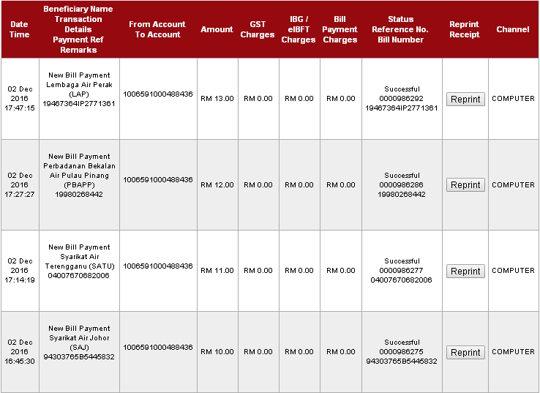

Transaction dated 07/12/2016

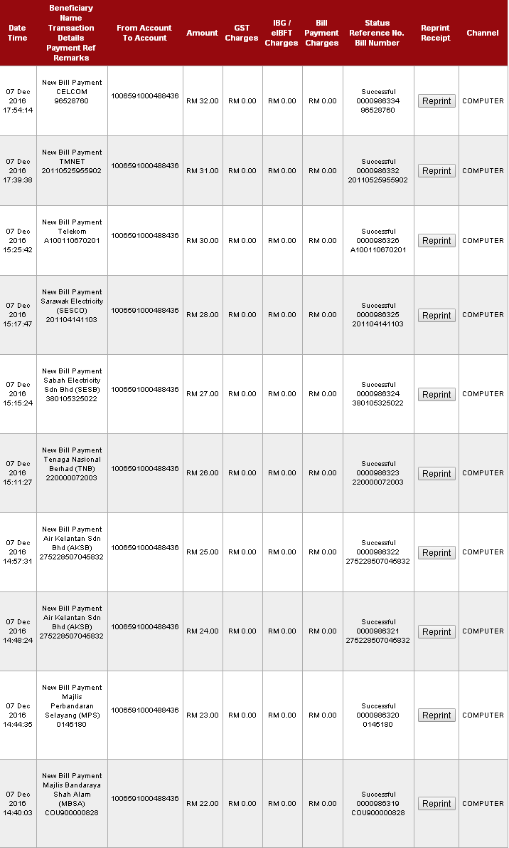

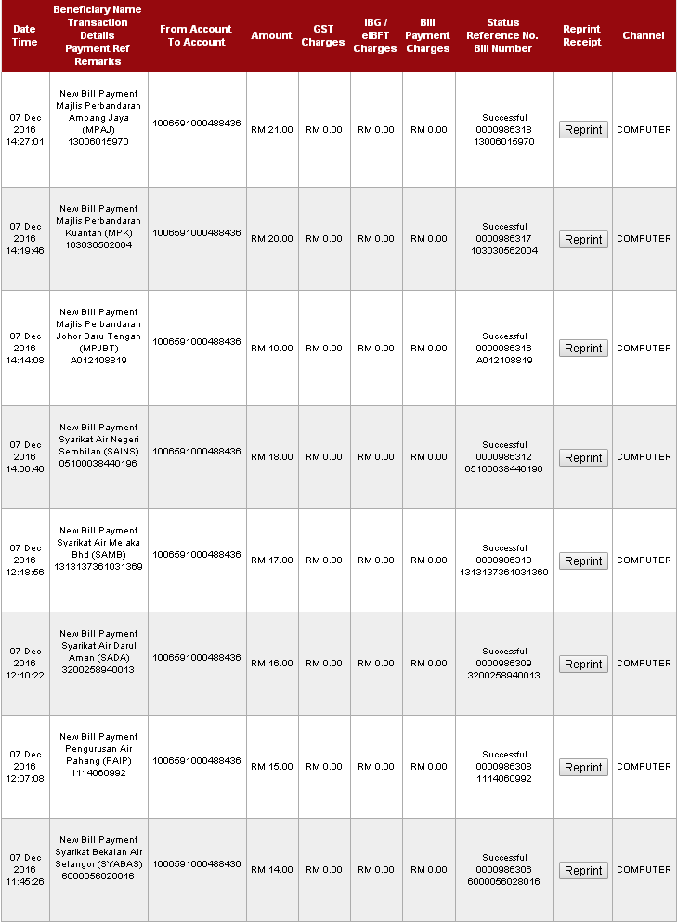

Transaction dated 08/12/2016:

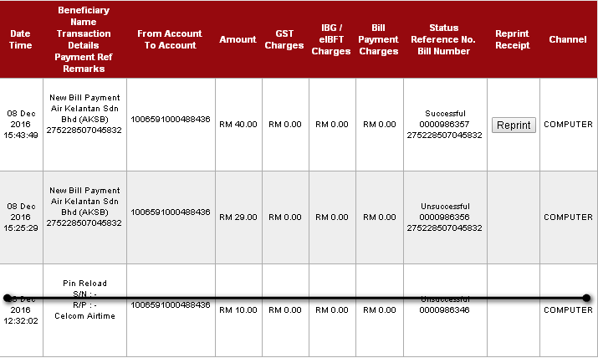

### BIB: Transaction History (Screenshot)

Transaction dated 02/12/2016:

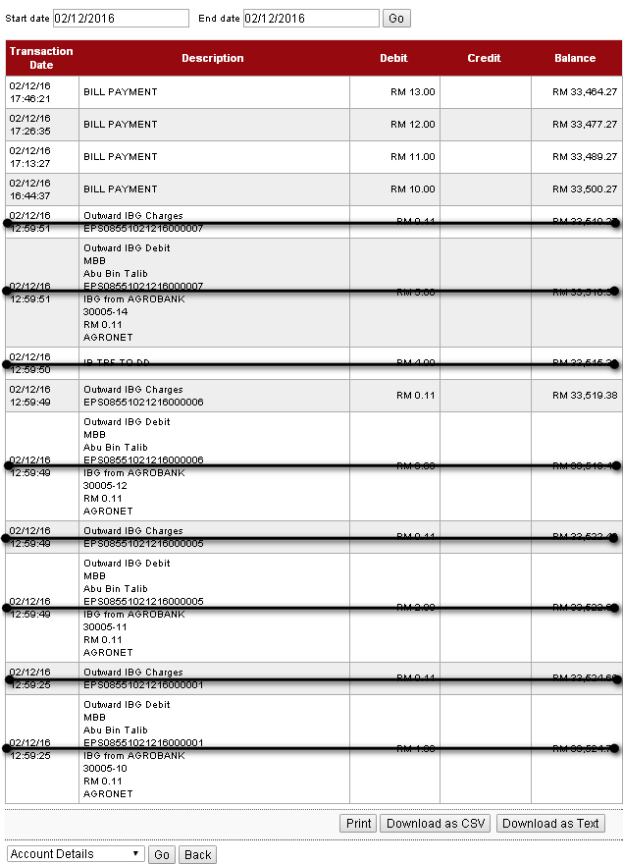

Transaction dated 07/12/2016

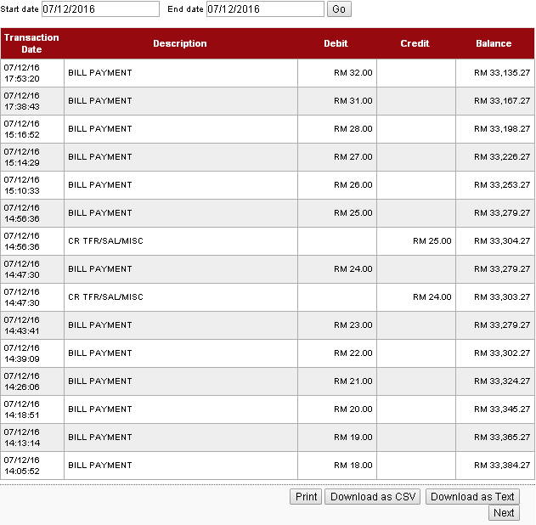

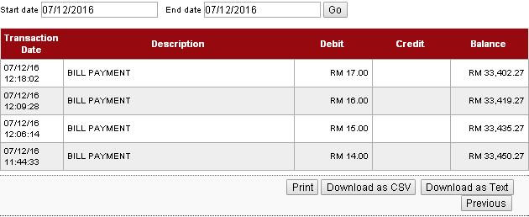

Transaction dated 08/12/2016:

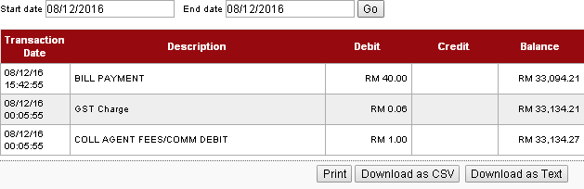

## IBAM: BIB Report

### 02/12/2016

Syarikat Air Johor (SAJ):

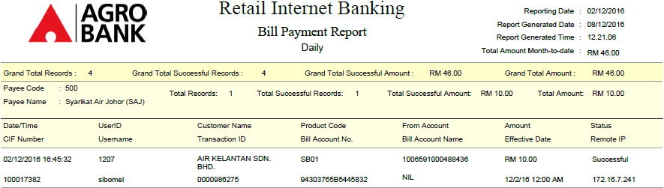

Syarikat Air Terengganu:

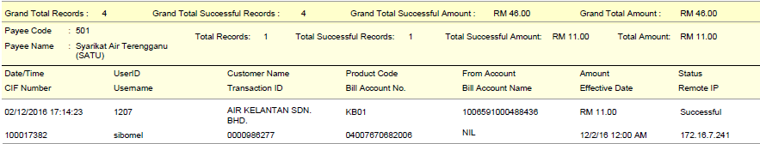

Perbadanan Bekalan Air Pulau Pinang (PBAPP):

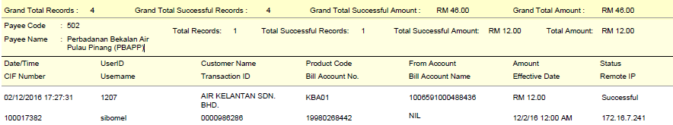

Lembaga Air Perak (LAP):

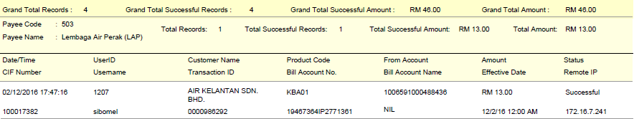

### 07/12/2016

TMNET

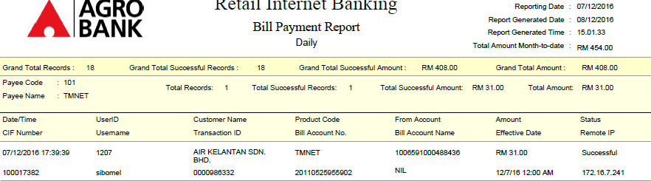

CELCOM

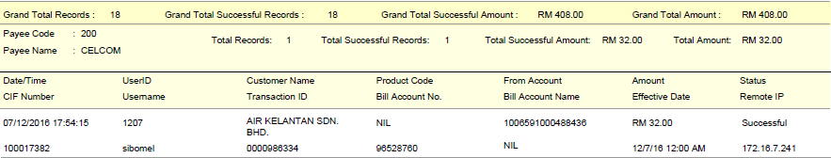

Telekom

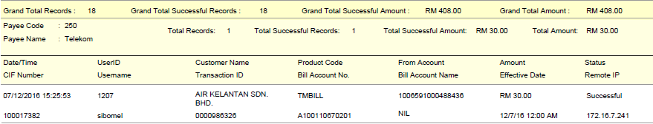

Tenaga Nasional Berhad (TNB)

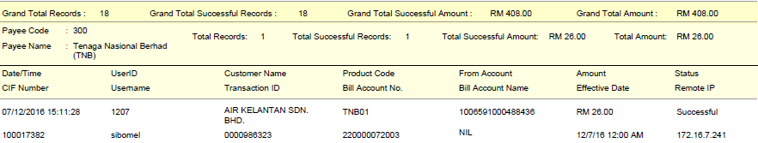

Sabah Electricity Sdn Bhd (SESB)

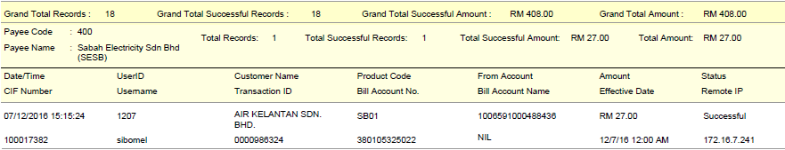

Sarawak Electricity (SESCO)

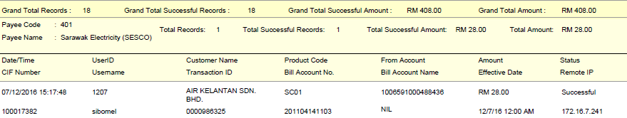

Air Kelantan Sdn Bhd (AKSB)

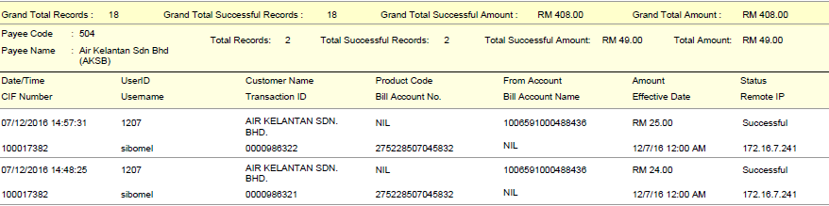

Syarikat Bekalan Air Selangor (SYABAS)

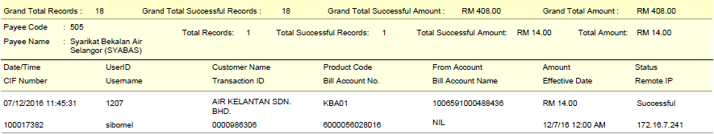

Pengurusan Air Pahang (PAIP)

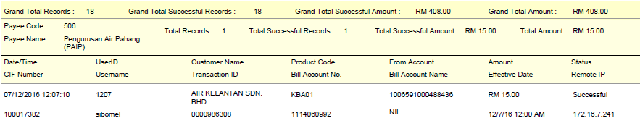

Syarikat Air Darul Aman (SADA)

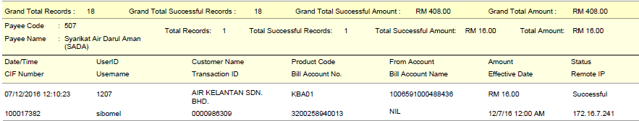

Syarikat Air Negeri Sembilan (SAINS)

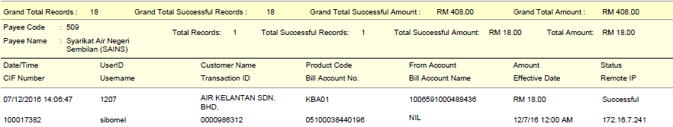

Majlis Perbandaran Johor Baru Tengah (MPJBT)

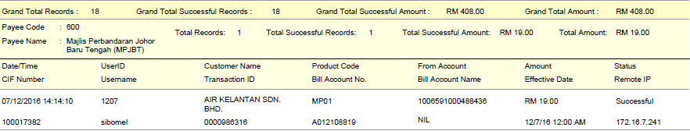

Majlis Perbandaran Kuantan (MPK)

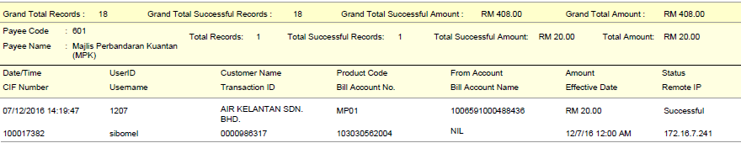

Majlis Perbandaran Ampang Jaya (MPAJ)

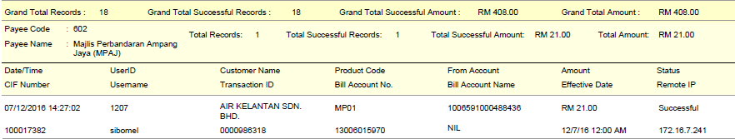

Majlis Bandaraya Shah Alam (MBSA)

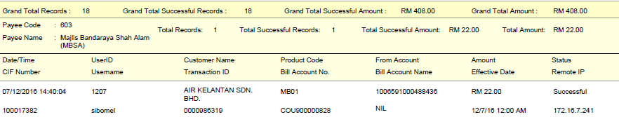

Majlis Perbandaran Selayang (MPS)

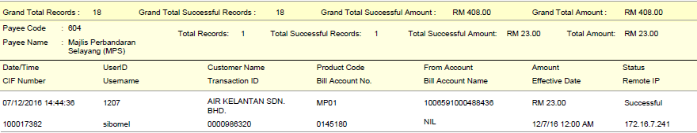

### 08/12/2016

Air Kelantan Sdn Bhd (AKSB)

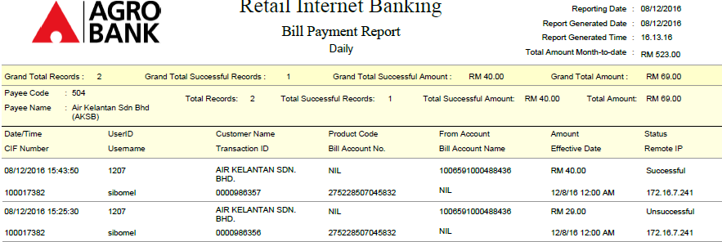

*Please be noted that all Customer Name display on report is AIR KELANTAN SDN BHD because the login user name is AIR KELANTAN SDN BHD. This is the same reason that cause the transaction for Air Kelantan Sdn Bhd were debited and credited.

