User unable to access Content>IB Report



His colleagues, Oshera Teo able to access. Instance same “http://10.20.208.4:7410/kfh_bvmc/mc/signin.do”



Try to edit Roles but encountered error

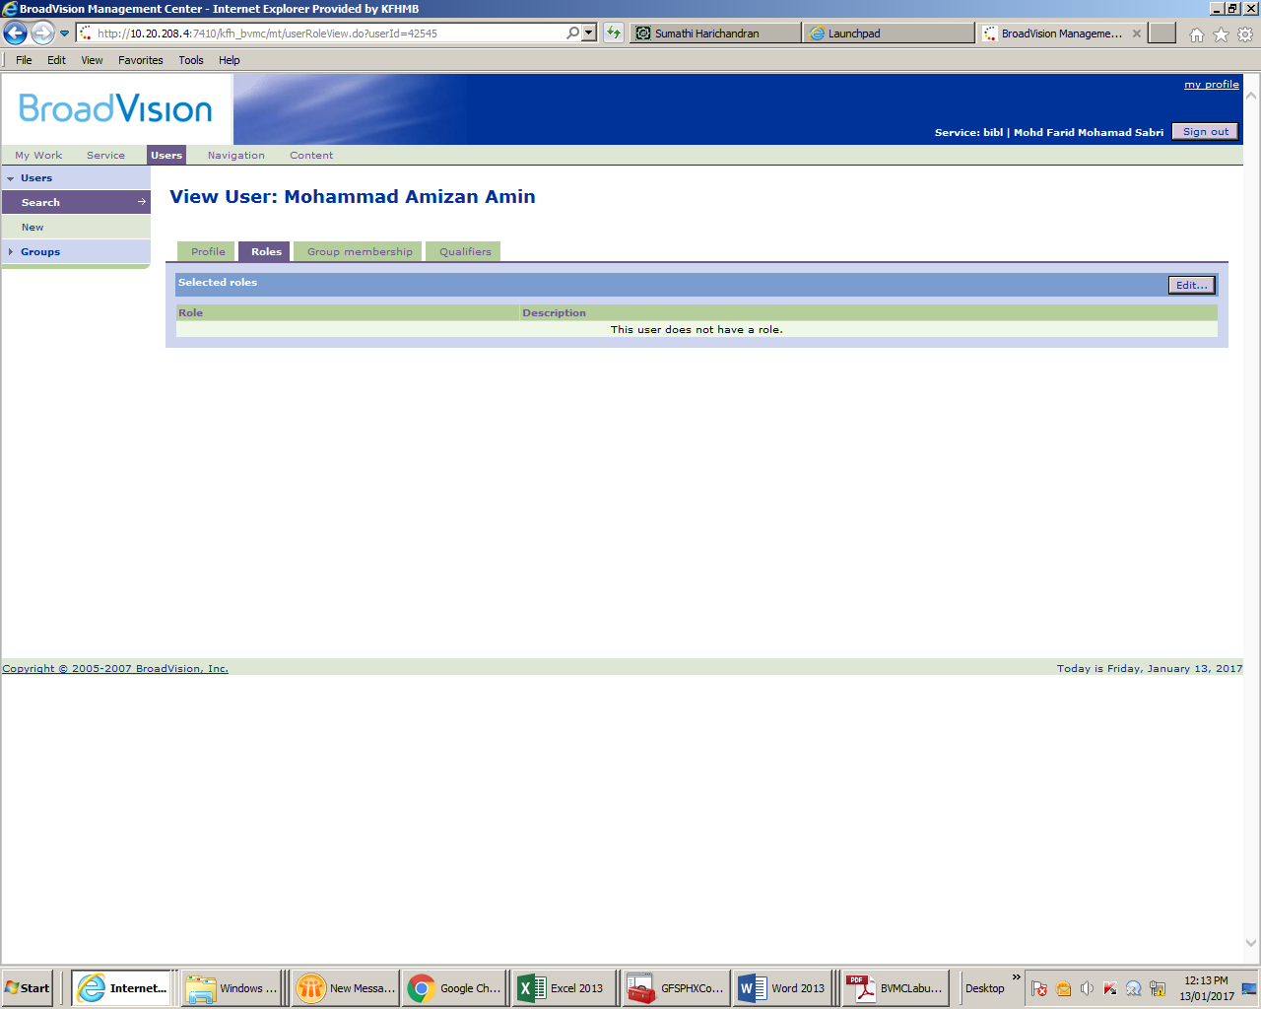

Click Edit> Error pop out

