Test Issue Log |  |  |  |  |  | SCP ID# :
Project Name: | AGROBANK BUSINESS INTERNET BANKING
Test Stage: | Unit Functionality Integration System Interface  Performance Regression Acceptance Pilot
Test Case Number: | Support #6922 |  |  | Test Started Date: |  |  | 05/01/2017
Test Title: | Report Maintenance
Test Description: | To ensure Report Maintenance can successfully be functioned.
Test Functionality: | IBAM  - IBAM > Report Maintenance
Test Procedure:
Test Result: | Pass: Fail: | Tested by: |  |  | Tan Jeng Wei
Reason for Failure: | Multiple issues.
TEST DESCRIPTION
- When access Ibam , click the Repot Maintenance.
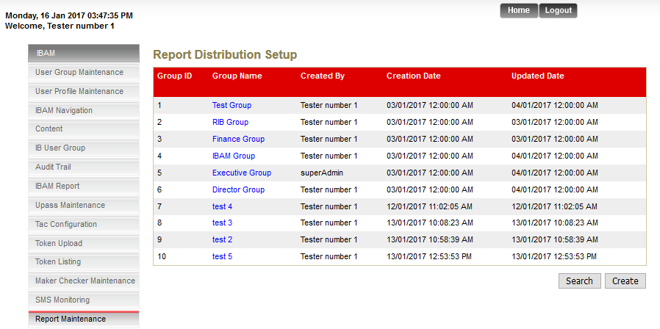
- Display the Search Result on IBAM Report Maintenance after click search.

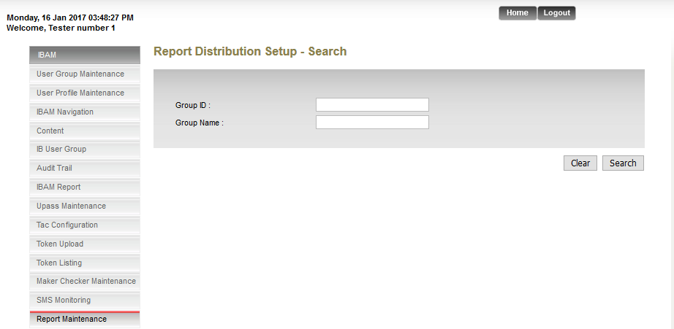

- Display the Report Maintenance Enquiry when no data.
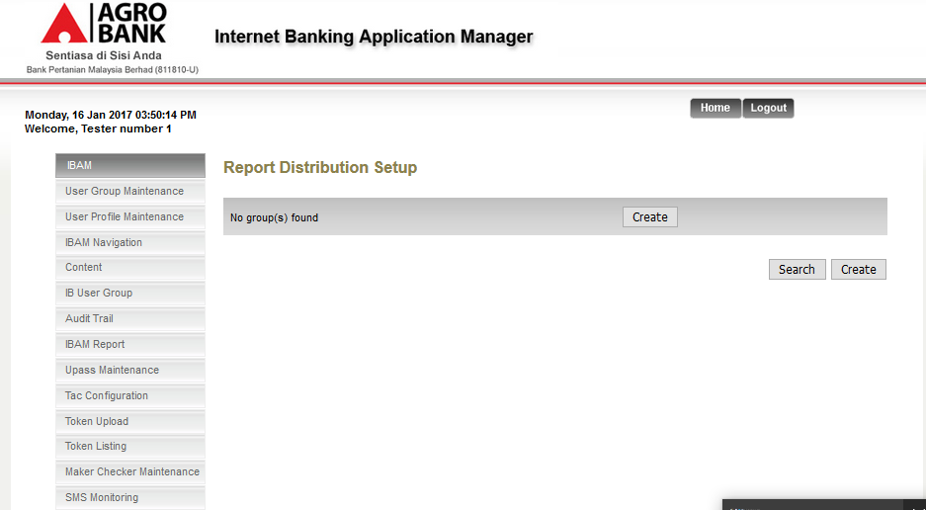

Bug Found:
Current Issues: Report Maintenance Enquiry displays when no Data.

Expected:

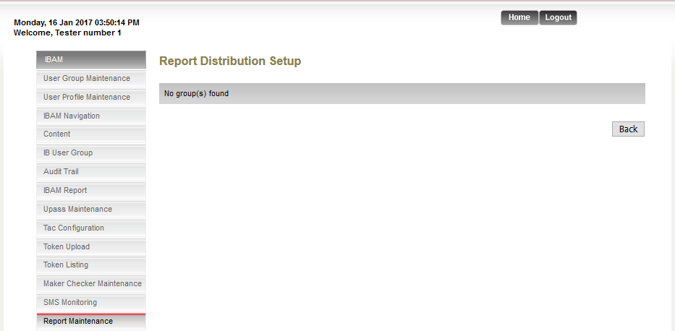

Back To Report Maintenance Enquiry Pages.

2) Current Issues : opposite side the confirm and back button
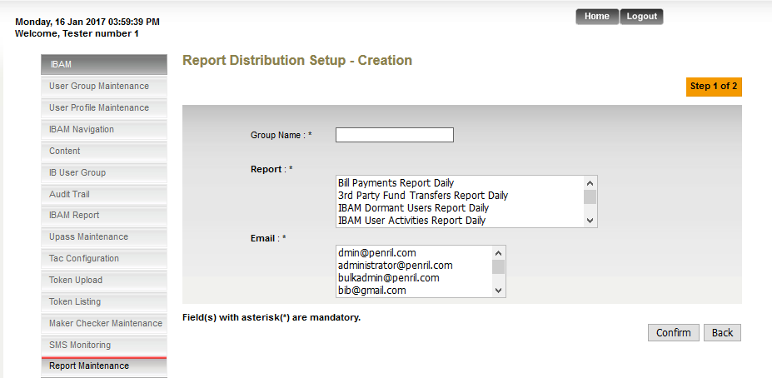

Expected Issues

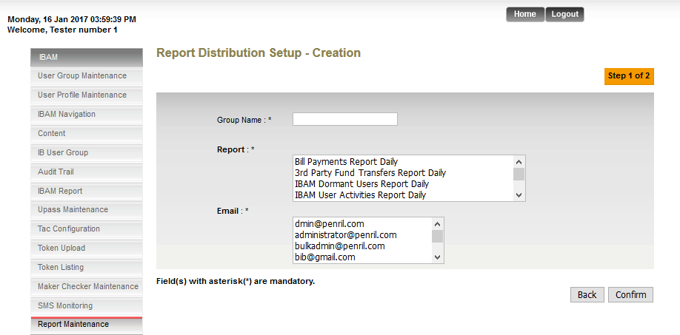

3) Current Issues : No validation for group name during create.
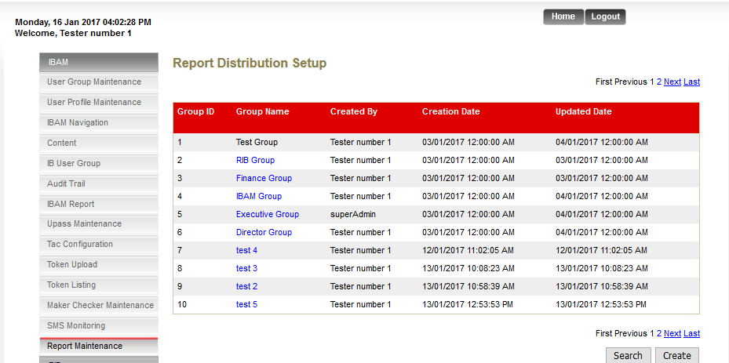

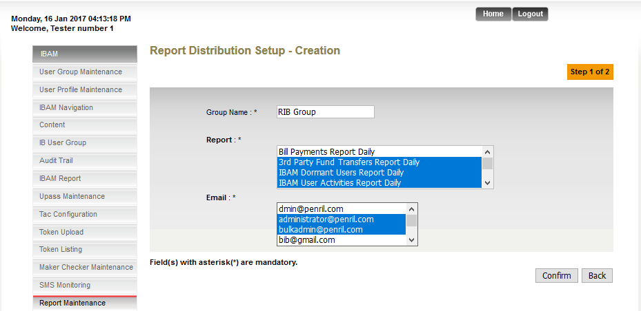

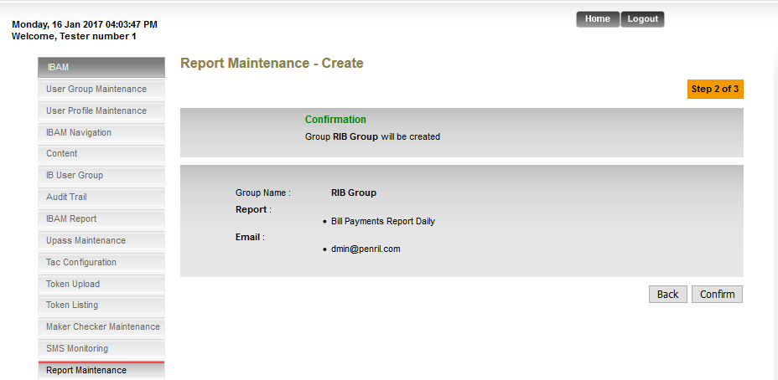

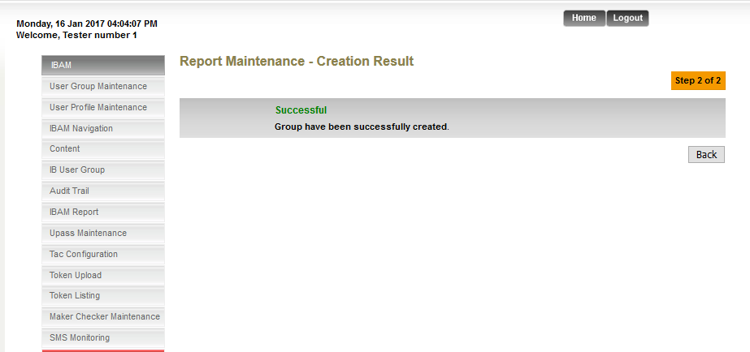

Expected Result:

- Should not able to Create Same Group Name.

4) Current Issues: Back to Wrong pages.

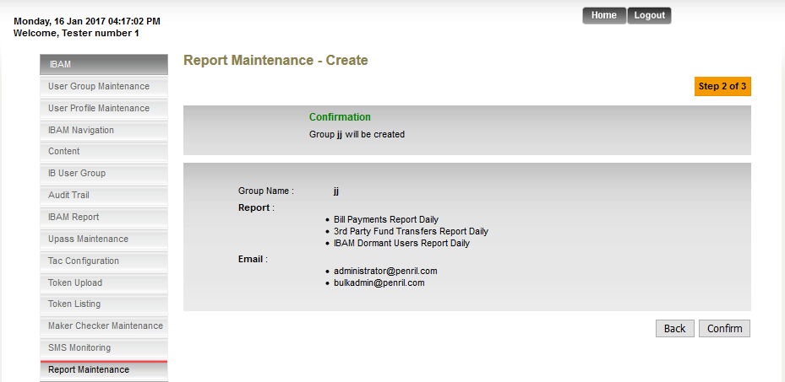

Expected result: Should back to this pages
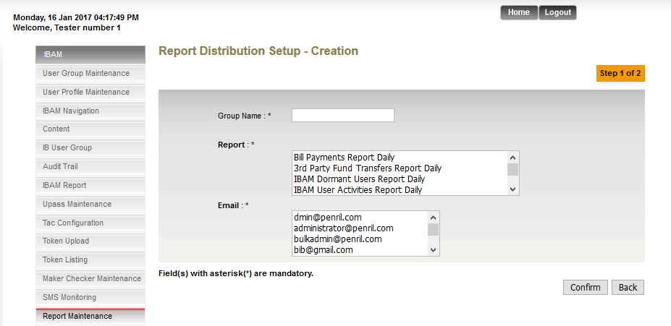

5) Current Issues: Contain 3 pages
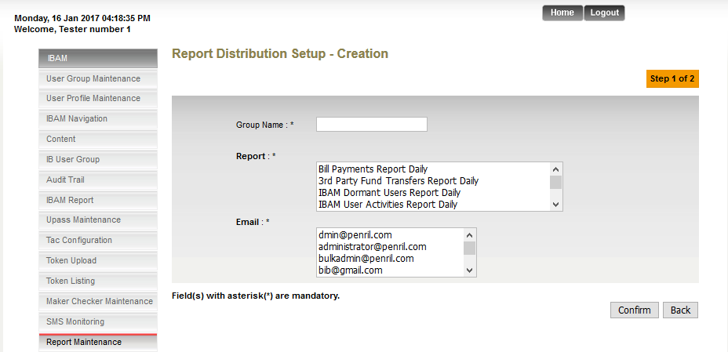

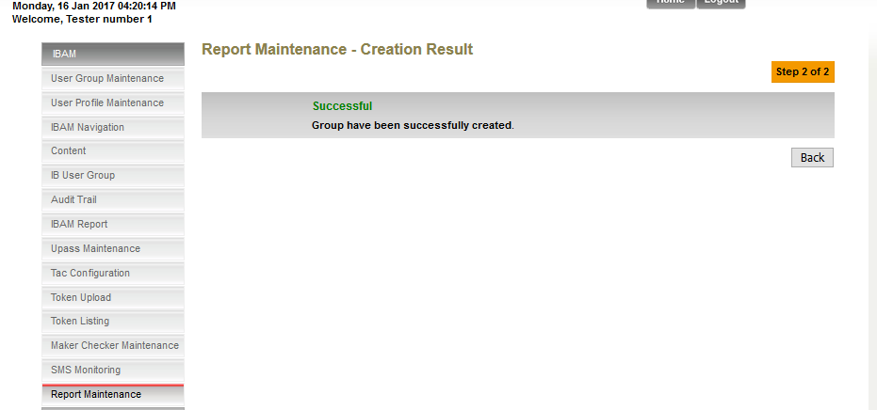

Expected Result: Correct Pages number are showing below

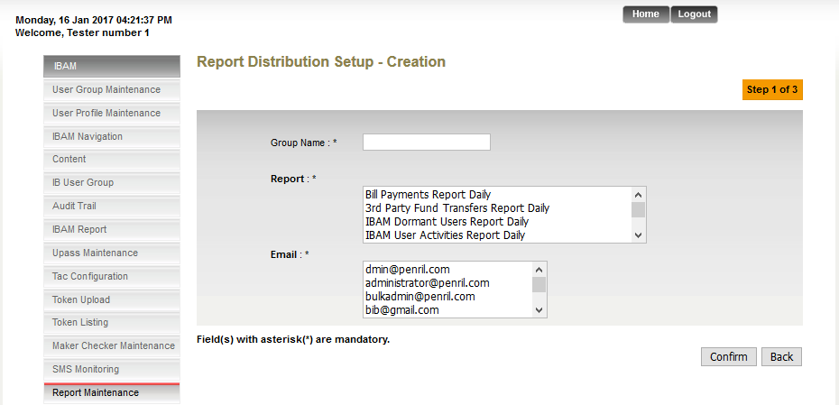

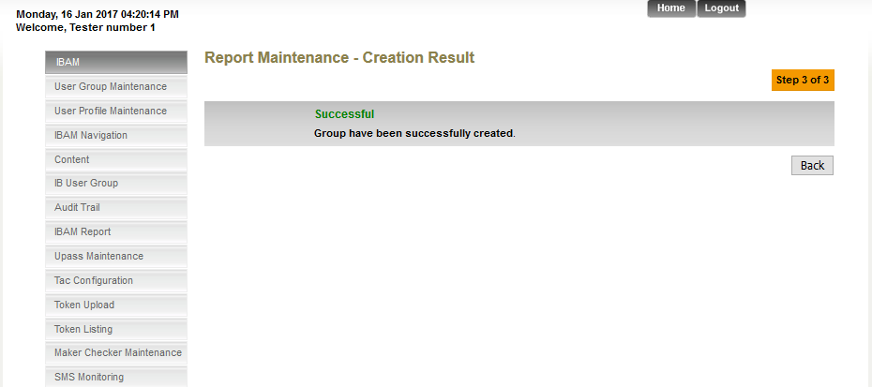

6) Current Issues : No display What group name created
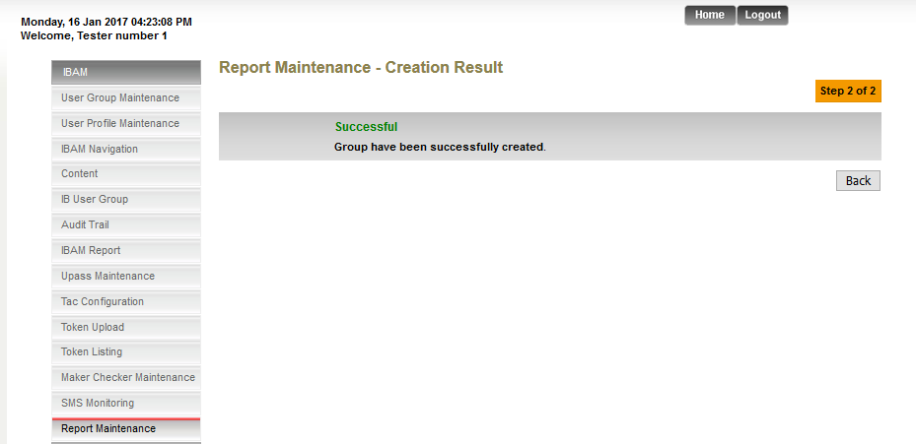

Expected Result:
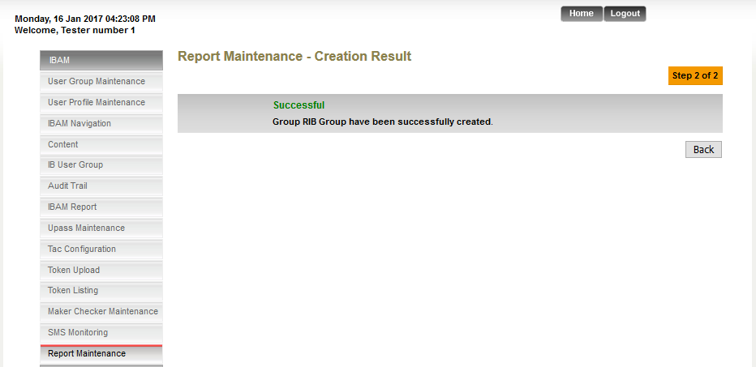

Should be able to display group name.

7) Current Issues : No able to back to previous screen
a) Click the group name Delete button
b) the screen are showing below

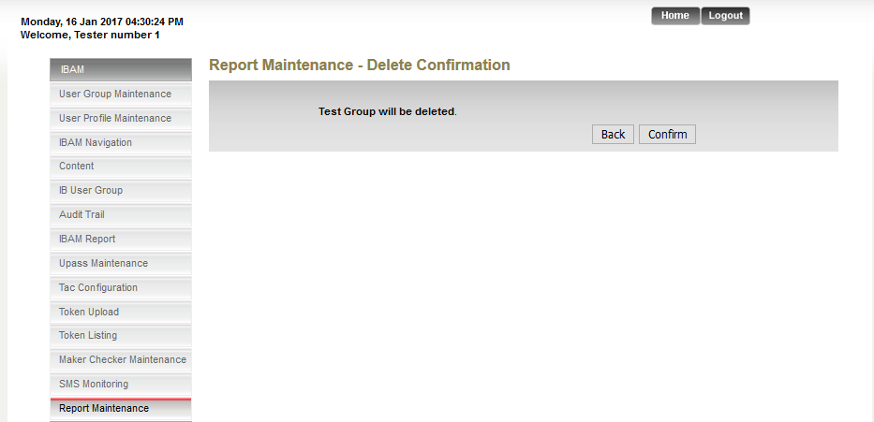
C) Click back button to previous Screen.
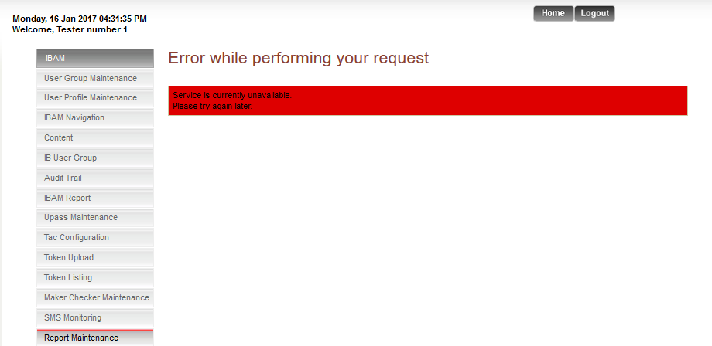

Expected Result: able back to previous screen are showing below.
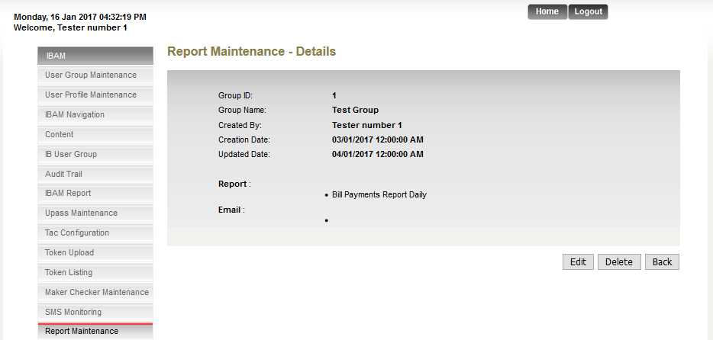

8) Current Issues: didn’t display which group name was deleted.

- Click group Name Delete ButtonConfirm
- The Pages screen are showing below
- 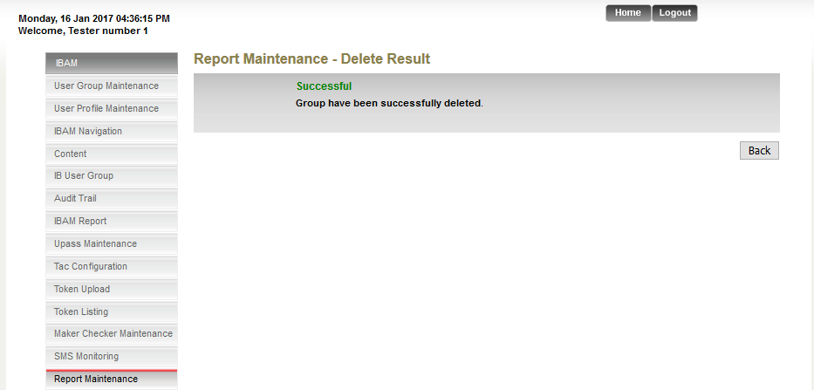

Expected Result: Should able to display which group name was deleted.
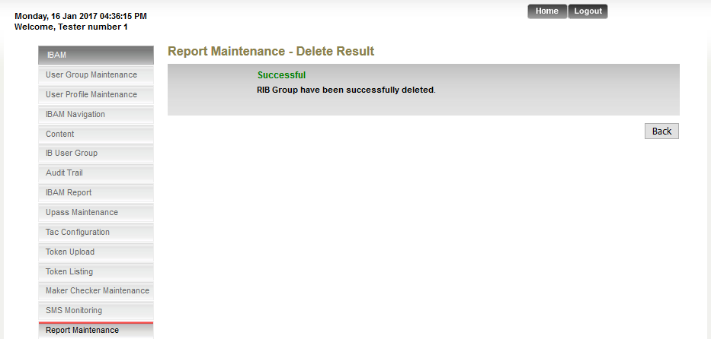

9) Current issues: Back to Wrong previous Pages.
A) Click Report maintenance group name Edit.
B) The screen are showing below
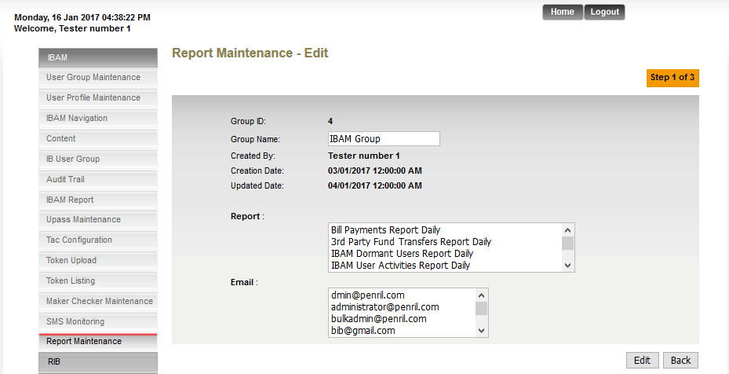

c) Click the back button will be back to Enquiry Pages.

Expected Result: Should able back to previous Pages are showing below:

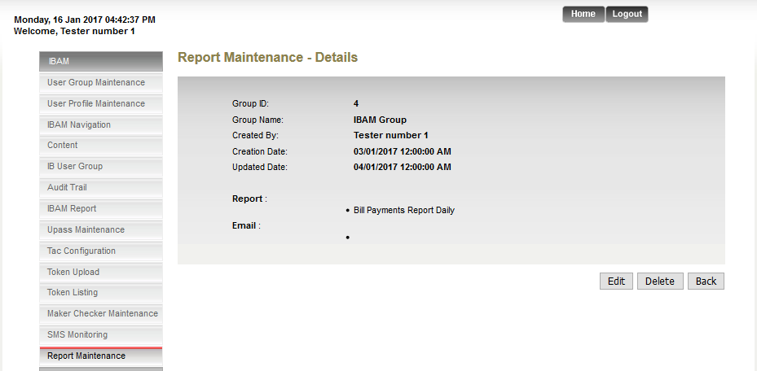

10) Current Issues: Wrong display button.
A) Click Report maintenance group name ButtonEdit button
B) The Screen is showing below.

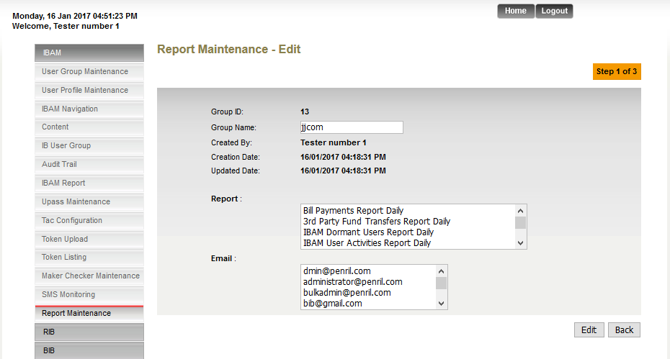

Expected Result: Should be display back and confirm.
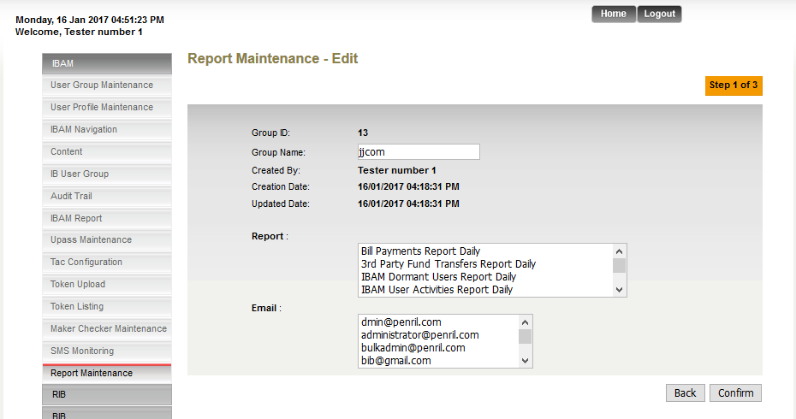

11) Current Issues : Didn’t display group name after edit
A) Click Report maintenance group name ButtonEdit buttonConfirm
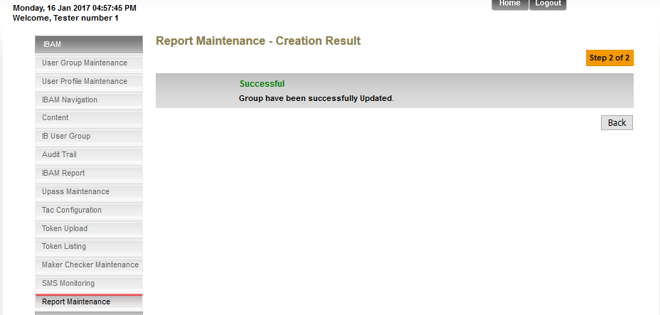

Expected Result: Should be able display which group name was edited or updated.

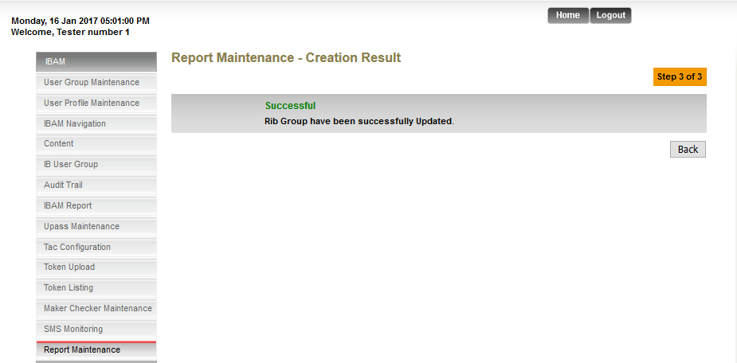

12) Current Issues: No validation Check Report and Email.
A) Click Report maintenance group name ButtonEdit button
B) The screen is showing below.
c) After check the confirm button, error page is showing below.

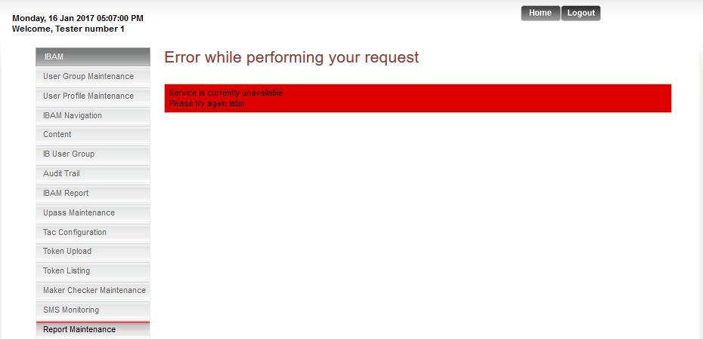

Expected Result: Showing remark for at least one report and one email must be selected.

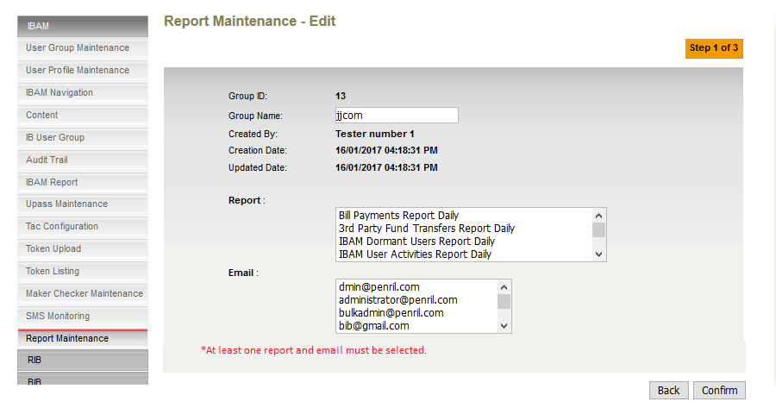
13) Current Issues: back to wrong previous screen.
a) Click report Maintenance group name edit confirm.
b) The screen is showing below.
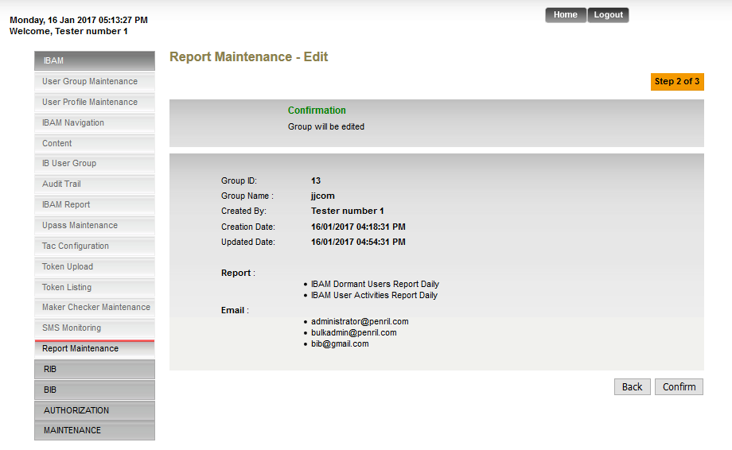

c) After click the back button, will be back to Enquiry pages.

Expected Result: Back to previous screen are showing below.

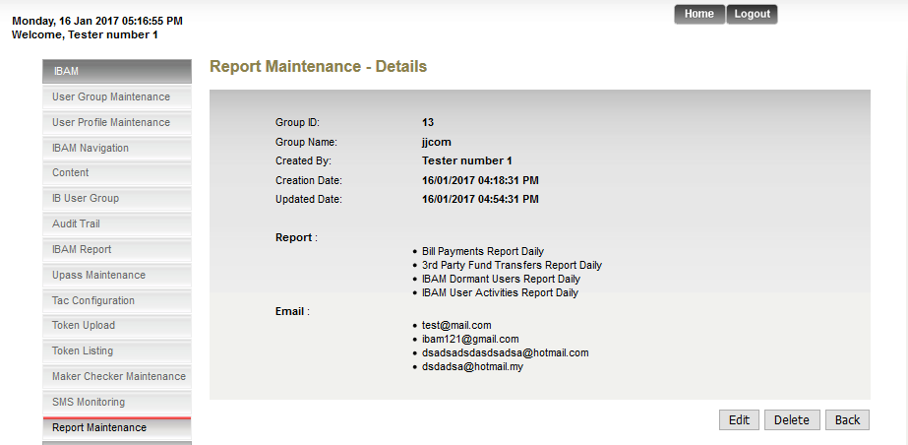

14) Current Issues: Back to wrong screen.
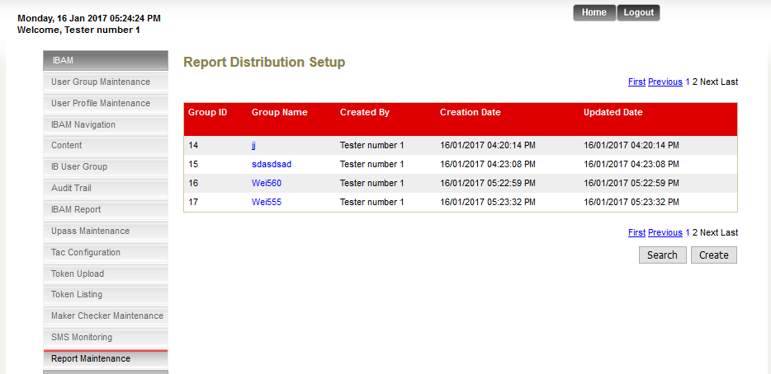
******click last pages.

- Click the group name the screen will showing below.
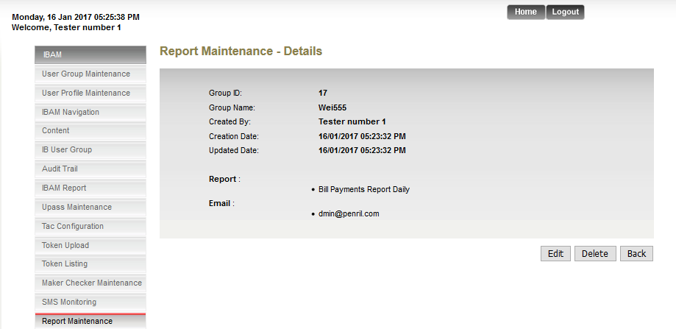
- Click to back button, it will back to first pages Enquiry, the screen showing below.
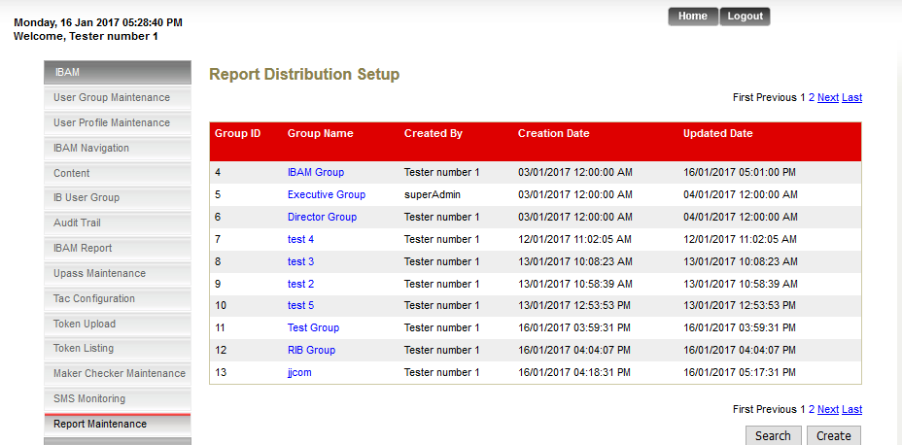
*** Back to first Enquiry Pages.

Expected Result: should back to last pages are showing below.

15) Current Issues:

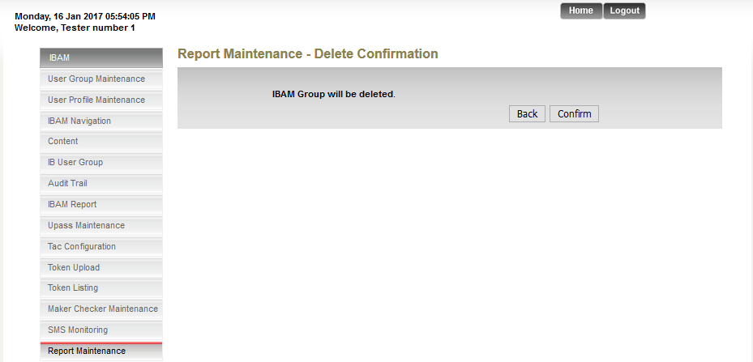

Expected Result:

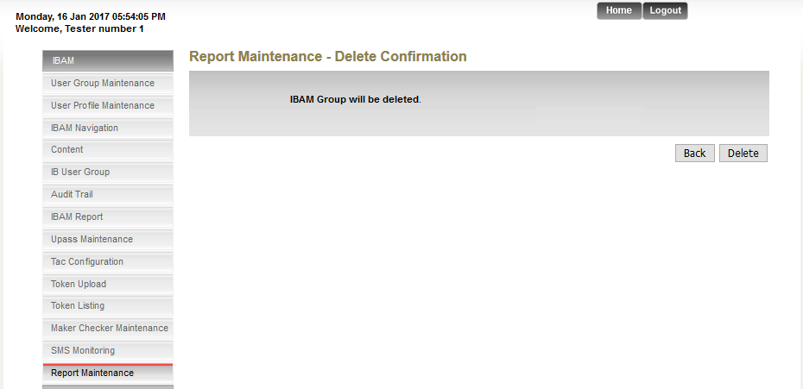

Reviewed By: (PMO)

