**Agrobank**

|  |
| --- |
| **BRS BIB** |
| Business Requirement and System Specification |

**(PENRIL/AGRO-BRS/PCF/20160316)**

**Version 1.0**

**18 January 2017**

Prepared By:



**Penril Datability (SEA) Sdn Bhd (384556-U)**

Suite A-07-07 Plaza Mon’t Kiara

No. 2, Jalan Kiara, Mon’t Kiara

50480 Kuala Lumpur, Malaysia

Tel: (603) 6201 2622Fax: (603) 6201 7622

Document Amendment Log

| **Rev. No** | **Date Update** | **Description of Change** | **Update By**  **<Name, Dept>** | **Review By**  **<Name, dept>** | **Approved By**  **<Name, Dept>** |
| --- | --- | --- | --- | --- | --- |
| 1.0 | 18/01/2017 | Initial Release | LIM CHUN FENG |  |  |
|  |  |  |  |  |  |
|  |  |  |  |  |  |
|  |  |  |  |  |  |
|  |  |  |  |  |  |

Document Amendment Log 2

Section A: Introduction 5

1 Objective 5

Section B: Internet Banking 7

2 Enhancement at BIB 7

2.1 Transaction History Details 7

Business Requirement Acceptance

I/We hereby verify that this Business Requirement consist of all the requirements requested by AGROBANK. The implemented system will fulfill ONLY this requirement.

I/We also hereby AGREE that this satisfies our entire requirement for **CR BIB Project**

Any future changes to this agreed scope will be treated as an enhancement to the system. Any future changes to the project timeline will be subjected to the final approval of the project steering committee.

**AGROBANK:**

|  |  |  |  |
| --- | --- | --- | --- |
| **Approved by** | **Role** | **Signature** | **Date** |
|  |  |  |  |
|  |  |  |  |
|  |  |  |  |
|  |  |  |  |
|  |  |  |  |
|  |  |  |  |
|  |  |  |  |

**Penril Datability (SEA) Sdn. Bhd.:**

|  |  |  |  |
| --- | --- | --- | --- |
| **Approved by** | **Role** | **Signature** | **Date** |
|  |  |  |  |
|  |  |  |  |

Section A: Introduction

This document served as the business requirement and system specification of adding/creating new function/module for display transaction details at Authorization Screen for Business Internet Banking.

This document shall explain all the features and functionalities, which is elaborating with screen captures, process flow, descriptions, input fields specifications and error messages. All screen designs provided in this document are samples and only illustration purpose for easy understanding. The screen designs are not final

# Objective

The objective of this document is to capture user requirements of adding/create new function/module by display transaction details at Authorization Screen for Bulk Payment, Payroll, and Statutory Bodies modules. This document will facilitate development and implementation of the mentioned modules of Internet Banking System for Agro bank.

The base line features description and screen designs will become a reference blueprint for the development team to develop the transactional and administration module. Hence, it is crucial that all stakeholders need to ensure the correctness and adequacy of the requirements captured in this document.

All stakeholders involved are expected to review and sign off this document before the development start. By signing off the document, the stakeholder has endorsed the correctness and accuracy and adequacy of the requirements documented in this document.



# 

**Transaction History Detail’s Process Flow**

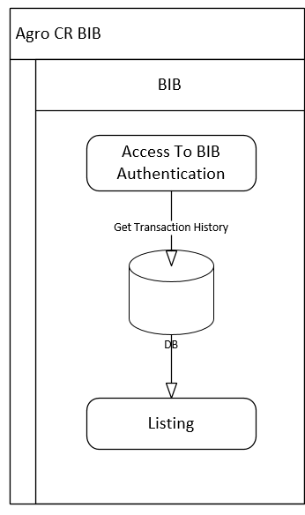

Section B: Internet Banking

# Enhancement at BIB

BIB>Transaction history details

**Purpose:**

To display transaction details on Authorization screen.

## Transaction History Details

#### Screen Flow

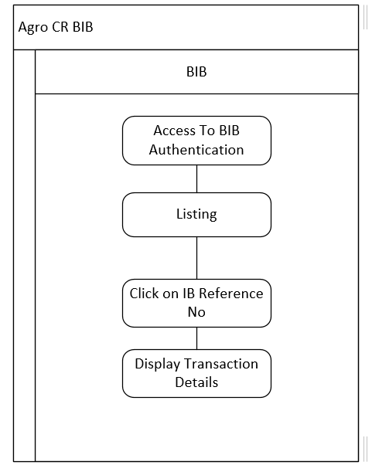

**Diagram 1: Agro CR BIB**

***Step 1:***

1. User login to BIB.
2. User click on Authorization.
3. User select Transaction by click on IB Reference No.
4. BIB system show screen as below

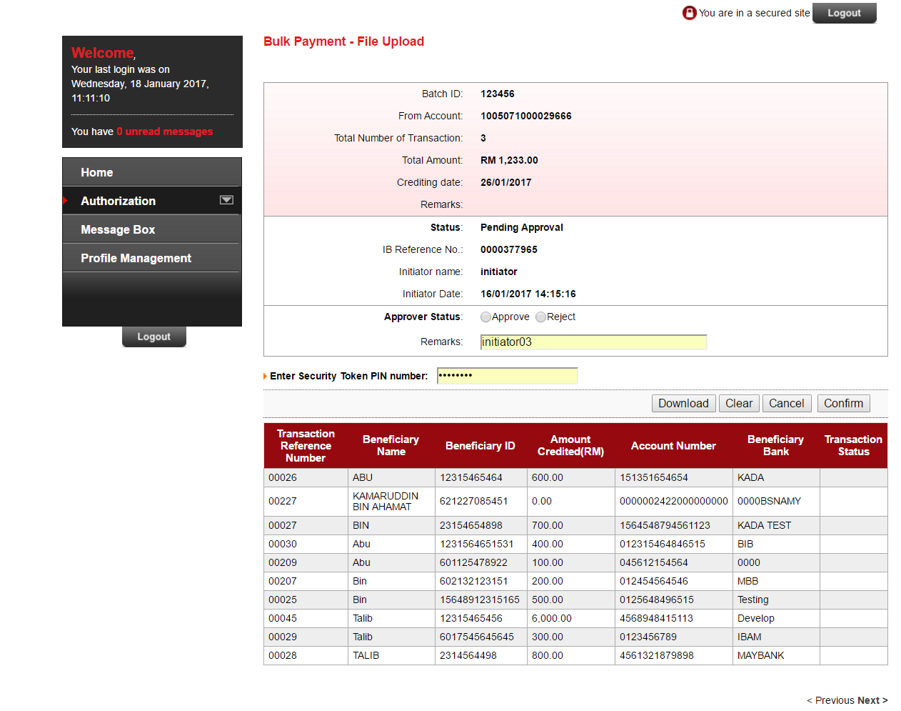

Figure 1 BIB Transaction Details

**Action:**

| **No** | **Action** | **Type** | **Description** |
| --- | --- | --- | --- |
|  | Previous | Button | Redirect to previous details list page |
|  | Next | Button | Redirect to next details list page |

Table 2: Transaction details list

**Display:**

| **No** | **Field** | **Database** | **Description** |
| --- | --- | --- | --- |
|  | Transaction Reference Number | BIB_BULK_PAYMENT_HISTORY_DETAIL.EFT_REC_NO | Reference number of transaction history |
|  | Beneficiary Name | BIB_BULK_PAYMENT_HISTORY_DETAIL.BENEFICIARY_NAME | Transaction recipient name |
|  | Beneficiary ID | BIB_BULK_PAYMENT_HISTORY_DETAIL.BENEFICIARY_ID | Transaction recipient ID |
|  | Amount Credited(RM) | BIB_BULK_PAYMENT_HISTORY_DETAIL.AMOUNT | Transaction history amount |
|  | Account Number | BIB_BULK_PAYMENT_HISTORY_DETAIL.BENEFICIARY_ACCOUNT | Transaction recipient account number |
|  | Beneficiary Bank | BIB_BULK_PAYMENT_HISTORY_DETAIL.RECIEVEING_MEMBER_BANK | Transaction recipient bank |
|  | Transaction Status | BIB_BULK_PAYMENT_HISTORY_DETAIL.STATUS_OF_BC | Transaction status |