Test Issue Log |  |  |  |  |  | SCP ID# :
Project Name: | AGROBANK BUSINESS INTERNET BANKING
Test Stage: | Unit Functionality Integration System Interface  Performance Regression Acceptance Pilot
Test Case Number: | Support |  |  | Test Started Date: |  |  | 23/01/2017
Test Title: | Approver can View File Details
Test Description: | - To ensure that approver can view the file details on screen  - To ensure that every page only contain up to 10 list only https://172.16.50.27/bib.sit.kada/common/Login.do
Test Functionality: | BIB  Bulk Payment  - Initiator: File Upload  - Approver: Authentication
Test Procedure: | - Login as Initiator and performed Bulk Payment (File Upload) transaction  - Login and to approve the transaction  - View the file details on screen  - Ensure that every page only contain up to 10 list only
Test Result: | Pass: Fail: | Tested by: |  |  | Erni Suhaireen binti Zulkifli
Reason for Failure: | - Amount should also display exactly as per user entered on Saga file  - Transaction Reference Number should also display exactly as per user entered on Saga file.
TEST DESCRIPTION
- Login as Initiator and performed Bulk Payment (File Upload) transaction
  - Bulk Payment history:
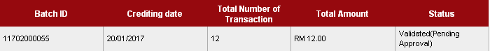
  - Agronet Transaction History:
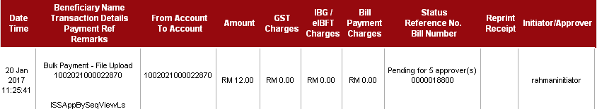
- Login as Approver and approve the transaction
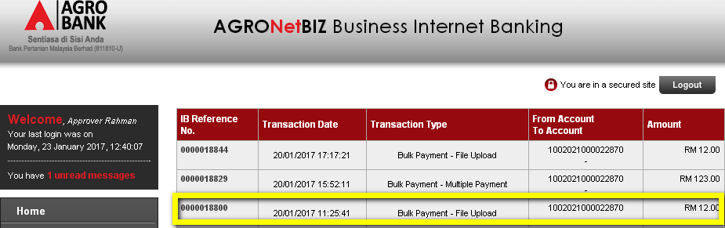

  - View the file details on screen
  - Ensure that every page only contain up to 10 list only
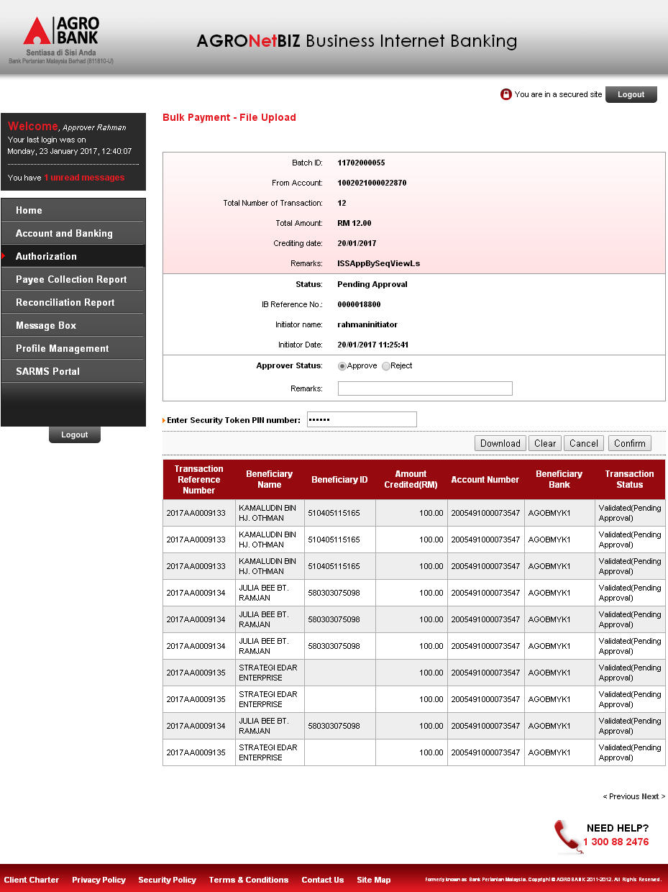
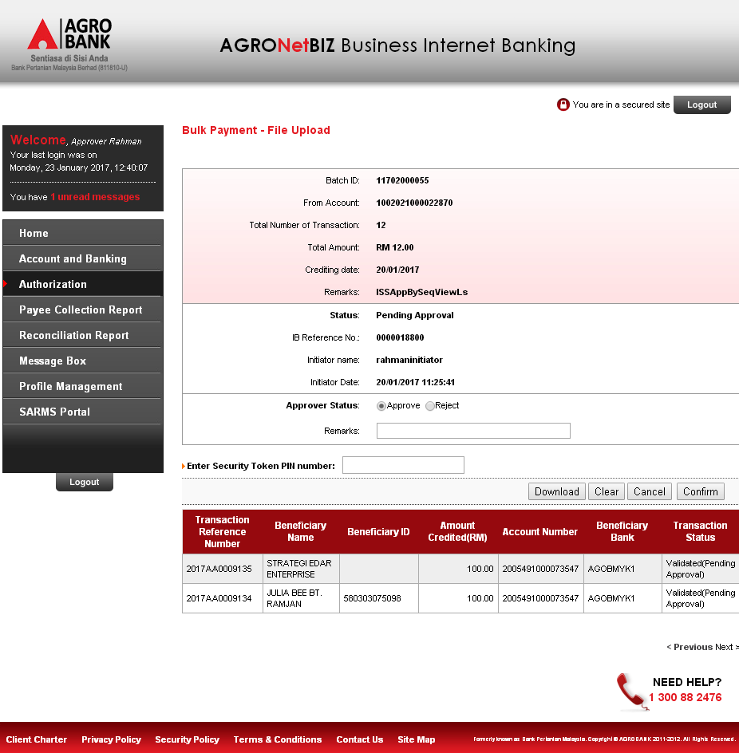

  - Compare with file upload details.
Bug Found
No | Current Result | Expacted Result
 | Amount entered on Saga file is RM1.00 for every detail. But at Approval page, amount display RM100.00 for every detail on this transaction | Amount should also display exactly as per user entered on Saga file
 | Transaction Reference Number displayed on Approval page not same as per entered on Saga file | Transaction Reference Number should also display exactly as per user entered on Saga file.

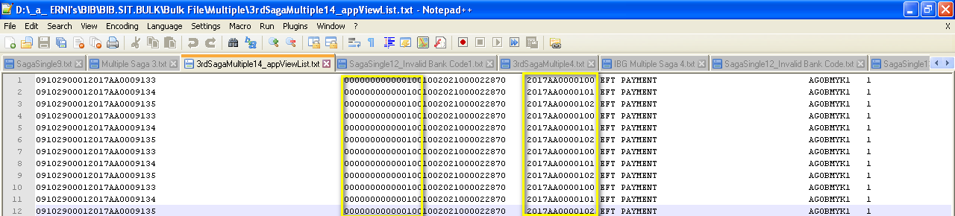
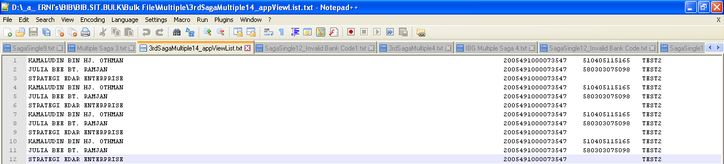
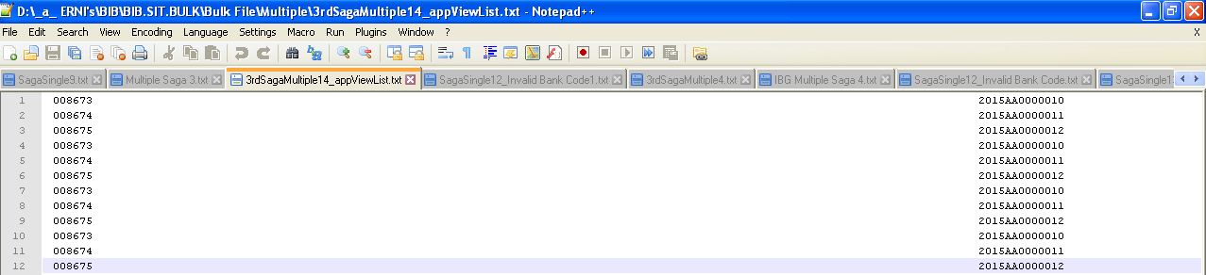
Reviewed By: (PMO)
 |  |  | Name/Position : Norhaidah Binti Md Dasuki / Senior Manager, Quality Assurance and Support  Date : 26/10/2016

