1. New Update for BRS, No need to Amount as Filter.

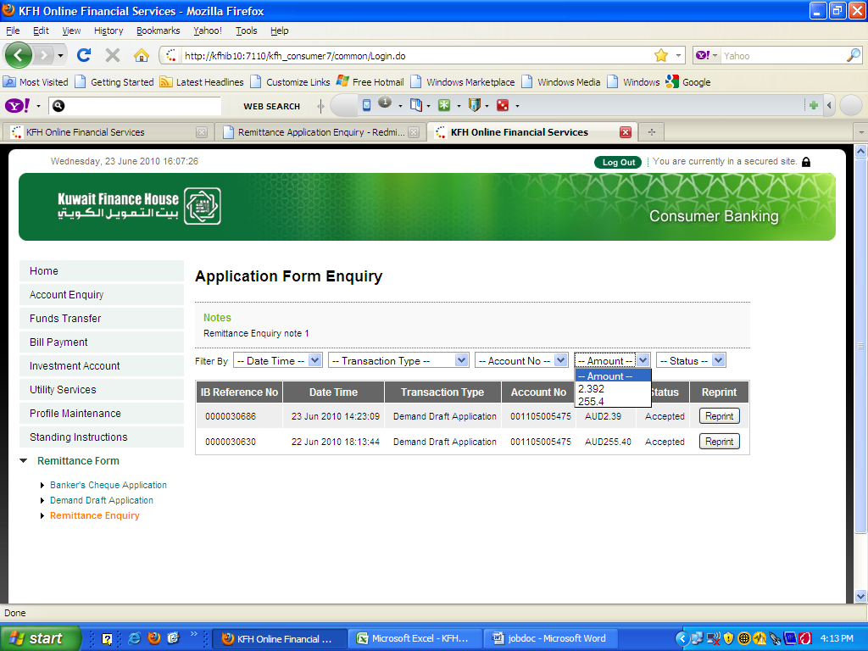

Please Remove Amount Option Box.