Test Issue Log |  |  |  |  |  | SCP ID# :
Project Name: | AGROBANK BUSINESS INTERNET BANKING
Test Stage: | Unit Functionality Integration System Interface  Performance Regression Acceptance Pilot
Test Case Number: | Support #6962 |  |  | Test Started Date: |  |  | 25/01/2017
Test Title: | EPF
Test Description: | To ensure system automatically download and save to download folder.
Test Functionality: | BIB  - Payroll > Statutory Bodies > EPF Other Payment Submission
Test Procedure:
Test Result: | Pass: Fail: | Tested by: |  |  | Erni Suhaireen binti Zulkifli
Reason for Failure: | After click on ‘Print Receipt’ systems pop up ‘Save As’ window. System should System should automatically download and save to download folder.
TEST DESCRIPTION
Screenshot:
Perform to Download EPF Payment Receipt
- On Result Page, click on ‘Print Receipt’ button
Bug Found:
No | Current Result | Expacted Result
 | After click on ‘Print Receipt’ systems pop up ‘Save As’ window. | System should automatically download and save to download folder.

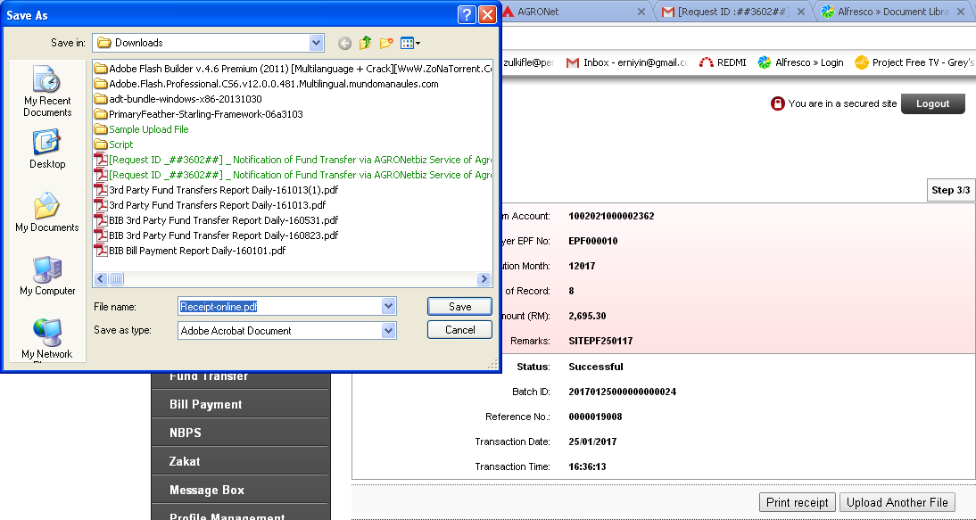

Reviewed By: (PMO)
 |  |  | Name/Position : Norhaidah Binti Md Dasuki / Senior Manager, Quality Assurance and Support  Date : 04/01/2017

