Test Issue Log |  |  |  |  |  | SCP ID# :
Project Name: | AGROBANK BUSINESS INTERNET BANKING
Test Stage: | Unit Functionality Integration System Interface  Performance Regression Acceptance Pilot
Test Case Number: | Support |  |  | Test Started Date: |  |  | 25/01/2017
Test Title: | Bulk Payment approval by sequence Email Notification
Test Description: | To ensure whether all approver group user get email notification after approve.  [Replicate issue: All user receive email notification not by sequence]  https://172.16.50.27/bib.preprod.sit/common/Login.do
Test Functionality: | BIB  Bulk Payment  - Initiator: File Upload  - Approver: Authentication
Test Procedure: | - Login as Initiator and performed Bulk Payment (File Upload) transaction  - Approver Group A:  Login and approve the transaction  - View the email notification received  - Approver Group B:  Login and approve the transaction  - View the email notification received  - Approver Group C:  Login and approve the transaction  - View the email notification received  - Approver Group D:  Login and approve the transaction  - View the email notification received  - Approver Group E:  Login and approve the transaction  - View the email notification received
Test Result: | Pass: Fail:  Conditional Pass: | Tested by: |  |  | Erni Suhaireen binti Zulkifli
Reason for Failure:
TEST DESCRIPTION
- Login as Initiator and performed Bulk Payment (File Upload) transaction
  - Result Page:
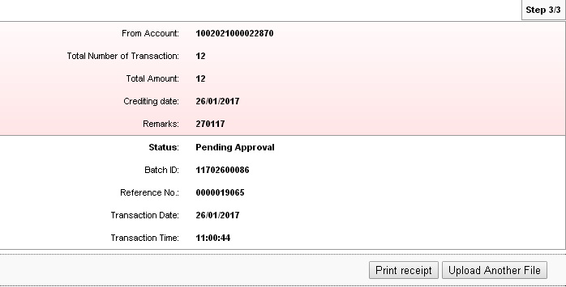
  - Bulk Payment History
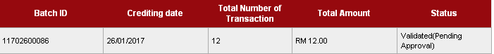
  - Agronet Transaction History
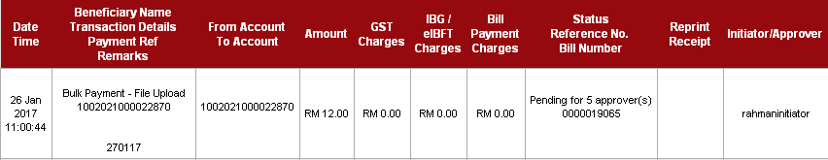

Approver Group | Email Address | Email Notification Received by Sequence
A | erni.zulkifle@penril.net | √
B | erniyin@gmail.com | √
C | pu3_am@yahoo.com | √
D | norahayu.md@yahoo.com | √
E | kemaruktravel@gmail.com | √

- Approver Group A:
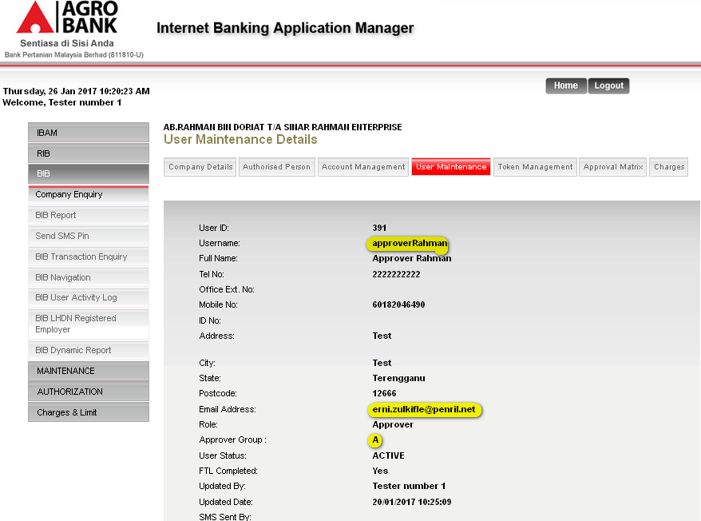
  - View the email notification received
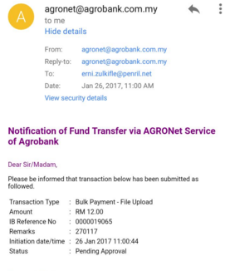

  - Login as Approver Group A and approve the transaction
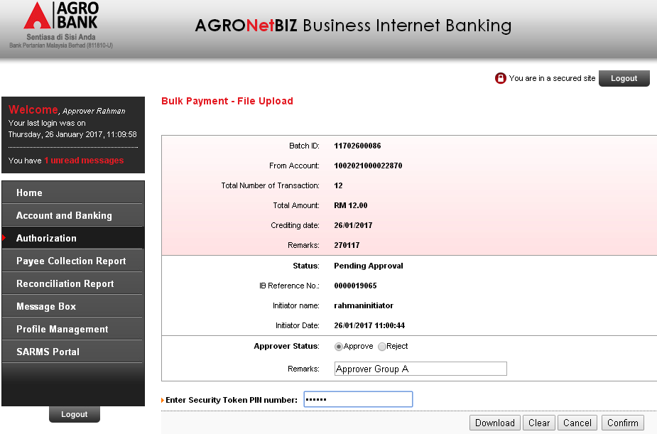
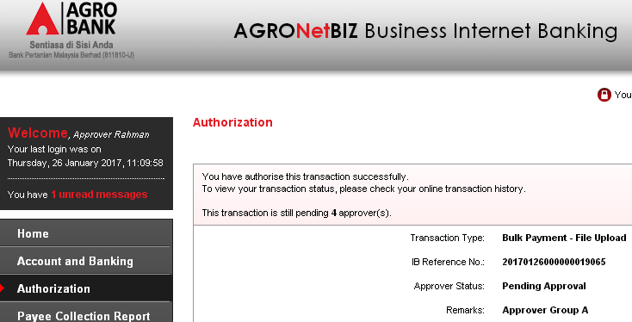

- Approver Group B:
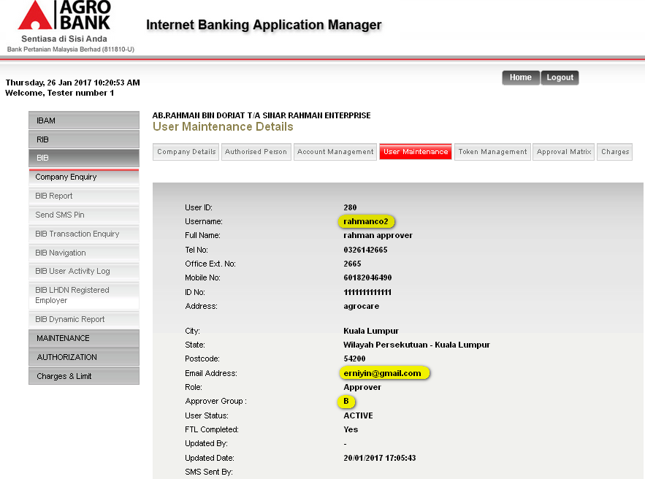
  - View the email notification received
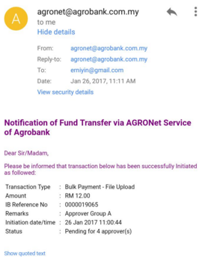

  - Login as Approver Group B and approve the transaction
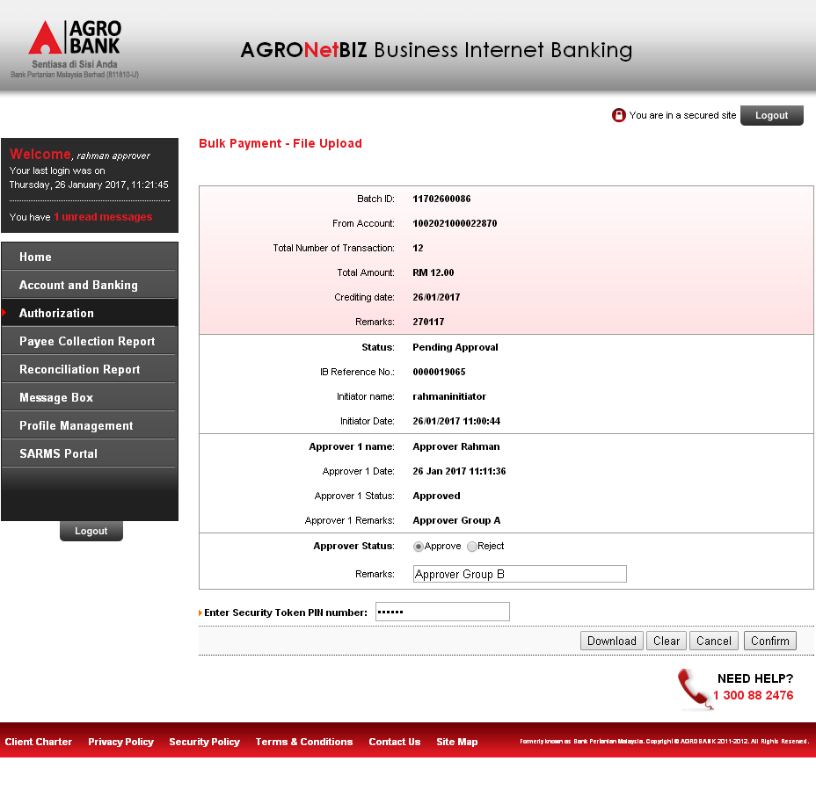
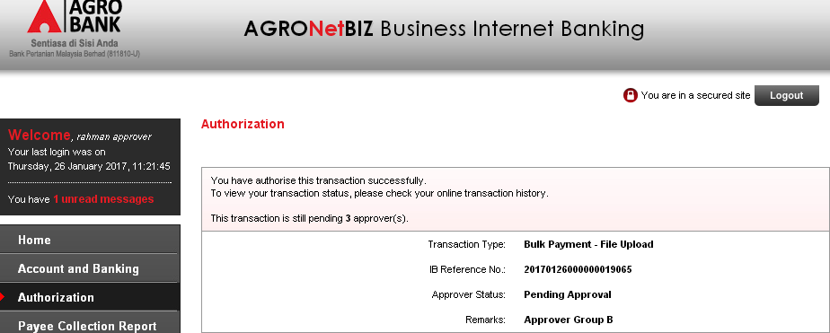

- Approver Group C:
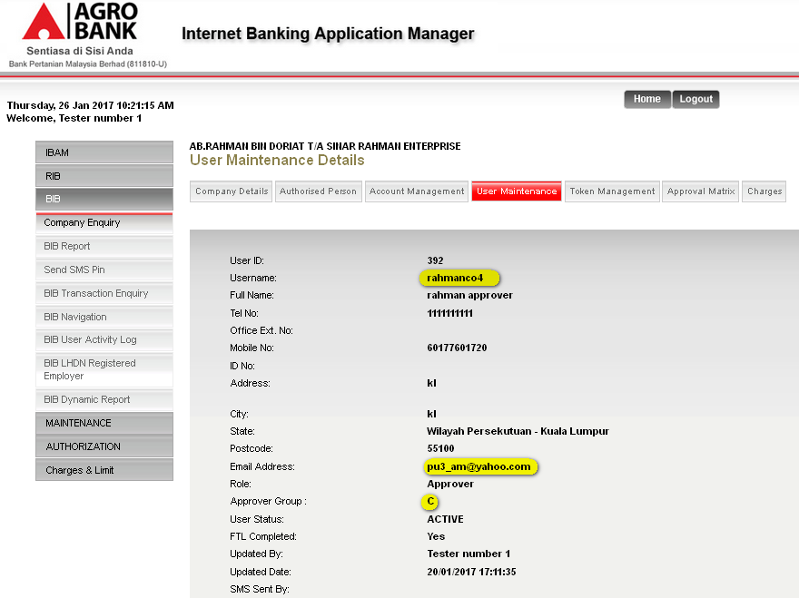
  - View the email notification received
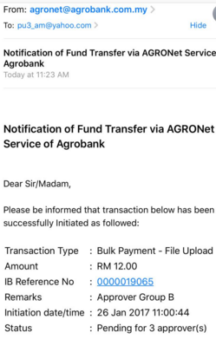
  - Login as Approver Group C and approve the transaction
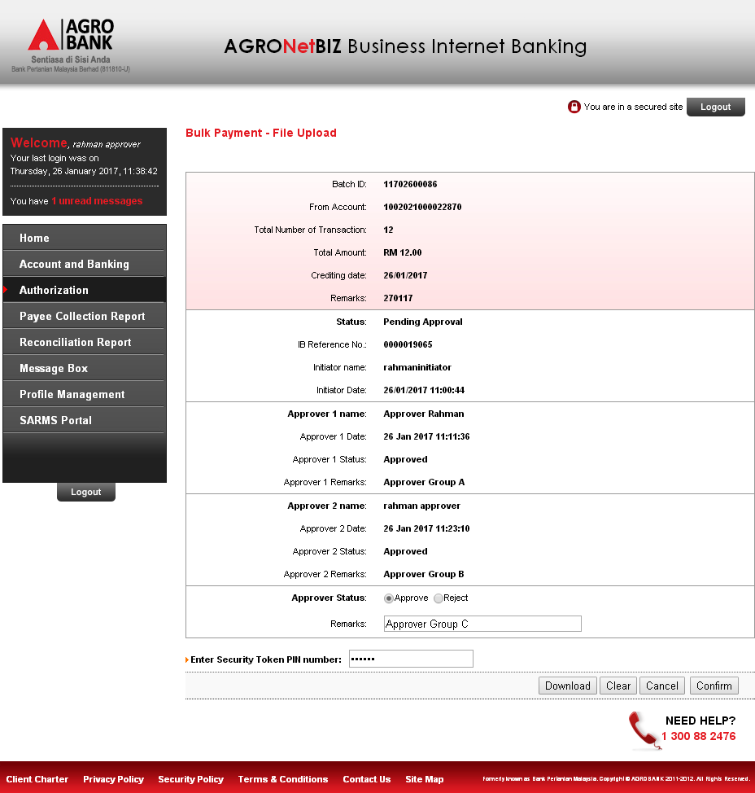
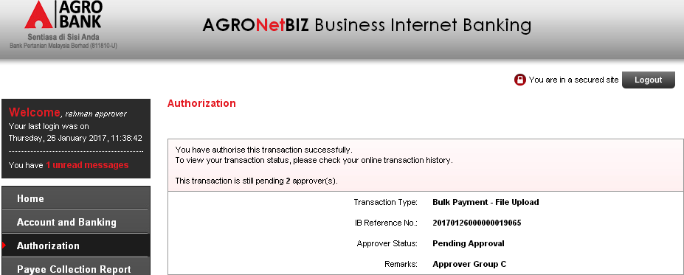

- Approver Group D:
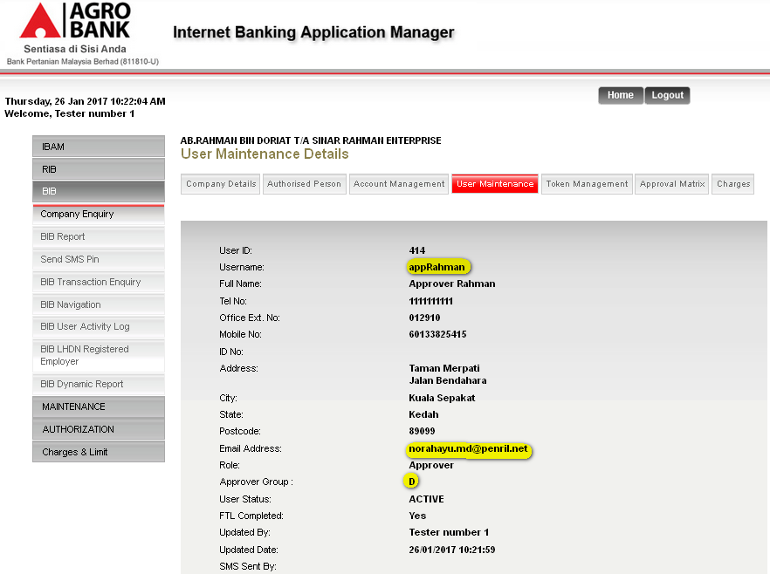
  - View the email notification received
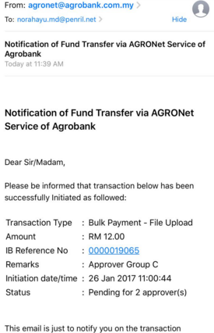

  - Login as Approver Group D to approve the transaction
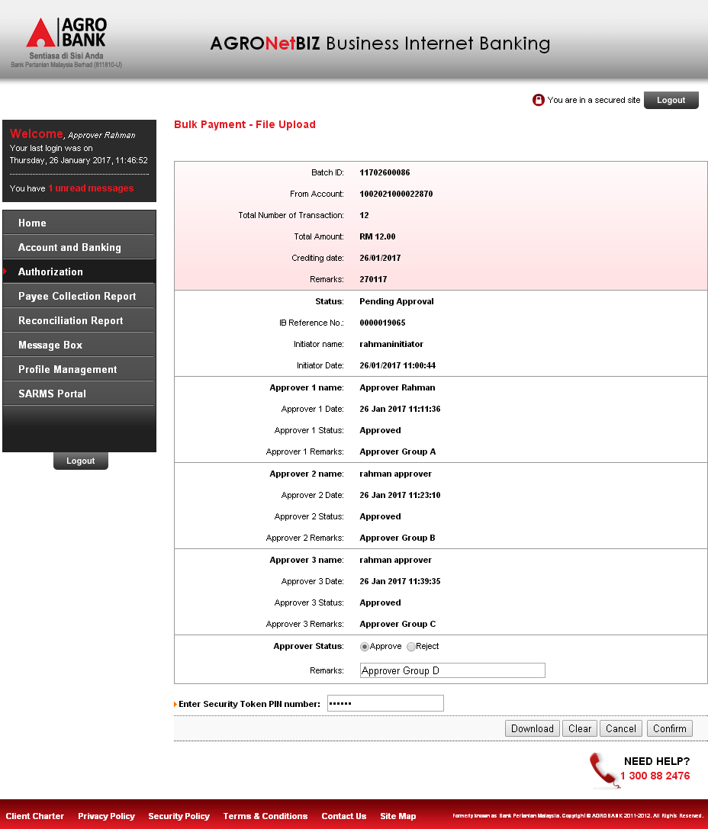
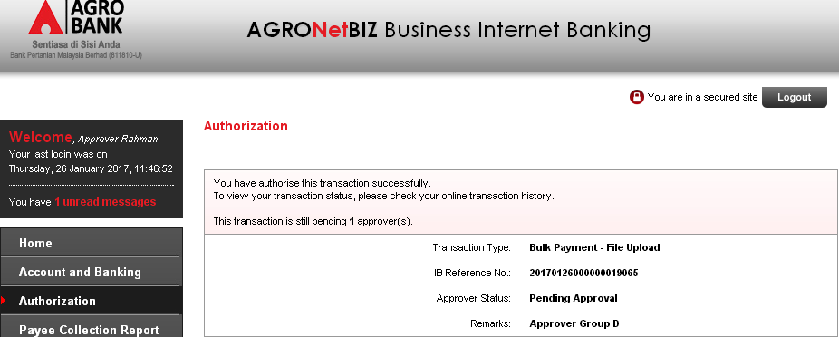

- Approver Group E:
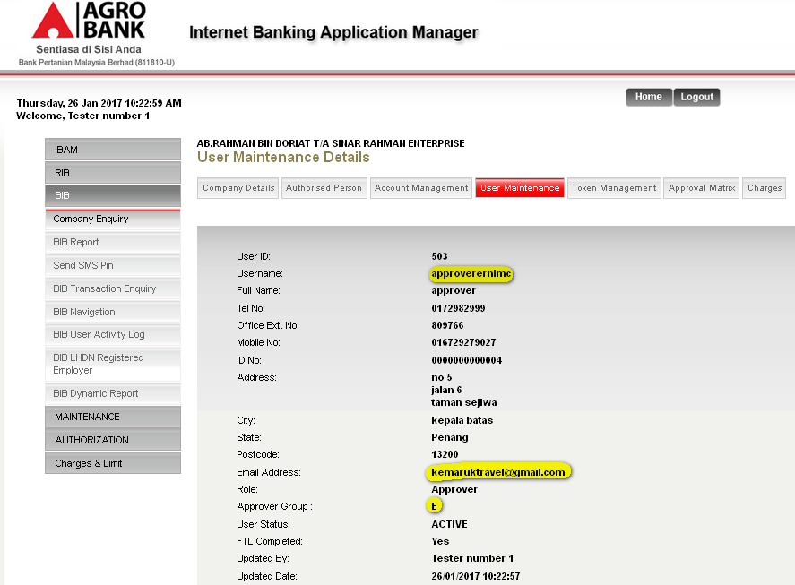
  - View the email notification received
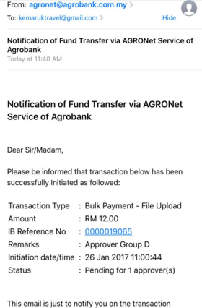

  - Login as Approver Group E and approve the transaction
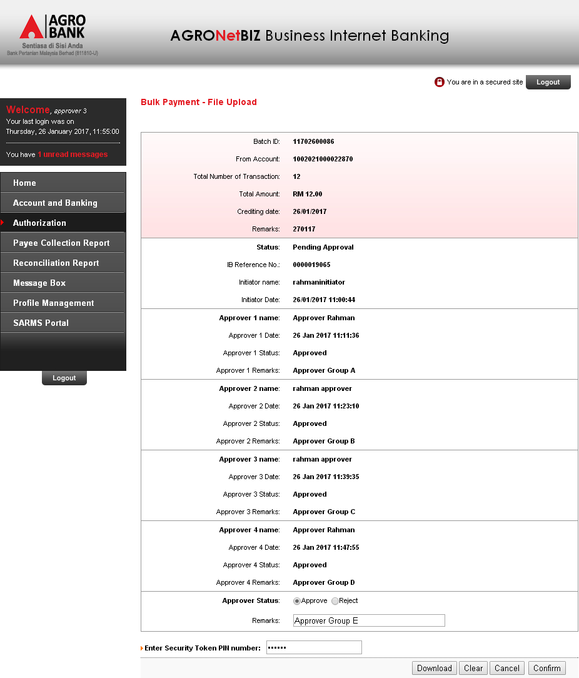
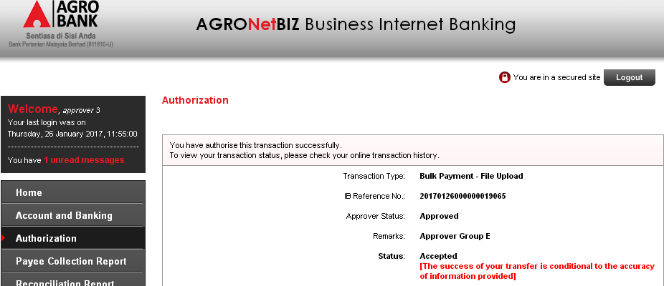

Reviewed By: (PMO)
 |  |  | Name/Position : Norhaidah Binti Md Dasuki / Senior Manager, Quality Assurance and Support  Date :

