Test Issue Log |  |  |  |  |  | SCP ID# :
Project Name: | AGROBANK BUSINESS INTERNET BANKING
Test Stage: | Unit Functionality Integration System Interface  Performance Regression Acceptance Pilot
Test Case Number: | Support #6962 |  |  | Test Started Date: |  |  | 06/02/2017
Test Title: | EPF
Test Description: | To verify status displayed.
Test Functionality: | BIB  - Payroll > Statutory Bodies > EPF
Test Procedure:
Test Result: | Pass: Fail: | Tested by: |  |  | Erni Suhaireen binti Zulkifli
Reason for Failure: | - Result page status : Pending Validation  - Statutory Bodies History - EPF :  - Status : Pending Validation  - Total Record : 8  *file upload record is 500  - System display error message as below when try to upload another file:  EPF file pending registration confirmation.
TEST DESCRIPTION
Screenshot:
- Scenario: Single User upload file with 500 records.
Result page status : Pending Validation
No | Current Result | Expacted Result
 | System display status “Pending Validation” on Result Page. | System should display status “Successful”
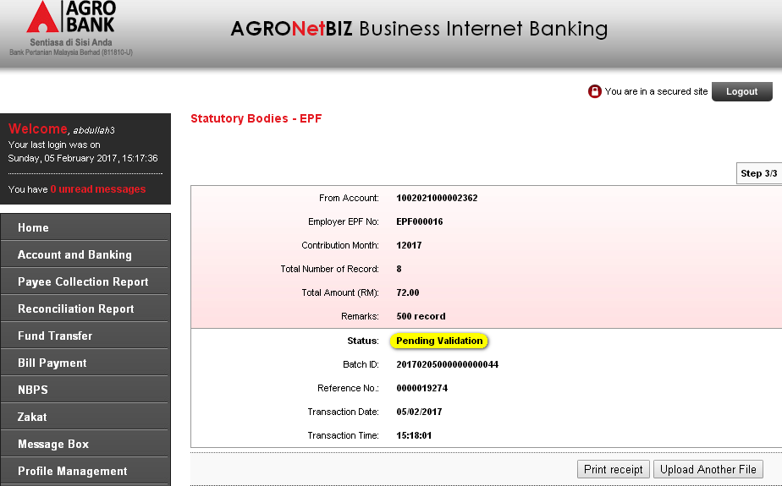
- Statutory Bodies History - EPF :
  - Status : Pending Validation
No | Current Result | Expacted Result
 | System display “Pending Validation” at Status column | System should display “Successful”
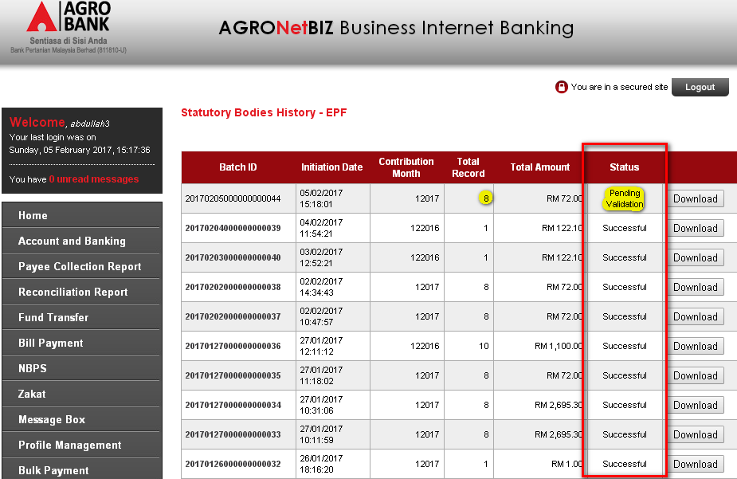
  - Total Record : 8
*file upload record is 500
No | Current Result | Expacted Result
2.2 | Total Record displays: 8  Total upload file : 500  *refer attached excel file | System should display total record as per total upload file


- Go to EPF page to upload another file.
System display error message as below when try to upload another file:
EPF file pending registration confirmation.
No | Current Result | Expacted Result
3. | Cannot perform to upload another file.  Error message displayed:  EPF file pending registration confirmation. | System should allow user to upload another file.

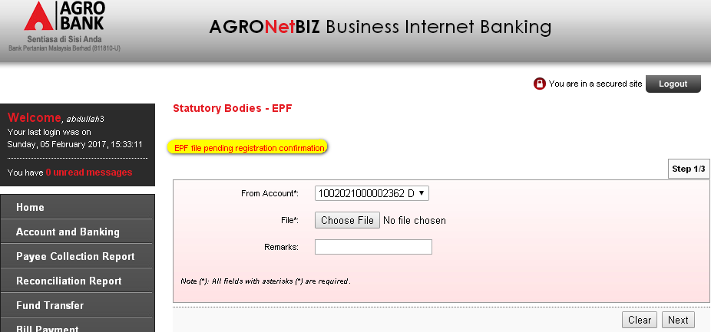

Reviewed By: (PMO)
 |  |  | Name/Position : Norhaidah Binti Md Dasuki / Senior Manager, Quality Assurance and Support  Date :

