Test Issue Log |  |  |  |  |  | SCP ID# :
Project Name: | AGROBANK BUSINESS INTERNET BANKING
hTest Stage: | Unit Functionality Integration System Interface  Performance Regression Acceptance Pilot
Test Case Number: |  |  |  | Test Started Date: |  |  | 08/02/2017
Test Title: | Result status unsuccessful
Test Description: | System display result status ‘Unsuccessful’. After check on IBAM, error reason is due to Date Verification Error, but the test date already set to today date which is 08/02/2017
Test Functionality: | BIB>Payroll>Statutory Bodies>EPF
Test Procedure: | - Attempting to upload new file. Result page status receive: Unsuccessful  - Login to IBAM to view on Error Reason.
Test Result: | Pass: Fail: | Tested by: |  |  | Erni Suhaireen binti Zulkifli
Reason for Failure: | Result status unsuccessful with error reason Date Verification Error while the date set on IB already set to current date.
TEST DESCRIPTION
Screenshot:
- Attempting to upload new file. Result page status receive: Unsuccessful
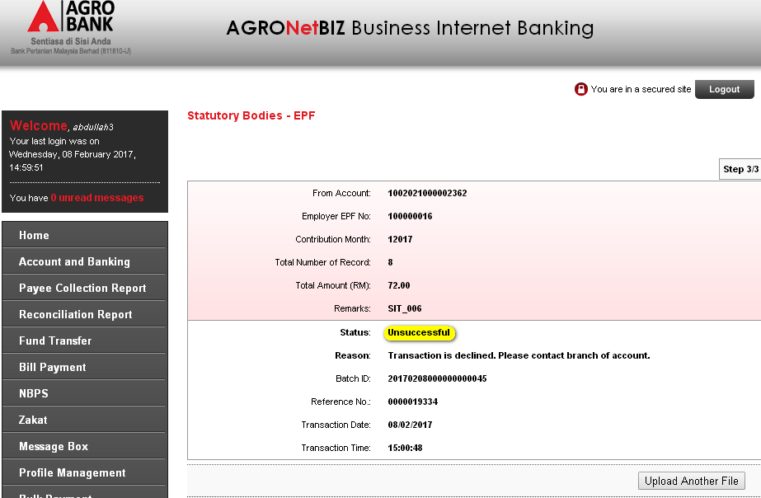
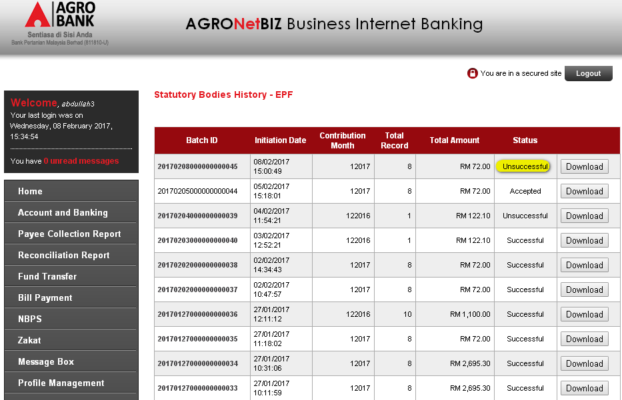
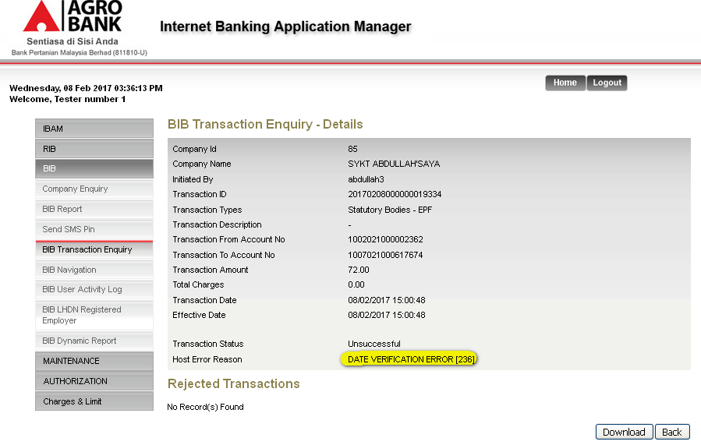

Reviewed By: (PMO)
 |  |  | Name/Position : Norhaidah Binti Md Dasuki / Senior Manager, Quality Assurance and Support  Date :

