Test Issue Log |  |  |  |  |  | SCP ID# :
Project Name: | AGROBANK BUSINESS INTERNET BANKING
hTest Stage: | Unit Functionality Integration System Interface  Performance Regression Acceptance Pilot
Test Case Number: |  |  |  | Test Started Date: |  |  | 08/02/2017
Test Title: | Unable to upload next file
Test Description: | Unable to upload next file after the previous file upload return status: Unsuccessful
Test Functionality: | BIB>Payroll>Statutory Bodies>EPF
Test Procedure: | - Attempting to upload new file. Result page status receive: Unsuccessful  - Perform to upload next file. Error message receive: EPF file pending registration confirmation.
Test Result: | Pass: Fail: | Tested by: |  |  | Erni Suhaireen binti Zulkifli
Reason for Failure: | User unable to upload the next file after attempting to upload the 1st file which returns status ‘Unsuccessful’.
TEST DESCRIPTION
Screenshot:
- Attempting to upload new file. Result page status receive: Unsuccessful
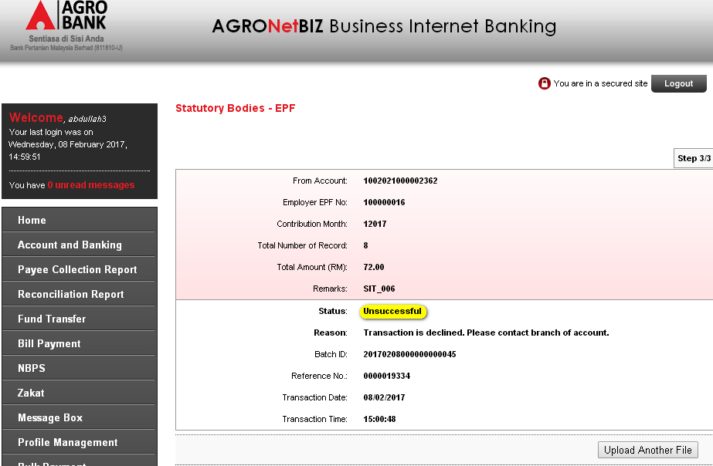
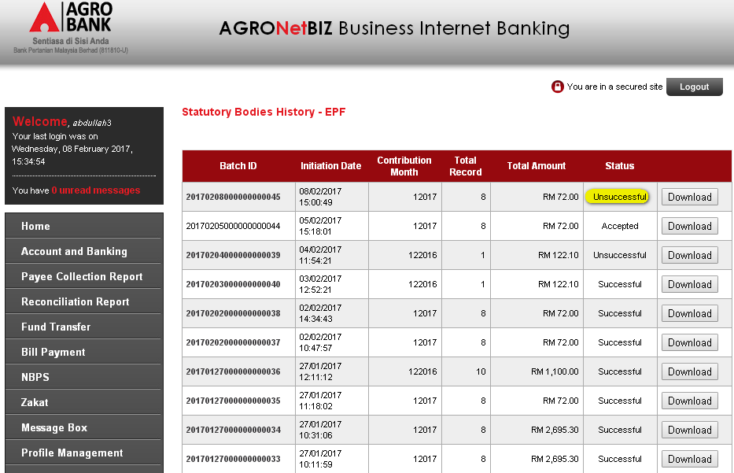
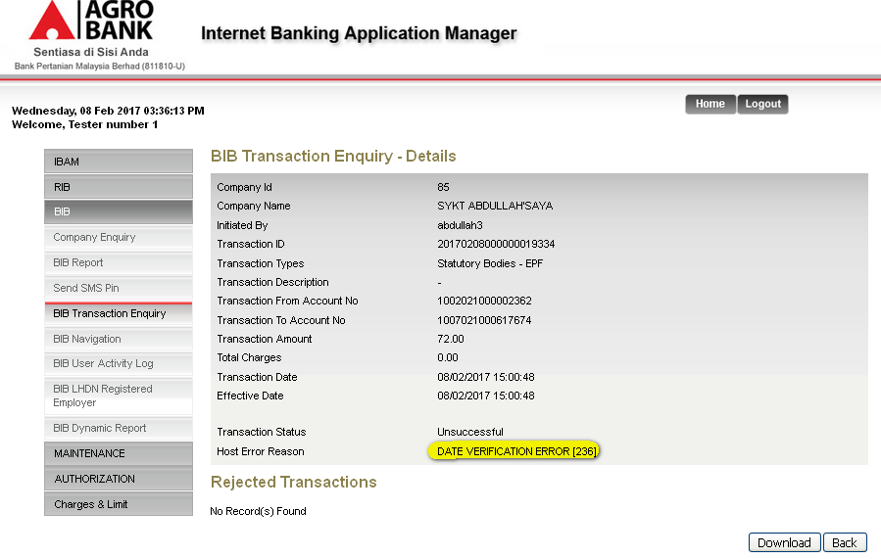

- Perform to upload next file. Error message receive: EPF file pending registration confirmation.
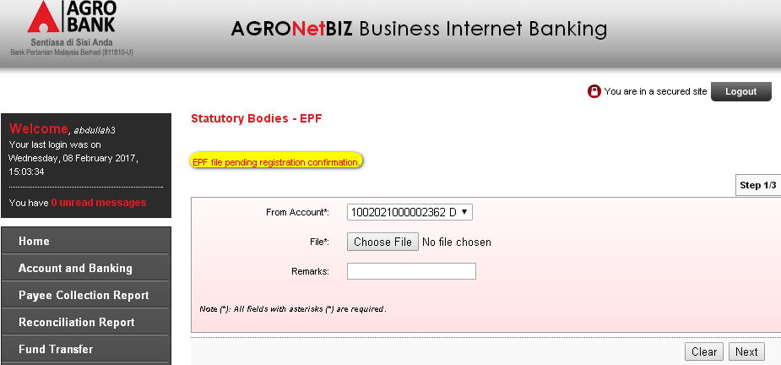
Reviewed By: (PMO)
 |  |  | Name/Position : Norhaidah Binti Md Dasuki / Senior Manager, Quality Assurance and Support  Date :

