Test Issue Log |  |  |  |  |  | SCP ID# : SIT_009
Project Name: | AGROBANK BUSINESS INTERNET BANKING
Test Stage: | Unit Functionality Integration System Interface  Performance Regression Acceptance Pilot
Test Case Number: | Support #7117 |  |  | Test Started Date: |  |  | 13/02/2017
Test Title: | SIT_009
Test Description: | To ensure Employer EPF No. field only allow for numeric only
Test Functionality: | BIB  - BIB> Authorization
Test Procedure:
Test Result: | Pass: Fail: | Tested by: |  |  | Erni Suhaireen binti Zulkifli
Reason for Failure:
TEST DESCRIPTION
Screenshot:
- Performing EPF Upload File
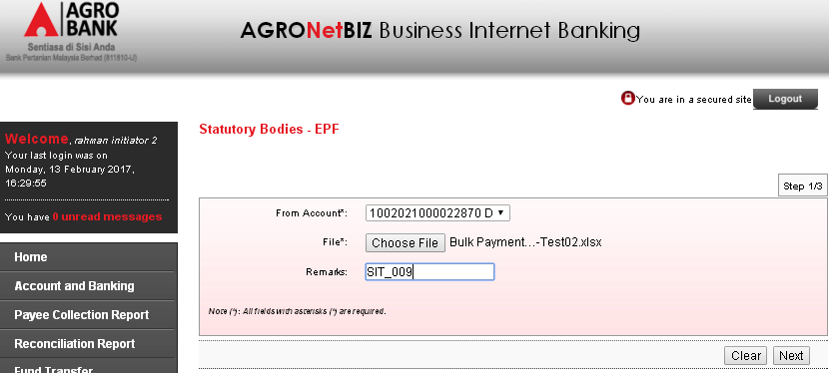
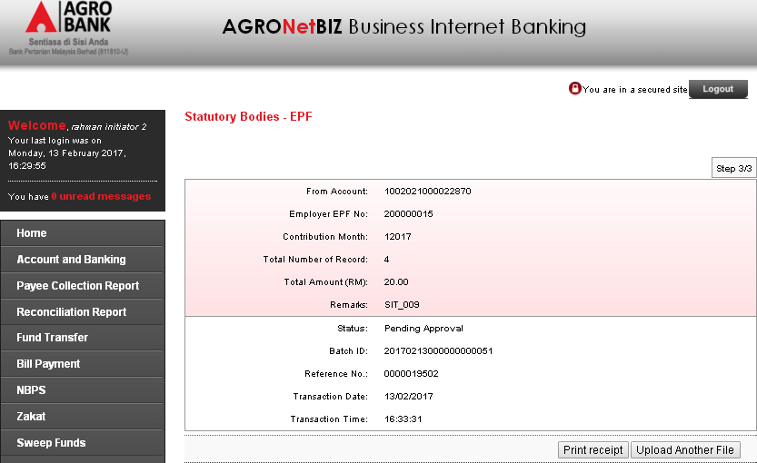
- Display EPF status.
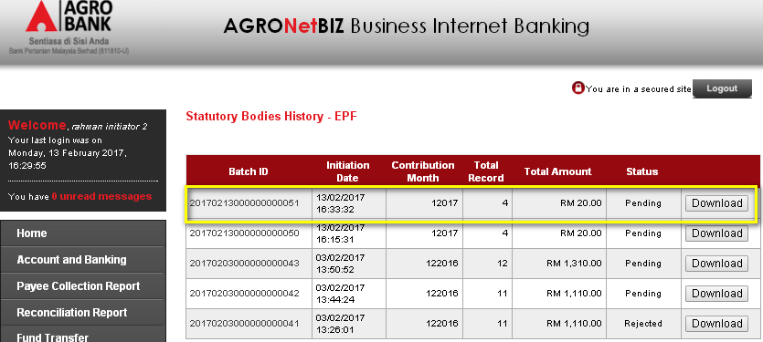

- Approve the transaction.
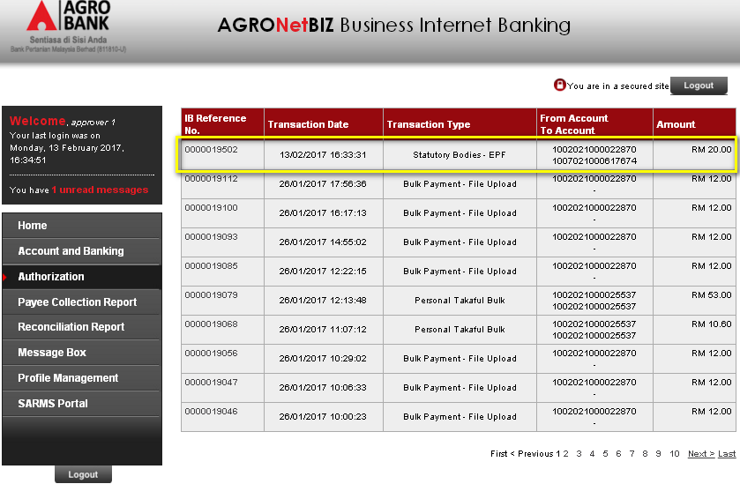
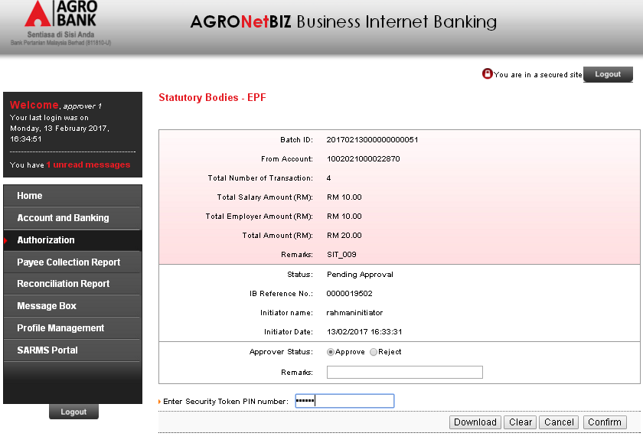
- Approval test result screen
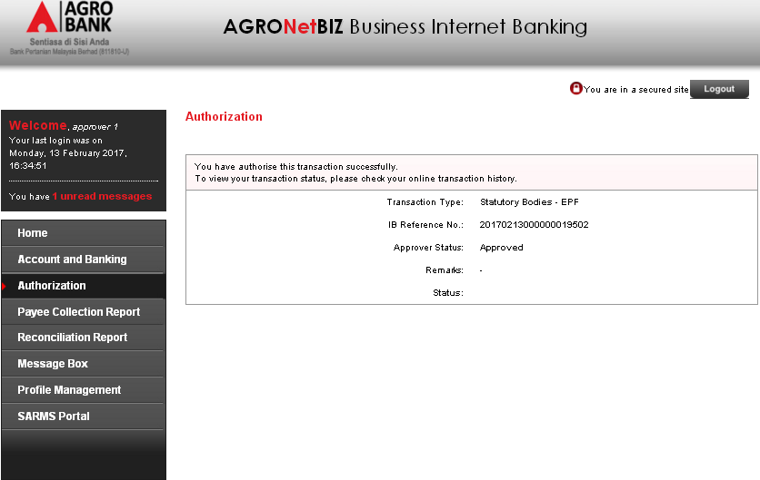
- EPF status after approve
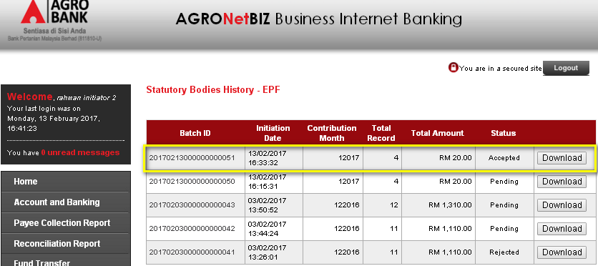
Reviewed By: (PMO)
 |  |  | Name/Position : Norhaidah Binti Md Dasuki / Senior Manager, Quality Assurance and Support  Date :

