

USER REQUIREMENT SPECIFICATION (URS) DOCUMENT

ONLINE PAYMENT GATEWAY
FOR AGRONet

Authors

Name | Designation & contact email | Remark
Halimah Mohammad Shukor | Virtual Banking, EBD

Amendment Record

Version | Date | Status | Description of Revision
1.0 | 15.08.2016 | New

TABLE OF CONTENTS

1.0 Introduction/System Overview 4
2.0 Problem Statement 4
3.0 Objective 4
4.0 Scope Of Work 4
5.0 Business Process Flow 5
6.0 Requirement Definition 5
7.0 Appendix 6

- INTRODUCTION/ SYSTEM OVERVIEW

Online Payment Gateway (OPG) is a merchant payment service that authorizes direct payments processing for e-commerce transactions or online retailers. A payment gateway facilitates a payment transaction by the transfer of information between a payment portal (such as a merchant online shopping website) and the front end payment processor i.e. acquiring bank (in this case, Agrobank).

OPG allows Agrobank’s customer to make payment online real-time via AGRONet internet banking access by directly debiting their current or savings account to a registered merchant with Agrobank.

OPG connects the bank’s internet banking application to an e-commerce website via a debit payment engine application that links the customer payment function at the merchant’s e-commerce website.

- PROBLEM STATEMENT

Currently there is no Payment Gateway at Internet Banking system. By having this engine IB user can make the online purchase payment by using the same User ID and password at AGRONet account.

- OBJECTIVE

To allows Agrobank’s customer to make payment online real-time via AGRONet internet banking access by directly debiting their current or savings account to a registered merchant with Agrobank.

- SCOPE OF WORK

  - Create a new Payment Gateway Engine using Internet Banking framework

  - Allow user to login and make online payment using the same AGRONet user id and password

  - Customize AGRONet Online Transaction History for Debit Payment transaction

  - Allow customer to view Debit Payment transaction on AGRONet Online Transaction History

- PROCESS FLOW

  - A customer places order on merchant website for an item, proceed to 'Submit Order' and select “Proceed with Payment”.

  - The merchant then forwards the transaction details to the payment gateway which then forwards the transaction information to the debit payment engine provided by the bank.

  - Customer will be prompted with a payment authorization page, whilst remain in session (not log out) with the e-commerce website.

  - Customer will be presented with a simplified login page to their AGRONet access and once successfully authenticated; customer immediately would see the relevant payment details (purchase info, total prize, order no. etc.) of which all these information are mapped automatically by the merchant website.

  - Once customer entered the TAC (one-time security code number received via SMS) and click “Confirm”, OPG will immediately authorize the payment by immediately debiting the amount to be paid from the selected banking account.

  - Once it is successful, the payment page will be re-directed to the e-commerce website to complete the full cycle of transaction whereby customer normally will be presented with receipt of transaction, reference number, mailing info, customer service number and other key info related to the online purchase.

  - OPG process overview is depicted as per below diagram:

  - Transaction Flow

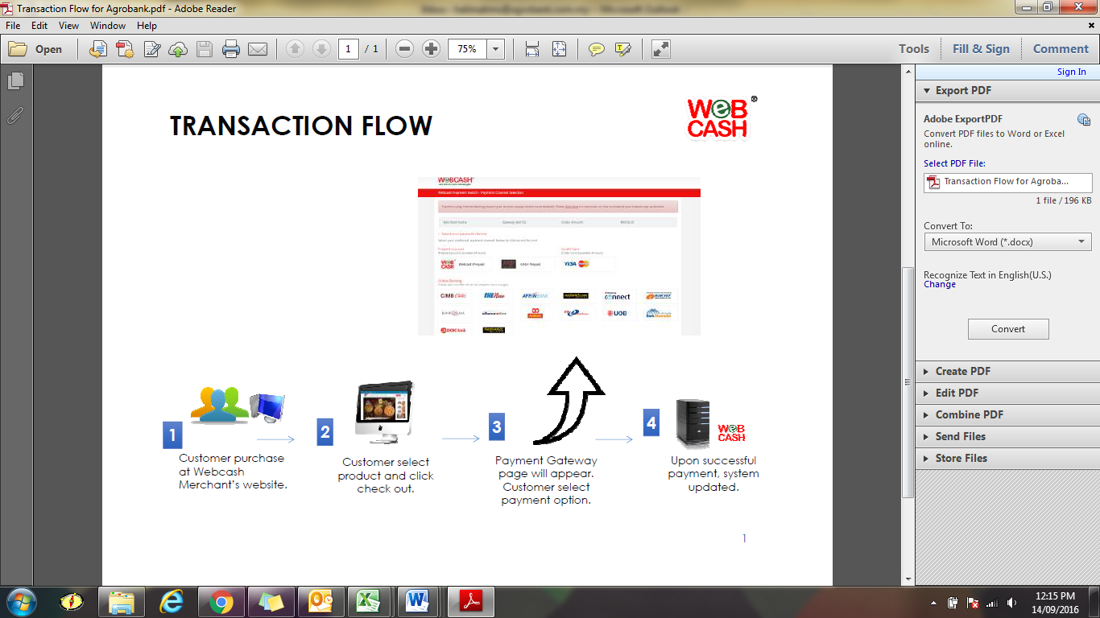

- REQUIREMENT DEFINITION

  - Integration Architecture

  - Integration APIs

Login URL and Parameters
This is the OPG login page that allowing merchant portal to redirect the payment page to AGRONet OPG via this URL.
URL = https://www.agronet.com.my/opg/login.do
URL hidden Parameter | Description
transactionData | A string which combines all 4 request parameters below in given format, is segregated by semi-colon (;).  Example: merchantID:data1;amount:data2;transactionID:data3;userID:data4;reference:data5

Request Parameter | Description | M/O
merchantID | The ID given by Agrobank to the merchant that for merchant identity. This ID is created in IBAM->Payee->Merchant module.  The ID is encrypted with the given RSA public key. | M
amount | Payment amount. This amount is encrypted with the given RSA public key. | M
transactionID | The transaction reference number from merchant site | M
userID | The user unique ID from the merchant portal. This ID will be saved for reference and quick tracing purpose. | M
reference | Reference such as sub merchant ID, remarks, and etc. | O

Call Back URL and Parameters
The Call back URL shall give by the merchant, which allowing AGRONet to redirect the OPG result page to merchant webpage via this URL.
Request Parameter | Description
amount | Payment amount, after processed in AGRONet OPG.
transactionID | The transaction reference number from merchant site
ibTransactionID | Online Payment Gateway transaction ID
statusCode | The status for the performed transaction  00 – Successful  For other code, the status message will be written in the message field.
message | This field is empty if statusCode is 00. Otherwise, this field will fill with error message.

Transaction Receipt API
This is a RESTful API allowing all merchant to enquire for the transaction status.
URL = https://www.agronet.com.my/opg/transactionEnq

Request Parameter:-
RESTful JSON Object Attribute | Description
merchantID | The ID given by Agrobank to the merchant that for merchant identity. This ID is created in IBAM->Payee->Merchant module.  The ID is encrypted with the given RSA public key.
userID | The user unique ID from the merchant portal.
transactionID | The transaction reference number from merchant site

Response Message:-
Request Parameter | Description
amount | Payment amount, after processed in AGRONet OPG.
transactionID | The transaction reference number from merchant site
ibTransactionID | Online Payment Gateway transaction ID
statusCode | The status for the performed transaction  00 – Successful  For other code, the status message will be written in the message field.
message | This field is empty if statusCode is 00. Otherwise, this field will fill with error message.

  - User Requirement

Item | Requirements
AGRONet/  Account & Banking | - Able to use the same AGRONet user id and password.  - Customize AGRONet Online Transaction History for transaction via Web Cash.  - Able to view Web Cash transaction at AGRONet Online Transaction History.  - Transaction shall be updated at the Transaction History as well.
Settlement/ Commission | - Settlement between Bank and Web Cash will be done by Virtual Banking Section in daily basis.  - There will be a collection account created for Web Cash with Agrobank.
Item | Requirements
- The transaction will be send to Web Cash via Bank standard ftp files format on the next day after batch completed.

- Bank will send gross amount to Web Cash in daily basis through their collection account with Agrobank.

- Customer will be charge RM1.06 (including GST) for each transaction via Web Cash and Bank will send total transaction amount including the customer charges + GST to Web Cash.

Example:
- Transaction amount | = RM 100.00
- Customer charges including GST | = RM 1.06
- Total transaction | = RM101.06

- Web Cash will send the commission to Agrobank via IBG transfer in monthly basis. Bank will earned RM0.50 for each transaction.

- ACCESS MATRIX & AUTHORIZATION

N/A

- INTERFACES

Refer Appendix 1 for details illustrations.

- LIST OF TRANSACTION CODE

New transcode

- FILE/DATA

N/A

- GENERAL LEDGER ACCOUNT

To used existing 3rd Party transfer accounting entries. Refer Appendix 2 for detail entries.

- INTEGRATION WITH OTHER CHANNELS

No. | Vendor | System
1. | Silverlake | Core banking system (host)
2. | Beans | Middleware

- REPORTS

  - Host Report [Branch Code 8551]

    - Critical Report

Update the transaction to report listed below:

- DD3703P CA/SA IBT TXN Total For Other Br
- DD3710P CA/SA Daily IBT TXN Report – for Other Branches

    - Noncritical Report

- GLEXT2P G/L Interface to Masterpiece

  - Internet Banking Report

    - Retail Internet Banking [RIB – AGRONet]

- Produce new daily Web Cash transactions report for AGRONet. Refer Appendix 3 for sample report

- Add Web Cash transaction data to Monthly Consolidated report

- FORMS AND VAUCHAR

N/A

- FUTURE REQUIREMENTS

N/A

