Kuwait Finance House

IBFT Technical
Documentation

Prepared By



Kuwait Finance House, Malaysia

&



VERSION: 1.0

Revision

Revision | Amendment | Ref In Doc | Updated By | Date
1.0 | New Document | All | Vincent | 07/12/2010

Table of Contents

1.0 Document Purpose 4
2.0 IBFT Integration 5
2.1 Overview of Integration 5
2.2 Flow of Process 6
3.0 PowerCard Connection 8
4.0 PowerCard Services Message Components 9
4.1 IB_ACCOUNT_ENQUIRY 9
4.1.1 Request Message 9
4.1.2 Response Message 10
4.2 Confirm_Transfer 10
4.2.1 Request Message 10
4.2.2 Response Message 11
5.0 IBFT Response Code 11
6.0 Appendix 12
6.1 esb.properties 12
6.2 IB_Account_Enquiry 13
6.2.1 Request Message 13
6.2.2 Response Message 13
6.3 Confirm_Transfer 14
6.3.1 Request Message 14
6.3.2 Response Message 14
6.4 IBFT Response Code & Description 15

Document Purpose

This document serves as a reference for KFH Technical personnel to do any enhancement to IBFT Services in future by modifying the configurations. It provides a brief description of the configurations and configuration files.
There are two common configuration files used in IBFT Module, .xml and .properties. This configuration files like change once and effect all. Means, only one configuration file will be changed and any other files that sharing the configuration file will get affected.
Finally, an example configuration file is given to guide the Technical personnel on how to make the changes.
Apart from the configuration of the application, parameter setting for IBFT via PowerCard is included.

IBFT Integration

Overview of Integration

Two (2) functions available in PowerCard that will call from Internet Banking (IB) to perform IBFT:
- IB Account Enquiry –To retrieve Beneficiary Name
- Confirm Transfer – To transfer fund to Beneficiary Account.
These functions will called by services from IB when initiating IBFT Transaction.
IBFT Transfer
Account Enquiry Services
Fund Transfer Services
Internet Banking

IB Account Enquiry

Confirm Transfer

Debiting & Crediting
PowerCard
MEPS

ESB

Figure 2.1: Components of IBFT System Integration

Flow of Process

Menu
Step 2
Step 1
Step 3
Figure 2.2: IBFT flow of process
As per figure 2.0 below are the description of steps in details:

Action | Description | Remarks
Step 1 | Input all Beneficiary Details from IB to retrieve Beneficiary Name. | Input:  - Rim No  - From Account No  - To Account No  - Amount  - Bank Code
Step 1 | Call to PowerCard to send the request to MEPS. | Function : IB_ACCOUNT_ENQUIRY
Step 1 | MEPS to return Beneficiary Name from other Financial Institution if available. | Beneficiary Name
Step 1 | PowerCard send the response from MEPS to IB
Step 1 | If Beneficiary Name is not available, retry Step 1
Step 2 | Return Beneficiary Name will confirm by sender. | Beneficiary Name verification
Step 2 | If Beneficiary Name is correct, call PowerCard to transfer the fund to Beneficiary Account. | Function: CONFIRM_TRANSFER  Input:  - Rim No  - From Account No  - To Account No  - Amount  - Bank Code
Step 2 | MEPS receive the transaction and forward to respective Financial Institution for crediting. | Crediting process
Step 2 | MEPS return the status of the transaction | Return status
Step 2 | PowerCard forward the response from MEPS.
Step 3 | Display the result of the transaction | Result of the transaction
Step 3 | Retry if performed transaction fail.
Table 2.1: Details flow of process

PowerCard Connection

PowerCard Connection settings to access IBFT Services kept in a properties file, “esb.properties”. This file resites within the application and the connection settings will be used to make the connection from IB to PowerCard. There are four (4) properties required to set:

Property name | Description
ibft.endpoint.powercard | End Poing URL (IP Address & Port)
ibft.endpoint.powercard.ws | Service Name
ibft.endpoint.powercard.username | UserName to access database
ibft.endpoint.powercard.passwd | Password to access database
Table 3.1: Connection properties

esb.properties file needs to be changed in all BV instances.
- /opt/BV1TO1/JBoss/server/bv_framework0/deploy/kfh_consumer/WEB-INF/classes/esb.properties
- /opt/BV1TO1/JBoss/server/bv_framework1/deploy/kfh_consumer /WEB-INF/classes/esb.properties
- /opt/BV1TO1/JBoss/server/bv_framework2/deploy/kfh_consumer/ WEB-INF/classes/esb.properties
- /opt/BV1TO1/JBoss/server/bv_framework3/deploy/kfh_consumer/ WEB-INF/classes/esb.properties

Refer to Appendix 6.1 for example properties file.

PowerCard Services Message Components

Two functions available:
(1) IB_ACCOUNT_ENQUIRY and
(2) CONFIRM_TRANSFER.
These functions will be triggered by IB with the required parameters. Below are the request and response messages of these functions.

IB_ACCOUNT_ENQUIRY

Request Message

FIELD | PARAMETER NAME | Depends | CONTENTS | EXAMPLE / REMARK
 | p_rim | Mandatory | String | 5570
 | p_account_from | Mandatory | String | 001105005475
 | p_account_to | Mandatory | String | 158220580719
 | p_amount | Mandatory | String | 100.00
 | p_bank_code | Mandatory | String | 58383
Table 4.1: Request properties values

- p_rim
This field defines the Sender Account Rim No
- p_account_from
This field defines the Sender Account Number
- p_account_to
This field defines the Beneficiary Account Number.
- p_amount
This field defines the Amount to be transferred to Beneficiary Account
- p_bank_code
This field defines the IBFT Member ID for the respective Bank.

Response Message

FIELD | PARAMETER NAME | Depends | CONTENTS | EXAMPLE / REMARK
 | p_response_code | Mandatory | String | 0.0
 | p_error_code | Optional | String | -10
 | p_benef_name | Optional | String | John Doe
 | RETURN_STATUS | Mandatory | String | 0
Table 4.2: Response properties values

- p_response_code
This field defines the details of RETURN_STATUS. Each code return describes the response message in detail.
- p_error_code
This field defines the reason of the failed transaction. Only present for fail transactions.
- p_benef_name
This field defines the beneficiary account holder name. This given name will be verified by Sender before confirming the fund transfer.
- RETURN_STATUS
This field defines the status of the transaction whether the performed transaction successful of fail.

Refer to Appendix 6.2 for example of Request and Response Message.

Confirm_Transfer

Request Message

FIELD | PARAMETER NAME | Depends | CONTENTS | EXAMPLE / REMARK
 | p_rim | Mandatory | String | 5570
 | p_account_from | Mandatory | String | 001105005475
 | p_account_to | Mandatory | String | 158220580719
 | p_amount | Mandatory | String | 100.00
 | p_bank_code | Mandatory | String | 58383
Table 4.3: Request properties values

- p_rim
This field defines the Sender Account Rim No
- p_account_from
This field defines the Sender Account Number
- p_account_to
This field defines the Beneficiary Account Number.
- p_amount
This field defines the Amount to be transferred to Beneficiary Account
- p_bank_code
This field defines the IBFT Member ID for the respective Bank.

Response Message

FIELD | PARAMETER NAME | Depends | CONTENTS | EXAMPLE / REMARK
 | p_response_code | Mandatory | String | 116.0
 | p_error_code | Optional | String | -12
 | p_audit_number | Mandatory | String | 987654321
 | p_reference_number | Mandatory | String | 1234567890
 | RETURN_STATUS | Mandatory | String | 0
Table 4.4: Response properties values

- p_response_code
This field defines the details of RETURN_STATUS. Each code return describes the response message in detail.
- P_error_code
This field defines the reason of the failed transaction. Only present for fail transactions.
- p_audit_number
This field defines the Audit Number of the transaction
- p_reference_number
This field defines the Reference Number of the transaction
- RETURN_STATUS
This field defines the status of the transaction whether the performed transaction successful of fail.

Refer to Appendix 6.3 for example Request and Response message.

IBFT Response Code

Response code returns from MEPS to describe the status of transaction. Each response code returns from MEPS has a meaning. All the description for the response code is maintained in a properties file. Whenever a response code returns, the system will capture the description for the respective response code. Refer to Appendix 6.4 for the list for Response Code and Description

Appendix

esb.properties
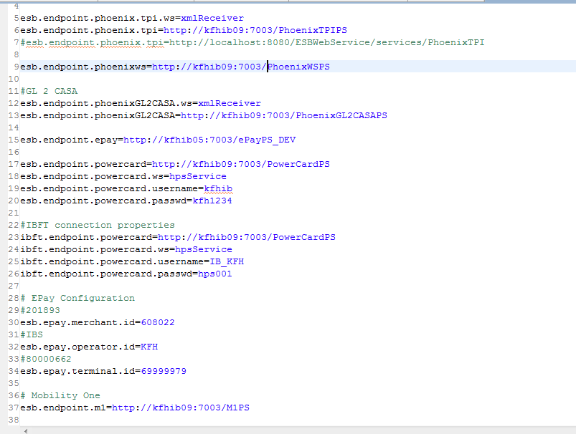

IB_Account_Enquiry

Request Message

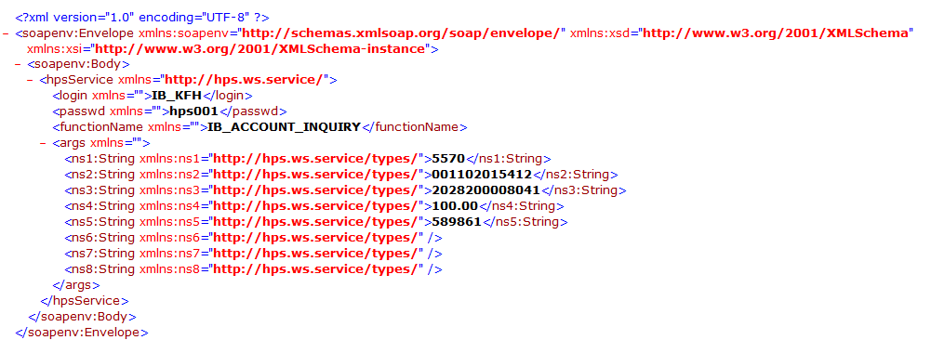
Rim No
From Account No
To Account No
Amount
Bank Code

Response Message

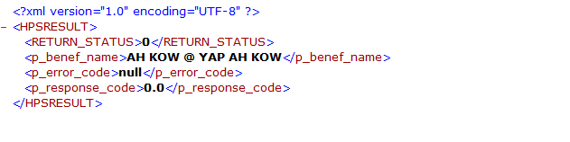

Confirm_Transfer

Request Message

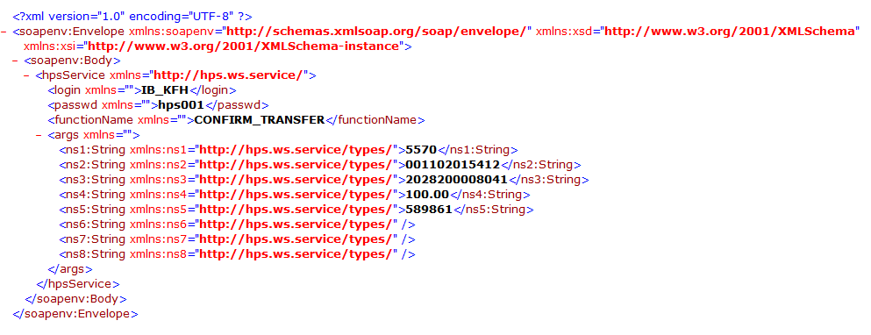
Rim No
From Account No
To Account No
Amount
Bank Code

Response Message
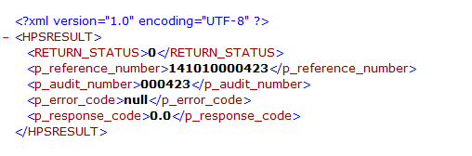

IBFT Response Code & Description

No | Response Code | Description
1 | 000 | Accepted
2 | 001 | Accepted with identification
3 | 003 | Accepted (VIP)
4 | 007 | Accepted, ICC updating
5 | 100 | Do not honour
6 | 101 | Card expired
7 | 102 | Fraud detected
8 | 104 | Card has reserved use
9 | 106 | PIN tries number allowed exceeded
10 | 107 | Refer to Card Issuer
11 | 108 | Refer to Card Issuer special conditions
12 | 109 | Wrong business
13 | 110 | Wrong amount
14 | 111 | Wrong card No.
15 | 112 | Data linked to PIN required
16 | 114 | No account for type requested
17 | 115 | Function requested not undertaken
18 | 116 | Insufficient funds
19 | 117 | PIN incorrect
20 | 118 | Card not recorded
21 | 119 | Transaction not authorised for Holder
22 | 120 | Transaction not accepted by terminal
23 | 121 | Withdrawal limits exceeded
24 | 122 | Security violation
25 | 123 | Exceeding withdrawal authorised frequency
26 | 125 | Card not in service
27 | 126 | Wrong PIN format
28 | 127 | Wrong PIN length
29 | 128 | Synchro error of PIN key
30 | 129 | Card counterfeit detected
31 | 180 | Shadow account not found
32 | 181 | Check account not found
33 | 182 | Saving account not found
34 | 183 | CVV invalid
35 | 184 | Date invalid
36 | 200 | Do not honour, capture card
37 | 201 | Card expired, capture card
38 | 202 | Fraud detected, capture card
39 | 204 | Card has reserved use, capture
40 | 205 | Card acceptor calls for acquirer security service, capture
41 | 206 | PIN validation tries number allowed exceeded
42 | 207 | Special Conditions, capture card
43 | 208 | Card lost, capture card
44 | 209 | Card stolen, capture card
45 | 210 | Card counterfeit detected, capture card
46 | 280 | Alternative amount cancelled
47 | 299 | Capture card
48 | 300 | Processing fulfilled
49 | 301 | Not supported by sender
50 | 302 | Unable to spot record in file
51 | 303 | Duplicate record, old record replaced
52 | 304 | Zone control error
53 | 305 | File locked
54 | 306 | Processing failed
55 | 307 | Format error
56 | 308 | Duplicate processing, new record rejected
57 | 309 | File unknown
58 | 381 | Recrord not found. Account not cut off. Withdrawal not processed
59 | 382 | Clearing balance record
60 | 383 | Updating balance
61 | 385 | Balance request
62 | 480 | Reversal correct
63 | 481 | Reversal amount incorrect
64 | 482 | Transaction already cancelled
65 | 503 | Totals not available
66 | 500 | Reconciliation succeeded
67 | 581 | Reconciliation already done
68 | 582 | Reconciliation procedure not available
69 | 800 | Cut-off in process
70 | 880 | Connection not accepted
71 | 888 | Send of cut-off
72 | 902 | Transaction invalid
73 | 908 | Transaction sender not referenced for switch
74 | 909 | System defect
75 | 911 | Issuer undue response
76 | 912 | Card issuer not available
77 | 992 | Issuer not found
78 | 993 | PINN verification not allowed
79 | 994 | Error in transaction processing
80 | 995 | Error in server processing

