Test Issue Log |  |  |  |  |  | SCP ID# :
Project Name: | AGROBANK BUSINESS INTERNET BANKING
Test Stage: | Unit Functionality Integration System Interface  Performance Regression Acceptance Pilot
Test Case Number: | Support #6962 |  |  | Test Started Date: |  |  | 20/02/2017
Test Title: | IBAM Report
Test Description: | To ensure that the font type and font size is standardize, also the report layout were display as per requirement needs
Test Functionality: | IBAM  - IBAM > BIB Report > File Type: PDF/XLS
Test Procedure:
Test Result: | Pass: Fail: | Tested by: |  |  | Erni Suhaireen binti Zulkifli
Reason for Failure: | - Font Type:  - To ensure the font type for Content (for: xls and pdf) is same as Header, just not bold : Arial  - Font Size:  - To ensure the font size for Content (for: xls and pdf)is same as Header : 9  - Report Layout:  - Amount value must be correctly in line with ‘Total Amount Month-to-Date’ (for: xls and pdf)  - To ensure ‘Remarks’ have space. (for: xls and pdf)  - To remove space in front of ‘Company Name’ at content. (for pdf only)
TEST DESCRIPTION
- Font Type:
  - To ensure the font type for Content (for: xls and pdf) is same as Header, just not bold : Arial
Current Result: Font type for Content is SensSerif while the Header font type is Arial
Expected Result: To standardize the font type according to Header(Arial), just not bold

Content:
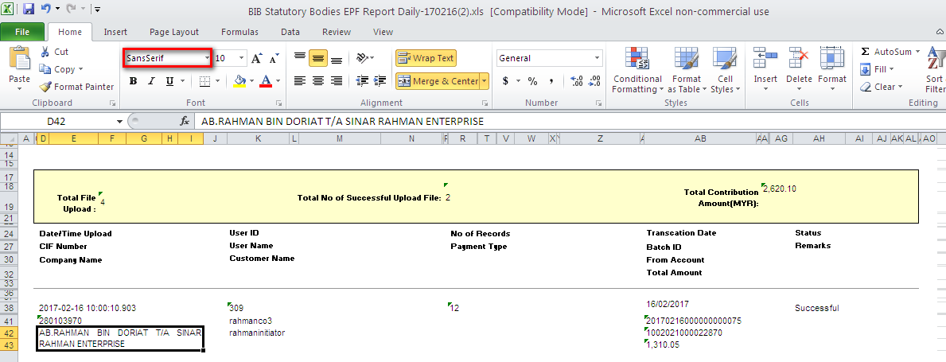
Header:
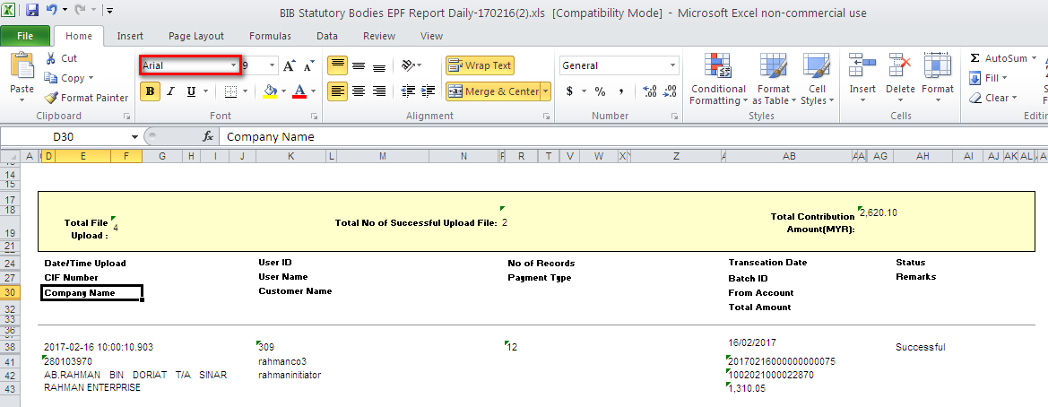

- Font Size:
  - To ensure the font size for Content (for: xls and pdf)is same as Header : 9
Current Result: Font size for Content is 10 while the Header font size 9
Expected Result: To standardize the font size according to Header (9), just not bold

Content:
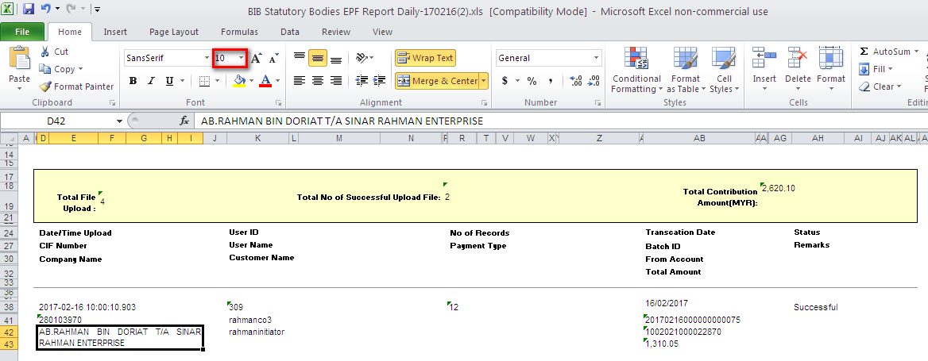
Header:
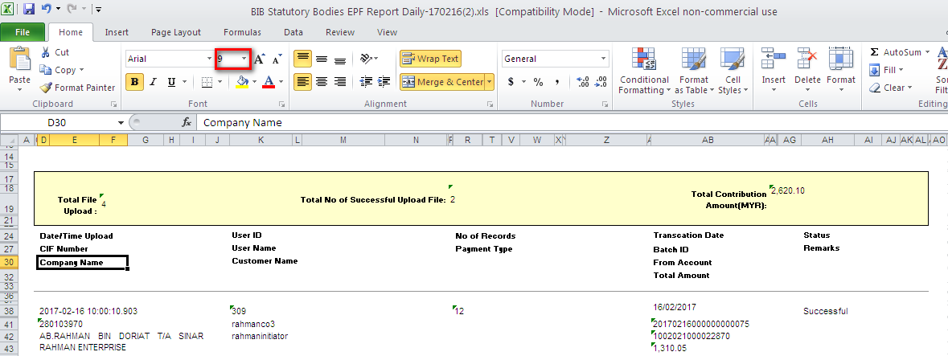

- Report Layout:
  - Amount value must be correctly in line with ‘Total Amount Month-to-Date’ (for: xls and pdf)
Current Result: Amount value is not correctly in line with ‘Total Amount Month-to-Date’
Expected Result: Expected it to be correctly in line

XLS format:
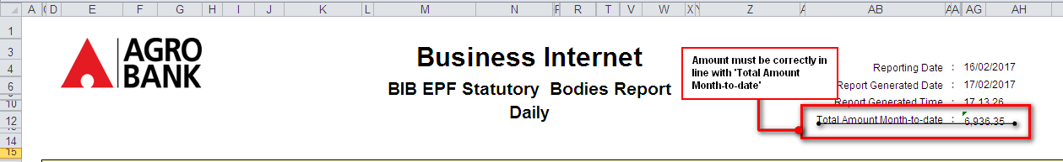
PDF format:
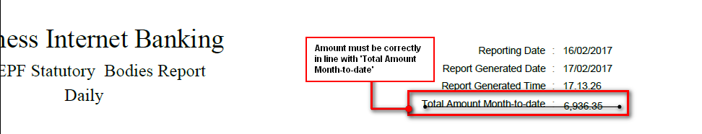

  - To ensure ‘Remarks’ have space. (for: xls and pdf)
Current Result: ‘Remarks’ word displayed in report does not have space, but when initiate this transaction user already includes space.
Expected Result: Expected it to have space

XLS Format:
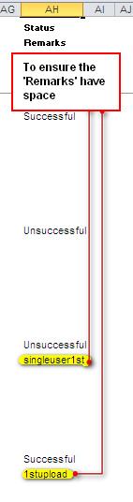
PDF Format:
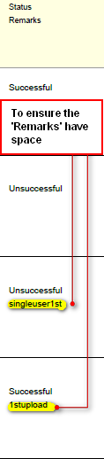

  - To remove space in front of ‘Company Name’ at content. (for pdf only)
Current Result: ‘Company Name’ at content currently displayed to have space at in front
Expected Result: To remove space in front of ‘Company Name’ at content
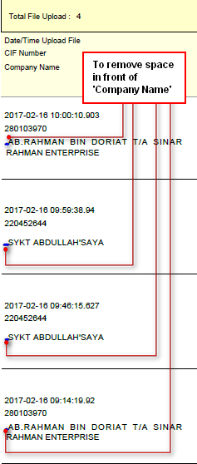
Reviewed By: (PMO)
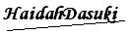 |  |  | Name/Position : Norhaidah Binti Md Dasuki / Senior Manager, Quality Assurance and Support  Date :

