Test Issue Log |  |  |  |  |  | SCP ID# : SIT_013
Project Name: | AGROBANK BUSINESS INTERNET BANKING
Test Stage: | Unit Functionality Integration System Interface  Performance Regression Acceptance Pilot
Test Case Number: | Support #7120 |  |  | Test Started Date: |  |  | 14/02/2017
Test Title: | SIT_013
Test Description: | To ensure error message pop up displayed: Header does not start with ‘H’. when enter other ‘H’ on ‘Header Record’ field at upload excel file.
Test Functionality: | BIB  - Payroll > Statutory Bodies > EPF
Test Procedure: | - On excel upload file, enter other than ‘H’ on ‘Payment Record’ field.  - Perform to upload file on BIB.
Test Result: | Pass: Fail: | Tested by: |  |  | Erni Suhaireen binti Zulkifli
Reason for Failure:
TEST DESCRIPTION
Screenshot:
- On excel upload file, enter another than ‘H’ on ‘Payment Record’ field.
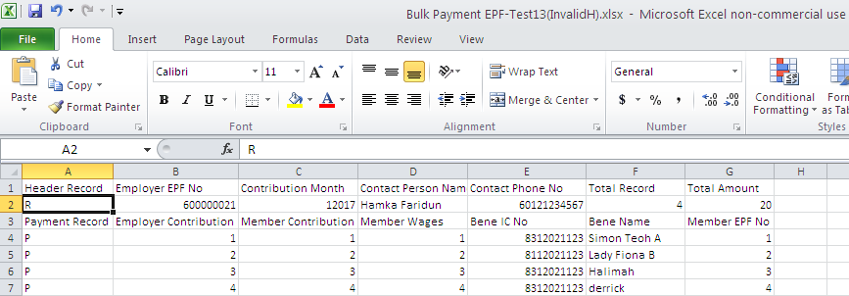

- Perform to upload file on BIB.
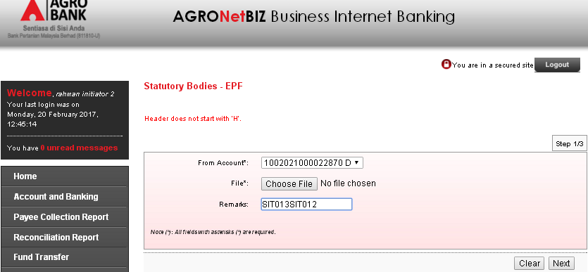
Error message displayed:
Header does not start with ‘H’.
Reviewed By: (PMO)
 |  |  | Name/Position : Norhaidah Binti Md Dasuki / Senior Manager, Quality Assurance and Support  Date :

