Kuwait Finance House

IBFT User
Documentation

Prepared By



Kuwait Finance House, Malaysia

&



VERSION: 1.0

Revision

Revision | Amendment | Ref In Doc | Updated By | Date
1.0 | New Document | All | Vincent | 07/12/2010

Table of Contents

1.0 Document Purpose 4
2.0 IBFT Member Bank List (Interbank List) 5
3.0 Create / Set IBFT Member Bank 5
4.0 Appendix 6
4.1 MEPS IBFT Member Bank 6
4.2 Create / Set MEPS IBFT Member Bank 7

Document Purpose

This document serves as a reference for KFH users to do any changes to IBFT Services in future by modifying the configurations. It provides a brief description of the function available for IBFT in BVMC and how to configure.

Also include examples of configuration to guide the users on how to make the changes.

IBFT Member Bank List (Interbank List)

A list of MEPS Member Bank maintained in BVMC to be used when performing IBFT. Each record contains a special code (Bank Code) that is recognized by MEPS to communicate with other Financial Institution (FI).

Appendix 4.1 shows the MEPS IBFT member bank list.

Create / Set IBFT Member Bank

Below are the Details that required to create new IBFT Member Bank. Item 4, 8 and 11 is a flag to turn ON or OFF the service whether it applied to the Member Bank.
The existing IB Interbank list is set to use for IBG and Rentas. To Add IBFT Service to the existing Member Bank, set values to IBFT fields.

No | Field | Description | Remarks
1 | Bank Code | The Code for the Bank
2 | Status | To turn ON or OFF the display
3 | Bank Full Name | The full name of the Bank
4 | Rentas | To turn ON or OFF the Use | Flag
5 | Rentas Member Code | Rentas Member Code
6 | Rentas Member ID | Rentas Member ID
7 | Rentas Member Name | Rentas Member Name to be display
8 | IBG | To turn ON or OFF the Use | Flag
9 | IBG Member ID | IBG Member ID
10 | IBG Member Name | IBG Member Name to be display
11 | IBFT via SAN | To turn ON or OFF the Use | Enhancement (Flag)
12 | IBFT Member ID | IBFT Member ID | Enhancement
13 | IBFT Member Name | IBFT Member Name to be display | Enhancement

Refer to Appendix 4.2 on how to create /set IBFT Member Bank

Appendix

MEPS IBFT Member Bank

Table 1.0: MEPS IBFT Member Bank

No | ABBR | DESC | ACQ ID
1 | ABB | AFFIN BANK BERHAD | 501664
2 | ABMB | ALLIANCE BANK MALAYSIA BERHAD | 504374
3 | AMFB | ARAB MALAYSIAN BANK BERHAD | 503419
4 | BKRB | BANK KERJASAMA RAKYAT BERHAD | 589267
5 | BPM | BANK PERTANIAN MALAYSIA | 589373
6 | BSN | BANK SIMPANAN NASIONAL | 420709
7 | CIMB | COMMERCE INTERNATIONAL MALAYSIA BERHAD | 501855
8 | EBB | EON BANK BERHAD | 589861
9 | HLB | HONG LEONG BANK | 588830
10 | MBB | MALAYAN BANKING BERHAD | 588734
11 | PBB | PUBLIC BANK BERHAD | 564162
12 | RHB | RHB BANK | 564160

Create / Set MEPS IBFT Member Bank

IB Interbank List is one of the content types to manage all MEPS IBFT Member Bank.
Below are the steps involved in creating IBFT Member Bank.

Step 1: Select IB Interbank List from the dropdown in Content

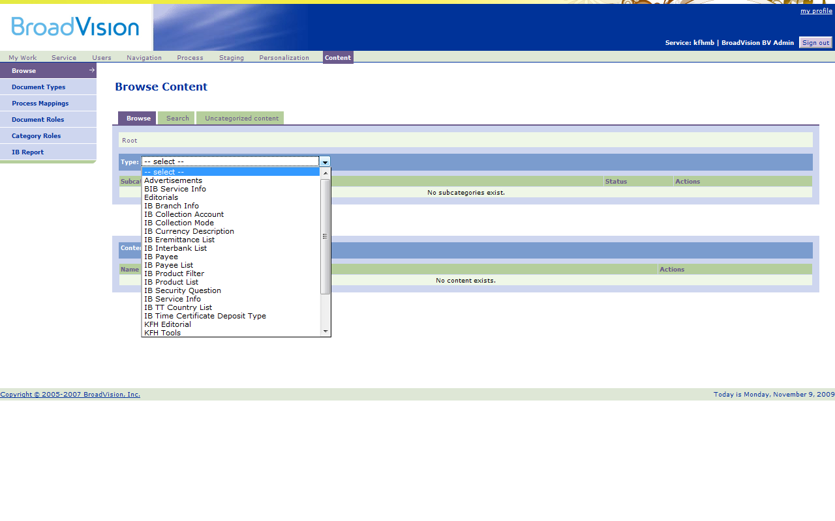
Figure 4.1: Select Content type

Step 2: Click on Category “kfh” to further into content.

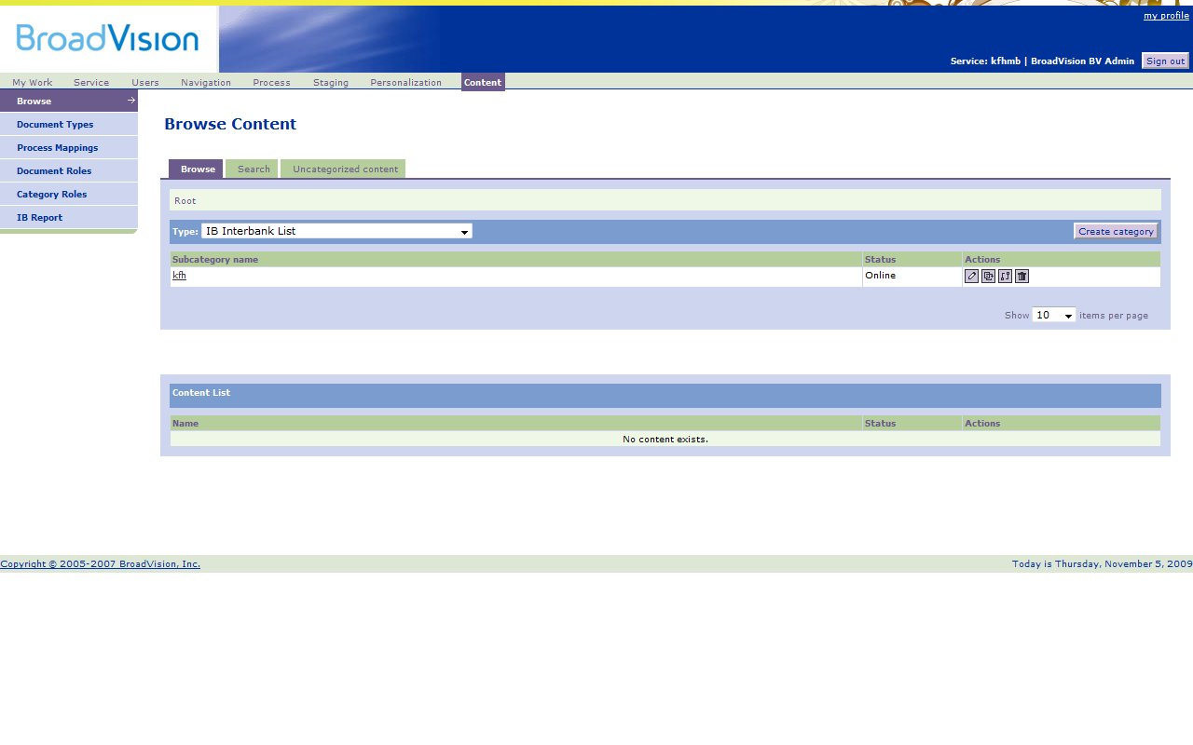
Figure 4.2: Proceed to Category & Subcategory

Step 3: Click on “Create content” to create new content (Member Bank).

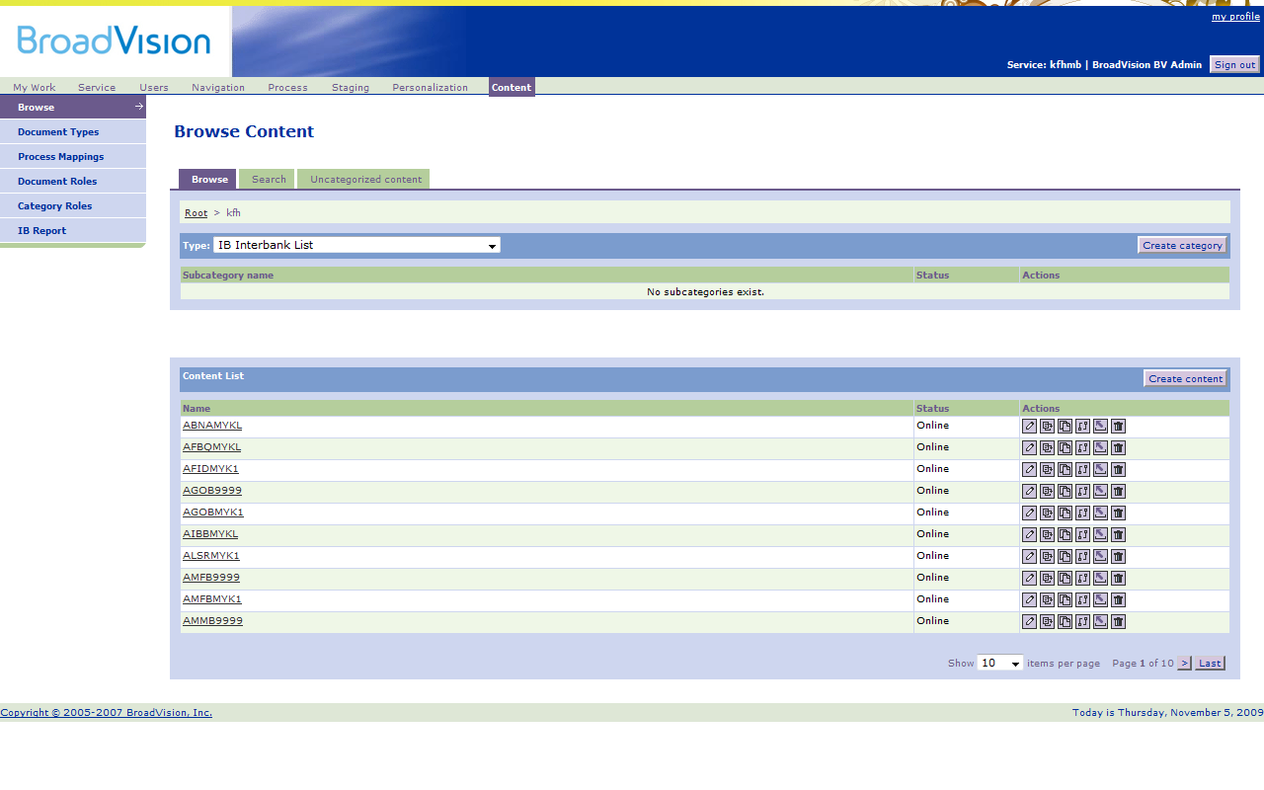
Figure 4.3: List of Content

Step 4: New Window pop up to fill up IBFT Member Bank Details.

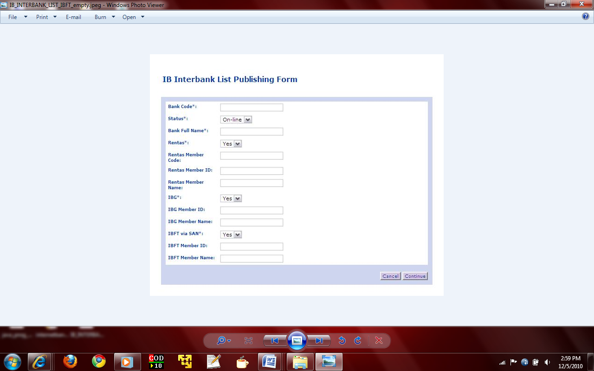
Figure 4.4: Create MEPS IBFT Member Bank
Step 5: Fill up the necessary Details of the IBFT Member Bank

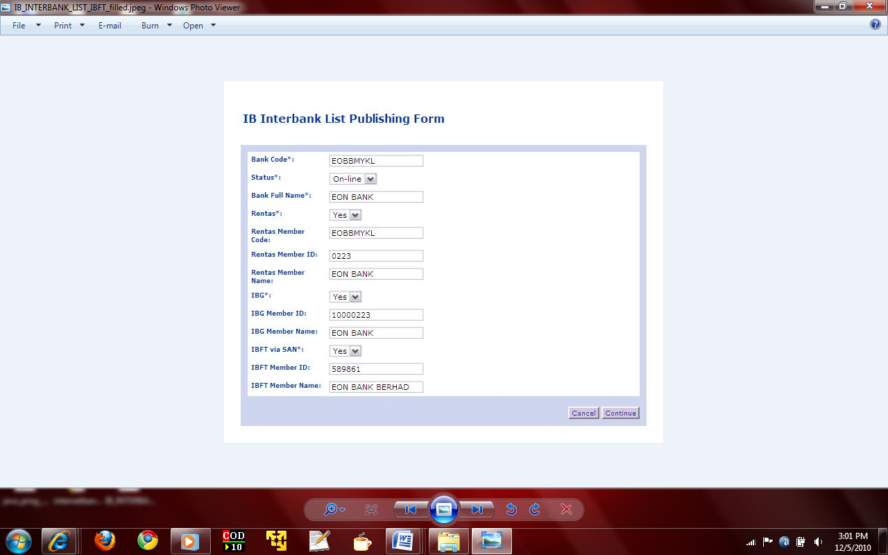
Figure 4.5: Fill in the Member Bank Details

Step 6: Finally click “Continue” to create New MEPS IBFT Member Bank.

